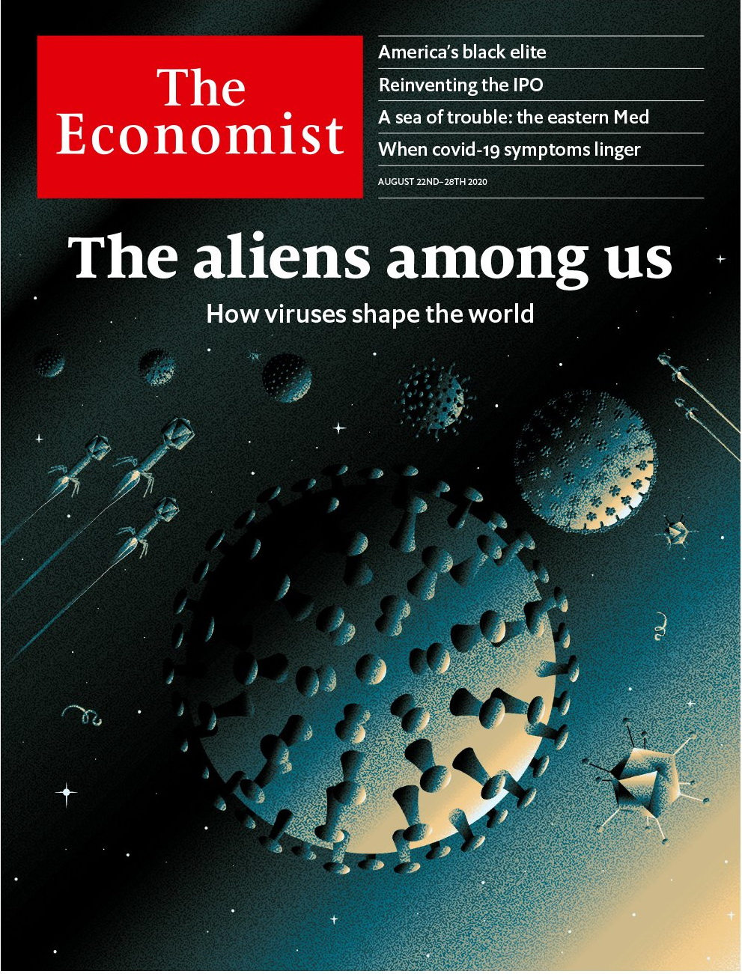

# Table of Contents

The world this week

Politics this week

Business this week

KAL’s cartoon

Leaders

The aliens among us

Israel and the Arab world: Out of the closet

Mali’s coup: Why the Sahel is suffering

Tech IPOs: Silicon Valley v Wall Street

Tensions in the eastern Mediterranean: A sea of trouble

Letters

On software problems, Britain, India, racism, Clement Attlee: Letters to the editor

Essay

The viral universe: The outsiders inside

United States

The presidential election: The postmaster always rings twice

America’s black elite: Our kind of people

Veterans in politics: Old soldiers

Lingua securitatis: From iPhones to aircraft carriers

Lexington: Unconventional

Internship

The Arctic: Drill music

The Americas

The Caribbean: Anxious isles

Canada: No more Morneau

Asia

Myanmar’s forever war: Will it ever stop?

Japan: Virtual respect for the dead

Thai democracy: Street cred

The internet in Pakistan: Calls waiting

Banyan: Sensitive Seoul

China

Hukou reform: Worlds apart

Chaguan: Past its Peak

Middle East & Africa

The United Arab Emirates: The strong, silent type

Israel and the Arab world: Who’s next?

Iran and covid-19: A rite old mess

African stamps: Wait a minute Mr Postman

Oil on protected waters: An oil spill off Mauritius threatens protected ecosystems

Mutiny in Mali: A coup that was coming

Europe

The Belarus uprising: The dictator hangs on, for now

Italy’s populists: Welcome to normal politics

Alexei Navalny in peril: Russia’s opposition leader is in a coma

Depopulating the Balkans: Ageing, dying, leaving

Charlemagne: Why Europeans love Schengen

Britain

Unemployment: It’s coming

Gymshark: Primus Insta pares

Public Health England: Turning German?

Exam marks: U and non-U

Race in Northern Ireland: Green or orange, not black

Media and society: No news is good news

Labour: Left out

Bagehot: Rule by algorithm

International

Tension in the eastern Mediterranean: Battling over boundaries

Business

Technology listings: Partying like it’s 1999

Apple’s Epic dust-up: Playing hard ball

Electric vehicles: Believe the hypercar

Entertainment: A big-sum game

Working hours: Weekend plans

Sino-American tech war: No more quarter

Schumpeter: Supply chained and bound

Finance & economics

Dubai: Navigating the storm

Mask economics: Cloth of gold

People’s Bank of China: Conforming to norms

Buttonwood: Foam party

Free exchange: State of the unions

Schools brief

Hidden figures: A flattened curve

Science & technology

Covid and chronic illness: Lingering fog

Books & arts

The American story: Twentieth-century fox

Johnson: Moral minorities

Colombia: A river and a nation

Home Entertainment: In the mind’s eye

British fiction: Unmoored

Economic & financial indicators

Economic data, commodities and markets

Graphic detail

Authoritarianism: Drifting apart

Obituary

Julian Bream: Passion plays



### Friday, August 21, 2020

|  |  |
| --- | --- |
| The world this week | 3 |
| Leaders | 5 |
| Letters | 1 |
| Essay | 1 |
| United States | 7 |
| The Americas | 2 |
| Asia | 5 |
| China | 2 |
| Middle East & Africa | 6 |
| Europe | 5 |
| Britain | 8 |
| International | 1 |
| Business | 7 |
| Finance & economics | 5 |
| Schools brief | 1 |
| Science & technology | 1 |
| Books & arts | 5 |
| Economic & financial indicators | 1 |
| Graphic detail | 1 |
| Obituary | 1 |

|  |  |  |
| --- | --- | --- |
|  | Sections | Leaders |

The world this week

Politics this week

.

Business this week

.

KAL’s cartoon

.

|  |  |  |
| --- | --- | --- |
|  | Sections | Leaders |

|  |  |  |  |
| --- | --- | --- | --- |
|  | Articles | Sections | Next |

# Politics this week

Aug 22nd 2020 |

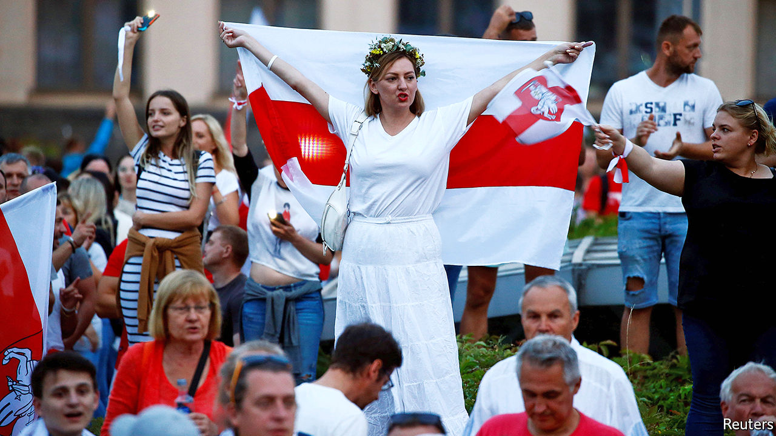

Alexander Lukashenko, the president of Belarus, continued to cling to power despite large demonstrations and strikes, after he fraudulently claimed victory in an election on August 9th. The European Union’s leaders have refused to recognise the result, and vowed to enact sanctions against officials involved in ballot fraud and in brutal attacks on demonstrators by Belarusian police. Vladimir Putin, Russia’s president, has not indicated whether he will come to his neighbour’s aid. See [article](https://www.economist.com/node/21791042).

Alexei Navalny, a Russian anti-corruption activist and the country’s main opposition leader, was taken into intensive care after falling ill on a flight from Siberia to Moscow. Doctors suspected that he had been poisoned. See [article](https://www.economist.com/node/21791048).

France deployed two fighter jets and a naval frigate to the eastern Mediterranean in response to Turkish moves to send gas-exploration vessels into disputed waters. The area is claimed by Greece. The Greek and Turkish navies have periodically been put on high alert since the tussle began last month. See [article](https://www.economist.com/node/21791024).

Another round of peace talks involving the government of Myanmar, the Burmese army and several ethnic groups were held in Naypyidaw, the capital. Hopes of ending the country’s ethnic strife have faded. See [article](https://www.economist.com/node/21791056).

Around 10,000 people marched in Bangkok calling for a return to democracy and the reform of the monarchy, the biggest anti-government rally in Thailand since the junta seized power in 2014. The protesters risked imprisonment under the country’s draconian lèse majesté laws, but that did not stop them giving three fingers to the authorities, a gesture inspired by “The Hunger Games”. See [article](https://www.economist.com/node/21791090).

New Zealand’s general election was delayed until October 17th because of a recent uptick in cases of covid-19.

America suspended its extradition treaty with Hong Kong and two other agreements with the territory. It is the latest in a number of actions taken by the American government in response to Beijing’s imposition of a national-security law, which the State Department said had “crushed the freedoms of the people of Hong Kong”.

China stepped up the pressure on Australia for its vocal criticism of various Chinese policies by announcing an anti-dumping investigation into the country’s wine exports.

The United Arab Emirates agreed to establish diplomatic relations with Israel, becoming the first Gulf state and just the third Arab country to formally recognise the Jewish state. The move was praised by several Arab leaders, leading to speculation that other countries in the region would soon follow the UAE’s lead. The Palestinians said they had not been told about the agreement. See article.

A UN-backed tribunal found Salim Ayyash guilty in absentia of killing Rafik Hariri, a former Lebanese prime minister, and 21 others in a bomb attack in Beirut in 2005. Three other defendants were acquitted. Though all four were members of Hizbullah, a Shia party-cum-militia close to the governments of Iran and Syria, the judges found no evidence that either Hizbullah’s leadership or Syria was involved.

Ibrahim Boubacar Keita, Mali’s president, was forced to resign after being arrested by rebel soldiers in a coup. Mr Keita dissolved parliament and said he wished to avert bloodshed. See article.

An attack by al-Shabab, a group linked to al-Qaeda, on a seaside hotel in Somalia’s capital, Mogadishu, killed at least 11 people.

America’s postmaster-general, Louis DeJoy, suspended proposed changes to the postal service’s operations until after November’s presidential election. Democrats accuse Mr DeJoy, who is one of Donald Trump’s big political donors, of trying to suppress postal votes. See article.

The Democrats held their national convention, virtually and without the usual razzamatazz. Although Milwaukee was the event’s official hub, the roll call that officially nominated Joe Biden as the party’s candidate for president was broadcast from each state. See article.

Bill Morneau resigned as Canada’s finance minister. Members of Mr Morneau’s family went on trips in 2017 paid for by WE Charity, which this year won a government contract to administer a student-grant programme. The ethics commissioner is investigating whether Mr Morneau and the prime minister, Justin Trudeau, violated conflict-of-interest rules. WE Charity has also paid tens of thousands of dollars to Mr Trudeau’s mother and brother to speak at events. See article.

Anti-abortion activists gathered at a hospital in Brazil’s north-eastern city of Recife to try to stop a ten-year-old girl from having an abortion. Her name had been revealed by an associate of the minister for women. Feminists rallied to support the girl, who had been raped by her uncle. She was entitled to the procedure under Brazil’s strict abortion laws.

Thousands of Argentines demonstrated against the government’s plan to extend lockdown measures. Protesters also object to a proposed reform of the judiciary, which they suspect will serve the interests of Cristina Fernández de Kirchner, the vice-president, who has been indicted for corruption.

## Coronavirus briefs

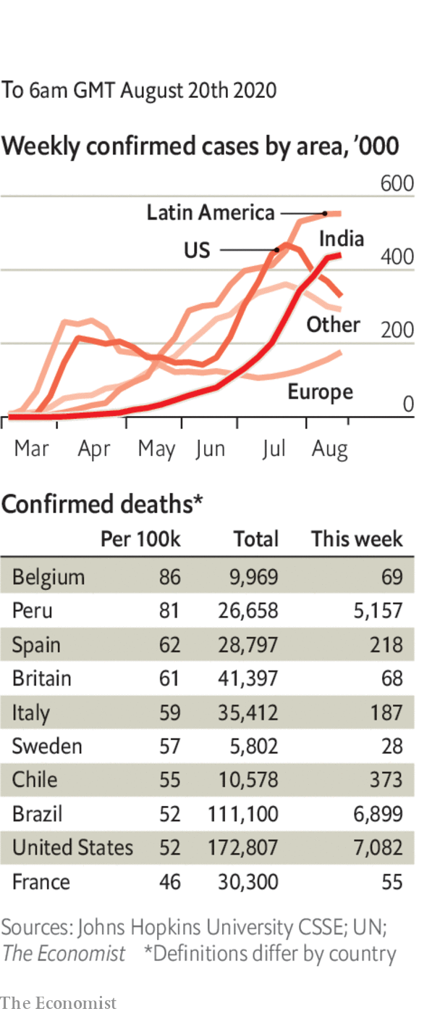

India’s cases soared past 2.8m, the third-highest in total behind America and Brazil.

Restrictions on social gatherings were reimposed in Seoul, after South Korea reported its highest number of daily infections since March. Churches are a big source of the outbreak.

Ireland reintroduced some restrictions and again asked people to work from home.

The World Health Organisation warned against a growing “vaccine nationalism”, as countries seek to hoard the prospective drugs rather than ensure their global availability.

Sweden and the Netherlands declined to make face masks mandatory in public despite rising numbers of infections. Both countries have implemented comparatively lenient social-distancing measures, and have higher-than-average rates of excess deaths.

This article was downloaded by calibre from <https://www.economist.com/the-world-this-week/2020/08/22/politics-this-week>

|  |  |  |  |
| --- | --- | --- | --- |
|  | Articles | Sections | Next |

|  |  |  |  |
| --- | --- | --- | --- |
| Previous | Articles | Sections | Next |

# Business this week

Aug 22nd 2020 |



The Trump administration issued an edict tightening the embargo on Huawei. The measure prevents anyone from supplying semiconductors to the Chinese maker of network equipment if they are made using American technology. It is the biggest blow the American government has yet landed on Huawei, which will now tap the stockpile of chips it has accumulated to cover such an eventuality. China said America’s action contravened international trade rules. See [article](https://www.economist.com/node/21791055).

## The clock ticks, for TikTok

Oracle was considering whether to bid for TikTok, according to reports. TikTok is another Chinese tech firm that has fallen foul of the American government; Donald Trump has ordered its parent company, ByteDance, to sell its American operations (though his decree is legally dubious). Microsoft is already vying to buy TikTok, but Mr Trump now supports Oracle’s bid.

The operator of the Hong Kong stock exchange reported a solid set of earnings for the first half, as revenues from trading, listing fees and clearing increased. The city’s political turmoil has done little to dent appetite for IPOs. A stream of Chinese tech companies are also offering secondary listings of their shares in Hong Kong, supplementing their listings in New York, as a hedge against warnings from American regulators that they face being delisted if they do not abide by US accounting rules.

Airbnb made it official and filed papers for an IPO. There were no details about when it might float shares on the stockmarket, or how many shares it would offer, but it is expected to be one of the biggest IPOs this year. See article.

In Europe Ryanair reduced its flight schedule for September and October by a fifth. Bookings have drooped again because of the resurging coronavirus. The airline had hoped to operate 70% of its capacity.

Official data showed that Japan’s GDP was 7.8% smaller in the second quarter than in the first. A plunge in consumption during the pandemic and a drop in exports were to blame, though the contraction was less severe than in America or most European countries. Japan was already in recession following a steep rise in the sales tax last year.

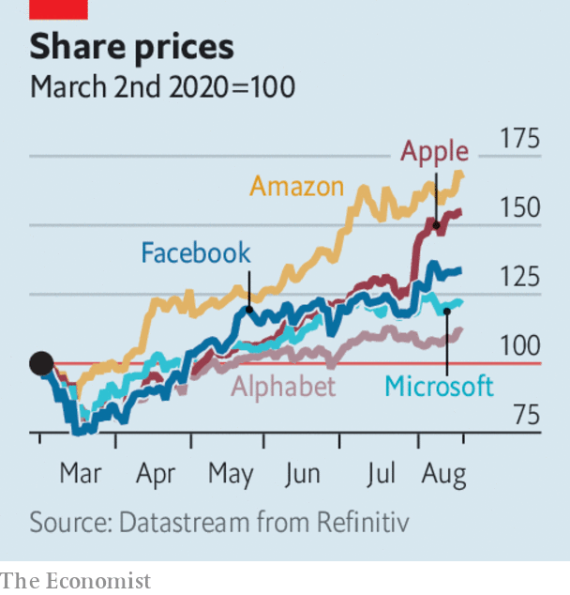

The S&P 500 closed at a record high for the first time since February. Like some other share-price indices the S&P has rocketed back from the market rout of mid-March, when America and Europe went into lockdown, though this has been fuelled mostly by the success of tech companies. Alphabet, Amazon, Apple, Facebook and Microsoft account for around a fifth of the index; the stocks of most other companies on the S&P are still below their February levels. Apple this week hit $2trn in value, after adding another $1trn to its market capitalisation in just five months. See article.

The rebound in stockmarkets led to more consternation about their detachment from the performance of the real economy. The dollar is another bellwether of the economic fallout of covid-19 in America. It dropped to a two-year low this week against a basket of currencies.

Californians were told to prepare for rolling power blackouts for the first since 2001. A number of factors including a heatwave were responsible. So was what Gavin Newsom, the governor, described as a “gap” in the ability of solar power to respond to increased demand.

Epic Games, which makes Fortnite, is taking Apple to court over the technology giant’s policy on in-app purchases. Apple takes a 30% cut from money spent within most iPhone apps, something that has long annoyed software developers. After Epic deliberately flouted Apple’s payment rules, Apple removed Fortnite from its app store, meaning iPhone users can no longer download one of the world’s most popular games. See article.

The bloodbath on Britain’s high streets showed little sign of abating, as Marks & Spencer announced 7,000 job cuts. The retailer is shedding around a tenth of its staff in total, the most in its 136-year history. See article.

Walmart had another bumper quarter. Net sales from its American operations for the three months ending July 31st were up by 9.5% compared with the same quarter last year, helped by a 97% rise in revenues from online shopping. At Target, a 195% increase in revenues from e-commerce helped the company chalk up its biggest-ever rise in quarterly sales.

## The work-life boundary

Carlyle, a global private-equity firm, reportedly told its staff not to use public transport to commute to their offices when they reopen, and if they use trains and buses at the weekend to quarantine for 14 days. Like other firms, Carlyle wants to limit the spread of covid-19. But the directive raises questions about how far a company can interfere in an employee’s private life. Using public transport during the pandemic is perfectly legal for its workers in London, for example; the only rule is to wear a face mask.

This article was downloaded by calibre from <https://www.economist.com/the-world-this-week/2020/08/22/business-this-week>

|  |  |  |  |
| --- | --- | --- | --- |
| Previous | Articles | Sections | Next |

|  |  |  |  |
| --- | --- | --- | --- |
| Previous | Articles | Sections | Next |

# KAL’s cartoon

Aug 22nd 2020 |

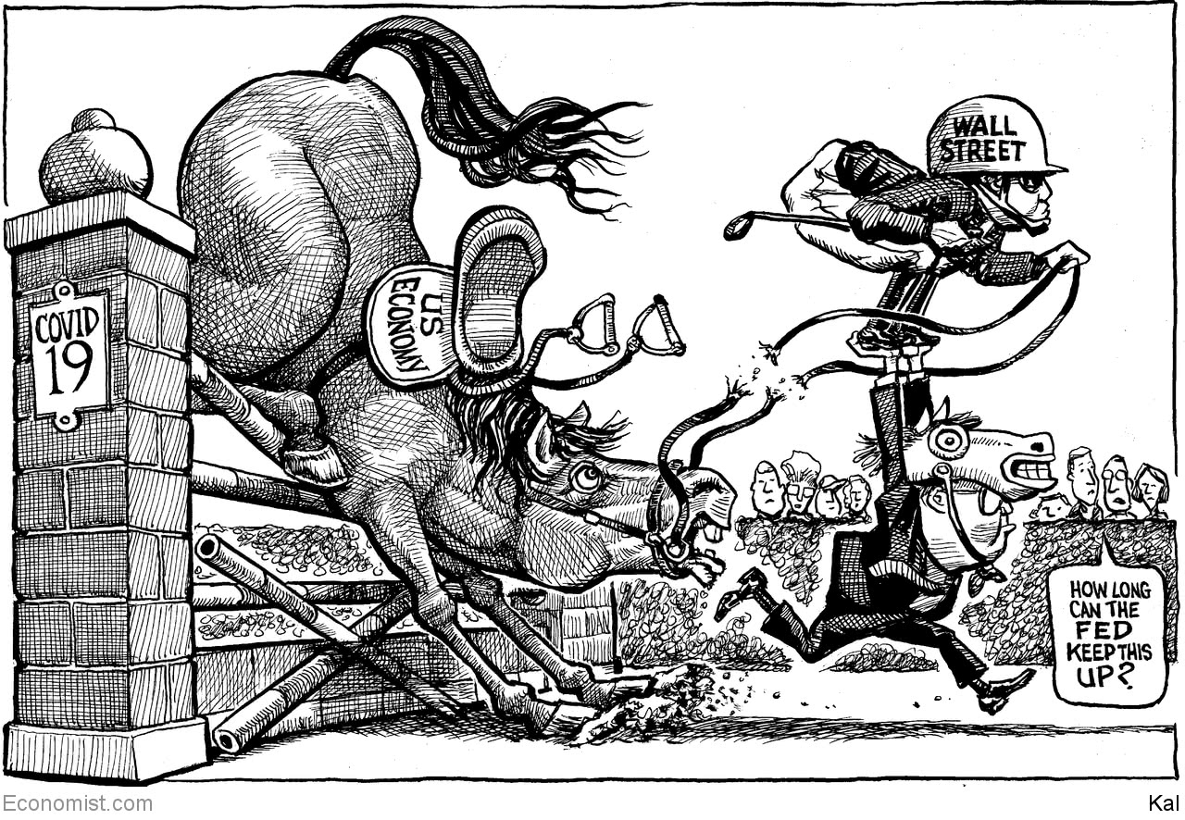

This article was downloaded by calibre from <https://www.economist.com/the-world-this-week/2020/08/22/kals-cartoon>

|  |  |  |  |
| --- | --- | --- | --- |
| Previous | Articles | Sections | Next |

|  |  |  |
| --- | --- | --- |
| The world this week | Sections | Letters |

Leaders

The aliens among us

.

Israel and the Arab world: Out of the closet

.

Mali’s coup: Why the Sahel is suffering

.

Tech IPOs: Silicon Valley v Wall Street

.

Tensions in the eastern Mediterranean: A sea of trouble

.

|  |  |  |
| --- | --- | --- |
| The world this week | Sections | Letters |

|  |  |  |  |
| --- | --- | --- | --- |
|  | Articles | Sections | Next |

#### The aliens among us

# How viruses shape the world

They don’t just cause pandemics

Aug 22nd 2020 |



HUMANS THINK of themselves as the world’s apex predators. Hence the silence of sabre-tooth tigers, the absence of moas from New Zealand and the long list of endangered megafauna. But SARS-CoV-2 shows how people can also end up as prey. Viruses have caused a litany of modern pandemics, from covid-19, to HIV/AIDS to the influenza outbreak in 1918-20, which killed many more people than the first world war. Before that, the colonisation of the Americas by Europeans was abetted—and perhaps made possible—by epidemics of smallpox, measles and influenza brought unwittingly by the invaders, which annihilated many of the original inhabitants.

The influence of viruses on life on Earth, though, goes far beyond the past and present tragedies of a single species, however pressing they seem. Though the study of viruses began as an investigation into what appeared to be a strange subset of pathogens, recent research puts them at the heart of an explanation of the strategies of genes, both selfish and otherwise.

Viruses are unimaginably varied and ubiquitous. And it is becoming clear just how much they have shaped the evolution of all organisms since the very beginnings of life. In this, they demonstrate the blind, pitiless power of natural selection at its most dramatic. And—for one group of brainy bipedal mammals that viruses helped create—they also present a heady mix of threat and opportunity.

As our [essay](https://www.economist.com/essay/2020/08/20/viruses-play-a-profound-role-in-ecology-and-evolution-as-well-as-in-human-health) in this week’s issue explains, viruses are best thought of as packages of genetic material that exploit another organism’s metabolism in order to reproduce. They are parasites of the purest kind: they borrow everything from the host except the genetic code that makes them what they are. They strip down life itself to the bare essentials of information and its replication. If the abundance of viruses is anything to go by, that is a very successful strategy indeed.

The world is teeming with them. One analysis of seawater found 200,000 different viral species, and it was not setting out to be comprehensive. Other research suggests that a single litre of seawater may contain more than 100bn virus particles, and a kilo of dried soil ten times that number. Altogether, according to calculations on the back of a very big envelope, the world might contain 1031 of the things—that is ten followed by 31 zeros, far outnumbering all other forms of life on the planet.

As far as anyone can tell, viruses—often of many different sorts—have adapted to attack every organism that exists. One reason they are powerhouses of evolution is that they oversee a relentless and prodigious slaughter, mutating as they do so. This is particularly clear in the oceans, where a fifth of single-celled plankton are killed by viruses every day. Ecologically, this promotes diversity by scything down abundant species, thus making room for rarer ones. The more common an organism, the more likely it is that a local plague of viruses specialised to attack it will develop, and so keep it in check.

This propensity to cause plagues is also a powerful evolutionary stimulus for prey to develop defences, and these defences sometimes have wider consequences. For example, one explanation for why a cell may deliberately destroy itself is if its sacrifice lowers the viral load on closely related cells nearby. That way, its genes, copied in neighbouring cells, are more likely to survive. It so happens that such altruistic suicide is a prerequisite for cells to come together and form complex organisms, such as pea plants, mushrooms and human beings.

The other reason viruses are engines of evolution is that they are transport mechanisms for genetic information. Some viral genomes end up integrated into the cells of their hosts, where they can be passed down to those organisms’ descendants. Between 8% and 25% of the human genome seems to have such viral origins. But the viruses themselves can in turn be hijacked, and their genes turned to new uses. For example, the ability of mammals to bear live young is a consequence of a viral gene being modified to permit the formation of placentas. And even human brains may owe their development in part to the movement within them of virus-like elements that create genetic differences between neurons within a single organism.

Evolution’s most enthralling insight is that breathtaking complexity can emerge from the sustained, implacable and nihilistic competition within and between organisms. The fact that the blind watchmaker has equipped you with the capacity to read and understand these words is in part a response to the actions of swarms of tiny, attacking replicators that have been going on, probably, since life first emerged on Earth around 4bn years ago. It is a startling example of that principle in action—and viruses have not finished yet.

Humanity’s unique, virus-chiselled consciousness opens up new avenues to deal with the viral threat and to exploit it. This starts with the miracle of vaccination, which defends against a pathogenic attack before it is launched. Thanks to vaccines, smallpox is no more, having taken some 300m lives in the 20th century. Polio will one day surely follow. New research prompted by the covid-19 pandemic will enhance the power to examine the viral realm and the best responses to it that bodies can muster—taking the defence against viruses to a new level.

Another avenue for progress lies in the tools for manipulating organisms that will come from an understanding of viruses and the defences against them. Early versions of genetic engineering relied on restriction enzymes—molecular scissors with which bacteria cut up viral genes and which biotechnologists employ to move genes around. The latest iteration of biotechnology, gene editing letter by letter, which is known as CRISPR, makes use of a more precise antiviral mechanism.

## From the smallest beginnings

The natural world is not kind. A virus-free existence is an impossibility so deeply unachievable that its desirability is meaningless. In any case, the marvellous diversity of life rests on viruses which, as much as they are a source of death, are also a source of richness and of change. Marvellous, too, is the prospect of a world where viruses become a source of new understanding for humans—and kill fewer of them than ever before. ■

This article was downloaded by calibre from <https://www.economist.com/leaders/2020/08/22/how-viruses-shape-the-world>

|  |  |  |  |
| --- | --- | --- | --- |
|  | Articles | Sections | Next |

|  |  |  |  |
| --- | --- | --- | --- |
| Previous | Articles | Sections | Next |

#### Into the open

# The Israel-UAE deal is good news for a troubled region

Even if tensions remain high elsewhere in the Middle East

Aug 22nd 2020 |

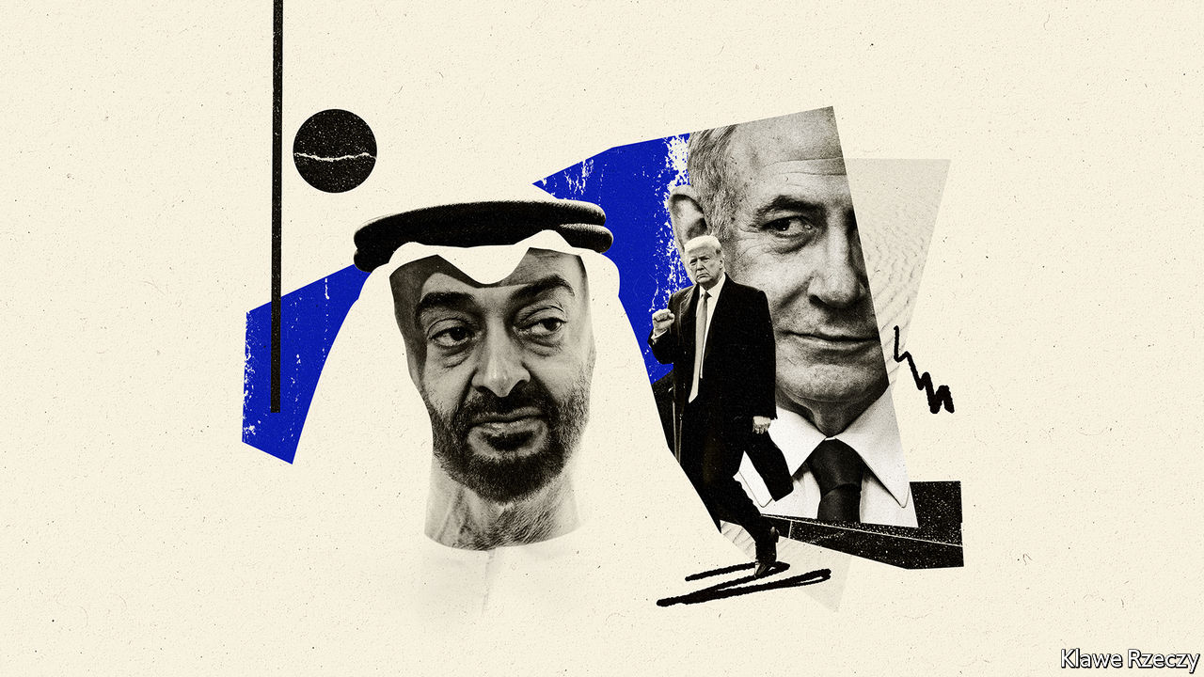

IT WAS NOT only Yasser Arafat, leader of the Palestinians, who watched with “grief and fury” as Anwar Sadat went to Israel in 1977. Several of the region’s autocrats severed ties with Egypt’s president over what some called a “treasonous” act. When, two years later, Sadat signed a peace deal with the Jewish state, they erupted in outrage again. Egypt was suspended from the Arab League, which imposed a boycott on the country and left Cairo for Tunis. In 1981 Sadat was murdered by jihadists who cited the peace deal as one of their main grievances.

In many ways the region looks the same as it did four decades ago. Autocracy is still in vogue; the Palestinians remain stateless. But relations between Israel and the rest of the Arab world are unrecognisable. When the United Arab Emirates (UAE) agreed to establish diplomatic ties with the Jewish state on August 13th, there was little grief or fury in the region’s capitals. Israel’s first formal relationship with a Gulf state, and its third with any Arab country (Egypt and Jordan being the others), was met with praise from many Arab leaders (see [article](https://www.economist.com/node/21791040)).

Some are calling it a “breakthrough”, others a “turning-point for peace”. But the deal is not remarkable for how it might transform the region. Rather, it reflects remarkable changes that have already taken place. A part of the world once defined by Arab-Israeli hostilities is no longer so; countries increasingly look towards the future, not the past, when shaping their policies. In a perennially troubled neighbourhood, this decline in tension is worth celebrating, even if other dangerous fault-lines remain.

It was no secret that Israel and the Gulf states had grown closer of late. Motivated by a common enemy, Iran, their armies and spy agencies swap intelligence. Recently, Israeli officials began popping up in Gulf capitals. But the UAE’s decision to take its relationship public will bring more benefits for both sides. Israeli business people are excited about their access to Dubai, the region’s financial hub—which happens to be in dire need of a clean-up (see article). Deals have already been signed between Israeli and Emirati firms. It feels like a much warmer peace than that between Israel and Egypt. Other Arab states are talking about following the UAE’s lead.

Give the Trump administration due credit. Seven months ago it unveiled a peace plan that was immediately rejected by the Palestinians and most Arab states, because it allowed Israel to annex about 30% of the occupied West Bank and gave the Palestinians something less than a state in return. But at the same time America was sponsoring secret talks between Israel and the UAE. Somehow, in a feat of diplomatic alchemy, American officials turned this far-fetched scheme into leverage. The UAE demanded no real concessions from Israel, other than a promise from Binyamin Netanyahu, the Israeli prime minister, that he would not move ahead with annexation at the moment.

The deal is a boon for Mr Netanyahu, who has been under fire at home over allegations of corruption and for his poor handling of covid-19. The prime minister claims there is “no change” to his pledge to annex parts of the West Bank. In reality, the deal lets him duck a tricky issue. His nationalist allies have wanted him to absorb Israeli settlements in the occupied territories, even though it would have brought international opprobrium. He has avoided that choice and, nonetheless, thrown the nationalists a bone. They have always rejected the idea of swapping land for peace, long the framework of talks with the Arabs. Peace for peace should suffice, they argued. Now, apparently, it does.

The big losers, as ever, are the Palestinians. Only three years ago the Arab states re-endorsed a strategy of offering normal relations with Israel in return for its withdrawal from the occupied territories and the establishment of a Palestinian state, among other things. But Arab rulers, particularly in the Gulf, have grown increasingly frustrated with the stale and stubborn Palestinian leadership. Perhaps exposing the charade of pan-Arab solidarity, and separating the Israeli-Arab conflict from the Israeli-Palestinian one, will lead to a more honest assessment of what is possible. For the time being, though, a just solution to the Palestinian plight feels as elusive as ever.

And what of those other fault-lines? The most dangerous lies between, on one side, America, Israel and much of the Arab world, and, on the other, Iran. Its economy is on the brink of collapse, while its proxy in Lebanon, Hizbullah, faces a backlash over a deadly explosion in Beirut. The Israel-UAE deal, as much as it reflects their shared antagonism to Iran, adds a new element to President Donald Trump’s “maximum pressure” campaign. Where that campaign will ultimately lead remains an open question. But officials in America and the Middle East would do well to remember that bitter enemies need not always remain so. ■

This article was downloaded by calibre from <https://www.economist.com/leaders/2020/08/22/the-israel-uae-deal-is-good-news-for-a-troubled-region>

|  |  |  |  |
| --- | --- | --- | --- |
| Previous | Articles | Sections | Next |

|  |  |  |  |
| --- | --- | --- | --- |
| Previous | Articles | Sections | Next |

#### Suffering in the Sahel

# A coup in Mali is unlikely to make matters better

Western countries cannot solve African crises with military support alone

Aug 22nd 2020 |

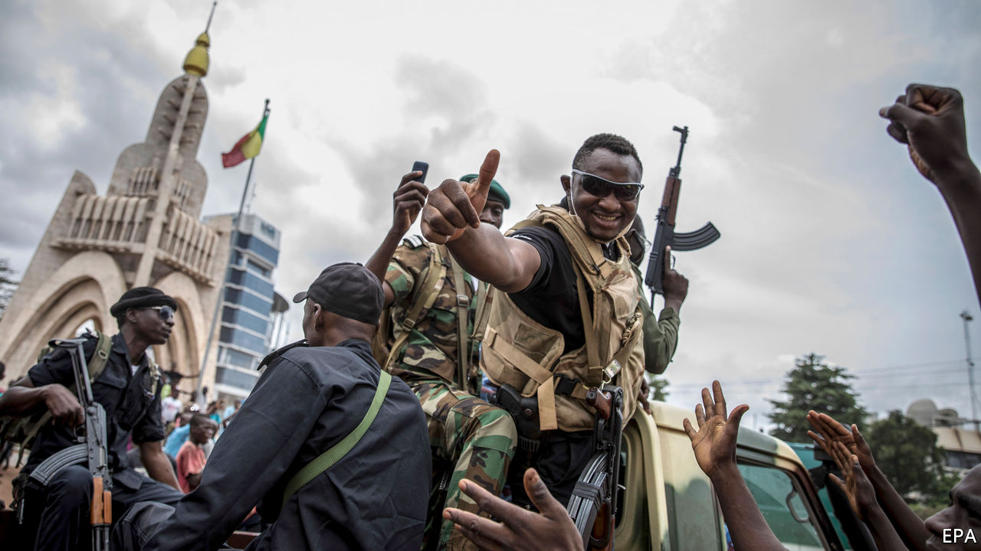

A COUP D’ETAT is almost never good news. In Mali the descent into violence accelerated dramatically in March 2012, when soldiers mutinied and launched attacks on the presidential palace, the state broadcaster and a military barracks in Bamako, the capital. The then president, Amadou Toumani Touré, was forced into exile. Within months, jihadists had taken over much of northern Mali. By the start of 2013 France felt obliged to intervene, sending soldiers and its air force to push the militants out of their strongholds in the cities of Timbuktu and Gao.

That seemed to have saved Mali from a terrible fate: the state’s complete collapse into the hands of fanatics. But the experience of 2012 could repeat itself. On August 18th soldiers in Bamako again left their barracks to overthrow the government. The president, Ibrahim Boubacar Keita, who came to power in elections in 2013, was arrested with his prime minister, and forced to resign (see article). As in 2012 the coup plotters have promised new elections. But, as then, the result may be more violence.

Western governments are dismayed by the mutiny, and the UN rightly called for the restoration of constitutional order. In Africa especially, coups beget coups. Mali is a hub for smuggling drugs, arms and people across Africa and to Europe; that problem may now worsen. But the West must shoulder some of the blame. In the years since France intervened, the limits of trying to solve political problems with military force (partly focused on counter-terrorism) have become ever plainer. The number of foreign troops in the southern fringe of the Sahel has grown. As well as hefty French and UN contingents, soldiers from Britain, America, Germany and countries next to Mali have weighed in. But they have done little to tackle the cause of the conflict: a weak, corrupt state with scant regard for its people.

At least 4,000 people were killed in the Sahel last year, around 40% of them in Mali. Since 2012 violence has spread from the north to the centre of the country—and across the region. The state has not only failed to stop the killing, it may have been complicit in it. Last year about 160 people, mostly ethnic Fulanis, were massacred by a Dogon militia in Ogossagou, a village in central Mali. Mr Keita promised such atrocities would be stopped. Yet in February this year tribesmen attacked Ogossagou again, killing 35 more. Human Rights Watch, an international monitor, has documented how Mali’s army let it happen, leaving the village just hours before the attack.

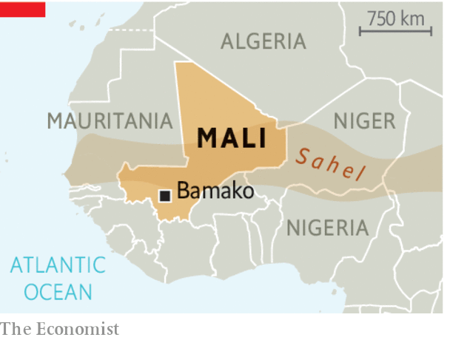

A state that does not protect its people from massacres is scarcely likely to succeed on other fronts. This coup was preceded by months of civil protests prompted by a decision of the constitutional court to overturn the results in 31 seats of parliamentary elections held in March. The court handed many back to Mr Keita’s party. But the protests were also fuelled by anger towards a government seen as crooked and feeble. It is unclear whether the coup-makers acted in league with the organisers of the protests, but they are likely to be embraced by them. The dismay of foreign governments will not bring back Mr Keita.

Mali’s security problems are far from unique in Africa. For over a decade Nigeria has struggled with Boko Haram’s insurgency. Kenya is still afflicted by terrorists in its Somali north-east. An Islamic State affiliate is on the rise in Mozambique. The fighters in such cases are invariably drawn from people with no stake in the state. The West has proffered soldiers, equipment and intelligence, but has done much less to encourage governments to settle grievances. In January President Emmanuel Macron threatened to withdraw French soldiers from the Sahel unless the region’s leaders clearly said they wanted them to stay. When they did, he increased the French contingent. A genuine threat to withdraw would be risky. Yet Western governments should consider whether their military aid can defeat extremists if they do not also tackle hopeless governance.■

This article was downloaded by calibre from <https://www.economist.com/leaders/2020/08/22/a-coup-in-mali-is-unlikely-to-make-matters-better>

|  |  |  |  |
| --- | --- | --- | --- |
| Previous | Articles | Sections | Next |

|  |  |  |  |
| --- | --- | --- | --- |
| Previous | Articles | Sections | Next |

#### Silicon Valley v Wall Street

# The IPO is being reinvented

Tech firms are taking advantage of frothy stockmarkets to experiment with new ways to go public. Good

Aug 22nd 2020 |

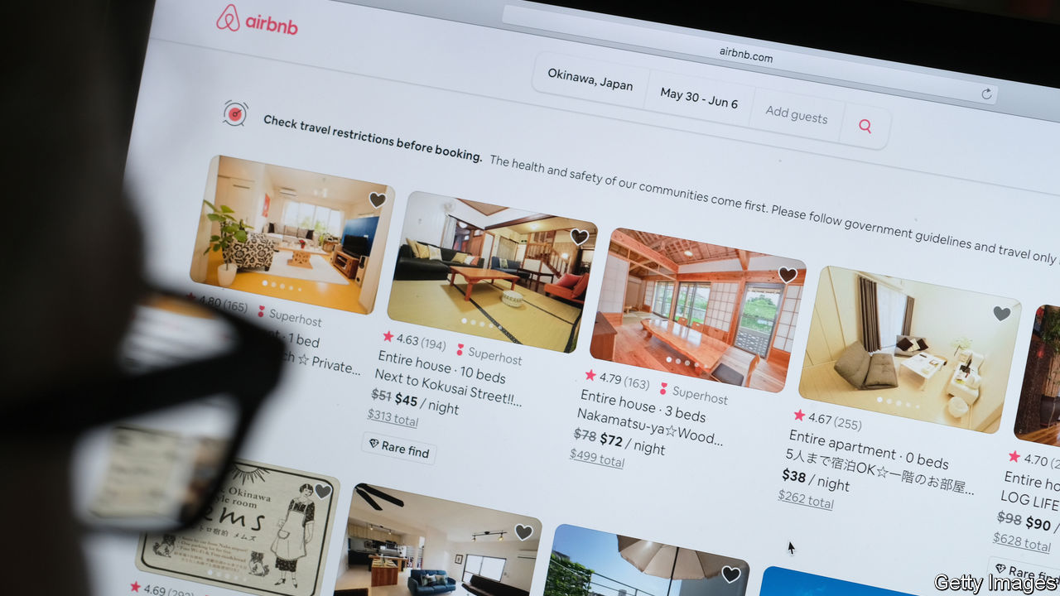

OVER THE past two decades fewer firms in America have listed on the stockmarket, opting instead to stay in the shadows for longer. Entrepreneurs and venture capitalists (VCs) make two complaints. First, initial public offerings (IPOs) are a rip-off. Second, the degree of outside scrutiny firms face can be uncomfortable. Now a new wave of tech firms are expected to go public, including Airbnb, a home-rental firm, and Palantir, which does data analytics (see [article](https://www.economist.com/node/21791050)). Some plan to use one of two alternative techniques for floating: direct listings and blank-cheque companies. This disruption to the conventional IPO market is risky but welcome. However, in the long run these newcomers won’t be able to escape ruthless outside scrutiny of their business models.

The decline of IPOs is striking. On average in the 25 years to 2000, 282 firms staged one each year, but since 2001 the figure has fallen to 115. This has made the economy more opaque and prevented ordinary people from investing in young firms. The underlying cause is a shift in the balance of power towards companies. Tech startups tend to be asset-light and need less capital, while the VC industry has grown and can fund firms for longer. Startups can thus delay going public. Amazon floated in 1997 when it was three years old, but the typical firm listing now is 11. There is a backlog of 225 unicorns—private startups worth over $1bn—which are supposedly worth a total of $660bn.

If firms are not acquired, they need to go public eventually. Staff want to sell their shares. Their VC backers are sitting on bloated portfolios and need to return cash to their investors. The push to clear this backlog began in 2019 and is gaining steam again. As well as Airbnb and Palantir, many other flotations are planned. In China stars such as Ant, a fintech giant, are listing, too. The pandemic has led to more buzz about the digital economy—Walmart has just reported soaring e-commerce sales. Central-bank stimulus has ginned up markets. And in America there is excitement about alternatives to IPOs.

In an IPO Wall Street banks act as middlemen between the firm and investors, negotiating a price. It’s a gruelling and expensive ordeal. Investors and regulators grill managers for months. Banks charge fees of 4-7% of the proceeds and sometimes sell firms’ shares too cheaply in order to please their clients at investment funds, who get a quick profit, or “pop”, on the first day of trading. Companies have thrown away $43bn of value in this way in the past decade, reckons Michael Mauboussin of Morgan Stanley. According to Bill Gurley, a VC investor, “that pop you hear is money going out of your pocket.”

One alternative to an IPO is a direct listing. Instead of a banker, a stock exchange sets the initial price, automatically balancing supply and demand just before the shares start trading. Last year Slack, a software firm, listed this way, and Palantir could follow. Another method involves blank-cheque companies known as “special-purpose acquisition companies”, or SPACS: listed shell companies that acquire private firms, instantly bypassing the IPO process. Virgin Galactic, a space firm, took this route in 2019. Both approaches have drawbacks. In a direct listing, the law says you cannot raise fresh capital, and without underwriters the share price can be volatile. Blank-cheque firms, meanwhile, have a patchy history, with sponsors often awarding themselves piles of shares, although one newcomer, a $5bn-7bn vehicle backed by Bill Ackman, an investor, says it will keep costs low.

These experiments put pressure on banks and regulators to improve the IPO process. The twist is that they are made possible by frothy markets (see Buttonwood). Some firms that have floated look overvalued—take Nikola, an electric-lorry firm, which has no material revenues but is valued at $16bn after a blank-cheque listing. Entrepreneurs and VCs love getting an easy ride, but they should be under no illusion: over time, the stockmarket hammers weak firms. Shares of Uber and Lyft, ride-hailing firms that floated in 2019, languish 35% and 61% below their listing price. WeWork, an office-rental firm, abandoned its listing last year after being exposed as a dud. By the end of the great flotation boom of 2020, the hope is that America will have established ways to make it easier for firms to go public. But make no mistake, some of the pioneer companies will be flops.■

This article was downloaded by calibre from <https://www.economist.com/leaders/2020/08/22/the-ipo-is-being-reinvented>

|  |  |  |  |
| --- | --- | --- | --- |
| Previous | Articles | Sections | Next |

|  |  |  |  |
| --- | --- | --- | --- |
| Previous | Articles | Sections | Next |

#### Trouble among NATO allies

# Dealing with a dangerous dispute in the eastern Med

Turkey and Greece must be encouraged to exchange views, not blows

Aug 22nd 2020 |

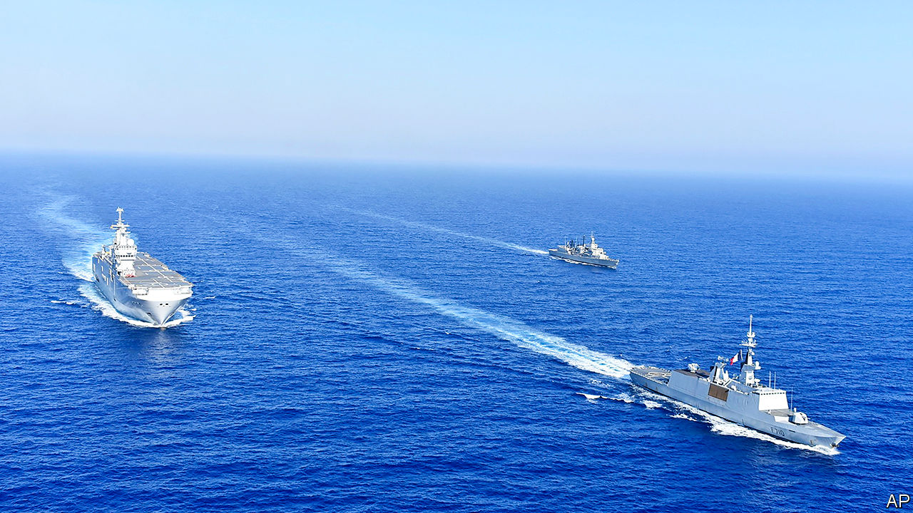

AT THIS TIME of year the eastern Mediterranean evokes thoughts of holiday beaches. It has become a destination for superyachts avoiding covid-hit Spain. Unfortunately, this summer the region is also luring warships, as tensions rise between Greece and Turkey over disputed waters. A collision between Greek and Turkish frigates on August 12th was the worst confrontation between the two NATO allies since a face-off on an uninhabited island in 1996 that nearly led to war. In a show of solidarity with Greece, a fellow EU member, France has moved a couple of Rafale fighter jets to Crete and deployed two warships to exercise with the Greek navy. Unless cool heads prevail, there is a risk that matters will escalate further—even as far as blows.

Three main ingredients make this a recipe for trouble. One is interest in the region’s gas resources, which for a decade have been attracting the attention not just of Greece and Turkey but also Cyprus, Israel, Egypt and others. Several countries aspire to be a regional energy hub, helping supply the European market and providing a strategic alternative to Russian gas. Boosters hoped pipelines running across the eastern Med area could be a catalyst for regional co-operation, which in some cases they have (see [article](https://www.economist.com/node/21791015)).

But elsewhere that hope has been overpowered by the second ingredient in the Mediterranean mix: the region’s rivalries. Instead of diluting them, the energy opportunity has intensified them. Cyprus remains divided between a Greek-Cypriot south and a Turkish Republic of Northern Cyprus recognised only by Turkey. Turkish gas exploration in Cyprus’s exclusive economic zone last year brought condemnation from the EU and some (largely symbolic) sanctions. Now Turkish ships are again conducting seismic surveys in Cypriot waters.

Relations between Greece and Turkey are always in danger of flaring up over contested territory. The latest clash has been in the making ever since the signing last November of an agreement between Turkey and Libya’s UN-backed Government of National Accord (GNA). The deal claims an expansive maritime boundary that looks outrageous to Greeks, and also to international law. German efforts to bring Greeks and Turks together for talks came close to working until Greece and Egypt earlier this month rushed to finalise an agreement on maritime zones that countered the one between Turkey and Libya. The Turkish response was to send a seismic-research vessel into the area, with a naval escort—which was involved in that collision with an elderly Greek frigate.

Aggravating all this are wider frictions involving Turkey, from Libya to Syria, the third ingredient stewing in the pot. In Libya, Turkey and France are at loggerheads; in June Turkish warships prevented a French frigate from inspecting a ship suspected of carrying arms to the GNA. The French do not mind pushing back. The Turks, for their part, condemn French interference and think Greece and its friends are ganging up against them. Turkey’s response, under its authoritarian president, Recep Tayyip Erdogan, is to throw its weight around. He may feel emboldened because some countries, such as Britain, are keen to avoid antagonising a NATO ally while others, notably Germany, fear that if pushed too hard Turkey could cause chaos by letting more migrants into Europe.

How to defuse the situation? In the past America might have stepped in to hold the ring (as it did after the clash in 1996). But the mess in the eastern Mediterranean shows how that old order is unravelling—and at what cost. On August 20th France’s president, Emmanuel Macron, was due to welcome Germany’s chancellor, Angela Merkel, to his presidential retreat at Fort de Brégançon on the French Med. A combination of Mr Macron’s muscle and Mrs Merkel’s mediation could yet prove effective in convincing Turkey that, though its rule-breaking cannot be accepted, its concerns will be listened to. The priority is to create some breathing space for Greece and Turkey to talk. A moratorium on exploration in disputed waters might be a good start.

The irony is that, given today’s low prices, major oil companies are delaying further drilling near Cyprus. The transition to cleaner energy is continuing apace. Energy companies are becoming ever more selective in their investments. The longer that the eastern Mediterranean’s leaders bicker, the greater the chance that gas riches beneath the seabed will remain there. ■

This article was downloaded by calibre from <https://www.economist.com/leaders/2020/08/22/dealing-with-a-dangerous-dispute-in-the-eastern-med>

|  |  |  |  |
| --- | --- | --- | --- |
| Previous | Articles | Sections | Next |

|  |  |  |
| --- | --- | --- |
| Leaders | Sections | Essay |

Letters

On software problems, Britain, India, racism, Clement Attlee: Letters to the editor

.

|  |  |  |
| --- | --- | --- |
| Leaders | Sections | Essay |

|  |  |  |  |
| --- | --- | --- | --- |
|  | Articles | Sections | Next |

#### On software problems, Britain, India, racism, Clement Attlee

# Letters to the editor

A selection of correspondence

Aug 22nd 2020 |

Letters are welcome via e-mail to letters@economist.com

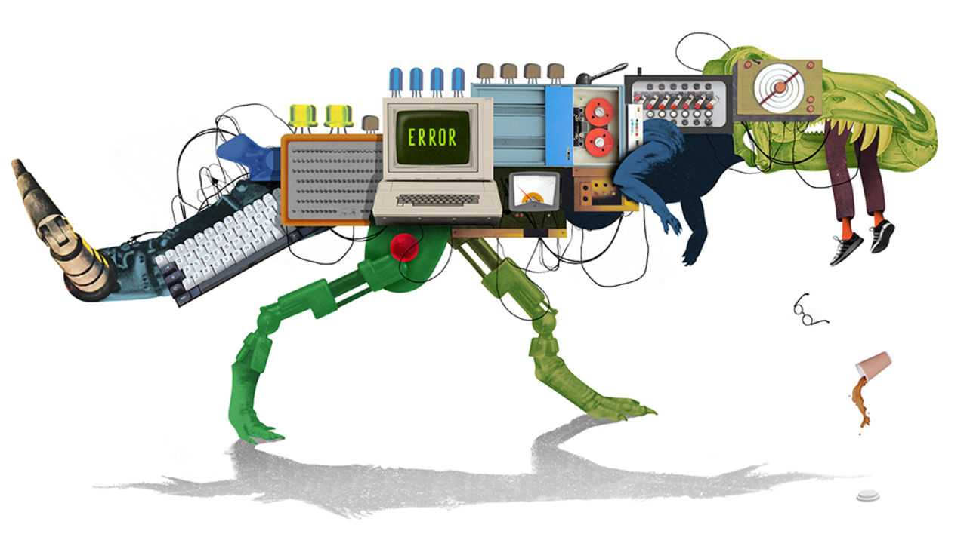

## When the computer says no

The software problems of Boeing, General Electric, Volkswagen and others are not new (Schumpeter, [July 18th](https://www.economist.com/business/2020/07/18/why-companies-struggle-with-recalcitrant-it)). The term “software engineering” was coined in the 1960s in the hope that traditional engineering methods could be applied to software development. Today, we routinely use systems that are far more complex and robust, which have largely been built by developers trained in computer science and software engineering. There is fierce competition to employ those skills; some companies hire graduates from coding schools with as little as three months of training.

Schumpeter noted the impact of rapidly changing technology on system quality. This is known as “technical debt”, an accumulation of problems with varying severity that makes it difficult and expensive to maintain the code. Some of the world’s critical software systems are based on code originally written over 40 years ago. The large legacy companies rely heavily on writing their own proprietary code with its high rate of errors, rather than including open-source software components that reduce the amount of new code, which would minimise the number of bugs. Our ability to develop software has improved, but companies that construct physical systems, such as cars, continue to underestimate what it takes to build high-quality software on time and on budget.

TONY WASSERMAN  
Professor of software management practice  
Carnegie Mellon University, Silicon Valley  
Mountain View, California

There are three other factors that explain why companies struggle with software projects. First, the general lack of knowledge about information literacy and computational thinking: many managers have never had any formal training in them. Second, software projects often change their scope and direction half way through the exercise. It is good to test new ideas, but that comes with a cost or delay that many executives struggle to understand. Imagine building a bridge and every week the plan changes. Would you expect it to be built on time and on budget?

And third, many “visionaries” love large transformational projects that turn the company upside down. But software is much more about improving the experience of people who work with it. Companies should start small and scale up where value emerges, not the other way around.

JOSE CARVALHO  
Madrid

Another problem is dependency: software depends on other software. For example, when you start a project in JavaScript and add a few dependencies you will pull in hundreds of other dependencies, written over years by thousands of developers. Each dependency is like a block of Lego. We attach them together by the bits at the edge (the interface) and assume that the bits in the middle work well. Most programmers spend their time attaching these blocks together, hoping that everything works well.

The main risk-mitigation strategy is to use dependencies that everyone else is using. The thinking goes that someone else would surely have audited the code or found issues with it. This works, until it doesn’t. A dependency might disappear or it might inject malicious code into the application. Most programmers lack the knowledge and inclination to search for issues in this vast stack.

We build skyscrapers of Lego, focusing on the top and only paying attention to our dependencies when the skyscraper starts swaying. This is not laziness. If every programmer tried to rewrite their stack it would take decades, and the world would have moved on. Besides, the next project is due in 14 days.

KRISHNA SUNDARRAM  
Engineer at Facebook  
London

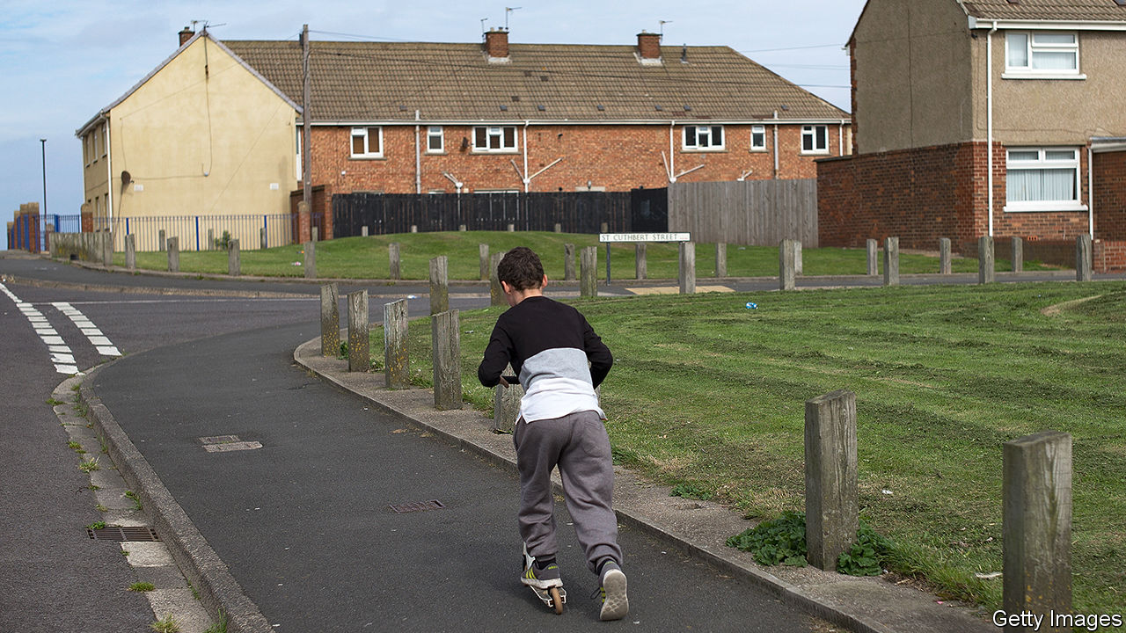

## Rebalancing Britain

Your anaemic plan for “levelling up” Britain would do little to achieve that goal (“Levelling up Britain”, [August 1st](https://www.economist.com/leaders/2020/07/30/levelling-up-britain-boris-johnson-has-a-big-idea-but-no-plan)). You didn’t mention HS2, a high-speed rail link, the best and most ambitious scheme to (literally) bridge the north, Midlands and south in England and link London far better to regional cities. You praised devolution while ignoring the weak tax base of the north: handing down tax-raising powers without real resources is worse than useless. And you treated as a joke a serious proposal to relocate Parliament to the north, which could do more than any other political reform to rebalance Britain.

ANDREW ADONIS  
House of Lords  
London  
* I read your article addressing regional inequality in Britain with interest. I noted that you implied that all of the south-east is relatively prosperous and that it is only northern regions of Britain which require ‘levelling up’. This is not the case: huge inequalities exist within the south-east just as they do in the north. The Southampton Itchen constituency bears striking similarities to deprived areas in the north despite being located in leafy Hampshire. Once the home of the Spitfire, shipbuilding and the Ford Transit van, it is also post-industrial. Unemployment today is higher and average wages are lower than some ‘red wall’ northern constituencies.

To truly level-up Britain the government needs to address inequality in all deprived areas, including the south-east. Investment in regional infrastructure is critical to deliver jobs with career prospects, good pay and job security–it takes almost as long to travel by train from Southampton to similarly left-behind Portsmouth as it does to get to London.   
Whilst I recognise much of what your article describes in the north you could just as easily have been writing about my constituency.   
  
ROYSTON SMITH   
Member of Parliament for Southampton Itchen  
Southampton

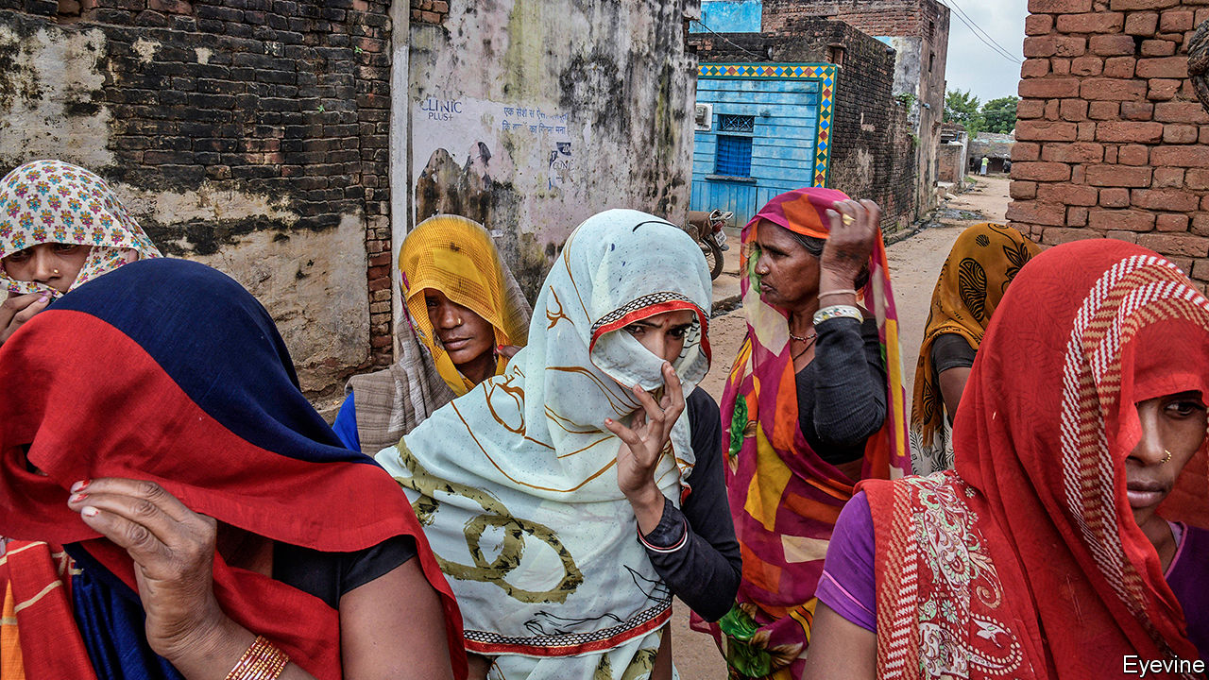

## Unacceptable

You mentioned that few Hindus in India observe strict ritual purity or consider Dalits literally untouchable (“No escape”, [July 25th](https://www.economist.com/asia/2020/07/23/even-as-india-urbanises-caste-discrimination-remains-rife)). Yet about a quarter of the respondents to the India Human Development Survey of 2011-12 were averse to Dalits entering their kitchen or sharing utensils. The figure cuts across religious groups (30% for Hindus), castes and geography.

AMOL SINGH RASWAN  
Evanston, Illinois

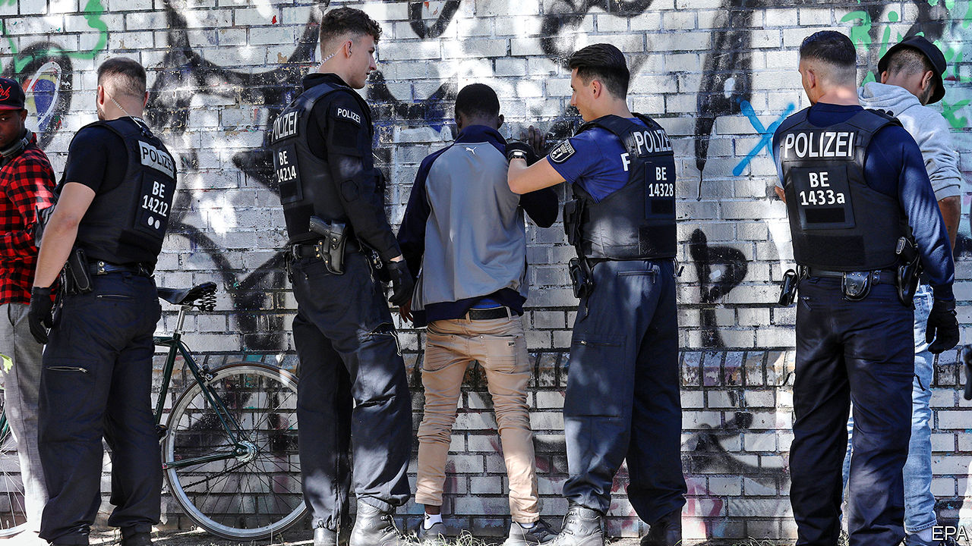

## Bad ideas

“See no evil” ([August 8th](https://www.economist.com/europe/2020/08/08/american-ideas-about-racism-are-influencing-europe)) observed that after the second world war philosophy that challenged racism “tended to flow westward” from Europe to America. However, in the decades leading up to the war it was the American concept of race that affected events in Europe. The Nazis, for example, were influenced by America’s virulently racist laws of the late 19th and early 20th-centuries, particularly with regards to eugenics and miscegenation. In 1935, the Third Reich sent legal experts who had crafted its racial policies to study American race law under the guise of researching legal and economic life. “Mein Kampf” praised America’s Immigration Act of 1924, which excluded most Asians; in 1928 Hitler spoke approvingly of white settlers gunning down millions of indigenous people.

EVA STOUMBOS  
Port Angeles, Washington

Your review of a book on Nazi spies in the United States (“The Führer’s man in Manhattan”, [August 15th](https://www.economist.com/books-and-arts/2020/08/15/the-fuhrers-man-in-manhattan)) notes the strength of Nazi hostility to America. There was also great admiration. The Nazis looked to the Jim Crow laws in the South as their model for the Nuremberg laws that targeted Jews.

JOHN WILLIAMS  
Cardiff

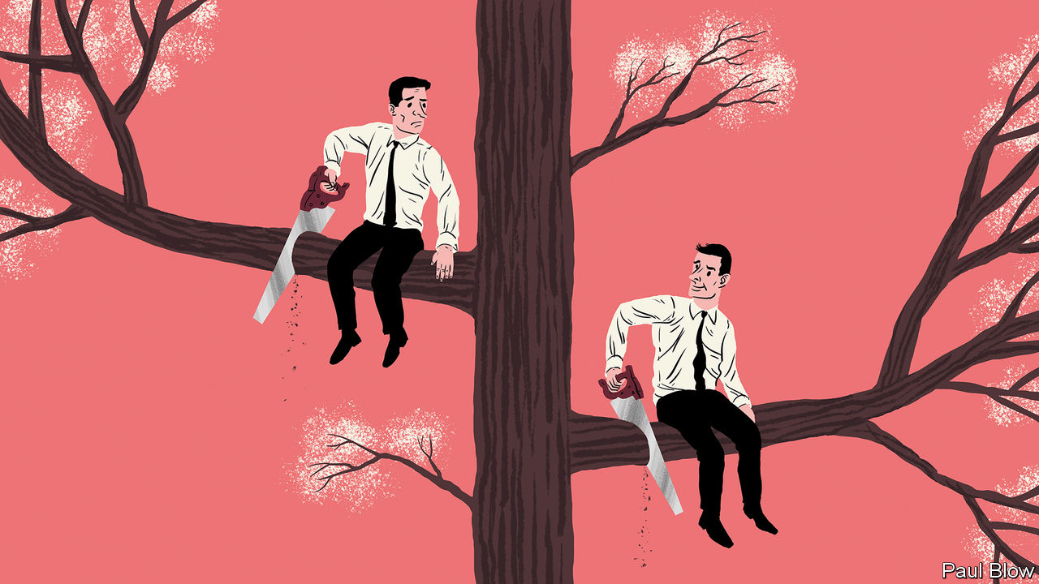

## Leadership qualities

Reading Bartleby on judgment ([July 18th](https://www.economist.com/business/2020/07/18/a-question-of-judgment)) brought to mind The Economist’s description of Clement Attlee in 1935, long before he was recognised as one of Britain’s greatest prime ministers: he “lacks the conspicuous attributes of a leader” but “has undeniable ability, judgment and integrity” (“Mr Attlee and Sir A. Sinclair”, [November 30th 1935](https://docs.google.com/gview?embedded=true&url=https://media.economist.com/sites/default/files/pdfs/editorial_links/Attleearticle.pdf)). Looking back at his success Attlee came up with this little ditty:

Few thought he was even a starter  
There were many who thought themselves smarter  
But he ended PM  
CM and OM  
An earl and a knight of the garter.

ANDREW CARROLL  
Sale, Cheshire

Bagehot’s column on the “lemons” in government ([July 18th](https://www.economist.com/britain/2020/07/18/the-talent-dearth-in-britains-government)) reminded me of something one of my surgical bosses said of John Moore, a health minister under Margaret Thatcher: “He rose without trace.”

ANDREW ARNOLD  
Barnoldswick, Lancashire

* Letters appear online only

This article was downloaded by calibre from <https://www.economist.com/letters/2020/08/22/letters-to-the-editor>

|  |  |  |  |
| --- | --- | --- | --- |
|  | Articles | Sections | Next |

|  |  |  |
| --- | --- | --- |
| Letters | Sections | United States |

Essay

The viral universe: The outsiders inside

.

|  |  |  |
| --- | --- | --- |
| Letters | Sections | United States |

|  |  |  |  |
| --- | --- | --- | --- |
|  | Articles | Sections | Next |

#### The viral universe

# Viruses have big impacts on ecology and evolution as well as human health

They are ubiquitous, diverse and very powerful

Aug 20th 2020 |



I  
The outsiders inside

HUMANS ARE lucky to live a hundred years. Oak trees may live a thousand; mayflies, in their adult form, a single day. But they are all alive in the same way. They are made up of cells which embody flows of energy and stores of information. Their metabolisms make use of that energy, be it from sunlight or food, to build new molecules and break down old ones, using mechanisms described in the genes they inherited and may, or may not, pass on.

It is this endlessly repeated, never quite perfect reproduction which explains why oak trees, humans, and every other plant, fungus or single-celled organism you have ever seen or felt the presence of are all alive in the same way. It is the most fundamental of all family resemblances. Go far enough up any creature’s family tree and you will find an ancestor that sits in your family tree, too. Travel further and you will find what scientists call the last universal common ancestor, LUCA. It was not the first living thing. But it was the one which set the template for the life that exists today.

And then there are viruses. In viruses the link between metabolism and genes that binds together all life to which you are related, from bacteria to blue whales, is broken. Viral genes have no cells, no bodies, no metabolism of their own. The tiny particles, “virions”, in which those genes come packaged—the dot-studded disks of coronaviruses, the sinister, sinuous windings of Ebola, the bacteriophages with their science-fiction landing-legs that prey on microbes—are entirely inanimate. An individual animal, or plant, embodies and maintains the restless metabolism that made it. A virion is just an arrangement of matter.

The virus is not the virion. The virus is a process, not a thing. It is truly alive only in the cells of others, a virtual organism running on borrowed hardware to produce more copies of its genome. Some bide their time, letting the cell they share the life of live on. Others immediately set about producing enough virions to split their hosts from stem to stern.

The virus has no plan or desire. The simplest purposes of the simplest life—to maintain the difference between what is inside the cell and what is outside, to move towards one chemical or away from another—are entirely beyond it. It copies itself in whatever way it does simply because it has copied itself that way before, in other cells, in other hosts.

That is why, asked whether viruses are alive, Eckard Wimmer, a chemist and biologist who works at the State University of New York, Stony Brook, offers a yes-and-no. Viruses, he says, “alternate between nonliving and living phases”. He should know. In 2002 he became the first person in the world to take an array of nonliving chemicals and build a virion from scratch—a virion which was then able to get itself reproduced by infecting cells.

The fact that viruses have only a tenuous claim to being alive, though, hardly reduces their impact on things which are indubitably so. No other biological entities are as ubiquitous, and few as consequential. The number of copies of their genes to be found on Earth is beyond astronomical. There are hundreds of billions of stars in the Milky Way galaxy and a couple of trillion galaxies in the observable universe. The virions in the surface waters of any smallish sea handily outnumber all the stars in all the skies that science could ever speak of.

Back on Earth, viruses kill more living things than any other type of predator. They shape the balance of species in ecosystems ranging from those of the open ocean to that of the human bowel. They spur evolution, driving natural selection and allowing the swapping of genes.

They may have been responsible for some of the most important events in the history of life, from the appearance of complex multicellular organisms to the emergence of DNA as a preferred genetic material. The legacy they have left in the human genome helps produce placentas and may shape the development of the brain. For scientists seeking to understand life’s origin, they offer a route into the past separate from the one mapped by humans, oak trees and their kin. For scientists wanting to reprogram cells and mend metabolisms they offer inspiration—and powerful tools.

II  
A lifestyle for genes

THE IDEA of a last universal common ancestor provides a plausible and helpful, if incomplete, answer to where humans, oak trees and their ilk come from. There is no such answer for viruses. Being a virus is not something which provides you with a place in a vast, coherent family tree. It is more like a lifestyle—a way of being which different genes have discovered independently at different times. Some viral lineages seem to have begun quite recently. Others have roots that comfortably predate LUCA itself.

Disparate origins are matched by disparate architectures for information storage and retrieval. In eukaryotes—creatures, like humans, mushrooms and kelp, with complex cells—as in their simpler relatives, the bacteria and archaea, the genes that describe proteins are written in double-stranded DNA. When a particular protein is to be made, the DNA sequence of the relevant gene acts as a template for the creation of a complementary molecule made from another nucleic acid, RNA. This messenger RNA (mRNA) is what the cellular machinery tasked with translating genetic information into proteins uses in order to do so.

Because they, too, need to have proteins made to their specifications, viruses also need to produce mRNAs. But they are not restricted to using double-stranded DNA as a template. Viruses store their genes in a number of different ways, all of which require a different mechanism to produce mRNAs. In the early 1970s David Baltimore, one of the great figures of molecular biology, used these different approaches to divide the realm of viruses into seven separate classes (see diagram).

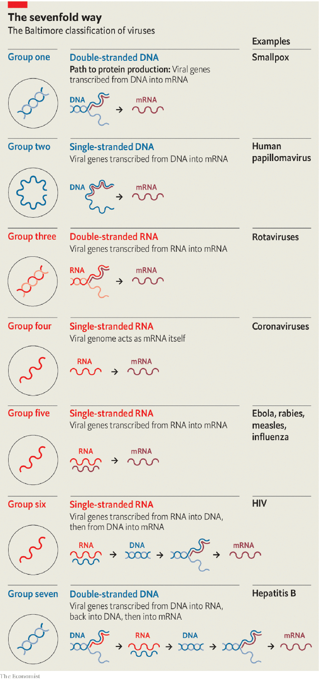

In four of these seven classes the viruses store their genes not in DNA but in RNA. Those of Baltimore group three use double strands of RNA. In Baltimore groups four and five the RNA is single-stranded; in group four the genome can be used directly as an mRNA; in group five it is the template from which mRNA must be made. In group six—the retroviruses, which include HIV—the viral RNA is copied into DNA, which then provides a template for mRNAs.

Because uninfected cells only ever make RNA on the basis of a DNA template, RNA-based viruses need distinctive molecular mechanisms those cells lack. Those mechanisms provide medicine with targets for antiviral attacks. Many drugs against HIV take aim at the system that makes DNA copies of RNA templates. Remdesivir (Veklury), a drug which stymies the mechanism that the simpler RNA viruses use to recreate their RNA genomes, was originally developed to treat hepatitis C (group four) and subsequently tried against the Ebola virus (group five). It is now being used against SARS-CoV-2 (group four), the covid-19 virus.

Studies of the gene for that RNA-copying mechanism, RdRp, reveal just how confusing virus genealogy can be. Some viruses in groups three, four and five seem, on the basis of their RdRp-gene sequence, more closely related to members of one of the other groups than they are to all the other members of their own group. This may mean that quite closely related viruses can differ in the way they store their genomes; it may mean that the viruses concerned have swapped their RdRp genes. When two viruses infect the same cell at the same time such swaps are more or less compulsory. They are, among other things, one of the mechanisms by which viruses native to one species become able to infect another.

How do genes take on the viral lifestyle in the first place? There are two plausible mechanisms. Previously free-living creatures could give up metabolising and become parasitic, using other creatures’ cells as their reproductive stage. Alternatively genes allowed a certain amount of independence within one creature could have evolved the means to get into other creatures.

Living creatures contain various apparently independent bits of nucleic acid with an interest in reproducing themselves. The smallest, found exclusively in plants, are tiny rings of RNA called viroids, just a few hundred genetic letters long. Viroids replicate by hijacking a host enzyme that normally makes mRNAs. Once attached to a viroid ring, the enzyme whizzes round and round it, unable to stop, turning out a new copy of the viroid with each lap.

Viroids describe no proteins and do no good. Plasmids—somewhat larger loops of nucleic acid found in bacteria—do contain genes, and the proteins they describe can be useful to their hosts. Plasmids are sometimes, therefore, regarded as detached parts of a bacteria’s genome. But that detachment provides a degree of autonomy. Plasmids can migrate between bacterial cells, not always of the same species. When they do so they can take genetic traits such as antibiotic resistance from their old host to their new one.

Recently, some plasmids have been implicated in what looks like a progression to true virus-hood. A genetic analysis by Mart Krupovic of the Pasteur Institute suggests that the Circular Rep-Encoding Single-Strand-DNA (CRESS-DNA) viruses, which infect bacteria, evolved from plasmids. He thinks that a DNA copy of the genes that another virus uses to create its virions, copied into a plasmid by chance, provided it with a way out of the cell. The analysis strongly suggests that CRESS-DNA viruses, previously seen as a pretty closely related group, have arisen from plasmids this way on three different occasions.

Such jailbreaks have probably been going on since very early on in the history of life. As soon as they began to metabolise, the first proto-organisms would have constituted a niche in which other parasitic creatures could have lived. And biology abhors a vacuum. No niche goes unfilled if it is fillable.

It is widely believed that much of the evolutionary period between the origin of life and the advent of LUCA was spent in an “RNA world”—one in which that versatile substance both stored information, as DNA now does, and catalysed chemical reactions, as proteins now do. Set alongside the fact that some viruses use RNA as a storage medium today, this strongly suggests that the first to adopt the viral lifestyle did so too. Patrick Forterre, an evolutionary biologist at the Pasteur Institute with a particular interest in viruses (and the man who first popularised the term LUCA) thinks that the “RNA world” was not just rife with viruses. He also thinks they may have brought about its end.

The difference between DNA and RNA is not large: just a small change to one of the “letters” used to store genetic information and a minor modification to the backbone to which these letters are stuck. And DNA is a more stable molecule in which to store lots of information. But that is in part because DNA is inert. An RNA-world organism which rewrote its genes into DNA would cripple its metabolism, because to do so would be to lose the catalytic properties its RNA provided.

An RNA-world virus, having no metabolism of its own to undermine, would have had no such constraints if shifting to DNA offered an advantage. Dr Forterre suggests that this advantage may have lain in DNA’s imperviousness to attack. Host organisms today have all sorts of mechanisms for cutting up viral nucleic acids they don’t like the look of—mechanisms which biotechnologists have been borrowing since the 1970s, most recently in the form of tools based on a bacterial defence called CRISPR. There is no reason to imagine that the RNA-world predecessors of today’s cells did not have similar shears at their disposal. And a virus that made the leap to DNA would have been impervious to their blades.

Genes and the mechanisms they describe pass between viruses and hosts, as between viruses and viruses, all the time. Once some viruses had evolved ways of writing and copying DNA, their hosts would have been able to purloin them in order to make back-up copies of their RNA molecules. And so what began as a way of protecting viral genomes would have become the way life stores all its genes—except for those of some recalcitrant, contrary viruses.



III  
The scythes of the seas

IT IS A general principle in biology that, although in terms of individual numbers herbivores outnumber carnivores, in terms of the number of species carnivores outnumber herbivores. Viruses, however, outnumber everything else in every way possible.

This makes sense. Though viruses can induce host behaviours that help them spread—such as coughing—an inert virion boasts no behaviour of its own that helps it stalk its prey. It infects only that which it comes into contact with. This is a clear invitation to flood the zone. In 1999 Roger Hendrix, a virologist, suggested that a good rule of thumb might be ten virions for every living individual creature (the overwhelming majority of which are single-celled bacteria and archaea). Estimates of the number of such creatures on the planet come out in the region of 1029-1030. If the whole Earth were broken up into pebbles, and each of those pebbles smashed into tens of thousands of specks of grit, you would still have fewer pieces of grit than the world has virions. Measurements, as opposed to estimates, produce numbers almost as arresting. A litre of seawater may contain more than 100bn virions; a kilogram of dried soil perhaps a trillion.

Metagenomics, a part of biology that looks at all the nucleic acid in a given sample to get a sense of the range of life forms within it, reveals that these tiny throngs are highly diverse. A metagenomic analysis of two surveys of ocean life, the Tara Oceans and Malaspina missions, by Ahmed Zayed of Ohio State University, found evidence of 200,000 different species of virus. These diverse species play an enormous role in the ecology of the oceans.

A litre of seawater may contain 100bn virions; a kilogram of dried soil perhaps a trillion

On land, most of the photosynthesis which provides the biomass and energy needed for life takes place in plants. In the oceans, it is overwhelmingly the business of various sorts of bacteria and algae collectively known as phytoplankton. These creatures reproduce at a terrific rate, and viruses kill them at a terrific rate, too. According to work by Curtis Suttle of the University of British Columbia, bacterial phytoplankton typically last less than a week before being killed by viruses.

This increases the overall productivity of the oceans by helping bacteria recycle organic matter (it is easier for one cell to use the contents of another if a virus helpfully lets them free). It also goes some way towards explaining what the great mid-20th-century ecologist G. Evelyn Hutchinson called “the paradox of the plankton”. Given the limited nature of the resources that single-celled plankton need, you would expect a few species particularly well adapted to their use to dominate the ecosystem. Instead, the plankton display great variety. This may well be because whenever a particular form of plankton becomes dominant, its viruses expand with it, gnawing away at its comparative success.

It is also possible that this endless dance of death between viruses and microbes sets the stage for one of evolution’s great leaps forward. Many forms of single-celled plankton have molecular mechanisms that allow them to kill themselves. They are presumably used when one cell’s sacrifice allows its sister cells—which are genetically identical—to survive. One circumstance in which such sacrifice seems to make sense is when a cell is attacked by a virus. If the infected cell can kill itself quickly (a process called apoptosis) it can limit the number of virions the virus is able to make. This lessens the chances that other related cells nearby will die. Some bacteria have been shown to use this strategy; many other microbes are suspected of it.

There is another situation where self-sacrifice is becoming conduct for a cell: when it is part of a multicellular organism. As such organisms grow, cells that were once useful to them become redundant; they have to be got rid of. Eugene Koonin of America’s National Institutes of Health and his colleagues have explored the idea that virus-thwarting self-sacrifice and complexity-permitting self-sacrifice may be related, with the latter descended from the former. Dr Koonin’s model also suggests that the closer the cells are clustered together, the more likely this act of self-sacrifice is to have beneficial consequences.

For such profound propinquity, move from the free-flowing oceans to the more structured world of soil, where potential self-sacrificers can nestle next to each other. Its structure makes soil harder to sift for genes than water is. But last year Mary Firestone of the University of California, Berkeley, and her colleagues used metagenomics to count 3,884 new viral species in a patch of Californian grassland. That is undoubtedly an underestimate of the total diversity; their technique could see only viruses with RNA genomes, thus missing, among other things, most bacteriophages.

Metagenomics can also be applied to biological samples, such as bat guano in which it picks up viruses from both the bats and their food. But for the most part the finding of animal viruses requires more specific sampling. Over the course of the 2010s PREDICT, an American-government project aimed at finding animal viruses, gathered over 160,000 animal and human tissue samples from 35 countries and discovered 949 novel viruses.

The people who put together PREDICT now have grander plans. They want a Global Virome Project to track down all the viruses native to the world’s 7,400 species of mammals and waterfowl—the reservoirs most likely to harbour viruses capable of making the leap into human beings. In accordance with the more-predator-species-than-prey rule they expect such an effort would find about 1.5m viruses, of which around 700,000 might be able to infect humans. A planning meeting in 2018 suggested that such an undertaking might take ten years and cost $4bn. It looked like a lot of money then. Today those arguing for a system that can provide advance warning of the next pandemic make it sound pretty cheap.

IV  
Leaving their mark

THE TOLL which viruses have exacted throughout history suggests that they have left their mark on the human genome: things that kill people off in large numbers are powerful agents of natural selection. In 2016 David Enard, then at Stanford University and now at the University of Arizona, made a stab at showing just how much of the genome had been thus affected.

He and his colleagues started by identifying almost 10,000 proteins that seemed to be produced in all the mammals that had had their genomes sequenced up to that point. They then made a painstaking search of the scientific literature looking for proteins that had been shown to interact with viruses in some way or other. About 1,300 of the 10,000 turned up. About one in five of these proteins was connected to the immune system, and thus could be seen as having a professional interest in viral interaction. The others appeared to be proteins which the virus made use of in its attack on the host. The two cell-surface proteins that SARS-CoV-2 uses to make contact with its target cells and inveigle its way into them would fit into this category.

The researchers then compared the human versions of the genes for their 10,000 proteins with those in other mammals, and applied a statistical technique that distinguishes changes that have no real impact from the sort of changes which natural selection finds helpful and thus tries to keep. Genes for virus-associated proteins turned out to be evolutionary hotspots: 30% of all the adaptive change was seen in the genes for the 13% of the proteins which interacted with viruses. As quickly as viruses learn to recognise and subvert such proteins, hosts must learn to modify them.

A couple of years later, working with Dmitri Petrov at Stanford, Dr Enard showed that modern humans have borrowed some of these evolutionary responses to viruses from their nearest relatives. Around 2-3% of the DNA in an average European genome has Neanderthal origins, a result of interbreeding 50,000 to 30,000 years ago. For these genes to have persisted they must be doing something useful—otherwise natural selection would have removed them. Dr Enard and Dr Petrov found that a disproportionate number described virus-interacting proteins; of the bequests humans received from their now vanished relatives, ways to stay ahead of viruses seem to have been among the most important.

Viruses do not just shape the human genome through natural selection, though. They also insert themselves into it. At least a twelfth of the DNA in the human genome is derived from viruses; by some measures the total could be as high as a quarter.

Retroviruses like HIV are called retro because they do things backwards. Where cellular organisms make their RNA from DNA templates, retroviruses do the reverse, making DNA copies of their RNA genomes. The host cell obligingly makes these copies into double-stranded DNA which can be stitched into its own genome. If this happens in a cell destined to give rise to eggs or sperm, the viral genes are passed from parent to offspring, and on down the generations. Such integrated viral sequences, known as endogenous retroviruses (ERVs), account for 8% of the human genome.

This is another example of the way the same viral trick can be discovered a number of times. Many bacteriophages are also able to stitch copies of their genome into their host’s DNA, staying dormant, or “temperate”, for generations. If the cell is doing well and reproducing regularly, this quiescence is a good way for the viral genes to make more copies of themselves. When a virus senses that its easy ride may be coming to an end, though—for example, if the cell it is in shows signs of stress—it will abandon ship. What was latent becomes “lytic” as the viral genes produce a sufficient number of virions to tear the host apart.

Though some of their genes are associated with cancers, in humans ERVs do not burst back into action in later generations. Instead they have proved useful resources of genetic novelty. In the most celebrated example, at least ten different mammalian lineages make use of a retroviral gene for one of their most distinctively mammalian activities: building a placenta.

The placenta is a unique organ because it requires cells from the mother and the fetus to work together in order to pass oxygen and sustenance in one direction and carbon dioxide and waste in the other. One way this intimacy is achieved safely is through the creation of a tissue in which the membranes between cells are broken down to form a continuous sheet of cellular material.

The protein that allows new cells to merge themselves with this layer, syncytin-1, was originally used by retroviruses to join the external membranes of their virions to the external membranes of cells, thus gaining entry for the viral proteins and nucleic acids. Not only have different sorts of mammals co-opted this membrane-merging trick—other creatures have made use of it, too. The mabuya, a long-tailed skink which unusually for a lizard nurtures its young within its body, employs a retroviral syncytin protein to produce a mammalian-looking placenta. The most recent shared ancestor of mabuyas and mammals died out 80m years before the first dinosaur saw the light of day, but both have found the same way to make use of the viral gene.

## You put your line-1 in, you take your line-1 out

This is not the only way that animals make use of their ERVs. Evidence has begun to accumulate that genetic sequences derived from ERVs are quite frequently used to regulate the activity of genes of more conventional origin. In particular, RNA molecules transcribed from an ERV called HERV-K play a crucial role in providing the stem cells found in embryos with their “pluripotency”—the ability to create specialised daughter cells of various different types. Unfortunately, when expressed in adults HERV-K can also be responsible for cancers of the testes.

As well as containing lots of semi-decrepit retroviruses that can be stripped for parts, the human genome also holds a great many copies of a “retrotransposon” called LINE-1. This a piece of DNA with a surprisingly virus-like way of life; it is thought by some biologists to have, like ERVs, a viral origin. In its full form, LINE-1 is a 6,000-letter sequence of DNA which describes a “reverse transcriptase” of the sort that retroviruses use to make DNA from their RNA genomes. When LINE-1 is transcribed into an mRNA and that mRNA subsequently translated to make proteins, the reverse transcriptase thus created immediately sets to work on the mRNA used to create it, using it as the template for a new piece of DNA which is then inserted back into the genome. That new piece of DNA is in principle identical to the piece that acted as the mRNA’s original template. The LINE-1 element has made a copy of itself.



In the 100m years or so that this has been going on in humans and the species from which they are descended the LINE-1 element has managed to pepper the genome with a staggering 500,000 copies of itself. All told, 17% of the human genome is taken up by these copies—twice as much as by the ERVs.

Most of the copies are severely truncated and incapable of copying themselves further. But some still have the knack, and this capability may be being put to good use. Fred Gage and his colleagues at the Salk Institute for Biological Studies, in San Diego, argue that LINE-1 elements have an important role in the development of the brain. In 2005 Dr Gage discovered that in mouse embryos—specifically, in the brains of those embryos—about 3,000 LINE-1 elements are still able to operate as retrotransposons, putting new copies of themselves into the genome of a cell and thus of all its descendants.

Brains develop through proliferation followed by pruning. First, nerve cells multiply pell-mell; then the cell-suicide process that makes complex life possible prunes them back in a way that looks a lot like natural selection. Dr Gage suspects that the movement of LINE-1 transposons provides the variety in the cell population needed for this selection process. Choosing between cells with LINE-1 in different places, he thinks, could be a key part of the process from which the eventual neural architecture emerges. What is true in mice is, as he showed in 2009, true in humans, too. He is currently developing a technique for looking at the process in detail by comparing, post mortem, the genomes of different brain cells from single individuals to see if their LINE-1 patterns vary in the ways that his theory would predict.

V  
Promised lands

HUMAN EVOLUTION may have used viral genes to make big-brained live-born life possible; but viral evolution has used them to kill off those big brains on a scale that is easily forgotten. Compare the toll to that of war. In the 20th century, the bloodiest in human history, somewhere between 100m and 200m people died as a result of warfare. The number killed by measles was somewhere in the same range; the number who died of influenza probably towards the top of it; and the number killed by smallpox—300m-500m—well beyond it. That is why the eradication of smallpox from the wild, achieved in 1979 by a globally co-ordinated set of vaccination campaigns, stands as one of the all-time-great humanitarian triumphs.

Other eradications should eventually follow. Even in their absence, vaccination has led to a steep decline in viral deaths. But viruses against which there is no vaccine, either because they are very new, like SARS-CoV-2, or peculiarly sneaky, like HIV, can still kill millions.

Reducing those tolls is a vital aim both for research and for public-health policy. Understandably, a far lower priority is put on the benefits that viruses can bring. This is mostly because they are as yet much less dramatic. They are also much less well understood.

The viruses most prevalent in the human body are not those which infect human cells. They are those which infect the bacteria that live on the body’s surfaces, internal and external. The average human “microbiome” harbours perhaps 100trn of these bacteria. And where there are bacteria, there are bacteriophages shaping their population.

The microbiome is vital for good health; when it goes wrong it can mess up a lot else. Gut bacteria seem to have a role in maintaining, and possibly also causing, obesity in the well-fed and, conversely, in tipping the poorly fed into a form of malnutrition called kwashiorkor. Ill-regulated gut bacteria have also been linked, if not always conclusively, with diabetes, heart disease, cancers, depression and autism. In light of all this, the question “who guards the bacterial guardians?” is starting to be asked.

The viruses that prey on the bacteria are an obvious answer. Because the health of their host’s host—the possessor of the gut they find themselves in—matters to these phages, they have an interest in keeping the microbiome balanced. Unbalanced microbiomes allow pathogens to get a foothold. This may explain a curious detail of a therapy now being used as a treatment of last resort against Clostridium difficile, a bacterium that causes life-threatening dysentery. The therapy in question uses a transfusion of faecal matter, with its attendant microbes, from a healthy individual to reboot the patient’s microbiome. Such transplants, it appears, are more likely to succeed if their phage population is particularly diverse.

Medicine is a very long way from being able to use phages to fine-tune the microbiome. But if a way of doing so is found, it will not in itself be a revolution. Attempts to use phages to promote human health go back to their discovery in 1917, by Félix d’Hérelle, a French microbiologist, though those early attempts at therapy were not looking to restore balance and harmony. On the basis that the enemy of my enemy is my friend, doctors simply treated bacterial infections with phages thought likely to kill the bacteria.

The arrival of antibiotics saw phage therapy abandoned in most places, though it persisted in the Soviet Union and its satellites. Various biotechnology companies think they may now be able to revive the tradition—and make it more effective. One option is to remove the bits of the viral genome that let phages settle down to a temperate life in a bacterial genome, leaving them no option but to keep on killing. Another is to write their genes in ways that avoid the defences with which bacteria slice up foreign DNA.

The hope is that phage therapy will become a backup in difficult cases, such as infection with antibiotic-resistant bugs. There have been a couple of well-publicised one-off successes outside phage therapy’s post-Soviet homelands. In 2016 Tom Patterson, a researcher at the University of California, San Diego, was successfully treated for an antibiotic-resistant bacterial infection with specially selected (but un-engineered) phages. In 2018 Graham Hatfull of the University of Pittsburgh used a mixture of phages, some engineered so as to be incapable of temperance, to treat a 16-year-old British girl who had a bad bacterial infection after a lung transplant. Clinical trials are now getting under way for phage treatments aimed at urinary-tract infections caused by Escherichia coli, Staphylococcus aureus infections that can lead to sepsis and Pseudomonas aeruginosa infections that cause complications in people who have cystic fibrosis.

Viruses which attack bacteria are not the only ones genetic engineers have their eyes on. Engineered viruses are of increasing interest to vaccine-makers, to cancer researchers and to those who want to treat diseases by either adding new genes to the genome or disabling faulty ones. If you want to get a gene into a specific type of cell, a virion that recognises something about such cells may often prove a good tool.

The vaccine used to contain the Ebola outbreak in the Democratic Republic of Congo over the past two years was made by engineering Indiana vesiculovirus, which infects humans but cannot reproduce in them, so that it expresses a protein found on the surface of the Ebola virus; thus primed, the immune system responds to Ebola much more effectively. The World Health Organisation’s current list of 29 covid-19 vaccines in clinical trials features six versions of other viruses engineered to look a bit like SARS-CoV-2. One is based on a strain of measles that has long been used as a vaccine against that disease.

Viruses engineered to engender immunity against pathogens, to kill cancer cells or to encourage the immune system to attack them, or to deliver needed genes to faulty cells all seem likely to find their way into health care. Other engineered viruses are more worrying. One way to understand how viruses spread and kill is to try and make particularly virulent ones. In 2005, for example, Terrence Tumpey of America’s Centres for Disease Control and Prevention and his colleagues tried to understand the deadliness of the influenza virus responsible for the pandemic of 1918-20 by taking a more benign strain, adding what seemed to be distinctive about the deadlier one and trying out the result on mice. It was every bit as deadly as the original, wholly natural version had been.

The use of engineered pathogens as weapons of war is of dubious utility, completely illegal and repugnant to almost all

Because such “gain of function” research could, if ill-conceived or poorly implemented, do terrible damage, it requires careful monitoring. And although the use of engineered pathogens as weapons of war is of dubious utility—such weapons are hard to aim and hard to stand down, and it is not easy to know how much damage they have done—as well as being completely illegal and repugnant to almost all, such possibilities will and should remain a matter of global concern.

Information which, for billions of years, has only ever come into its own within infected cells can now be inspected on computer screens and rewritten at will. The power that brings is sobering. It marks a change in the history of both viruses and people—a change which is perhaps as important as any of those made by modern biology. It is constraining a small part of the viral world in a way which, so far, has been to people’s benefit. It is revealing that world’s further reaches in a way which cannot but engender awe. ■

Editor’s note: Some of our covid-19 coverage is free for readers of The Economist Today, our daily [newsletter](https://my.economist.com/user#newsletter). For more stories and our pandemic tracker, see our [hub](https://www.economist.com/news/2020/03/11/the-economists-coverage-of-the-coronavirus)

This article was downloaded by calibre from <https://www.economist.com/essay/2020/08/20/viruses-have-big-impacts-on-ecology-and-evolution-as-well-as-human-health>

|  |  |  |  |
| --- | --- | --- | --- |
|  | Articles | Sections | Next |

|  |  |  |
| --- | --- | --- |
| Essay | Sections | The Americas |

United States

The presidential election: The postmaster always rings twice

.

America’s black elite: Our kind of people

.

Veterans in politics: Old soldiers

.

Lingua securitatis: From iPhones to aircraft carriers

.

Lexington: Unconventional

.

Internship

.

The Arctic: Drill music

.

|  |  |  |
| --- | --- | --- |
| Essay | Sections | The Americas |

|  |  |  |  |
| --- | --- | --- | --- |
|  | Articles | Sections | Next |

#### The postmaster always rings twice

# More mail-in voting doubles the chances of recounts in close states

We ran 100,000 simulations to quantify this effect

Aug 22nd 2020 | WASHINGTON, DC

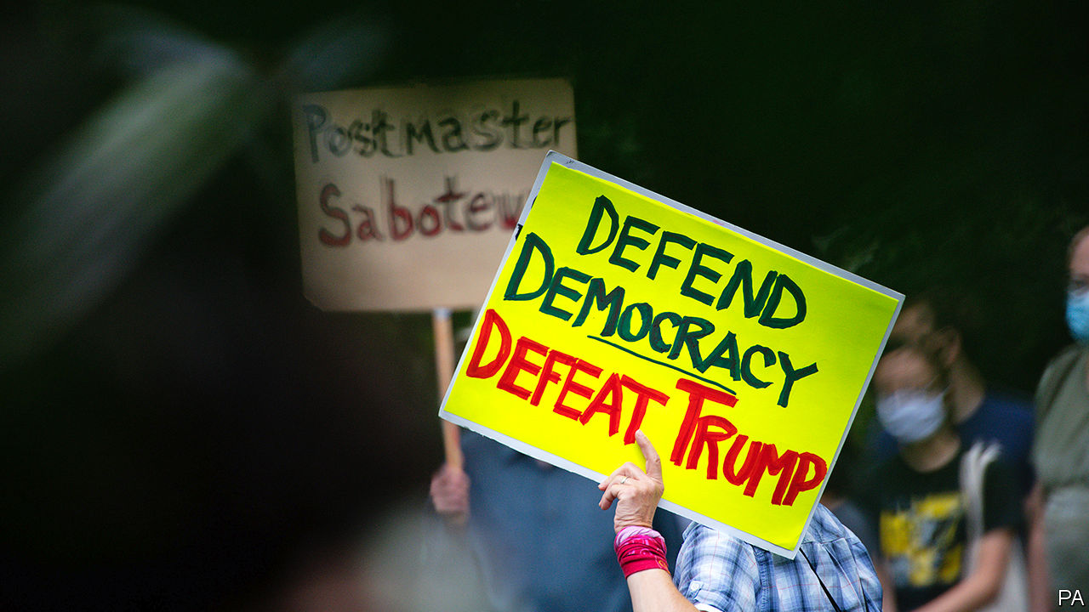

THE REPUBLICAN PARTY goes into its virtual convention next week in a mess. According to The Economist’s election model, the president is trailing by nine points in the popular vote and is currently expected to end up roughly 70 electoral votes shy of the 270-vote threshold on polling day. But has Donald Trump found a way to stack the deck in his favour? A large number of Americans will cast votes by post between now and November. And the US Postal Service, which has to deliver those votes, is in the midst of a partisan fight.

The postal service was created by the Second Continental Congress in 1775, and though it has a public-service mandate—to deliver mail to the whole country—it receives no public funding. In recent years it has consistently lost money, because Americans have been sending less first-class mail, among other things. Louis DeJoy, who ran a large logistics firm, was brought in as the postmaster-general in May with a mandate to fix its finances by finding savings.

Yet Mr DeJoy is also a prominent Republican donor. In 2017 he was one of three national finance chairmen of the Republican National Convention, along with Michael Cohen, the president’s personal lawyer (who is now in jail), and Elliott Broidy, an investor. This alarms Democrats, who spy a scheme by the president to steal an election he would otherwise lose.

Mr Trump opposes voting by mail because he thinks it is bad for Republicans. Mr DeJoy’s reorganisation has slowed down mail delivery in a way that therefore seems to accord with the president’s re-election strategy. Panicked voters have been snapping and posting pictures of the famous blue mailboxes, some of which have been carted off as part of the efficiency drive. The postal service’s board of governors, composed of both Republican and Democratic appointees, proposed a $25bn (0.1% of GDP) public subsidy, which House Democrats have taken up. Mr Trump is not keen. “If we don’t make a deal,” he told Fox News, “that means they don’t get the money. That means they can’t have universal mail-in voting, they just can’t have it.”

The postal service’s capacity has been particularly reduced in cities in swing states such as Pontiac, Michigan; Philadelphia, Pennsylvania; Columbus, Ohio; and even in Houston, Texas. The USPS warned 46 states that mailed-in ballots could arrive too late to be counted. Mr DeJoy then said that changes to the postal service would be postponed to avoid disrupting the election.

Is that the end of the saga? Not quite. Even if the USPS is functioning as normal, an increase in voting by mail could still have a significant effect on the result. In New York’s primary in July, staffing shortfalls combined with a surge in postal voting meant thousands of ballots were not sent out on time, and many others were discarded for minor technical errors. According to election officials, one out of every five ballots sent by mail were rejected—more than three times the statewide rejection rate from 2016. In November, election workers could be inundated with ballots that could take weeks to count.

Using our election-forecasting model, polls on how likely voters are to vote by mail and how often postal votes typically get rejected, we have tried to quantify the effect that more postal voting might have on the election. There are four factors to consider: the share of voters casting ballots by post; the share of those ballots that get rejected (eg, because they arrive after the deadline); the share of those ballots that get cast for each candidate; and the overall share of the vote going to Mr Trump or to Joe Biden regardless of voting method.

We obtained data on these factors from a variety of sources. For the likelihood of voting by mail, we rely on a Pew Research Centre poll of voters between July 27th and August 2nd. According to this survey, 39% of voters are planning to cast postal votes this year. A 2018 canvass of state data from the United States Election Assistance Commission, which helps states with administrative issues related to voting, revealed that the average rejection rate for postal votes was about 4% in states with the least vote-by-mail infrastructure and experience, and 1% in the best-prepared—though rates in extreme cases can exceed 15%.

For the partisan composition of postal votes, we analysed data from YouGov, which conducts polls on The Economist’s behalf, and found that roughly 80% of voters who are planning to cast their ballots for either Messrs Trump or Biden by post favour the Democratic candidate. Finally, for the share of voters nationally who will pick Mr Biden over Mr Trump, we took predictions from our presidential forecast.

There is no secret formula for combining these numbers. What happens, for example, if even more people vote by mail, but they are less Democratic? What if the race is closer than we predict? To answer these questions, we generated 100,000 different combinations of our four factors and altered the results of our election forecast accordingly. For each simulation, Democrats get punished more by postal-service and election-office inefficiencies (deliberate or not), when the election is close, when more votes are cast by mail and if those votes lean towards Mr Biden. In sum we find that slightly above-average rejection rates for postal ballots could clip about 0.6 percentage points from the Democratic candidate’s vote margin. But in the very unlikely case where rejection rates approach 10% in the average state—more than three times the normal rate—Mr Biden could lose closer to four percentage points relative to his standing in a fair contest (see chart).

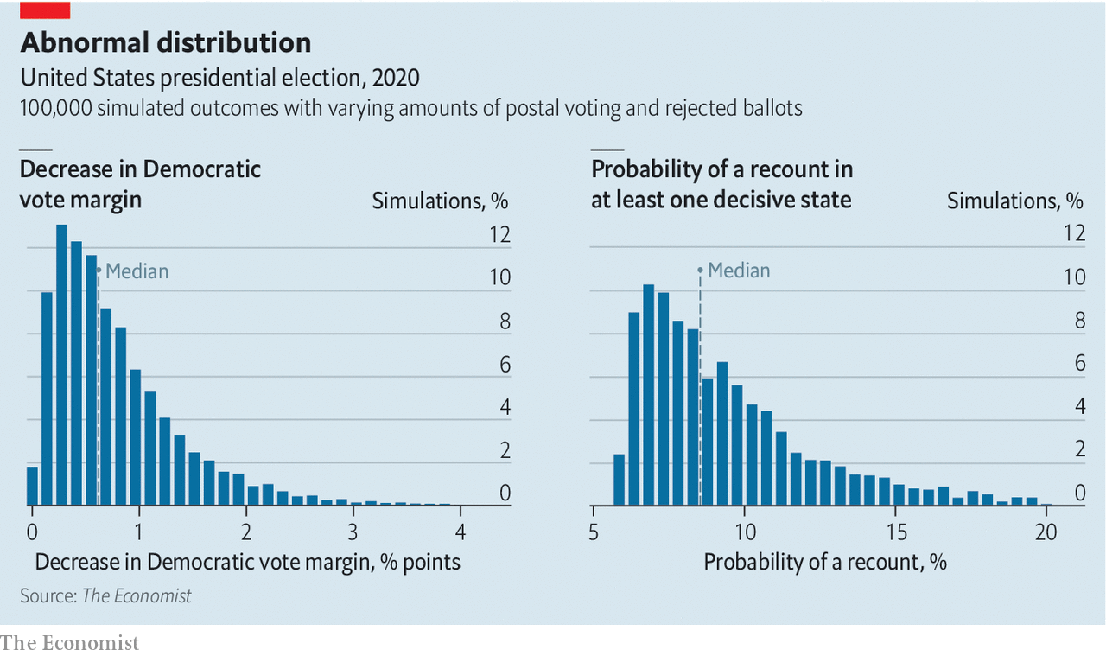

Although such a scenario is unlikely, even small glitches with postal voting cause a sizeable increase in the probability of a recount in one of the decisive states. Failure of election workers to attach postmarks to ballots, voters assigning signatures that do not match the state’s rolls (typically because elderly voters have trouble with the pen, or young voters have no record against which to match), and failure to deposit a ballot before the deadline are all common errors that can lead postal votes to be rejected—and they only become more common when more people vote by mail. According to our modelling, the chance that a marginal state ends up in recount territory (typically when the margin between the candidates is less than half a percentage point) is around 5%, before factoring in trouble with vote-by-mail. It nearly doubles to 9% when these postal simulations are taken into account. Few Americans who voted in 2000 will have forgotten that debacle, when after several weeks Florida’s hanging chads decided the presidency. A large increase in voting by mail, plus a big increase in rejected ballots, could lead to a repeat in November, even if Mr DeJoy is as good as his word.■

This article was downloaded by calibre from <https://www.economist.com/united-states/2020/08/22/more-mail-in-voting-doubles-the-chances-of-recounts-in-close-states>

|  |  |  |  |
| --- | --- | --- | --- |
|  | Articles | Sections | Next |

|  |  |  |  |
| --- | --- | --- | --- |
| Previous | Articles | Sections | Next |

#### Our kind of people

# America’s black upper class and Black Lives Matter

The United States is also home to the biggest group of highly successful black folk in the world

Aug 22nd 2020 | CHICAGO



LAWRENCE OTIS GRAHAM recalls where he first met Kamala Harris, last summer, in Martha’s Vineyard. It was at the holiday home of Spike Lee, a film director, who held a $1,500-a-head fundraiser for the woman who is now number two on the Democratic ticket. “She is the new Barack Obama for us,” says the thrilled Mr Graham, an author and property lawyer from New York. By “us” Mr Graham means African-Americans, and in particular the glitziest end of African-American high society.

He knows of whom he speaks. He made a name in 1999 by publishing “Our Kind of People”, a sympathetic insider account of the habits, clubs and lifestyles of America’s wealthiest black families. Early on the book, now in its 37th printing, proved controversial. Some whites were ignorant of how black millionaires had thrived, a few of them since the 1870s. “People often don’t think of blacks having different socioeconomic classes,” he says. Some fumed at being publicly named as part of a black aristocracy; others were furious for being left out. Some poorer black readers, in turn, raged at the wealthy.

On average black Americans remain significantly less well-off than whites, including among the richest. Among the top 10% of black earners, for example, the median family has accumulated assets worth $343,160, said a Brookings Institution report in February. For the equivalent top 10% of white families it was more than five times higher, at $1,789,300. By one Federal Reserve measure, around 2% of black families have assets worth more than $1m; over 15% of white ones do.

Yet even if the African-American elite is not huge, it is influential, as a planned televised serialisation of Mr Graham’s book will show. The most prominent black families long formed invitation-only clubs where they socialised, created professional networks and presented their children at debutante balls. A prime example is Jack and Jill of America, founded in 1938, a society which claims 40,000 members in 247 chapters, and which is devoted to shaping children into future leaders in business, society and politics.

It continues to go strong. This week it held its 44th national convention—a four-day, virtual shindig. It is unabashedly for the most successful. Danielle Brown, its president, dislikes the word “elite”, but says 98% of members’ children attend university. (That matters: rising higher-education rates best explain why the earnings of top-paid African-Americans have kept climbing in the past half century, even as those of most black workers steadily fell.) Almost everyone goes on to thrive professionally. “They are pretty much at the top of wherever they go,” she says.

Her outfit, as any rich club must, does plenty of charity work. This year its members helped to pay for 247 needy students to finish college, she says. It also promotes civic duties, the virtue of voting and the benefits of a sound financial education. That is all worthy—but in contrast to the occasionally riotous efforts of Black Lives Matter (BLM) activists, it can look terrifically staid. At its “cotillion” dances demure teenagers, in white Cinderella ball gowns, vie to deliver the deepest curtsy as pearl-wearing older ladies look on.

Not all alumni are relaxed talking of their past. Few politicians brag of belonging to an elite group. Cory Booker, a senator from New Jersey, rarely brings up his youthful time in Jack and Jill. Don’t expect Ms Harris, member of a similarly august group of women volunteers, The Links Inc, to mention it on the stump. Yet many of the most radical leaders or their children—including those of Malcolm X and of Mr Lee—had links to Jack and Jill or similar outfits.

How do high-society African-Americans respond to upheavals from the covid-19 pandemic, killings by police, and BLM protests of recent months? For Mrs Brown, BLM is “representative of the civil-rights movement, with a new name”. She praises protesters for their “vigilance” and for stirring public—including white—concern over matters that were previously ignored. But BLM, in her view, is just one of a “wonderful plethora” of groups, clubs, sororities, voter-registration outfits and charities: “We need different people doing different things.”

Lerry Knox, a wealthy Chicagoan who runs an international infrastructure-investment fund, and Farissa Knox, who runs an ad agency, also in Chicago, see it in a similar light. The ongoing BLM debate “over white supremacy” is welcome. “I support what BLM is doing. It’s a narrative that needs to be spoken,” says Mrs Knox. But the couple prefer to invest their personal funds and time in local groups that educate black residents on the benefits of completing census forms, sitting for jury duty and, especially, registering to vote. Structural changes, they say, will come from institutions, including the companies they lead, or from judicial reform and getting new people elected to office. Rage voiced on the streets can dissipate fast.

Yet even the wealthiest align with street protesters in their fury over threats and harassment from police. Mr Knox is blunt about the risks any African-American man faces in public. Mr Graham recounts being stopped and hounded by a plainclothes policeman near his home, while collecting his daughter from school—even though he was the chairman of his county police board. He describes how rich black families, on moving into mostly white neighbourhoods, learn to visit local police stations to hand out photos of their families, in an effort to stave off trouble. “We have to be proactive,” he says. “It is absolutely demeaning to act in this way, but we have too many stories of what happens when you don’t. Don’t assume we’ve bought our way out of this treatment.”■

This article was downloaded by calibre from <https://www.economist.com/united-states/2020/08/22/americas-black-upper-class-and-black-lives-matter>

|  |  |  |  |
| --- | --- | --- | --- |
| Previous | Articles | Sections | Next |

|  |  |  |  |
| --- | --- | --- | --- |
| Previous | Articles | Sections | Next |

#### Old soldiers

# War heroes no longer dominate American politics as they once did

They are now outnumbered by lawyers, bankers and business folk

Aug 17th 2020 |

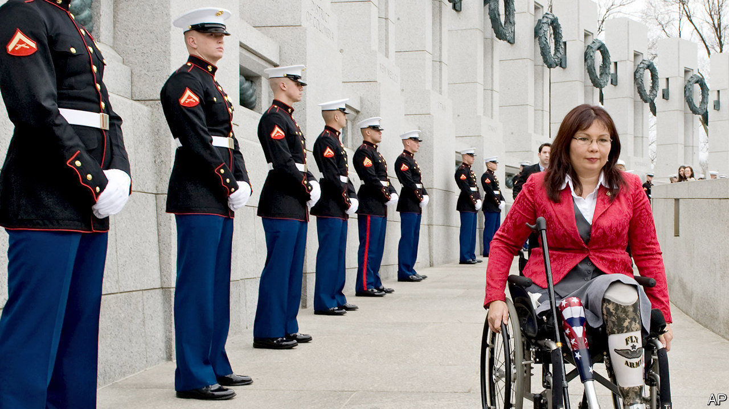

FOR TWENTY years Elaine Luria sailed the seas with America’s navy, rising to the rank of commander. In January 2019, two years after retiring, she entered the House of Representatives as a member for Virginia’s 2nd district, one of 96 ex-servicemen and -women in the 116th Congress. Veterans like Ms Luria remain over-represented in politics—they make up 7% of the adult population but nearly three times that share of Congress—but their numbers have dwindled over the years. That reflects electoral attitudes to military service that are more ambivalent than America’s esteem for veterans might suggest.

For much of American history, soldiers have dominated the country’s legislative branch. The first Congress, in 1789, was stacked with veterans of the revolutionary war: almost three in five of its members had fought in that conflict or previous ones. In the 20th century, a steady succession of wars in Europe, Korea and Vietnam, fuelled by a national draft, supplied an even larger stream of lawmakers with military experience. Between 1965 and 1975, seven out of every ten members of both houses were veterans, rising to four-fifths of the Senate in the latter year.

Their ranks have thinned ever since. Veterans lost their majority status in the House at the turn of the 1990s and in the Senate a decade later. Today 18% of the House and 19% of the Senate have done military service. Veterans are now comfortably outnumbered by lawyers, bankers and business folk, having once dwarfed them. The obvious explanation for this reversal of fortunes is that, with the end of the draft in 1973 and a shrinking army, there are fewer veterans to elect. There were over 26m of them in 2000 (13% of the adult population); now there are 18m (7%). But their share of seats in Congress has fallen even faster than their share of the population.

Part of the answer is that women, who entered Congress in growing numbers from the late 1980s, are under-represented in the armed forces, making up just 16.5% of the army. Another factor is that the cost of a campaign has spiralled over the years, says Rebecca Burgess of the American Enterprise Institute, a think-tank. And because today’s soldiers and sailors tend to run for office more quickly after leaving service than their counterparts who served in Vietnam, this can leave them with weaker networks. Though Ms Luria represents a navy-dominated district of Virginia in which she put down roots 20 years ago, she points out that many of her globetrotting peers might find it harder to feel the call of service to a particular community.

When veterans do run for office, their service is respected but not necessarily rewarded. In surveys, the public are considerably more enthusiastic about the idea of a veteran candidate than about business executives or religious leaders, according to Jeremy Teigen of Ramapo College of New Jersey. But studies by Mr Teigen show that these feelings wane at the ballot box.

In the first post-9/11 elections for the House of Representatives, in 2002, veteran Democrats collected just 2% more of the vote than non-veteran Democrats, even when accounting for other factors. In 2006 veteran Republicans took 1.3% more of the vote than non-veteran Republicans. At the last mid-terms in 2018, veterans had no edge at all. Notably, every combat veteran running for the presidency since 1990 has lost, sometimes to draft dodgers.

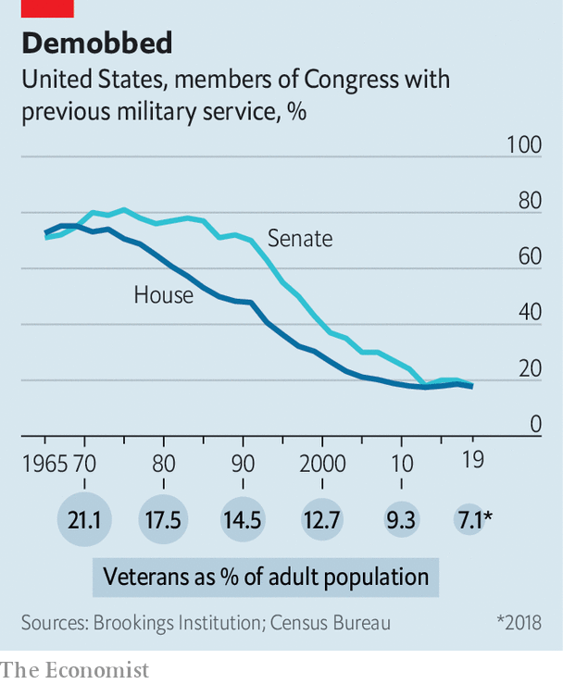

That might be seen as a welcome development. In June, Mike Mullen, a former chairman of the joint chiefs of staff, lamented that “too many foreign and domestic policy choices have become militarised”. Yet the paradox is that the absence of military experience among lawmakers and leaders could compound the problem. A study published in 2002 by Christopher Gelpi and Peter Feaver found that, between 1816 and 1992, as the percentage of veterans in Congress and the White House decreased, the probability of America getting into a military tangle actually went up.

Contrary to stereotype, those who have never worn a uniform are typically more willing to countenance intervention for humanitarian or nation-building purposes, says Danielle Lupton of Colgate University in New York state. A paper by Ms Lupton analysing votes in the House of Representatives during the wars in Afghanistan and Iraq finds that lawmakers with military experience are also more likely to favour congressional oversight of operations and limits on deployments.

Even if veterans no longer stand astride American politics as they once did, they continue to play an outsized role. That is clearest in primary elections, in which parties choose their candidates. Regardless of whether they win or lose in November, veterans are disproportionately likely to put themselves forward as candidates in the first place and to be selected by parties, says Mr Teigen. A country founded on a fear of standing armies has not lost its fondness for those who marched in its ranks.■

Dig deeper:  
Sign up and listen to Checks and Balance, our [weekly newsletter](https://www.economist.com/checksandbalance/) and [podcast](https://www.economist.com/podcasts/2020/08/14/checks-and-balance-our-weekly-podcast-on-american-politics) on American politics, and explore our [presidential election forecast](https://projects.economist.com/us-2020-forecast/president)

This article was downloaded by calibre from <https://www.economist.com/united-states/2020/08/17/war-heroes-no-longer-dominate-american-politics-as-they-once-did>

|  |  |  |  |
| --- | --- | --- | --- |
| Previous | Articles | Sections | Next |

|  |  |  |  |
| --- | --- | --- | --- |
| Previous | Articles | Sections | Next |

#### From iPhones to aircraft carriers

# American national-security maximalism can be self-defeating

If everything is a security threat, then nothing is

Aug 22nd 2020 |

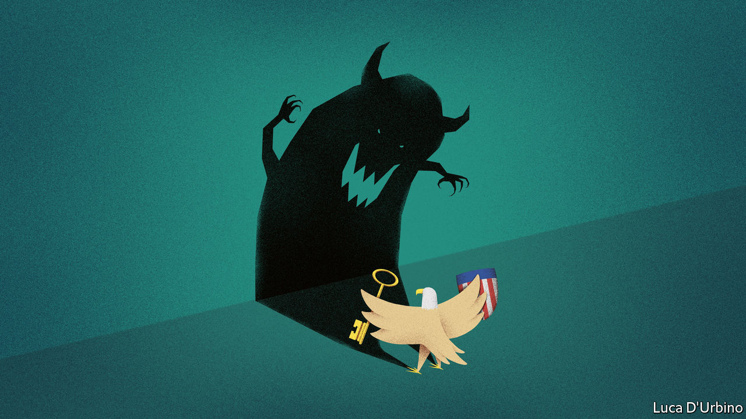

TO THE TECHNOCRATS who preside over America’s export rules, “national security” used to mean anything to do with weapons, particularly weapons of mass destruction. The technocrats’ job, and the purpose of the export rules to which they tended, was to prevent weapons and their components from reaching the hands of America’s enemies.

This started changing in 2016, at the end of Barack Obama’s second term in office, after China’s government announced it would spend $150bn over the next ten years to subsidise its semiconductor industry. The plan put American national security at risk, a council of technology advisers reported to Mr Obama in January 2017, just before Donald Trump took office. The subsidies threatened to hand control of cutting-edge chip technology to Chinese firms, leaving America’s armed forces short of high-tech supplies.

The remit of export control expanded, leading to the present-day sanctions against Huawei, a Chinese telecoms-equipment firm (see article). But Mr Trump and his administration proved keen to apply the term in other domains, peppering it through speeches and tweets. The New York Times is a threat to national security. Canada, America’s pleasant northern neighbour, is a threat to national security. Joe Biden, the Democratic candidate for president? A threat to national security.

The effluvia of Mr Trump’s political agenda can be discarded, but the placement of microchips in the national-security scope, coupled with the administration’s expansive view of the issue, has big consequences. The algorithms that run on chips, and the data that flow through them, have drifted into its crosshairs too.

On August 6th Mr Trump invoked national security to order bans of two Chinese apps, WeChat and TikTok, on the ground that they have the potential to be used as weapons by the Chinese Communist Party, spying on Americans, or distributing propaganda automatically at scale through tweaks to algorithms that are controlled by engineers in Beijing or Shenzhen.

This expansion of national security is not baseless—there is no doubt that America’s competitors are tapping into digital networks to gain an edge. But it does present problems. The portion of economic activity that relies on the flow of data in, out and within the United States is rising fast. If these data flows are seen broadly as a national-security issue, then the portion of economic activity that they underpin is too. This may end up harming America.

That is because national-security decisions are often characterised by secrecy, unilateralism and top-down instruction—when security is really at stake there is no time for collaborating with allies, informing the public, or the pondering of technocrats. But this way of operating is antithetical to global trade and business, including its digital slice. With an ever-growing portion of economic and social activity deemed a matter of national security, America’s government must directly intervene in markets and its citizens’ affairs.

Mr Trump’s executive order on securing technology supply chains, issued in May 2019, provides a worked example of the problem. The rule implementing Mr Trump’s command gives the Department of Commerce the power to block any “transaction” that poses “undue risk” to America’s tech supply chains, its critical infrastructure or its digital economy. This wording is so broad that “it could capture under government control nearly every transaction in US commerce”, according to IBM, an American computer company.

It is easy to hurt the industry that the government is seeking to protect by unintentionally isolating it from global markets. IBM said Mr Trump’s supply-chain rule “would lead to substantial disengagement of US businesses from global markets, reducing their competitiveness, threatening US jobs, and hurting US economic growth”.

A mass of potential tech national-security threats wait in the wings. The computers in American data centres are often made in China. They run every service from YouTube to Bank of America. Cainiao, a Chinese logistics network, is capitalising on the pandemic to expand, aiming to deliver goods anywhere in the world within 72 hours. It will collect lots of data in the process. Tencent, which owns WeChat, makes some popular war-based video games through subsidiary companies. It is easy to construe all this as a threat.

The pandemic has inflated the share of American economic activity carried out digitally. This raises the stakes. But there are solutions that do not rely on resignation to foreign influence. One is to carry out the less clandestine bits of national-security policy in the digital domain more transparently, letting the public, and thereby investors, understand the rules under which the government is operating. Those rules ought also to be applied consistently, creating a stable business environment. Where there is real evidence of state espionage, or cyber attacks, or where the welfare of Americans is directly at risk, the full trappings of national security should remain. Multilateralism is also important. By binding allies into the same set of rules for the digital economy, America could prevent the self-harm that comes with unilateralism. Global investors would have no choice but to follow the rules.

Without these changes, America may one day encounter a paradox: the invocation of national-security doctrine in its current form risks having a negative impact on the nation’s security. Because when everything becomes a matter of national security, then, in the end, nothing is. ■

This article was downloaded by calibre from <https://www.economist.com/united-states/2020/08/22/american-national-security-maximalism-can-be-self-defeating>

|  |  |  |  |
| --- | --- | --- | --- |
| Previous | Articles | Sections | Next |

|  |  |  |  |
| --- | --- | --- | --- |
| Previous | Articles | Sections | Next |

#### Lexington

# Democrats set factionalism aside for the big push against Donald Trump

How long will party unity hold?

Aug 22nd 2020 |

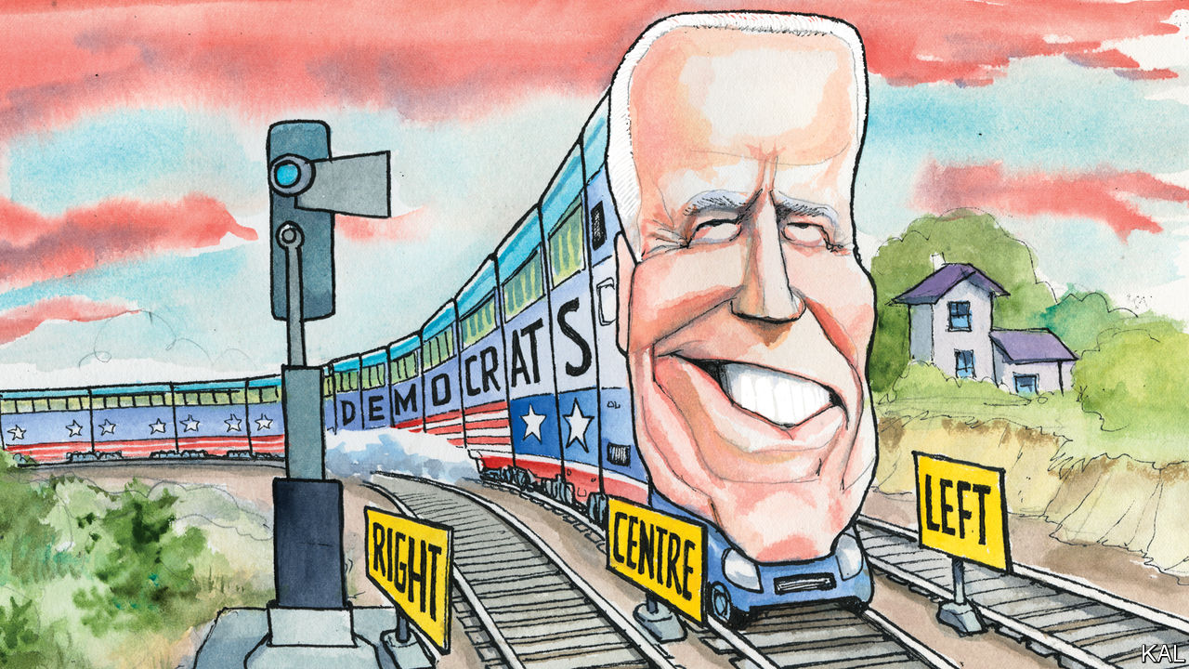

IN THEIR PRESCIENT book “It’s Even Worse Than It Looks” the political scientists Norm Ornstein and Thomas Mann coined a phrase that has come to encapsulate the relative standing of America’s two main parties: “asymmetric polarisation”. While acknowledging that both were becoming more radical, the term describes how much more jarring and pronounced this shift is on the right.

In a little over a decade Republicans have gravitated from John McCain’s big-tent moderation, via Mitt Romney’s more stringent conservatism, to become, in Mr Ornstein’s phrase, “a radical Trumpist cult”. On the left, hardliners such as Bernie Sanders and Alexandria Ocasio-Cortez have meanwhile challenged but not fundamentally altered their party’s centre-left pitch. Democrats have gravitated from Barack Obama campaigning for a $10 an hour minimum wage, to Hillary Clinton campaigning for $12, to Joe Biden promising $15. Republicans who decry their opponents as radical socialists are, like disorientated train passengers leaving a station, chiefly misattributing their own accelerating momentum to a relatively stationary neighbour. Their febrile opposition to Mr Obama’s health-care reform, though it was modelled on one promulgated by Mr Romney, is one of many illustrations of this.

Mr Biden’s primary win, which was confirmed at the Democrats’ virtual national convention this week, suggested their train had in fact moved even less than many thought. Even after the left flexed its muscles and dominated coverage of the contest, the former vice-president won almost twice as many votes as Mr Sanders with a platform not dramatically to the left of his two predecessors. Emboldened by Mr Trump’s unpopularity, which makes Mr Biden the favourite to win in November, he now appears to be attempting an even more audacious ploy: to rebuild America’s eroded centre.

This week’s covid-disrupted Democratic convention, which has been taking place in two-hour daily instalments, provided evidence for this. At the halfway mark, centrists—including sometime Republicans such as John Kasich and Colin Powell, both of whom endorsed Mr Biden—were far more prominent than left-wingers. To the extent that lefties such as Mr Sanders featured, it was to stress their commitment to Democratic unity—more forcefully than they did during the party’s ill-tempered 2016 confab.

The virtual convention also involved hardly any mention of divisive policy. The main focus was on Mr Biden’s kindness, conciliatory manner and long record—which the left hates —of seeking bipartisan compromise. The friendly Republicans helped underline that. A segment on Mr Biden’s deep friendship with Mr McCain contributed a genuinely endearing moment.

This emphasis was consistent with the primaries. As they made clear, most Democratic voters mainly want to remove Mr Trump and, despite having little enthusiasm for the old, rather inarticulate Mr Biden, think his moderation and inoffensiveness, combined with his stature, make him the likeliest to do so. That most left-wingers are also putting victory (over “fascism”, as Ms Ocasio-Cortez put it) ahead of ideological purity this time has further liberated him to be his authentically moderate self.

No longer need he tie himself into knots over his various “evolutions” on social issues. It is now enough for him to smile and represent a united Democratic front against a detested president—as Michelle Obama implied, by saying how much she hated politics, while offering her fulsome endorsement.

The staging of the convention also helped the Biden campaign bury the usual infighting. The traditional stadium-affair pits factions against one another like football fans. This year’s “roll-call”, during which delegates rang in the votes from their respective states, left a more expansive impression of national politics. As the sequence of masked figures, wearing local dress in Hawaii or touting Rhode Island seafood, called in votes from across their continent-sized country, intra-party rivalries seemed small or irrelevant. The convention was intended as an all-American repulse to Mr Trump. It quite often came over that way.

This was politically spot-on. So long as Mr Trump continues to stir up Democratic voters—as he will—Mr Biden’s task will be to keep breathing unity, promising decency, avoiding blunders (and, in his secret heart, praying for no miracle vaccine before November 4th). He has shown himself to be up to this and it may be enough. He may also lack the campaign skills to do more.

A perhaps more intriguing question is whether the Democrats’ burst of pragmatism could outlast the election. The conventional wisdom is, of course not. The activist left exists to make trouble. It has already put Mr Biden on notice that its compliance is Trump-specific. Yet there are two possible caveats to that.

The 2018 mid-terms and this year’s primaries tightened the centre-left’s grip on the party. A sizeable Democratic victory, replenishing its stock of moderates disproportionately, would do so further. New Democratic senators from Georgia or North Carolina would have little time for Mr Sanders.

## Moderation televised

In addition, the crises the next administration will inherit could create propitious circumstances for trade-offs. A Biden one would probably start by pushing a huge stimulus, with blanket Democratic and some Republican support (given that almost $3trn has already been splurged on a bipartisan basis). The left might be mollified with some portion of that: for example, lavish climate-related spending, a promise of Mr Biden’s platform that represents less a leftward shift than a new political consensus.

That is still a way off; Mr Biden could come unstuck in the coming weeks. But, at the time of writing, he is on track. His campaign is making the most of his talents. It is giving those Americans justly concerned about the future of their democracy something to hope for. It even did so this week, in a possible first for presidential campaigning, while making some pretty watchable TV.■

This article was downloaded by calibre from <https://www.economist.com/united-states/2020/08/22/democrats-set-factionalism-aside-for-the-big-push-against-donald-trump>

|  |  |  |  |
| --- | --- | --- | --- |
| Previous | Articles | Sections | Next |

|  |  |  |  |
| --- | --- | --- | --- |
| Previous | Articles | Sections | Next |

# Internship

Aug 22nd 2020 |

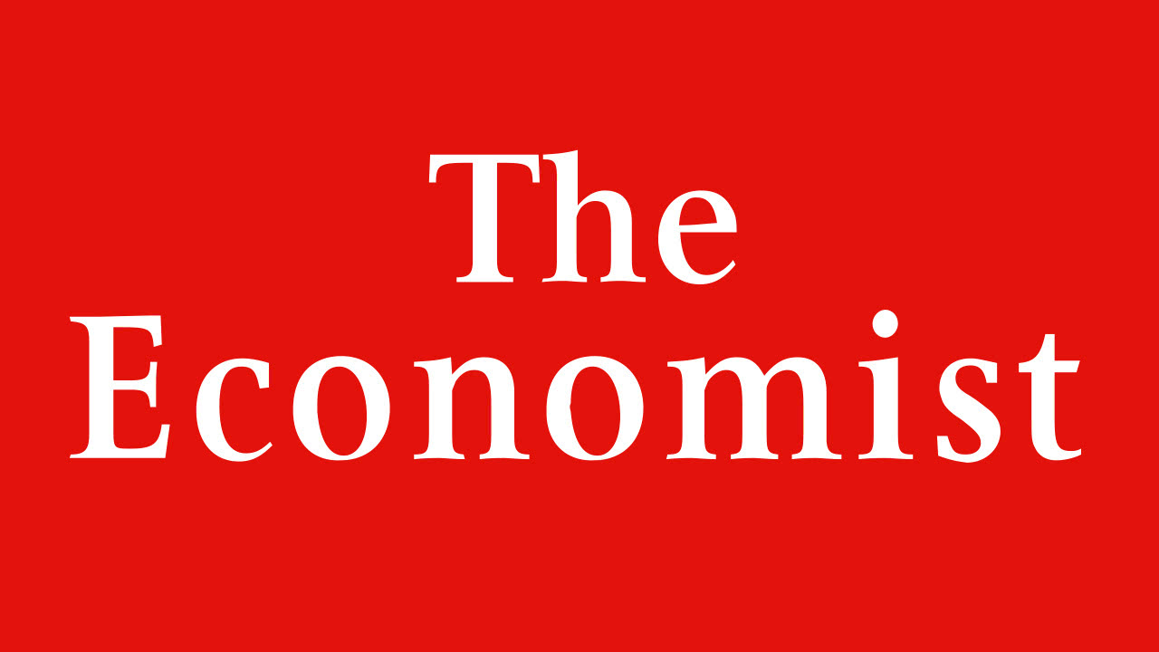

Internship: The Economist is seeking applicants for two paid fellowships in America. Each fellow will spend six months as a journalist working with our New York and Washington bureaus, writing articles about politics and policy in the United States. Previous experience in journalism is not necessary, but applicants should possess a love of writing, inquiry and debate. We welcome all applicants regardless of ethnic origin, national origin, gender, race, religious beliefs, disability, sexual orientation or age. Applicants should send an original unpublished article of up to 600 words suitable for publication in The Economist’s United States section and a CV to americanfellowship@economist.com by October 30th.

This article was downloaded by calibre from <https://www.economist.com/united-states/2020/08/22/internship>

|  |  |  |  |
| --- | --- | --- | --- |
| Previous | Articles | Sections | Next |

|  |  |  |  |
| --- | --- | --- | --- |
| Previous | Articles | Sections | Next |

#### The hydroxychloroquine of energy policy

# Drilling in Alaska’s national wildlife refuge makes no sense

Environmentally or economically

Aug 19th 2020 | KAKTOVIK, ALASKA

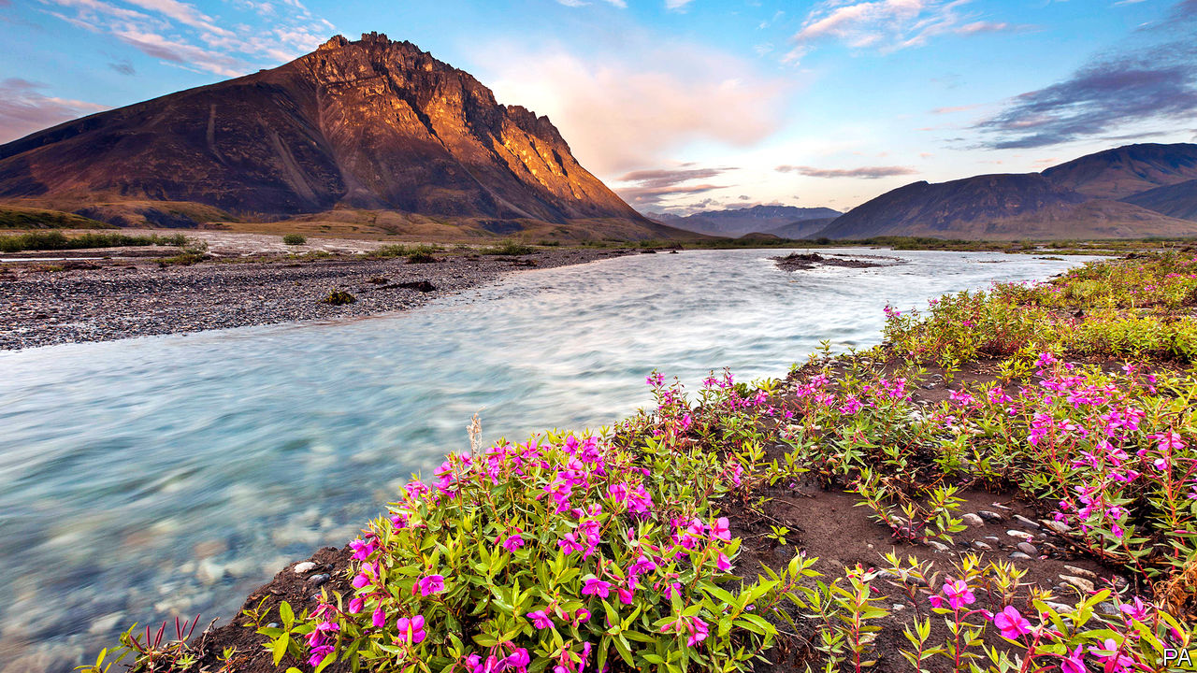

FOR AMERICANS still cooped up by the covid-19 epidemic, the Arctic National Wildlife Refuge in northern Alaska is the stuff of dreams. On a recent rafting trip down the Hulahula river in the refuge Robert Thompson, an Inupiaq guide, saw 1,000 caribou and a dozen bears and wolves on tundra that stretched up into high mountain peaks under a big sky. On August 17th the US Department of the Interior released a plan to make 1.6m acres of the refuge’s coastal plain available for oil and gas exploration and development.

Mr Thompson, who lives in Kaktovik, a tiny village within the refuge, sees the impact every day of climate change, which is warming the Arctic twice as fast as the rest of the planet. The ground near his house has collapsed as the permafrost thaws. More polar bears are prowling around because their sea-ice habitat is disappearing. Mr Thompson has had to shoot two that chased him to his front door. And increased coastal erosion has swallowed 400 feet of his family’s property.

The federal study that paved the way for the drilling announcement assumes that oil production in the refuge will last for 70 years. But a government assessment in 2018 has already determined that, without rapid reductions in carbon emissions, warming temperatures will kill thousands of Americans annually. “I wonder what the heck [our descendants] are going to think of us when we’re saying ‘Drill, baby, drill’,” says 73-year-old Mr Thompson.

Production on Alaska’s North Slope currently satisfies about 2% of the country’s daily appetite for oil from existing fields, which lie about 100 miles west of the refuge. The Trump administration is blazing ahead with new development despite the climate implications and polling that shows two-thirds of American voters oppose drilling in the Arctic preserve.

Investment in the region also looks increasingly dicey. North Slope crude prices dipped into negative territory in the spring because of the pandemic shutdown, and they remain weak. BP, one of the pioneers on Alaska’s North Slope, is leaving the region. A number of big banks have bowed to public pressure and stepped back from investing in Arctic oil development, including Goldman Sachs, JPMorgan Chase, Wells Fargo, UBS and Deutsche Bank.

Warming temperatures are also increasing the already high cost of doing business in this remote place. Existing oil and gas infrastructure is designed for freezing temperatures—a climate that is becoming a relic of decades past. Winter—the season of ice and snow-roads, which ease transport and construction in this vast northern terrain that is nearly equal parts land and water—is a month shorter than it used to be. Melting permafrost has already triggered leaks and may put hundreds of wellheads at risk of failure.

The Arctic refuge provides crucial habitat for the Porcupine caribou herd, a critical resource for the Gwich’in people, as well as a useful one for coastal Inupiaq like Mr Thompson. “Nobody has ever told me where I’ll be able to do subsistence hunting if they sell off the land to the oil companies,” he says.

In short, the project makes neither economic nor environmental sense. As pure politics it does have something in its favour, at least for the president. The push to park drill rigs in the refuge would fulfil his campaign promise to boost domestic energy production, whereas Joe Biden, the Democratic nominee, promises net zero greenhouse-gas emissions by 2050, in part by reducing reliance on fossil fuels. The president’s appetite for destruction in the Arctic, in other words, probably has more to do with winning Pennsylvania and other swing states that pit frackers against environmentalists than anything else.■

For more coverage of climate change, register for The Climate Issue, our fortnightly [newsletter](https://www.economist.com/theclimateissue/), or visit our [climate-change hub](https://www.economist.com/news/2020/04/24/the-economists-coverage-of-climate-change)

This article was downloaded by calibre from <https://www.economist.com/united-states/2020/08/19/drilling-in-alaskas-national-wildlife-refuge-makes-no-sense>

|  |  |  |  |
| --- | --- | --- | --- |
| Previous | Articles | Sections | Next |

|  |  |  |
| --- | --- | --- |
| United States | Sections | Asia |

The Americas

The Caribbean: Anxious isles

.

Canada: No more Morneau

.

|  |  |  |
| --- | --- | --- |
| United States | Sections | Asia |

|  |  |  |  |
| --- | --- | --- | --- |
|  | Articles | Sections | Next |

#### Anxious isles

# The pandemic’s indirect hit on the Caribbean

The region has been spared the worst ravages of covid-19. That has not protected its economies

Aug 22nd 2020 |

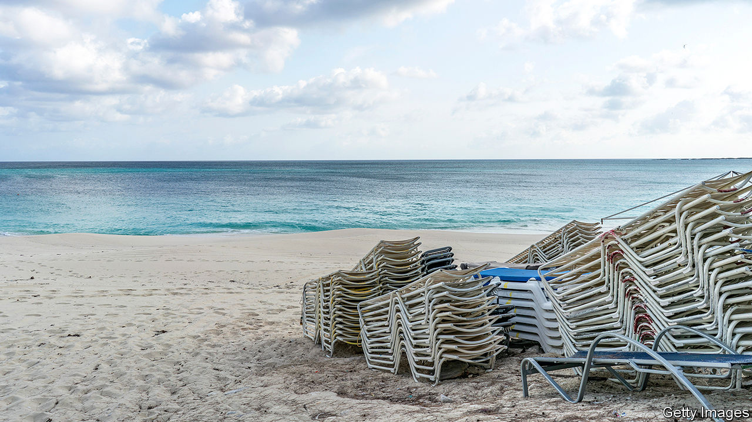

Editor’s note: Some of our covid-19 coverage is free for readers of The Economist Today, our daily [newsletter](https://my.economist.com/user#newsletter). For more stories and our pandemic tracker, see our [hub](https://www.economist.com/news/2020/03/11/the-economists-coverage-of-the-coronavirus)

WHEN A HIGHLY infectious disease is the biggest threat to global well-being, islands with small populations have an advantage. They can seal themselves off. The English-speaking islands of the Caribbean have by and large done this. Most have, at least until recently, kept rates of infection low (see chart). Some small islands, such as Anguilla and Montserrat, have no confirmed infections.

But that has not protected the Caribbean from the economic consequences of the pandemic. Much of the region depends on tourism, which has been hit hard. In Jamaica, which with 3m people is the most populous of the Anglophone islands, tourism accounts for 10% of GDP. Its indirect contribution is much higher. Remittances, another big source of income, especially for Jamaica, have slumped as workers in rich countries have lost their jobs. The drop in energy prices will offset part of these losses in most Caribbean countries, which are oil importers. Trinidad & Tobago, however, depends on exports of gas.

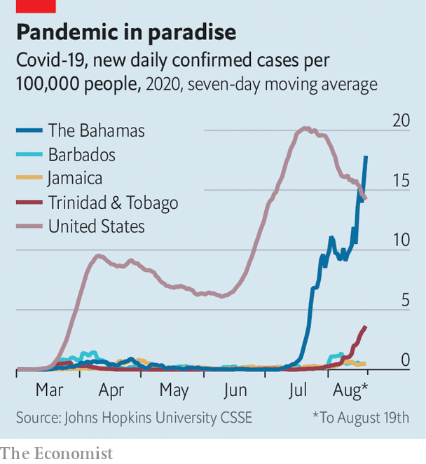

The islands’ economies are likely to contract by a tenth or more this year. The Central Bank of Barbados, an especially prompt reporter of data, says the country’s economy contracted by 27% in the second quarter compared with the same period last year. More than a fifth of workers filed for unemployment benefit.

Governments now face an agonising choice. Should they keep their countries relatively closed to contain the pandemic, or open them back up to revive their economies, at the risk of spreading the virus? They must also watch out for the weather. Forecasters predicted that the storm season, which runs from June to November, would be unusually active. A major hurricane would make matters far worse for any island it strikes.

The region’s economic turmoil has seemingly tranquillised its politics. Unlike New Zealand, which postponed an election due on September 19th because of a covid-19 outbreak, most Caribbean countries have stuck to their electoral schedules or even decided to vote early. Facebook appearances and motorcades have mostly supplanted the star-studded rallies and walkabouts that bring colour and clamour to Caribbean political campaigns.

Incumbents have done well. Timothy Harris, prime minister of St Kitts & Nevis, increased his majority in June. Trinidadians re-elected Keith Rowley on August 10th. A day later Jamaica’s prime minister, Andrew Holness, hoping to extend the incumbents’ winning streak, called a snap election for September 3rd. His Jamaica Labour Party has a double-digit lead over the opposition People’s National Party (PNP), according to recent opinion polls.

That is not because Jamaica has been spared the worst of the crisis. Covid-19 struck at the peak of the winter tourism season. To shield itself, the country shut down airports. Resorts emptied.

On June 15th the government reopened airports, but that has not tempted tourists back. The tourism ministry reports 90,000 arrivals over the past two months, about 20% of normal. Many may be Jamaicans living abroad. The US State Department continues to advise Americans contemplating a trip to Jamaica to “reconsider”.

Other forms of foreign income have shrunk. Remittances in April were a tenth lower than a year before. Some call centres became centres of infection and had to close. Banana plantations are a memory and sugar is in decline. Since March the Jamaican dollar has lost a tenth of its value against the American one. That has helped push up inflation. A journalist in Kingston, the capital, reports that the cost of his lunch has jumped from J$350 at the beginning of the year to J$450 ($3).

Mr Holness, who won by less than a percentage point in the last election, held in early 2016, seems to have persuaded Jamaicans that he is the man to pull the country out of its hole. In 2019 Jamaica completed a six-year course of austerity prescribed by the IMF (and begun under the PNP). That held down economic growth, which was just 0.1% last year, but has left Jamaica with a cushion of foreign-exchange reserves. In May the IMF stepped back in with an emergency loan of $520m, about 3.5% of GDP.

Fossil-fuel-rich Trinidad & Tobago has large foreign-currency reserves. But most Caribbean countries have less to spend. Barbados, which is highly indebted, is shoring up its finances under Mia Mottley, prime minister since 2018, and getting help from the IMF. The Bahamas has not recovered from Hurricane Dorian, which struck last year. The IMF is helping it, too.

Governments pray for a pickup in tourism when the peak season begins in December. But their efforts to tempt back travellers may spread disease without boosting growth much. After the Bahamas reopened its airports to flights from Florida in July, the number of covid-19 cases jumped. The State Department changed its advice for the Bahamas to a stark “Do not travel”.

Jamaica’s government is trying to avoid the problem by requiring tourists to stay at their hotels or resorts. But that is difficult to enforce. Social distancing tends to break down during election campaigns. Recorded infections jumped in Trinidad & Tobago after polling day. Jamaica’s “nomination day” on August 18th, the deadline for registering candidates, brought out carousers from both parties.

Peter Phillips, Mr Holness’s opponent, is not expected to put up much of a fight. He has been treated for cancer and has had to beat off challenges for the leadership of the PNP twice since September. His approval rating is below 20%. The prime minister called his snap poll on the same day that Joe Biden chose Kamala Harris, whose father was born in Jamaica, to be his running-mate. Jamaicans were delighted. Mr Holness hopes to be safely re-elected before voters remember how much they have to worry about. ■

This article was downloaded by calibre from <https://www.economist.com/the-americas/2020/08/22/the-pandemics-indirect-hit-on-the-caribbean>

|  |  |  |  |
| --- | --- | --- | --- |
|  | Articles | Sections | Next |

|  |  |  |  |
| --- | --- | --- | --- |
| Previous | Articles | Sections | Next |

#### No more Morneau

# The resignation of Canada’s finance minister hurts and helps Trudeau

Now the prime minister can spend more freely

Aug 22nd 2020 | OTTAWA

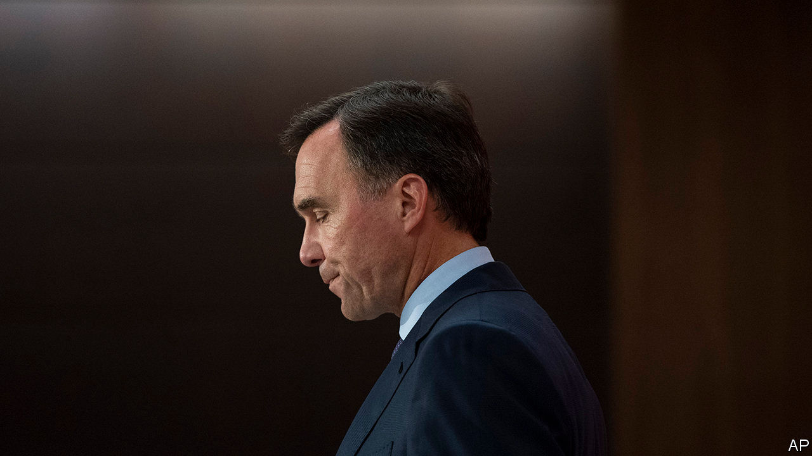

CANADA’S PRIME MINISTER, Justin Trudeau, can claim to have managed the pandemic well. His country has had far fewer cases and deaths as a proportion of its population than the United States. Government spending to protect the economy from the pandemic’s worst effects was prompt and well targeted. The economy looks as if it will recover faster than its neighbour’s. Although Mr Trudeau’s Liberal Party lost its majority in the election held in October, its fortunes recovered after the virus struck.

Lately, though, things have gone badly wrong for Mr Trudeau. The most visible sign of this was the sudden resignation on August 17th of Bill Morneau, the finance minister since the Liberals won power in 2015, who has led the economic response to covid-19. He was swiftly replaced by Chrystia Freeland, the deputy prime minister (who keeps that job).

Mr Morneau said he was leaving because Canada needs a finance minister with a long-term commitment to rebuild after the pandemic. He had decided long ago that he would not serve in more than two governments (the next election is due by 2023). Ergo he should leave now. He is also vacating his parliamentary seat.

Two other explanations are more plausible. One is Mr Morneau’s involvement in a scandal, into which Mr Trudeau has also been dragged. The second is that the finance minister and his boss disagreed over how fiscal policy should now proceed. Mr Morneau’s departure enables Mr Trudeau to spend more freely.

Parliament’s ethics commissioner and its ethics committee are investigating whether both men had a conflict of interest when the cabinet in May awarded a contract worth C$43.5m ($33m) to WE Charity to administer a programme that rewards students for helping their communities. In the preceding five years, WE paid Mr Trudeau’s mother and brother more than C$350,000 for appearing at events. Mr Morneau, whose daughter worked for the charity, and members of his family travelled to Ecuador and Kenya in 2017 at WE’s expense. Neither Mr Trudeau nor Mr Morneau recused himself from the decision to give government work to WE.

Both apologised. Mr Morneau says he has repaid more than C$41,000 that he realised belatedly he owed for travel costs. By the end of July the Liberals’ approval rating had dropped to 34%, six percentage points lower than it was in June, according to Abacus, a pollster.

A second source of tension may have been fiscal policy. The government expects a deficit of C$343bn this year, 16% of GDP. Mr Morneau went along with that, but wanted to take advantage of economic recovery to reduce the deficit swiftly. Mr Trudeau, on the other hand, is eager to boost post-pandemic spending on social programmes and the environment without raising taxes.

He prorogued Parliament, which ends the ethics committee’s investigation into the WE affair. (The commissioner’s probe continues.) When the legislature reopens next month he will dare the three opposition parties to vote him out in a confidence motion. The Conservatives, who are due to announce a new leader on August 23rd, may vote to topple him. So might the Bloc Québécois. But Mr Trudeau may survive thanks to the left-leaning New Democrats. Strapped for cash, they are loth to fight an election. And they may find much to like in Mr Trudeau’s post-pandemic plans.

Echoing the “just-society” rhetoric of his father, Pierre, who was prime minister in the 1970s, he wants to move “towards a society that is fairer and more welcoming, towards communities that are better prepared for future crises”. He is likely to propose a prescription-drug benefit and creation of a national child-care scheme. How much he will spend will begin to become clear in the budget, which should have been presented in March.

Ms Freeland, who won praise from provincial premiers for her co-ordination of a national response to the pandemic, will probably back that project more enthusiastically than Mr Morneau would have. A green recovery is “very important”, she declared in her first statement as finance minister. It matters as much to Mr Trudeau’s reputation as to Canada’s future.■

This article was downloaded by calibre from <https://www.economist.com/the-americas/2020/08/22/the-resignation-of-canadas-finance-minister-hurts-and-helps-trudeau>

|  |  |  |  |
| --- | --- | --- | --- |
| Previous | Articles | Sections | Next |

|  |  |  |
| --- | --- | --- |
| The Americas | Sections | China |

Asia

Myanmar’s forever war: Will it ever stop?

.

Japan: Virtual respect for the dead

.

Thai democracy: Street cred

.

The internet in Pakistan: Calls waiting

.

Banyan: Sensitive Seoul

.

|  |  |  |
| --- | --- | --- |
| The Americas | Sections | China |

|  |  |  |  |
| --- | --- | --- | --- |
|  | Articles | Sections | Next |

#### Peace talks without peace

# Why the stalemate in Myanmar persists

The generals are still unwilling to make concessions

Aug 18th 2020 | SINGAPORE

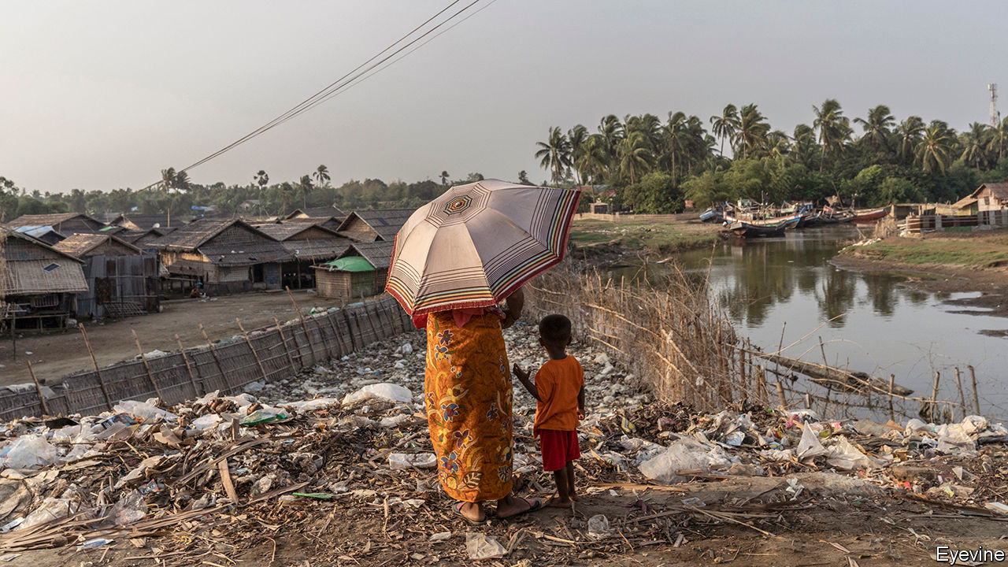

SUSPENDED IN THE air, several feet above Aung San Suu Kyi’s head, was an image of a dove with an olive branch in its beak. Ms Suu Kyi, Myanmar’s leader, was delivering her opening remarks at the “21st Century Panglong Conference”, a series of talks designed to end the numerous ethnic insurgencies that have ravaged her country since its founding in 1948. The poster of the dove gestures towards the hope Ms Suu Kyi inspired when she was elected in 2015 that she might one day silence the guns.

That day, alas, is nowhere close. Sporadic clashes continue to occur in Kachin, Kayin and Shan states. A new conflict has since 2018 erupted in Rakhine and neighbouring Chin states, where nearly 1,000 civilians have died and at least 80,000 people been displaced. On August 19th, 230 delegates from the government, the army and ten ethnic-minority groups gathered in Naypyidaw, the capital since 2006, for a three-day peace pow-wow before a general election in November. They may have wondered, seeing that paper dove, when they will see the flesh-and-blood version.

It was never going to be easy. Ms Suu Kyi inherited the world’s longest-running civil war. Her peace process was named after the first “Panglong Conference”, convened by her father, Burma’s independence leader, in 1947. Ever since, conflict between the army and a plethora of ethnic-based forces has spluttered on in many of the country’s border regions. The peace process that Ms Suu Kyi inherited from Myanmar’s previous leader is “one of the most labyrinthine” ever, according to the Transnational Institute (TI), an international research outfit.

Thein Sein, her de facto predecessor, had drawn up a Nationwide Ceasefire Agreement (NCA), which promised a federal system. Those who signed it would graduate to the next phase: political dialogue. But the army angered the most powerful rebel outfits when it declared in 2015 that six of their number would not be permitted to sign the NCA. As a result just eight armed groups, representing 20% of Myanmar’s guerrillas, signed up. This created a complicated, two-track peace process: dialogue with NCA signatories; and bilateral ceasefire talks with non-signatories. Since Ms Suu Kyi’s ascent to power, she has been able to convince just two piffling non-signatories to commit themselves to the NCA, and has made no real progress in peace talks.

The army is not helping. She cannot force it to extend an olive branch to its foes. The constitution gives the army, or Tatmadaw, control of the ministries of defence, home and border affairs, and a quarter of the seats in parliament, so in effect it has a veto on constitutional reform. It “has not made any commitments or any real concessions to ethnic groups during the peace process,” says Tom Kramer of TI. In fact it has deliberately sabotaged peace, adds David Mathieson, an analyst, for instance by clashing with the two beefiest NCA signatories, the Karen National Union (KNU), an ethnic-Karen (or Kayin) group, and the Restoration Council of Shan State (RCSS), an ethnic-Shan group. In October 2018 both withdrew from the peace process.

Since January 2019 the Tatmadaw has also stepped up the confrontation with the Arakan Army, an ethnic-Rakhine group, one of the six prevented from signing the NCA in 2015, leading to the bloodiest fighting in Myanmar in decades. “They’ve not been pursuing peace, they’ve been pursuing conflict,” says Priscilla Clapp, who advises the Asia Society, an American think-tank. The commander-in-chief views Ms Suu Kyi as a rival, and does not want to hand her any political victories.

Moreover, the Tatmadaw has always been viscerally opposed to federalism. It is committed to the idea of Myanmar as a unitary state, dominated by the ethnic majority, the Bamar. “I don’t think they want a genuine peace,” says Naw K’nyaw Paw, the general-secretary of the Karen Women’s Organisation.

The Tatmadaw leaves Ms Suu Kyi little room to manoeuvre. Yet she has made many missteps. At first she set about jump-starting the peace process with gusto. She hoped that a deal would be the swiftest route to constitutional reform, the only way to curb the power of the army, something she longs to do. The army has said that ending hostilities is a precondition for reform. But as the scale of the challenge of brokering peace impressed itself on her, Ms Suu Kyi’s enthusiasm waned. She turned her attention to other matters.

Even as her government neglected peace negotiations, it inflamed relations with ethnic minorities. In March the government declined to give state legislatures, some of which are dominated by ethnic parties, the right to choose their chief ministers. Ms Suu Kyi has failed to acknowledge the long-standing grievances of ethnic minorities or to tackle concerns among ethnic groups about the army’s breaches of the NCA. She has not sketched a vision of what a federal union might look like. “A lot of ethnic voters feel betrayed,” says Mr Kramer. “We are disappointed in her,” says Ms Naw K’nyaw Paw.

The prospect of facing voters at the polls with nothing to show for years of peace talks has stirred Ms Suu Kyi into action. There are promising signs. In January the KNU and RCSS returned to the negotiating table, apparently reassured by the government’s willingness to tackle some of their concerns. But none of the principles likely to be agreed on at Panglong goes beyond what is already in the constitution or existing law. And as Ms Naw K’nyaw Paw says, if the process does not include every armed group, “we are wasting a lot of our time.” She suspects that the government has convened this week’s conference merely to “save face” ahead of the election. It will do nothing to stop the fighting that she laments is “always” present in Myanmar.■

This article was downloaded by calibre from <https://www.economist.com/asia/2020/08/18/why-the-stalemate-in-myanmar-persists>

|  |  |  |  |
| --- | --- | --- | --- |
|  | Articles | Sections | Next |

|  |  |  |  |
| --- | --- | --- | --- |
| Previous | Articles | Sections | Next |

#### Virtual respect for the dead

# Covid-19 has made it hard for the Japanese to visit family graves

But they have found high-tech ways round the problem

Aug 22nd 2020 | TOKYO

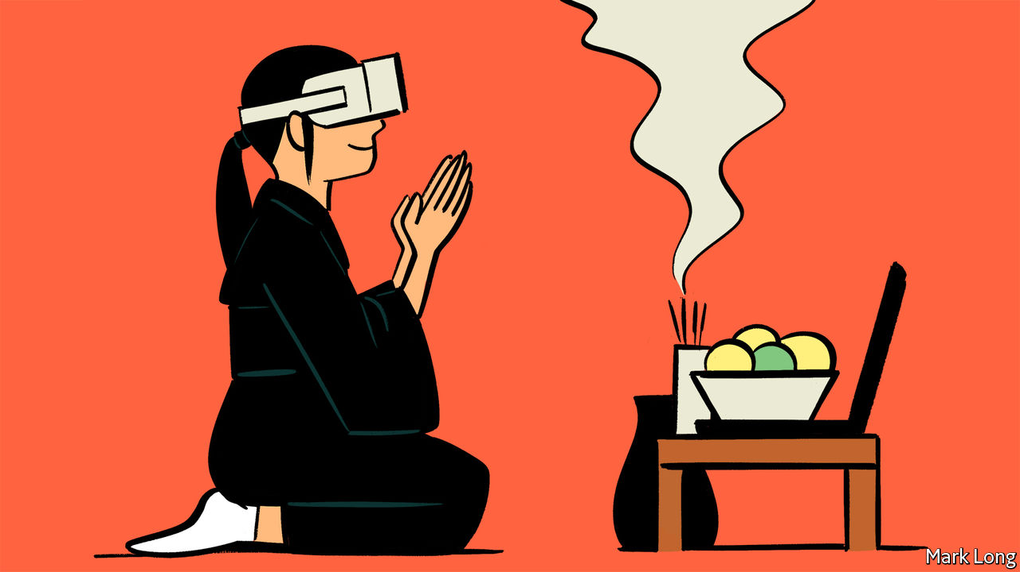

EVERY AUGUST the spirits of fallen ancestors rise all across Japan. During obon, the living commemorate them with offerings of food at altars, gather for festivals, and perform collective dances known as bon odori. Many stream back to their home towns to be with family and visit cemeteries to pay respects to their dead. “Graves are a place to talk,” says Yamazaki Masako of Zenyuseki, a tombstone carvers’ trade association.

This year covid-19 has upset the routine. Japan’s viral caseload is relatively small, with just 1,148 total deaths, roughly America’s daily average. But a recent rise in infections, especially in big cities such as Tokyo and Osaka, has spread the jitters. Citizens have been discouraged from travelling home and festivals have been cancelled. Family reunions have been held online to protect vulnerable elderly relatives.

Failure to visit grave-sites creates “a different type of stress—different from not being able to travel”, laments Ms Yamazaki. To help relieve the pain of missing those obligations to the past, her association turned to futuristic technology. For ¥25,000 ($236) it will produce a virtual-reality experience to let you visit a grave from the comfort of your home. “You can see it from all directions, 360 degrees,” boasts Ms Yamazaki. “It’s like you’re actually there.”

Others have hired proxies to visit the dead on their behalf. With Japan’s population ageing and urbanising, online graveyard visits and tombstone-cleaning services were already doing brisk business. Goendo, one such firm, says inquiries and website traffic have doubled this year. Its agents can be hired to weed, pick up rubbish, wash tombstones, arrange flowers and light incense sticks—then live-stream it all for families by video-chat. Kurashi no Market, an online services marketplace, reported that demand for grave visits in this year’s obon had nearly tripled. Reviewers have raved. “I was so relieved to see the image of a beautifully cleaned grave with flowers,” wrote a client who had fretted about not being able to visit in the flesh.

Obon came to Japan via China along with Buddhism. The word is thought to derive from the Sanskrit ullambana (deliverance from suffering). First practised in Japan in the seventh century, the custom fused with local folk traditions. “At another tap of the drum, there begins a performance impossible to picture in words, something unimaginable, phantasmal—a dance, an astonishment,” wrote Lafcadio Hearn, a 19th-century chronicler of Japan, who was in awe of a bon odori. “All together glide the right foot forward one pace, without lifting the sandal from the ground, and extend both hands to the right, with a strange floating motion and a smiling, mysterious obeisance.” Today’s live-streamed moves might seem equally phantasmal.

Editor’s note: Some of our covid-19 coverage is free for readers of The Economist Today, our daily [newsletter](https://my.economist.com/user#newsletter). For more stories and our pandemic tracker, see our [hub](https://www.economist.com/news/2020/03/11/the-economists-coverage-of-the-coronavirus)

This article was downloaded by calibre from <https://www.economist.com/asia/2020/08/22/covid-19-has-made-it-hard-for-the-japanese-to-visit-family-graves>

|  |  |  |  |
| --- | --- | --- | --- |
| Previous | Articles | Sections | Next |

|  |  |  |  |
| --- | --- | --- | --- |
| Previous | Articles | Sections | Next |

#### Street cred

# Audacious student protests are rocking Bangkok

But the government looks stronger than it was

Aug 20th 2020 | SINGAPORE

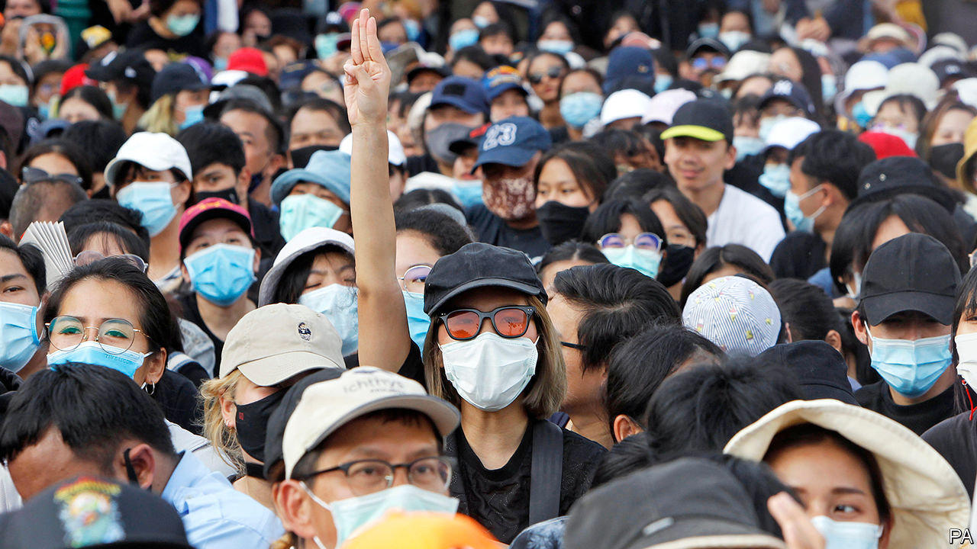

IT WAS THE largest demonstration since Prayuth Chan-ocha, the prime minister, seized power in a coup in 2014. On August 16th more than 10,000 protesters flocked to the Democracy Monument in Bangkok, Thailand’s capital. Student unions and youth groups have led protests for more than a month across the country. They want the government to step down. They demand a new constitution and an end to the harassment of opposition campaigners. More controversially, at a rally at Bangkok’s Thammasat University on August 10th, some agitators openly called for reform of the monarchy, still a strict taboo.

Thailand has endured 12 coups since revolution brought an end to absolute monarchy in 1932. Wrestling between generals and politicians has yielded 20 constitutions over the years. Military regimes boost their legitimacy through reverence for the crown. For almost two decades a feud between “yellow shirts” (royalist elites) and “red shirts” (supporters of Thaksin Shinawatra, a populist former prime minister) has divided Thai politics.

The latest protests are somewhat different. They have their roots in unrest that began in February, before social-distancing measures for covid-19 put public demonstrations on ice. Future Forward, a progressive party less than two years old, was dissolved by the constitutional court. Its leader, Thanathorn Juangroongruangkit, though he has been banned from politics for a decade, has inspired millions of Thais with his call to reform the army, decentralise government and tackle big business.

In many ways Mr Prayuth is stronger than he has been for months. In a recent cabinet reshuffle, technocrats favoured by him gained powerful posts. The new minister of finance is a former banker who inherits the task of sorting out the virus-ravaged economy; the central bank expects it to contract by more than 8% this year. The prime minister’s closest comrade, Prawit Wongsuwan, has calmed infighting within the army-aligned party, Palang Pracharat, that nominated Mr Prayuth for his post last year—by becoming its new leader.

The protesters reject the very system that protects Mr Prayuth and his allies. For one thing, any election held under the constitution favours them. Thailand’s upper house, an appointed body which includes bigwigs from the armed forces, has a say in the choice of prime minister after any popular vote. These senators can also block efforts to alter the constitution, since Article 256 needs at least a third of them to amend it. So the opposition’s attempts to change that article look doomed.

The protesters’ open criticisms of the monarchy—including objections to King Maha Vajiralonkorn’s financial arrangements and his personal control over military units—are the first of their kind. Harsh lèse-majesté laws, which can land a person in prison for up to 15 years for defaming, insulting or threatening high-ranking royals, have fallen from official favour. But critics of the crown are still targeted under laws against sedition, defamation and computer crime.

That does not deter the most daring. A “Harry Potter” protest has amusingly played on such repression, with marchers dressed as wizards declaring themselves against “he-who-cannot-be-named”.

Crafting a robust response is tricky for the government. The longer the protests drag on, the bigger the headache for the unpopular Mr Prayuth. Politicians and universities have sternly criticised anti-royal sentiments. The government plans to hold a forum to discuss matters with students. At the same time it has identified dozens of protesters who will be in its sights from now on; some have already been detained. The education minister says the police can now arrest law-breakers on campus.

Yet avoiding the sort of violent clashes that occurred in the 1970s appears to be a priority for Mr Prayuth and his inner circle. “They learned a lot from the past with other coups,” reckons a Thai academic. “They know that confrontations and violence mean the end of their power.” A far happier result for the protesters would be the end of Mr Prayuth’s leadership altogether. ■

This article was downloaded by calibre from <https://www.economist.com/asia/2020/08/20/audacious-student-protests-are-rocking-bangkok>

|  |  |  |  |
| --- | --- | --- | --- |
| Previous | Articles | Sections | Next |

|  |  |  |  |
| --- | --- | --- | --- |
| Previous | Articles | Sections | Next |

#### Calls waiting

# The internet is patchy on Pakistan’s north-west frontier

The men with the guns still call the digital shots

Aug 22nd 2020 | ISLAMABAD

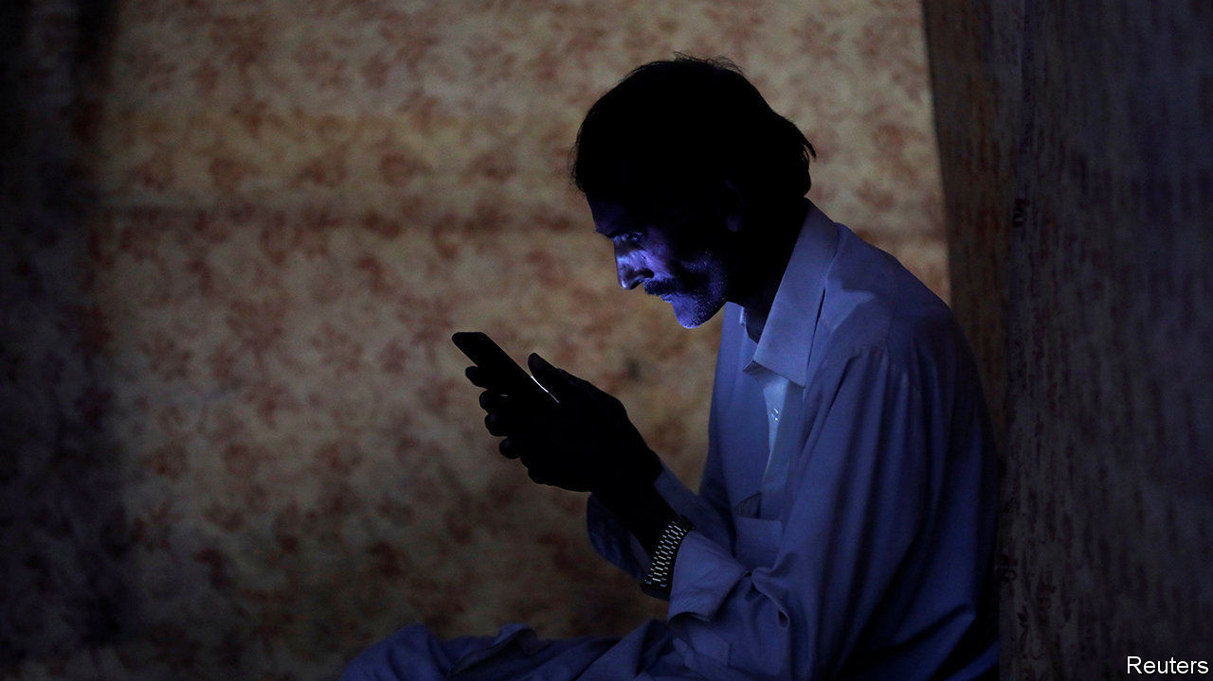

IMTIAZ HUSSAIN’S weekly meeting with his academic supervisor has become rather fraught. The 28-year-old postgraduate is researching Pakistan’s energy policy at one of the country’s most prestigious universities. But the internet at his home in Kurram, a district on the border with Afghanistan, keeps letting him down. Mr Hussain’s cable connection is an expensive luxury in a region where many people go without internet of any kind. Yet using it for video-calling is a struggle. “Connnectivity…drops every minute,” he complains.

Pakistan’s internet is shoddy, particularly outside its big cities. An index of “internet inclusiveness” produced by the Economist Intelligence Unit, a sister firm of this newspaper, ranks Pakistan 76th out of 100 countries, and almost last in Asia. Poor and non-existent connections have lately become a big headache for students sent home from university as a result of the pandemic, most of whom are required to keep studying remotely. Their frustrations have led to eye-catching protests in dozens of places, ranging from Balochistan province in the south of the country to Gilgit Baltistan in the north.

Internet provision in Kurram and neighbouring districts is especially bad. The border region was run at arm’s length by British colonial administrators, who viewed it as a rugged buffer against Afghanistan and saw little reason to develop it. These districts remained a backwater after independence, when they became known as the Federally Administered Tribal Areas (FATA). They became a haven for the Taliban. The people there suffered terribly during the militants’ many battles over the years with Pakistan’s army.

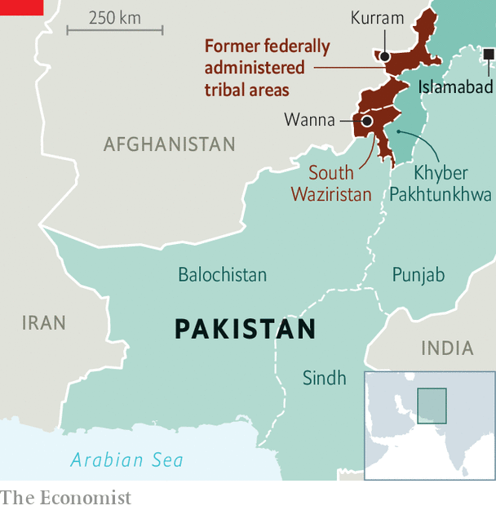

In 2018 FATA was merged into Khyber Pakhtunkhwa province. The idea was that making the region less of an administrative oddity would grant residents more political rights and perk up investment. But the struggles of local students to get online are just one illustration of how far there is to go. In much of the region the internet is restricted to the largest towns. Government offices and army bases get priority, say residents. Izhar Uddin, a 20-year-old studying computer science who lives in South Waziristan, says officials have offered to help students get online at government offices in Wanna, the district capital. But that is nearly 100km from his home. He has chosen instead to live with his cousin in Dera Ismail Khan, a better-connected city about three hours’ drive away.

The government of Khyber Pakhtunkhwa province, run by the Pakistan Tehreek-e-Insaf, the party of the prime minister, Imran Khan, says internet connections are a priority. But telecoms is a federal matter. Federal ministers also nurture digital dreams of putting government services online and creating apps. Few internet and mobile-network providers, however, see much profit in wiring up sparsely populated districts.

Moreover, policymakers often view internet access as a source of instability, says Usama Khilji, who researches internet rights for an NGO. That may explain the shortage of the mobile-phone signals that provide internet access in the most remote and insecure parts of the rest of the world. Security in the tribal districts has improved since the army drove out the Taliban, but the generals still call the shots. Even the existing internet connections sometimes get switched off.■

This article was downloaded by calibre from <https://www.economist.com/asia/2020/08/22/the-internet-is-patchy-on-pakistans-north-west-frontier>

|  |  |  |  |
| --- | --- | --- | --- |
| Previous | Articles | Sections | Next |

|  |  |  |  |
| --- | --- | --- | --- |
| Previous | Articles | Sections | Next |

#### Banyan

# South Korea’s liberal rulers unleash their inner authoritarians

Used to dishing out the criticism, they seem unwilling to take it

Aug 20th 2020 |

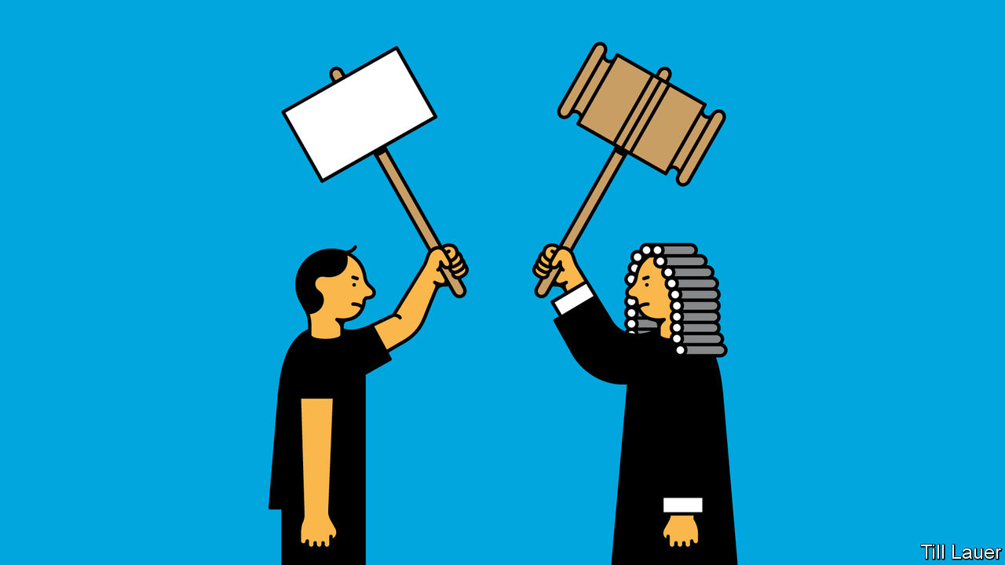

SOUTH KOREA has a proud history of noisy opposition to the powers that be. Japanese colonisers found their subjects unruly. Homegrown military dictators, who brutally suppressed their citizens’ democratic yearnings for decades, eventually yielded to widespread protests. Even democratically elected leaders have incurred the wrath of civil society. Park Geun-hye, the predecessor of Moon Jae-in, the current president, was chased out of office in 2017 after millions of South Koreans took to the streets to decry rampant corruption in her government.

Ms Park’s left-wing successors had vowed to do better. Mr Moon, a former activist and human-rights lawyer, and his Minjoo party claim to embody the legacy of the pro-democracy movement. They promised to honour the spirit of the protests that swept them to power. The country would become more egalitarian. The government would be more open, tolerant of dissent and responsive.

Those good intentions seem to be flagging. Opponents of the government are again finding that their views may attract litigation rather than benign indifference or even constructive responses. Nearly a fifth of civil libel suits against media organisations last year involved senior officials, more than during Ms Park’s administration.

Last month the president’s office appealed against a court ruling that cleared a conservative newspaper of defaming Mr Moon’s wife in an opinion column (the writer mused over whether the couple’s official overseas trips were too heavy on sightseeing). A right-wing YouTuber has been jailed for spreading rumours about Cho Kuk, a former senior official in Mr Moon’s government (Mr Cho has since been disgraced). The Minjoo party lodged a criminal complaint against a political-science professor after she criticised it for being self-serving and suggested that progressives should vote for other parties; the complaint was withdrawn after a public outcry. NGOs led by North Korean refugees who dislike the government’s conciliatory stance towards the North have lost their non-profit status and allege police harassment.

There is trouble in the legislature, too. Earlier this month Minjoo lawmakers proposed a bill that would grant the government the power to order the media to correct “fake news” (a similar bill was proposed by the conservatives in 2017). Another set of bills being considered seeks to punish anyone spreading “distorted” historical accounts of a crackdown in 1980 on pro-democracy protesters.

Park Kyung-sin, a law professor and free-speech advocate at Korea University, thinks the government’s touchiness in the face of criticism has its roots in “a long-standing vendetta between progressives and the conservative media”. Even in government, left-wingers have not shed their self-image as underdogs. They tend to think of certain media outlets as arms of political parties, and have a “siege mentality” when it comes to their critics.

Activists forged their political identities against a military dictatorship implacably hostile to their aims, so opponents’ freedom of expression was not a priority. South Korean politics—and many media organisations—remain polarised, with cross-party co-operation virtually unheard of. Loyalty to one’s own camp is prized above all. Kim Kyung-ryul, a progressive intellectual who broke with his former comrades over attitudes to Mr Cho’s conduct earlier this year, has likened the two main parties to “backstreet gangster groups” serving only their own interests.

Mr Park is keen to stress that current developments are less worrying than the systematic use of criminal defamation law against political opponents that occurred under previous administrations. Some Minjoo lawmakers are still trying to soften the country’s punitive defamation laws, whereby journalists and ordinary citizens can get long prison sentences for damaging reputations, even if their offending statements are true. Despite the recent litigiousness of some of their colleagues, South Korea’s rank on the world press-freedom index is higher than it was a few years ago.

South Korean politicians love to quote ancient wisdom. The government might do well to ponder the words of King Sejong, a model ruler and rich source of inspiring quotations from the Joseon era. “I am neither virtuous, nor skilful at governing. There will definitely be times when I do not act upon the heavens’ wishes. So look hard for my flaws and make me answer to their reprimands,” he said, in 1425.

This article was downloaded by calibre from <https://www.economist.com/asia/2020/08/20/south-koreas-liberal-rulers-unleash-their-inner-authoritarians>

|  |  |  |  |
| --- | --- | --- | --- |
| Previous | Articles | Sections | Next |

|  |  |  |
| --- | --- | --- |
| Asia | Sections | Middle East & Africa |

China

Hukou reform: Worlds apart

.

Chaguan: Past its Peak

.

|  |  |  |
| --- | --- | --- |
| Asia | Sections | Middle East & Africa |

|  |  |  |  |
| --- | --- | --- | --- |
|  | Articles | Sections | Next |

#### Worlds apart

# Changes to China’s hukou system are creating new divides

The rich find it easier to move to big cities; the poor are being pushed towards small ones

Aug 19th 2020 | WUWEI, ANHUI

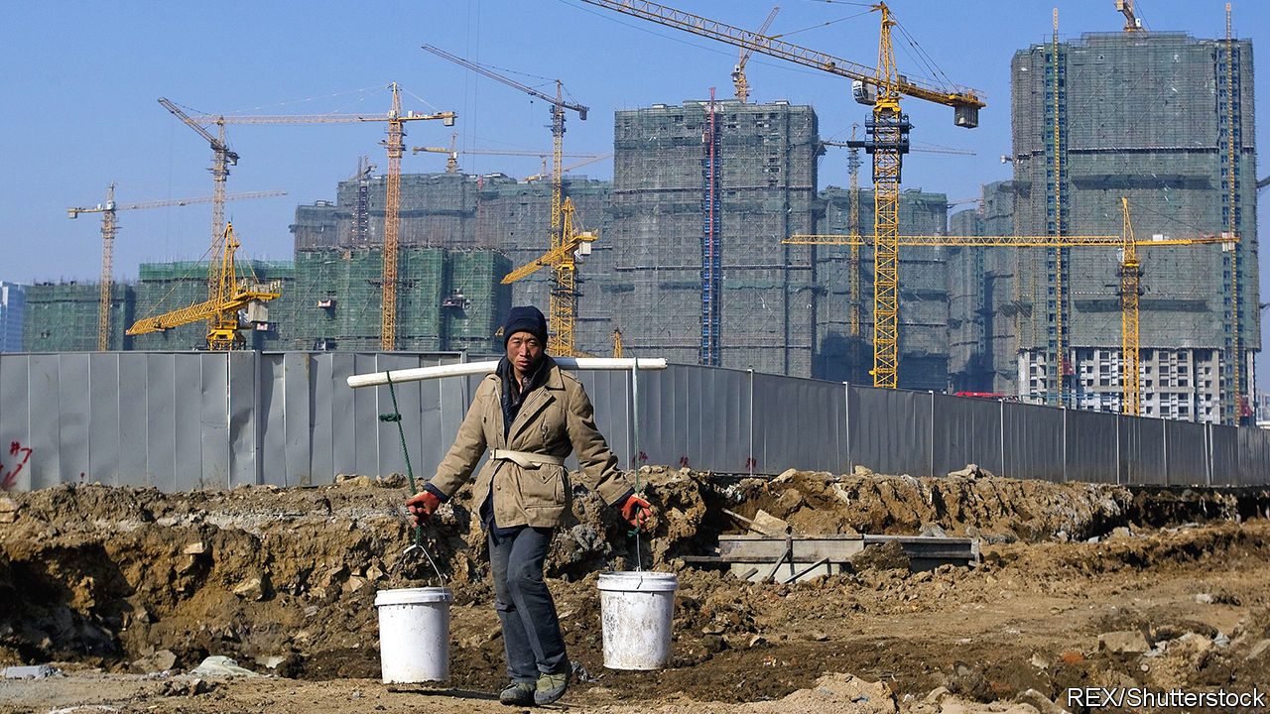

CHEN JUN had a good job in Shanghai making eyeglasses. Last year he gave it up and went back to his home village in Anhui, an inland province. He dug out a basin, filled it with water and stocked it with crayfish. He went not for the work—there is less money in crayfish farming than in lens crafting—but for his family. Mr Chen could not afford to bring his children to the city, so had left them at home to be raised by his parents. But his parents were ageing and his children needed attention. “It could not go on like that,” he says, still wearing his blue factory jacket from Shanghai.

Mr Chen’s story is wearily familiar. Millions of Chinese rural migrants work in cities for years, often apart from their families, before returning to their homes in the countryside. This unhappy circulation is a result of the hukou system, a household registry that prevents most migrants from moving to cities on a permanent basis. Because he did not have a Shanghai hukou, Mr Chen could not get his children into a local state school. He could not get a housing subsidy or collect unemployment insurance. He was only ever passing through.

The hukou system has long divided rural Chinese from their urban peers. During the Maoist era it determined whether people worked in industry or agriculture. Its grip on daily life has since faded, but it still determines which village, town or city each Chinese person truly calls home: where they may access the full range of welfare benefits and government services, from pensions to public education. In recent years officials have vowed to relax the system further in order to promote urbanisation, which is needed to drive economic growth. Many observers are sceptical; the Communist Party has promised reform for decades. Yet the system is gradually changing, albeit in ways that are creating new fractures between rich and poor.

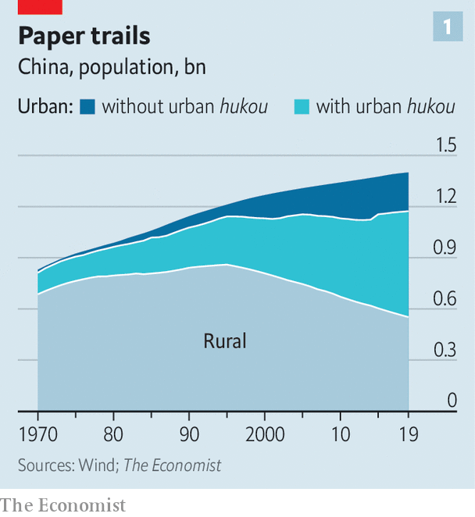

In absolute terms China’s urbanisation is an astonishing success. The population of its cities has risen to nearly 850m, five times larger than four decades ago, when people started moving around more freely. Some 61% of Chinese now live in cities, and a further 1%—more than 15m people—join them each year. Yet about 230m people reside in cities without holding a local hukou, as did Mr Chen when he was in Shanghai (see chart 1). They are treated much like second-class citizens. Officials insist that they want to change this. In 2014 the government published a “new urbanisation plan”; it promised that by the end of this year it would help 100m people to swap their rural hukou for an urban one.

In practice this push has played out in two contrasting ways. The central government’s focus has been on boosting smaller cities. Officials fear that big cities would be overwhelmed if they were to offer residency rights to low-skilled workers. Better to direct them to places that would benefit from new arrivals. Six years ago it instructed cities with populations of less than 1m to offer a local hukou to anyone who applied. Last year, it called on cities with populations of less than 3m to do the same.

At the same time, many of China’s big cities—with the notable exceptions of Beijing and Shanghai—are trying to attract higher-skilled, wealthier residents. They generally offer four routes to a local hukou, much like the pathways to immigration in Western countries: investing in a local business; buying a home; having a degree; or holding a qualified job. In a study reviewing 120 cities’ policies, Zhang Jipeng, an economist, found that prosperous coastal cities had raised their standards for obtaining a local hukou in recent years, whereas inland cities had lowered them. Chinese media frequently refer to a “talent war” being waged among municipal governments eager to lure young professionals. By attracting home buyers, they also hope to boost their property markets.

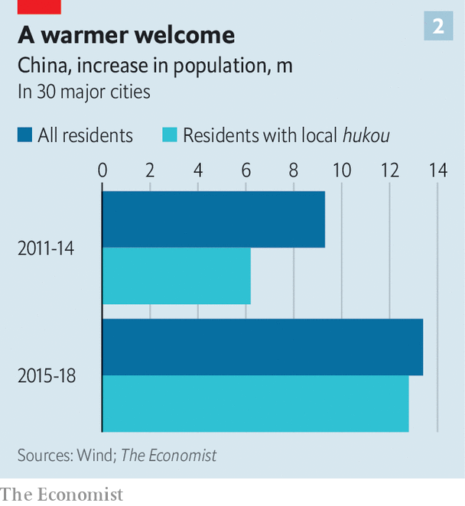

The Economist looked at data from 30 major cities to assess what effect these tweaks are having. Between 2011 and 2014, the increase in their overall population was 50% larger than the increase in their hukou-holding population. That suggests that roughly one out of every three new residents had to get by without a local hukou. But from 2015 to 2018, the increase in local hukou holders was almost identical to the increase in their total populations (see chart 2). In booming inland cities such as Chengdu and Xi’an, hukou issuance actually outstripped new arrivals (that can happen when existing residents, often recent graduates, obtain local hukou).

Hukou reforms carried out by small cities have had much less of an effect. These places have opened their doors to poorer migrants, but few are choosing to walk through them. A new study of 337 cities by Ren Zeping, an economist with Evergrande, a property developer, found that those with smaller populations had generally suffered outmigration over the past two decades, and that the recent reforms had not stemmed the tide.

Instead, these smaller cities are encountering a phenomenon that had once seemed implausible: rural migrants are not much interested in moving to them and, when they do, would rather remain registered for official purposes in the villages that they have come from. Government surveys of rural migrants have found that only about a fifth of respondents are willing to acquire a hukou in their adopted cities. Lu Ming of Shanghai Jiaotong University says the logic is simple: if big cities, with abundant resources and job opportunities, were to offer residency to migrants, they would leap at the offer, but smaller cities do not have the same appeal.

## Hedging their bets

One reason rural migrants hesitate to transfer their hukou to a city is that doing so typically requires them to give up the use of their land in the countryside. They consider farmland a resource to fall back on in hard times—as millions did earlier this year when growth cratered because of lockdowns imposed to control covid-19. Giving up land feels especially risky when many of the small cities that are open to receiving poor rural migrants can afford to provide only limited social benefits in return. Migrants with land near expanding cities also anticipate that officials may some day offer them compensation in order to build on it.

Officials are aware of the problem and discuss two possible solutions. One is to sever land rights from hukou, allowing migrants to register in small cities while also hanging on to their fields. But that is fraught because rural land is formally owned by villages, not individuals—something that the party has little appetite to change. The other solution is to provide better funding for social-security systems in cities around the country, ensuring that urban residents can get good services wherever they are. But that would require the central government to stump up much more cash—something that it has also shown little appetite to do.

Instead, a gap is opening between the benefits offered by rich, mostly coastal cities and those in struggling regions such as China’s north-east. Whereas the hukou system has historically cemented inequalities between urbanites and country-dwellers, it now enforces a divide between people born into wealthy cities and those who must scrape by in poor ones. “The rising issue is where you are actually registered, and what that registration means for your entitlements,” says Samantha Vortherms of University of California, Irvine.

Thus the hukou system remains a drag on China’s development, even in its semi-relaxed form. The biggest cities are engines of productivity and innovation. They should be still bigger and fewer people should toil in the countryside. Wen-Tai Hsu of Singapore Management University estimates that letting people settle wherever they want would boost the Chinese economy by roughly as much as did its entry into the World Trade Organisation two decades ago. It would also help cope with the grim demographic trends that afflict some cities with very strict hukou rules. Kam Wing Chan of the University of Washington notes that, without lots of newcomers, the proportion of Beijing’s population over the age of 65 will double to 22% in a decade and reach 47% by 2050. Unless China wants its capital to be known as the world’s nursing-home powerhouse, it will need to loosen hukou restrictions well before then.

Despite the limited relaxation so far, the government looks likely to meet its target of creating 100m new urban hukou holders by the end of this year. Indeed, it is on track to exceed that target. Sleight of hand has helped. Officials have been rushing to draw new city boundaries, declaring that areas previously considered rural are in fact urban districts. At a stroke, people registered there become urbanites.

That has happened to Chen Jun, the crayfish farmer in Anhui. He returned to a village that was part of Wuwei county; in December Wuwei was rebranded as a city. This is not a new trick, though it appears to be getting more common. One third of all of those who became urban residents between 2010 and 2015 earned that status when their formerly rural communities were reclassified as urban, according to a recent study led by Gan Li of the Southwestern University of Finance and Economics.

This redistricting is not entirely meaningless. The reclassification gives local governments greater taxation and spending powers. And many of the areas newly defined as urban were clearly heading in that direction. At the heart of Wuwei, high-rise housing and a glossy white shopping centre sit next to dilapidated alleys where farmers sell live chickens. With its upgraded status, the local government says it will “build a high-quality city”, investing in car parks, landscaping and public housing. But for Mr Chen the life on offer in Wuwei City will still be far inferior to what he could have had in Shanghai. The medical care is worse, the schools shabbier and the pension smaller. He may be a denizen of one of China’s newest cities, but a truly urban life remains a distant dream.■

This article was downloaded by calibre from <https://www.economist.com/china/2020/08/19/changes-to-chinas-hukou-system-are-creating-new-divides>

|  |  |  |  |
| --- | --- | --- | --- |
|  | Articles | Sections | Next |

|  |  |  |  |
| --- | --- | --- | --- |
| Previous | Articles | Sections | Next |

#### Chaguan

# China’s rulers will pay a high price for repression in Hong Kong

It will have an outsize impact on whether foreigners trust China

Aug 22nd 2020 |

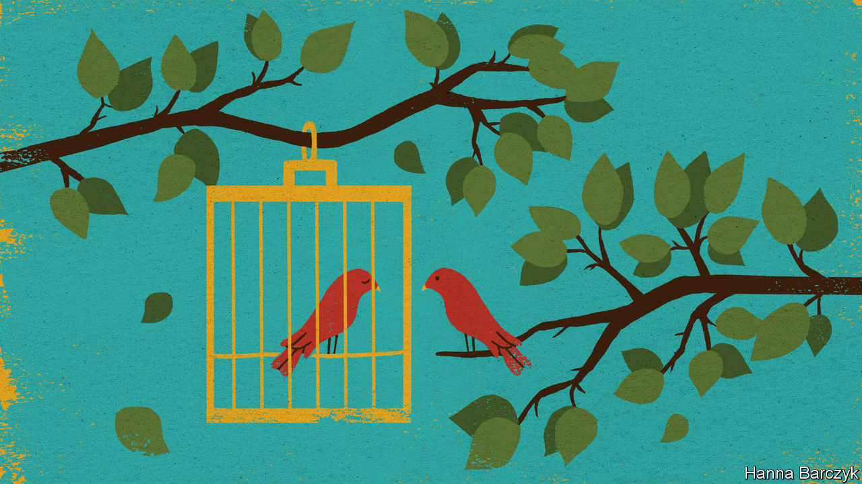

THE WORLD has a right to be shocked by China’s rapid crushing of civic freedoms in Hong Kong. But outsiders should not be surprised. Western politicians spent years arguing that China, out of pure self-interest, should grant Hong Kong greater autonomy, or at least preserve liberties promised by the slogan “One Country, Two Systems”. That was always a doomed effort. In part, pleas to grant Hong Kong more freedoms reflected a misjudgment about the incentives that guide the swaggering-yet-paranoid hard men who lead China’s Communist Party today. In part, Western arguments were a bluff, based on half-veiled threats that multinational companies, foreign investors and banks might walk away from Hong Kong’s lucrative financial markets if the territory’s political freedoms were too brutally curbed. China is now calling that bluff.

There is a self-reinforcing logic to China’s actions. A sweeping national-security law imposed on Hong Kong in July has, by the mere fact of its existence, created a new test of patriotism that citizens must pass. Hong Kong’s election officers recently disqualified a dozen pro-democracy politicians from seeking seats in the city’s Legislative Council at elections scheduled for September. The candidates’ purported misdeeds included questioning the need for a national-security law. Circular logic even saw opposition politicians disqualified for pledging to vote against the government. Just in case some missed the message, a day later the election, during which opposition parties expected to make big gains, was postponed for a year, ostensibly as a pandemic-fighting precaution.

Chinese officials do not much care if Westerners are outraged. Casting Hong Kong protesters as dupes, officials claim (and may even believe) that the Trump administration is using the city’s openness to attempt a “colour revolution”, in cahoots with such democracy supporters as Jimmy Lai, a Hong Kong newspaper owner arrested and paraded through his newsroom in handcuffs by 200 policemen. Other officials are coldly cynical. They think that lots of foreign governments and businesses mostly want to make money in Hong Kong. Cynics also think that many expatriates quietly opposed last year’s anti-government protests, some of which were violent, and will welcome the silencing of troublemakers.

Nor do Chinese leaders seem scared that repression in Hong Kong will cost them hearts and minds in Taiwan, though that democratic island was once promised that, if it agrees to rule by Beijing, it will have its own version of “One Country, Two Systems”. On the mainland, senior figures have told Westerners that the Taiwanese will soon envy Hong Kong’s renewed prosperity. Chinese leaders “are feeling quite triumphant over Hong Kong”, says a diplomat. “They think it’s theirs and this is what they have to do.”

China’s rulers are half-right. Hong Kong is theirs. It also matters more to them than it does to any foreign government (especially with covid-19 battering economies). That includes the government of Britain, the city’s former colonial master. Britain has offered a path to citizenship for up to 3m Hong Kongers, drawing Chinese rebukes. However, it is also anxious to promote trade with China, especially after Brexit. On July 28th European Union foreign ministers expressed “grave concern” about the national-security law, but could not agree on concrete, joint actions. Indeed, in Beijing, some European diplomats privately call Hong Kong an obsession of the Anglophone world. Japan is both unhappy about Hong Kong, a close partner, and unwilling to do much about it.

Narrowly, China’s rulers will get away with crushing Hong Kong’s freedoms. But in myriad, hard-to-quantify ways, they will pay a price. Chinese officials are quick to allege impure motives when outsiders express concern for Hong Kong. Britain is called nostalgic for its empire. The Global Times, a party tabloid, calls Mr Lai a “traitor to the Chinese race” for his past appeals for foreign support. But it is not race treachery if Hong Kongers make common cause with democrats overseas. Nor is it racism if Westerners find Hong Kong the most comprehensible place in China.

Party bosses and their apologists love to play up China’s exceptionalism. They call authoritarianism a reflection of China’s vast size, its poverty, its history or even its collectivist, Confucian culture. Such excuses do not work as well in Hong Kong. A modern, remarkably open world city, its hybrid culture includes many familiar, Western-style freedoms. That legibility makes its fate unusually important in shaping foreign perceptions of China.

## A question of trust

Chinese officials insist that last year’s protests were a bid to split the motherland and seek Hong Kong’s secession. In truth, only a small minority of Hong Kongers support independence, a hopeless dream. Protesters last year talked more about democracy as a way to preserve liberties meant to last until 2047. Those include a raucous free press to hold the powerful to account, schools and universities with a mandate to inculcate critical thinking in the young, and a rule of law in which individuals have inalienable rights. British colonial rulers denied Hong Kong real democracy. But when given the chance to cast meaningful ballots, most voters have consistently supported more direct elections. Now China’s rulers have made their preference clear. They hate to be defied and loathe losing elections, so are rolling Hong Kong’s freedoms back.

Western governments and people cannot alter China’s choices in Hong Kong. But they are entitled to draw conclusions from those decisions. China wants to become a high-technology superpower, selling the world 5G networks, nuclear-power stations or—who knows—a covid-19 vaccine. China’s diplomats want a seat at the top table in global forums where standards and norms are agreed upon. Its universities want to strike partnerships with academic institutions around the world. Those are all reasonable ambitions, but they depend heavily on trust. Repression in Hong Kong will have an outsize impact on whether foreigners trust China. That may anger party bosses. It should not be a surprise.■

This article was downloaded by calibre from <https://www.economist.com/china/2020/08/22/chinas-rulers-will-pay-a-high-price-for-repression-in-hong-kong>

|  |  |  |  |
| --- | --- | --- | --- |
| Previous | Articles | Sections | Next |

|  |  |  |
| --- | --- | --- |
| China | Sections | Europe |

Middle East & Africa

The United Arab Emirates: The strong, silent type

.

Israel and the Arab world: Who’s next?

.

Iran and covid-19: A rite old mess

.

African stamps: Wait a minute Mr Postman

.

Oil on protected waters: An oil spill off Mauritius threatens protected ecosystems

.

Mutiny in Mali: A coup that was coming

.

|  |  |  |
| --- | --- | --- |
| China | Sections | Europe |

|  |  |  |  |
| --- | --- | --- | --- |
|  | Articles | Sections | Next |

#### The strong, silent type

# The United Arab Emirates has become a force in the Middle East

Its deal with Israel is indicative of a quiet, yet savvy foreign policy

Aug 22nd 2020 | ABU DHABI AND BEIRUT

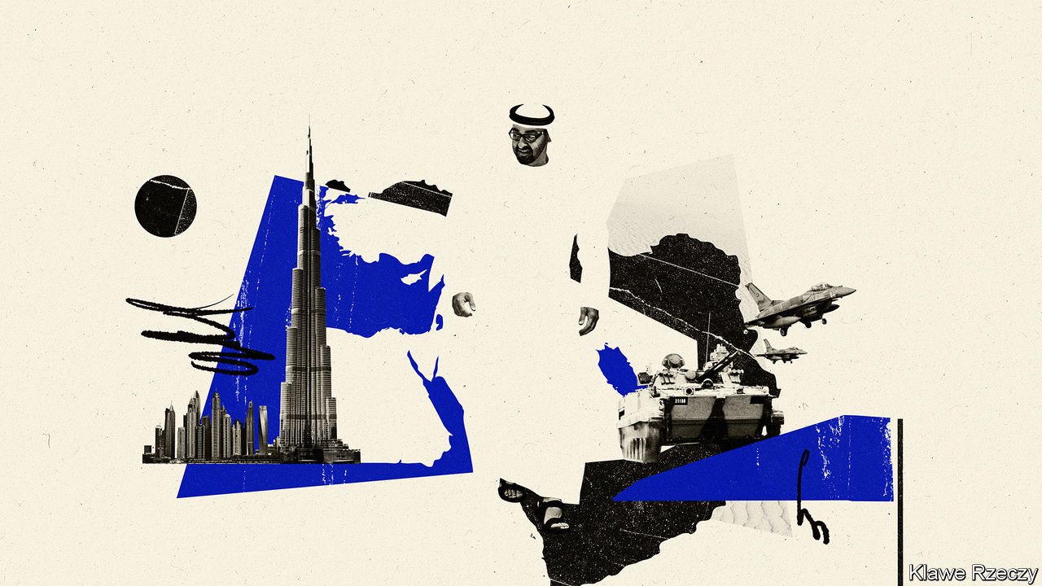

IT WAS NOT quite Anwar Sadat speaking before the Knesset, or King Hussein and Yitzhak Rabin clutching hands in the Rose Garden. That would not have been Muhammad bin Zayed’s style. The agreement between Israel and the United Arab Emirates (UAE), announced on August 13th, was hashed out quietly by spies and sheikhs and unveiled largely on Twitter. It made the UAE the first Gulf country and only the third Arab state to open formal relations with Israel. Yet it had all the pomp and circumstance of a tariff agreement.

Though long overshadowed by Saudi Arabia, Prince Muhammad, the UAE’s de facto ruler (pictured in illustration), has turned his small country of 10m people into arguably the most influential Arab state. It wields soft power through Dubai, the region’s business hub, and firms like DP World, a shipping giant. A compact but capable army provides a sharper edge. Emirati money and media have backed coups and intrigue across the Middle East.

Much of this is done quietly, allowing the UAE to evade the scrutiny applied to bigger powers. Savvy at playing politics in Washington, Paris and other capitals, it positions itself as a reliable partner. “We realise our size,” says one Emirati official. “We need to be part of collective policies.” Westerners who advise the government in Abu Dhabi, often ex-diplomats or retired soldiers, slip into the first-person plural, as if there is no daylight between their employer and their native countries.

Yet the UAE is increasingly willing to go its own way. Its priorities differ from some of its neighbours’: more pragmatic towards Iran and more hostile towards political Islam. It broke with the Saudis in Yemen, the Americans in Libya, and many of its partners in Syria. Optimists hope it can spread “the Dubai model”—good governance, a vibrant economy, an admirable emphasis on religious tolerance—across the Middle East. But the UAE’s efforts to secure its own interests may just as well entrench the region’s woes.

In military matters it is true that the UAE rarely acts alone. But it plays an outsized role. The troops it sent to Yemen in 2015 were the most effective piece of a Saudi-led coalition fighting the Houthis, a Shia rebel group. Their departure last summer left the Saudis little choice but to start negotiating their own exit. Emirati drones propped up Khalifa Haftar, the Libyan warlord who tried last year to conquer Tripoli, until Turkey’s superior forces put paid to that effort.

Officials at the Pentagon admiringly call the UAE “little Sparta”. Actual Spartans might have found its glitzy hotels a touch frivolous. But the aphorism reflects frustration with Arab states that spend billions on Western kit yet accomplish little with it. The Emiratis have proved more capable.

They are also less dogmatic, at least in some areas. Most Gulf states joined the effort to unseat Bashar al-Assad in Syria. The UAE was the first to recognise its failure. It reopened its embassy in Damascus in December 2018 despite concerns from allies. Some Emiratis insist, implausibly, that the mission focuses simply on consular cases. Others argue that engaging Mr Assad may make him more receptive to change. “It’s about trying to bring Syria back to the Arab fold,” says one official.

Such hopes are unrealistic. But the willingness to court Mr Assad reflects a wider split on how to handle his main backer: Iran. The Saudis see Iran as an existential threat. The Emiratis have no love for it either. They harbour a long-running territorial dispute over islands in the Gulf; Western officials blame Iran for the sabotage of oil tankers in Emirati waters last year. Yet the UAE takes a softer line. Firms linked to Iran and its allies do business in Dubai. Not all of it is legitimate (see [article](https://www.economist.com/node/21791062)). Once an eager backer of America’s “maximum pressure” campaign, the UAE has recently tried to lower tensions.

The UAE’s more assertive role roughly coincides with the ascent of Muhammad bin Salman, or MBS, the Saudi prince who became heir to the throne in 2017. “MBS is young, he’s new, and he’s busy with socioeconomic changes at home,” says a Western diplomat in the Gulf. “The Emiratis felt they needed to pick up the slack.”

In some cases the Saudis were happy to let them. For decades the Saudis wielded influence in Lebanon through Rafiq and Saad Hariri, the father-and-son duo who served as prime ministers for 16 of the past 28 years. But on their watch corruption spread, while Hizbullah, the Iranian-backed militia and political party, became Lebanon’s most powerful actor.

After the Saudis briefly kidnapped Saad in 2017 in a failed attempt to bring political change, they washed their hands of the country. “They gave the Lebanon file to the Emiratis,” says a diplomat in Beirut. The Emiratis have been content to let it languish: they have not stepped in to bail out Lebanon’s bankrupt government.

With its factious politics, Lebanon is unappealing territory for the UAE. Underlying much of its regional policy is a suspicion of mass politics. The Arab uprisings of 2011, seen from Abu Dhabi, brought not hope but chaos. The UAE wants “evolution, not revolution”, says an official. In practice this means a preference for anti-Islamist autocrats who pose as modernisers.

Perhaps the exemplar of this is Abdel-Fattah al-Sisi, the Egyptian general who led a coup, with Gulf support, against an elected Islamist government in 2013. At times he seems to model himself on the Emirati crown prince. Mr Sisi’s ambition to build a gleaming new capital in the desert east of Cairo is reminiscent of Dubai. Periodic lectures to Egyptians about their work ethic or physical fitness evoke the top-down approach to shaping society in the UAE.

That may work for the UAE, which keeps citizens and residents in line with a comfortable standard of living, electronic surveillance and, for the foreigners, the threat of deportation. But Mr Sisi’s fondness for Gulf-style mega-projects seems wasteful in a poor country of 100m people; his intolerance for politics grates on citizens of a country that, for all its years of dictatorship, has a rich political tradition. What works in Dubai does not necessarily work elsewhere—neither as evolution, nor as an effort to forestall future revolution. ■

This article was downloaded by calibre from <https://www.economist.com/middle-east-and-africa/2020/08/22/the-united-arab-emirates-has-become-a-force-in-the-middle-east>

|  |  |  |  |
| --- | --- | --- | --- |
|  | Articles | Sections | Next |

|  |  |  |  |
| --- | --- | --- | --- |
| Previous | Articles | Sections | Next |

#### Who’s next?

# The Arab countries most likely to recognise Israel

The United Arab Emirates has charted a path. Others will probably follow

Aug 22nd 2020 | JERUSALEM

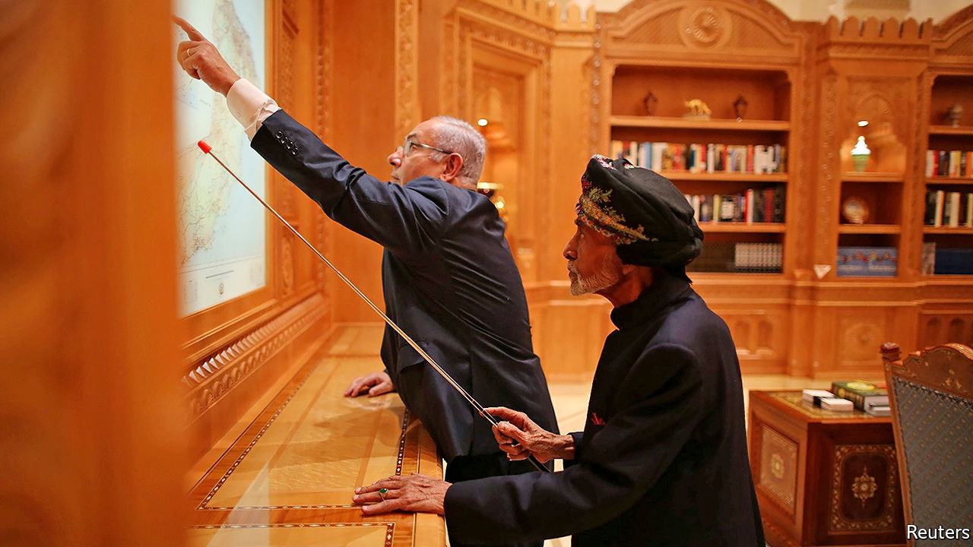

“NOW THAT the ice has been broken, I expect more Arab and Muslim countries will follow the United Arab Emirates’ lead,” said President Donald Trump on August 13th, when the UAE became just the third Arab state (after Egypt and Jordan) to establish formal ties with Israel. The move was greeted with approval by several of the region’s leaders, who have long had secret dealings with the Jewish state. So who will be next to bring them into the open?

A good bet is Oman, which congratulated Israel and the UAE on their agreement. In the past Oman has played the role of interlocutor between Israel and the Arab world. In 2018 the late Sultan Qaboos hosted Binyamin Netanyahu, the first visit by an Israeli prime minister to the Gulf in over two decades (pictured). But in January a new sultan, Haitham bin Tariq, took over. He dismissed the foreign minister on August 18th, a day after the top diplomat spoke to his Israeli counterpart. The move came as part of a larger government shake-up, but Sultan Haitham may not yet feel secure enough to take such a bold step.

If Oman doesn’t go next, perhaps Bahrain will. Its cabinet praised the “historic” Israel-UAE deal. Its prime minister has reportedly talked to the chief of Israel’s spy agency. And it has hosted Israeli officials before. American diplomats unveiled the economic half of Mr Trump’s Middle East peace plan in Bahrain’s capital, Manama, last year. The tiny kingdom is close to the UAE and, like Israel, it views Iran as a threat.

Some point to Sudan as a strong possibility. Its interim leader, Abdel Fattah al-Burhan, met Mr Netanyahu this year in Uganda, where they agreed to start normalising ties. Lately, though, Sudan has sent mixed messages.

On the other side of Africa, Morocco is a decent bet too. It has played a leading role in previous Arab peace initiatives with Israel and was once a hub of Jewish life. Hundreds of thousands of Israelis hail from the north African state. Nearby Mauritania is another contender. It had formal ties with Israel from 1999 to 2009, but broke them off because of war over Gaza. Still, it praised the UAE’s “good judgment”.

A long shot is Saudi Arabia. Muhammad bin Salman, the kingdom’s crown prince and de facto ruler, has said that formal relations could be mutually beneficial. He seems envious of Israel’s economic and technological might. The two countries already co-operate to counter Iran. But formal ties are probably still a step too far for the conservative kingdom. ■

This article was downloaded by calibre from <https://www.economist.com/middle-east-and-africa/2020/08/22/the-arab-countries-most-likely-to-recognise-israel>

|  |  |  |  |
| --- | --- | --- | --- |
| Previous | Articles | Sections | Next |

|  |  |  |  |
| --- | --- | --- | --- |
| Previous | Articles | Sections | Next |

#### A rite old mess

# Iran’s clerics argue over how to hold the festival of Muharram

Social-distancing doesn’t appear to be on the cards

Aug 22nd 2020 |

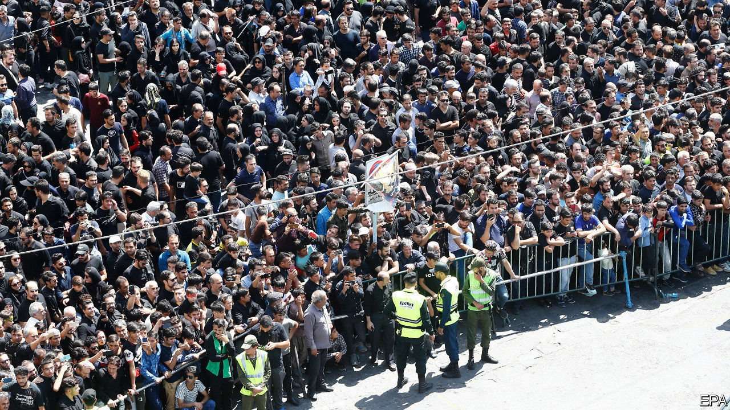

LAST MONTH Saudi Arabia did something unprecedented. To slow the spread of covid-19, it restricted participation in the haj, the annual pilgrimage to the holy city of Mecca, which every Muslim is expected to perform once in their life. Somewhere between 1,000 and 10,000 people already resident in the kingdom were allowed to take part—a tiny fraction of the 2.5m pilgrims who attended last year from around the world. It has been well over a century since the ritual was so disrupted.

Iran is taking a very different approach to this year’s Muharram ceremonies, which begin on August 20th and bring millions of Muslims together to mourn the death of Imam Hussein, the Prophet Muhammad’s grandson and favoured martyr of Shia Islam. “Even if we die, we will hold this year’s Muharram ceremonies splendidly,” says Saeed Haddadian, a maddah, or cantor, who chants for Iran’s supreme leader, Grand Ayatollah Ali Khamenei.

So vast crowds will file through the streets, beating their chests, banging huge drums and re-enacting the passion with mock swords. They will wail their laments in black-draped basements and share food close together. Nothing could spread the virus faster, but President Hassan Rouhani, a cleric himself, says the pageant “cannot be cancelled”. As in past years, his officials have erected stages festooned with coloured flags in streets across the country.

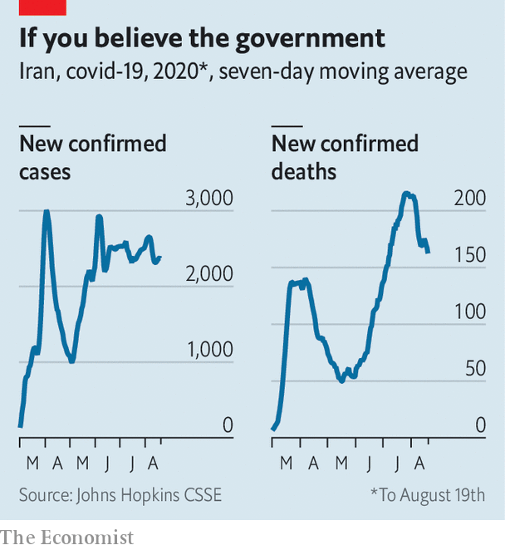

Iran’s doctors are aghast. Officials say the virus has killed just over 20,000 people—the highest death toll in the Middle East. But a BBC Persian-service investigation found that the government’s own records appeared to show that covid-19 had killed almost 42,000 people by July 20th.

The second wave was certainly deadlier than the first. And the mass gatherings of Muharram risk triggering a third. For months Iranians have been told to forgo mourning rites for loved ones and hold funerals online. But now Mr Rouhani says the entire populace can mourn a man who died long ago, if masks are worn. “Masks won’t stop transmission by sweat and tears,” says an official on Iran’s covid-19 task force.

Mr Rouhani is in thrall to the hardline clerics who dominate Iran’s politics. They think the Muharram showpiece may revive flagging enthusiasm for Islam in public life. Cantors like Mr Haddadian are religious pop stars. The president, for his part, is desperate to preserve a semblance of normality in the face of an economy in steep decline. Another lockdown, he fears, could provoke mass protests and even hunger. So doom-mongers are being muzzled. When a newspaper reported claims by a senior Iranian medic that the real death toll was 20 times the official tally, it was promptly shut down.

Not all clerics are so rash. Grand Ayatollah Ali al-Sistani, a popular Iraq-based cleric, says “alternatives” to the processions should be found. A Shia body in India urges believers to mourn online. Even Mr Khamenei says the advice of Iran’s covid-19 task force should be heeded. He knows many Iranians already blame the clerics for the virus, since it surfaced in Qom, Iran’s holiest city, and was spread by pilgrims going home. Another wave, he warns, may unleash “catastrophe”. ■

Editor’s note: Some of our covid-19 coverage is free for readers of The Economist Today, our daily [newsletter](https://my.economist.com/user#newsletter). For more stories and our pandemic tracker, see our [hub](https://www.economist.com/news/2020/03/11/the-economists-coverage-of-the-coronavirus)

This article was downloaded by calibre from <https://www.economist.com/middle-east-and-africa/2020/08/22/irans-clerics-argue-over-how-to-hold-the-festival-of-muharram>

|  |  |  |  |
| --- | --- | --- | --- |
| Previous | Articles | Sections | Next |

|  |  |  |  |
| --- | --- | --- | --- |
| Previous | Articles | Sections | Next |

#### Wait a minute Mr Postman

# Why African countries issue stamps celebrating English cricketers

It helps pay the bills

Aug 20th 2020 | NAIROBI



LEN HUTTON was an accomplished cricketer. English fans cherish the record 364 runs he racked up in a Test match against Australia in 1938. It would not be unreasonable to surmise, however, that this feat is less remarked on in the Central African Republic (CAR), a former French colony with no cricketing pedigree. So it may seem odd that in 2016 the CAR issued a set of commemorative stamps to mark the centenary of Hutton’s birth—and odder still that French-speaking Niger and Portuguese-speaking Mozambique did the same (see picture).

The practice, it seems, is not restricted to bygone English cricketers. Jan Brueghel the Elder died 395 years ago in January, a milestone Sierra Leone’s postal authorities considered significant enough to warrant a philatelic tribute. Other African states seem to prefer Baroque music to Flemish art. It is just possible that the people of Guinea-Bissau might have let the 260th anniversary of the death of Johann Sebastian Bach slip by without much fanfare. Fortunately, their postal service was less remiss.

Stamp issues usually let countries celebrate national heroes. Yet there is a rationale for printing stamps of long-deceased foreigners. You would be hard pressed to walk out of a post office in Bangui, the CAR’s benighted capital, with a Hutton stamp. But collectors scouring the internet are willing to pay handsomely for such stuff. A set of Hutton stamps from the CAR fetches €15.50 ($18.50). Niger’s depiction of a besuited Hutton is sufficiently sought-after to command a €2 premium. This is a handy way for African states to boost revenues.

Genuine philatelists get prissy about this sort of thing. Stamps should be issued only to meet local demand, they insist. Yet targeting the collectors’ market is not new. Smaller and poorer countries have been at it for 70 years, notes Ian Harvey of the Royal Philatelic Society London. Even Britain’s august Royal Mail is accused of collector-gouging.

Still, there are signs that the practice is getting out of hand. In recent years several African countries have appointed a Lithuanian-based outfit called Stamperija to design and print their stamps. Stamperija, philatelists grumble, has flooded the market with tat. Collectors calculate that, with the help of Stamperija, Sierra Leone, with a population of 7.6m and a barely functioning postal service, churned out 1,566 different stamps last year, compared with 268 released by Britain and 139 by India.

Stamperija’s gaudy designs are not to everyone’s liking. And producing so many stamps can lead to mistakes. A set of Stamperija stamps issued in 2014 for the CAR turned out not to picture Marilyn Monroe, as planned, but a New York drag artist. Few of Stamperija’s clients seem bothered, though. “It is willing buyer, willing seller,” says a postal official in Sierra Leone. “So what’s the problem?”

This article was downloaded by calibre from <https://www.economist.com/middle-east-and-africa/2020/08/20/why-african-countries-issue-stamps-celebrating-english-cricketers>

|  |  |  |  |
| --- | --- | --- | --- |
| Previous | Articles | Sections | Next |

|  |  |  |  |
| --- | --- | --- | --- |
| Previous | Articles | Sections | Next |

#### Oil on protected waters

# An oil spill off Mauritius threatens protected ecosystems

The country is scrambling to assess the damage

Aug 20th 2020 |

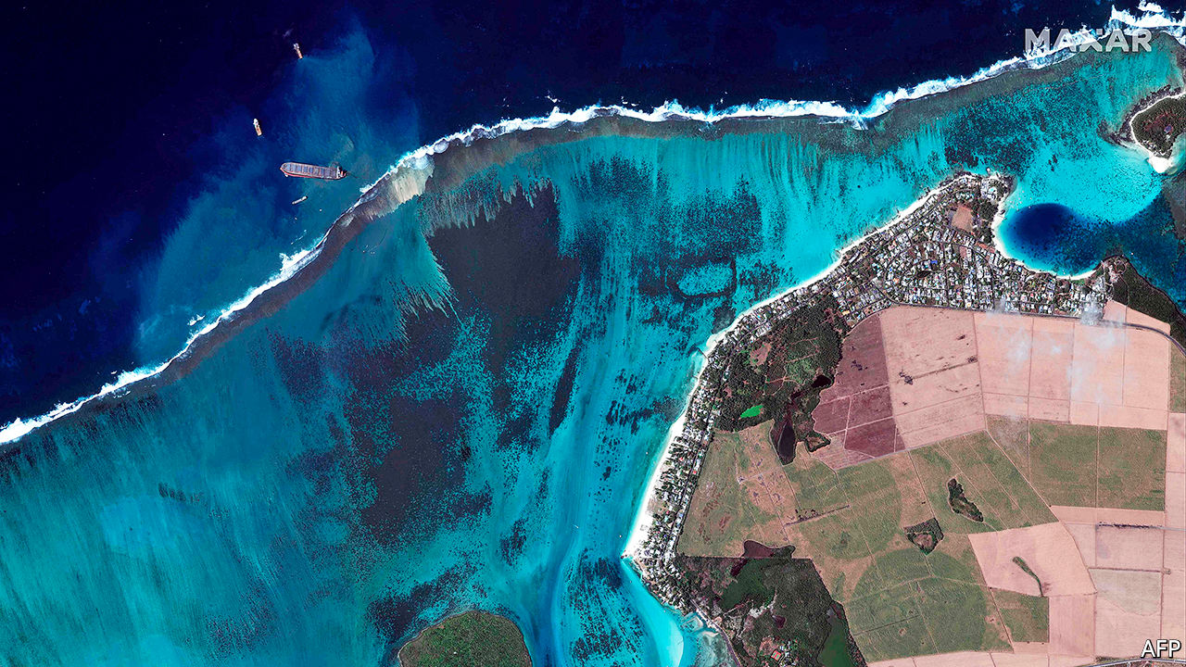

IT SEEMED as if the worst of 2020 was over for Mauritius. The island state has done a better job than most other African countries in quelling covid-19. It was planning to restart the tourism industry that accounts for 9% of GDP and employs nearly a fifth of the workforce. Then on July 25th MV Wakashio, a Japanese-owned merchant ship, ran aground on a coral reef off the south-east coast. It leaked more than 1,000 tonnes of fuel oil before breaking apart on August 16th. This is far from the largest oil spill in southern African history; in 1991 a tanker released 260,000 tonnes off Angola. But rarely has a spill occurred so close to protected marine ecosystems. Mauritius, with the help of France and Japan, is scrambling to assess the damage.

For more coverage of climate change, register for The Climate Issue, our fortnightly [newsletter](https://www.economist.com/theclimateissue/), or visit our [climate-change hub](https://www.economist.com/news/2020/04/24/the-economists-coverage-of-climate-change)

This article was downloaded by calibre from <https://www.economist.com/middle-east-and-africa/2020/08/20/an-oil-spill-off-mauritius-threatens-protected-ecosystems>

|  |  |  |  |
| --- | --- | --- | --- |
| Previous | Articles | Sections | Next |

|  |  |  |  |
| --- | --- | --- | --- |
| Previous | Articles | Sections | Next |

#### A coup that was coming

# What next for Mali?

Mutinous soldiers have toppled the president. They may have more trouble dealing with protesters and jihadists

Aug 19th 2020 | JOHANNESBURG

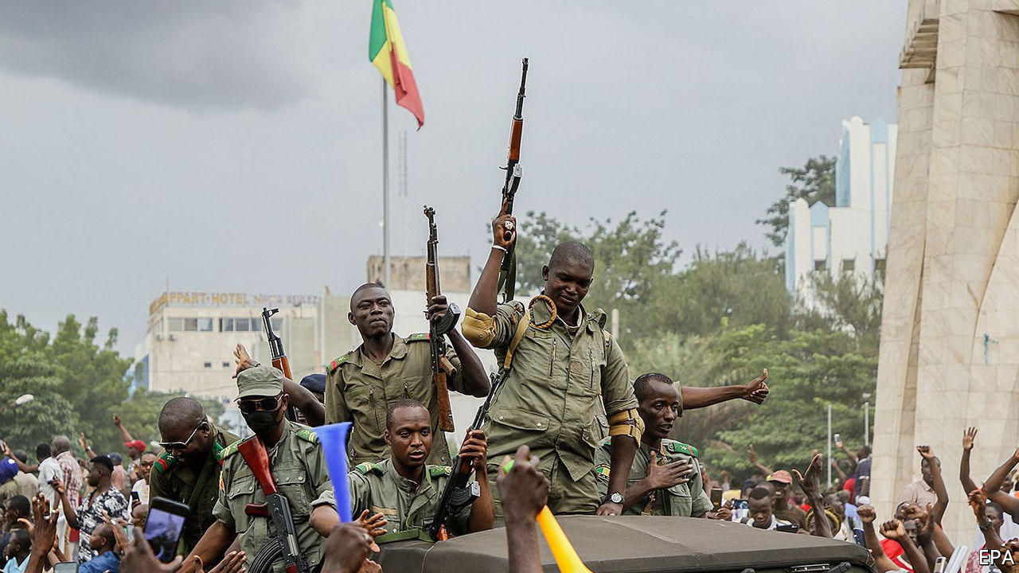

MALIANS ARE no strangers to coups d’état. In 1991 the armed forces stepped in after sustained protests against Moussa Traoré, the dictator who had ruled the west African country since 1968. (Traoré himself had led a coup against his predecessor.) In March 2012 mutinous soldiers angry at the government’s handling of a rebellion in the north ousted the president, Amadou Toumani Touré.

The latest coup, on August 18th, has familiar echoes. It comes after months of protests. Like the events of 2012, it began with a mutiny at a base in Kati, a garrison town 15km (9 miles) outside the capital, Bamako. Soldiers arrested the president, Ibrahim Boubacar Keita, who in a video later that day announced his resignation from behind a face mask. “Do I really have a choice?” he asked. “Because I do not wish blood to be shed.” A day later five members of the new junta announced on television that they want “a civil political transition”.

For all the similarities, the context is different from eight or 29 or 52 years ago. In the aftermath of the coup in 2012 Islamists took advantage of the political vacuum to launch attacks throughout the northern two-thirds of the country, prompting France to send in troops. Following its intervention, France, the African Union (AU) and ECOWAS, the regional bloc, backed a UN mission, called MINUSMA, to keep the peace while elections were held and a new political settlement reached.

Mr Keita won presidential elections in 2013 and 2018. An agreement between the government and northern rebel groups was ostensibly reached in Algiers in 2015, the latest of several such deals since the early 1990s. But, like the others, it has failed to quell the discontent.

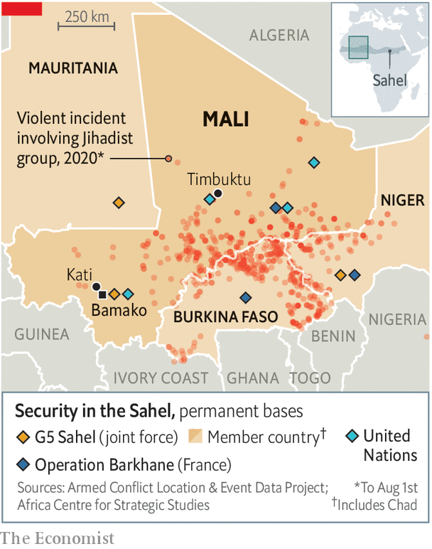

An inept, out-of-touch government led by a southern elite has done little to stop escalating jihadist violence—and even less to deal with its root causes. In the first half of 2020 more than 1,800 people were killed in fights involving jihadists and ethnic militias, almost as many as were killed in 2019 (see map). The presence of Western forces, 15,000 UN peacekeepers and an EU-led training mission has not stopped the bloodshed. Malian efforts to arm local militias have made matters worse.

Anger at the government’s handling of the conflict has risen steadily. Soldiers, as well as their wives and widows, have lambasted the officials in charge of operations. Allegations that those in or close to power are taking advantage of a corrupt war economy have increased. Outsiders have tended to push military solutions to political problems. The folly of that approach has been clear in recent months. After dodgy legislative elections held in March and April, during which time an opposition politician was kidnapped, protesters took to the streets. In July the security forces killed at least 11 people.

It is unclear whether there was any co-ordination between the officers behind the coup and the groups leading the protests. A leader of the opposition M5-RFP movement told the BBC that the coup was a “relief”. The junta says it wants fresh elections. Mahmoud Dicko, an influential imam, could act as a kingmaker.

Outside Mali condemnation of the coup has been swift. Moussa Faki Mahamat, chair of the AU’s secretariat, said he “rejects any attempt at the unconstitutional change of government in Mali”. ECOWAS, which had been trying to cajole Mr Keita into a deal with the protest movement, criticised the “putschists”, closed neighbouring borders with Mali and promised sanctions against the leaders of the coup.

ECOWAS states do not want Malians giving their own people any ideas, especially with presidential elections due later this year in Burkina Faso and Ivory Coast, which have both seen recent protests. (Ghana is also scheduled to go to the polls.) The more coups go unpunished, the more likely they are in future.

Neighbouring countries also share Western concerns about what the coup means for jihadist violence in the Sahel. As the events of 2012 suggest, Islamists are opportunistic and will take advantage of political paralysis. On August 19th France and Niger called an emergency meeting of the UN Security Council.

Condemnation of the coup may not, however, lead to the reinstallation of Mr Keita. If he were to be propped up, he could collapse again. Whatever the approach, it will need to amount to more than deals among incompetent elites. That may be what the jihadists want. But it is not what Malians deserve. ■

This article was downloaded by calibre from <https://www.economist.com/middle-east-and-africa/2020/08/19/what-next-for-mali>

|  |  |  |  |
| --- | --- | --- | --- |
| Previous | Articles | Sections | Next |

|  |  |  |
| --- | --- | --- |
| Middle East & Africa | Sections | Britain |

Europe

The Belarus uprising: The dictator hangs on, for now

.

Italy’s populists: Welcome to normal politics

.

Alexei Navalny in peril: Russia’s opposition leader is in a coma

.

Depopulating the Balkans: Ageing, dying, leaving

.

Charlemagne: Why Europeans love Schengen

.

|  |  |  |
| --- | --- | --- |
| Middle East & Africa | Sections | Britain |

|  |  |  |  |
| --- | --- | --- | --- |
|  | Articles | Sections | Next |

#### Hanging on, for now

# Aleksandr Lukashenko is trying to beat protesters into submission

Belarus’s dictator hopes for Russian support and European indifference

Aug 22nd 2020 | MINSK

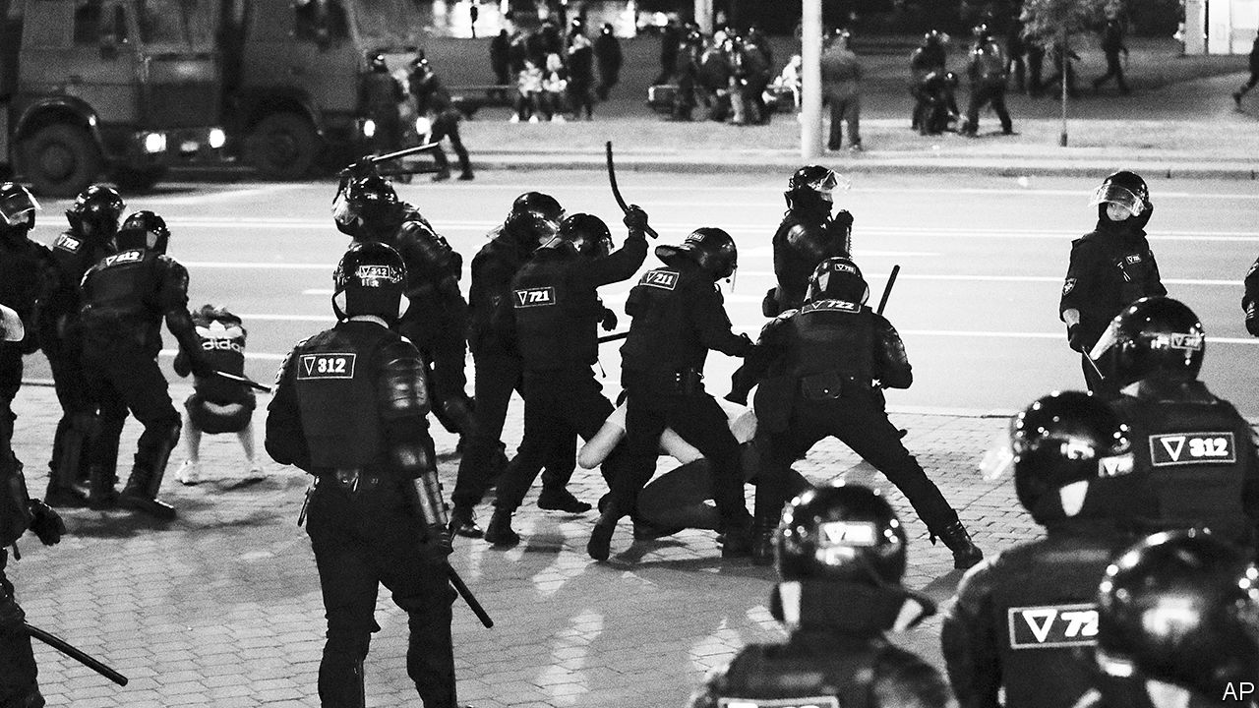

THE MENACING concrete-walled jail on Minsk’s Okrestina Street played a central role in the reign of terror unleashed last week by Alexander Lukashenko, the dictator who has ruled Belarus for the past quarter century, to put down an uprising that has come close to overthrowing him. Prison guards worked overtime on those who dared to protest against Mr Lukashenko’s theft of the presidential election on August 9th. Prisoners were forced to kneel with their hands behind their backs for hours in overcrowded cells. Men and women were stripped, beaten and raped with truncheons. “You wanted change, how’s that for change,” went a widely reported refrain. An admirer of Joseph Stalin, Mr Lukashenko has proved a worthy disciple.

The repression was ostentatious: some victims were paraded on state television. By August 19th, at least four people had been killed. The aim was both to terrorise citizens and to bind the regime’s officers by having them commit atrocities together, a tactic used by dictators and mafiosi to prevent defections. But the violence led to yet bigger protests, forcing Mr Lukashenko to restrain his goons and release most of those who had been unlawfully detained.

On August 17th a crowd of protesters approached the prison, demanding the release of those still inside. They appeared ready to storm the building, but were stopped by a human chain of about 150 activists and priests. “There are snipers on the roof, and they are nervous. The last thing we need are more victims,” shouted one activist, a celebrity bodybuilder named Anatoly Gavrilov. Storming the prison might have broken the protests’ code of non-violence, and given Mr Lukashenko—and his backers in Moscow—an excuse for harsher repression.

So far the protests against Mr Lukashenko have been almost entirely non-violent. Marchers obey traffic signals, remove their shoes before standing on benches, pick up rubbish and go home at an agreed time. Demonstrations have engulfed the entire country, not just Minsk, co-ordinated by activists through a Telegram messenger channel called Nekhta (“someone”).

They have also touched off strikes at state factories whose workers once formed the core of Mr Lukashenko’s support. On August 16th, factory workers joined an estimated 200,000 demonstrators in Minsk, the largest protest in the country’s history. The next day Mr Lukashenko flew by helicopter to the MZKT factory, which makes military vehicles, hoping to shore up his support. Instead, workers began chanting for him to resign. “As long as you don’t kill me, there won’t be any other elections,” Mr Lukashenko snapped back.

Yet there are signs that some strikes are coming unstuck. Sergei Dylevsky, a worker at the Minsk Tractor Factory who this week was elected head of its strike committee, admitted that arrests and threats to sack strikers had undermined resolve. Only 200 men out of 17,000 at the factory were ready to “go to the end”, he said.

The protests’ lack of political organisation has been both a strength and a limitation. Svetlana Tikhanovskaya, the ex-schoolteacher who most likely won the election (running in place of her husband, a jailed vlogger), has been a symbol of the revolution rather than its leader. Forced into exile in Lithuania, she has launched a national co-ordination council including workers and intellectuals to negotiate a peaceful transition of power. Mr Lukashenko ominously promised to “cool the heads” of its members.

Having lost all semblance of legitimacy, Mr Lukashenko is dependent on his security services. Yevgeny Yuskevich, a former prosecutor, says the dictator has invested heavily in them. His officers are “bound together by a sense of mutual responsibility, often criminal, and the ideology of a brotherhood standing alone against the enemy.” Riot policemen have been rewarded with money and medals. There have been no high-profile defections in the army or security services. Mid-level bureaucrats are “ready to switch” given the right signal, Mr Yuskevich says, but the risk would be high.

Their loyalty, and Mr Lukashenko’s fate, ultimately depend on the Kremlin—something both Mr Lukashenko and the West recognise. Belarus’s president used to play Russia and the West against each other. Now he has dropped that gambit. Mr Lukashenko has spoken at least four times to Vladimir Putin in the past week to ensure his backing. He refused to take a call from Angela Merkel, Germany’s chancellor. Mrs Merkel and Emmanuel Macron, the French president, have also spoken to Mr Putin, warning him against a military incursion. Mr Putin has told Western powers not to meddle in his backyard.

Mr Putin has no need to invade. He may even be pleased to watch Mr Lukashenko suffer: last year the Belarusian leader rejected his plan for deeper political integration between their countries. But he cannot afford to let a repressive regime that has rigged elections be overthrown by a popular revolution, lest it give his own people the wrong idea. Seeing the uprising choked off, and the EU recognise his dominance, would be sufficient.

At an emergency video summit on August 19th, EU leaders promised sanctions against Mr Lukashenko’s regime but in effect ruled out mediating in the conflict. “We will be very, very careful to ensure that it is not us telling Belarus what to do,” said Mrs Merkel. Thierry Breton, France’s EU commissioner, went so far as to declare that “Belarus is not Europe.”

Meanwhile, the gates of the Okrestina Street jail remain locked. Nationwide, about 40 people are missing since the protests started. Alexei Kazlyuk, an activist for Human Constanta, a Belarusian human-rights organisation, says that, given the extremes of the documented violence, it would be “surprising” were the number of deaths not to increase. ■

This article was downloaded by calibre from <https://www.economist.com/europe/2020/08/22/aleksandr-lukashenko-is-trying-to-beat-protesters-into-submission>

|  |  |  |  |
| --- | --- | --- | --- |
|  | Articles | Sections | Next |

|  |  |  |  |
| --- | --- | --- | --- |
| Previous | Articles | Sections | Next |

#### Welcome to politics

# Italy’s populist Five Star Movement is becoming a more normal party

Meanwhile, the far-right populists of the Northern League are losing popularity

Aug 22nd 2020 | ROME

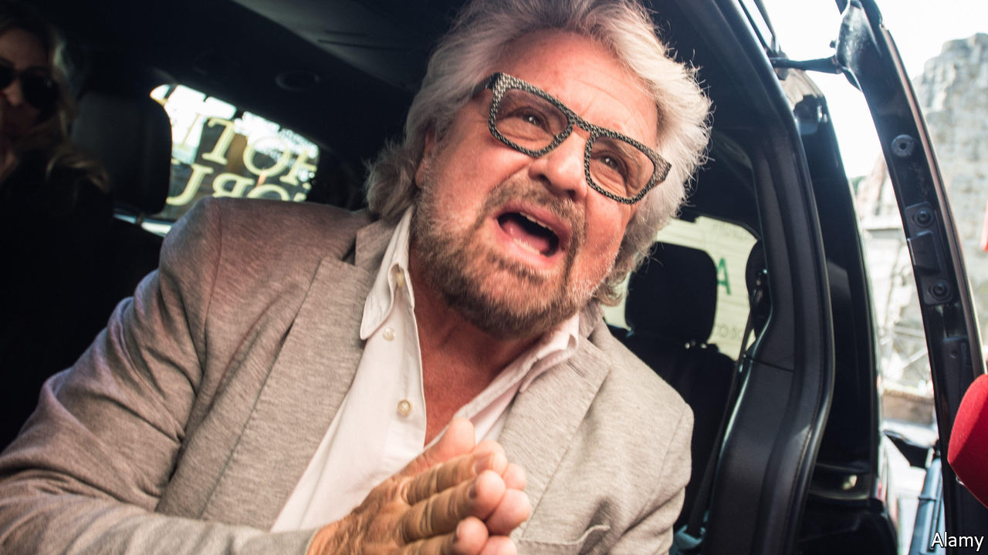

SOME SEE Italy’s anti-establishment Five Star Movement (M5S) as a destabilising force which, by refusing to ally itself with mainstream parties, logjammed Italian politics for years. Others see it as an eccentric but original group that genuinely cares about corruption, the environment and using digital technology to give ordinary people a voice in politics. Depending on which view you take, the online referendum of M5S’s members held on August 13th-14th was either a triumph or a disaster, because they ditched two of its core principles.

The M5S voted by four to one to modify a rule that limits members to a total of two terms in all elected offices. Henceforth, serving as a local councillor will not count—a change that will allow Virginia Raggi, the mayor of Rome and previously a city councillor, to run for a second term. The movement also voted 60% to 40% to drop its opposition to formal alliances with traditional parties, at least locally. That means M5S can link up with its government coalition partner, the centre-left Democratic Party (PD), at municipal elections on September 20th-21st. The poll represents a step back from populism in a country that has been pioneering it ever since Silvio Berlusconi, a media tycoon, came to power in the 1990s.

The two-term limit was central to Five Stars’ contention that ordinary people make better politicians than the allegedly corrupt professionals. But dropping the taboo on alliances may have more effect. It is seen as a step towards a long-term partnership with the PD, which emerged out of parties including the former Communists. In the region of Liguria, which also votes next month, the two parties have already agreed on a joint candidate for governor: Ferruccio Sansa, a journalist. “What we aim to do in this campaign is to put flesh on the bones of a coalition that until now has existed largely on paper,” he says.

In some ways the time is ripe. Italy’s other populist movement, the far-right Northern League, is in deep trouble. Its poll ratings have plunged from 37% last summer to below 25%. Many of its followers have switched to backing the Brothers of Italy (FdI) party, led (despite its name) by a woman, Giorgia Meloni. The FdI, which has roots in Italy’s neo-fascist movement, is as conservative as the League, but more conventional and less hostile to the EU.

Ms Meloni is not as fond of social media as the League’s leader, Matteo Salvini, nor of the publicity stunts which have undermined his credibility. (Last year he played the national anthem while DJing bare-chested at a beach club, surrounded by bikini-clad dancers.) Mr Salvini’s non-stop criticism of the government for its handling of covid-19 also seems to have cost him support. Ms Meloni has carped too, but has sounded more responsible.

“She is more subtle than Salvini and knows better how to play the game,” says Sofia Ventura of the University of Bologna. But, she notes, Ms Meloni shares many of the League’s ideas, like hatred of immigration and conspiracy theories about George Soros, a billionaire philanthropist. Between the League and the FdI, “almost 40% of Italians support the radical right.”

Much will depend on how Giuseppe Conte’s coalition government manages the EU recovery money about to wash through Italy. If the PD and the M5S can stay in office until the funds begin flowing next year, they will gain a formidable instrument for patronage. But the financial advantage still rests with their opponents, who have wealthy backers. Mr Sansa discovered this when he tried to hire a comedian for a campaign rally: “He told me he’d already been offered more money by the other side than I have for the entire campaign.” ■

This article was downloaded by calibre from <https://www.economist.com/europe/2020/08/22/italys-populist-five-star-movement-is-becoming-a-more-normal-party>

|  |  |  |  |
| --- | --- | --- | --- |
| Previous | Articles | Sections | Next |

|  |  |  |  |
| --- | --- | --- | --- |
| Previous | Articles | Sections | Next |

#### Alexei Navalny in peril

# Russia’s opposition leader is in a coma, seemingly poisoned

Aug 22nd 2020 |

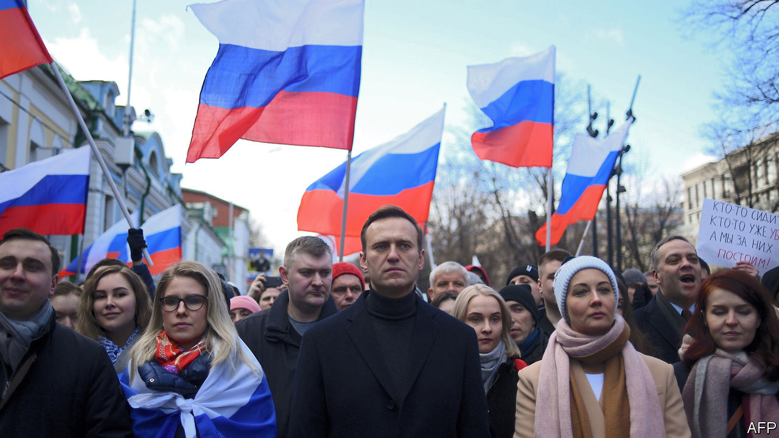

AS The Economist went to press, Alexei Navalny, the Russian opposition leader, was in a coma with symptoms of poisoning. He fell unconscious on a flight from the Siberian city of Tomsk to Moscow after drinking tea at the airport. The plane made an emergency landing in Omsk, where Mr Navalny was put in intensive care. His condition is worse than it was last year, when he appeared to have been poisoned while in custody.

This article was downloaded by calibre from <https://www.economist.com/europe/2020/08/22/russias-opposition-leader-is-in-a-coma-seemingly-poisoned>

|  |  |  |  |
| --- | --- | --- | --- |
| Previous | Articles | Sections | Next |

|  |  |  |  |
| --- | --- | --- | --- |
| Previous | Articles | Sections | Next |

#### Balking at Balkan babies

# The Balkans are getting short of people

The demography of south-eastern Europe threatens its hopes of prosperity

Aug 22nd 2020 | BELGRADE

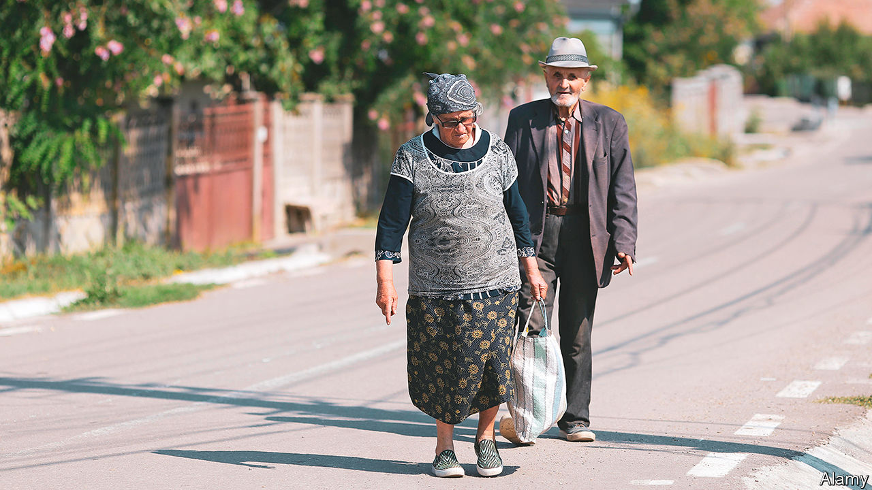

SOUTH EASTERN EUROPE is in a Catch-22. The region’s many problems prompt young, talented people to leave in droves. But it will not catch up with the rest of Europe without young, talented people to generate prosperity. Across the Balkans, populations are shrinking and ageing, and unless that changes even more will leave.

Measuring demography in the Balkans is difficult: apart from those for births and deaths, data are hard to come by. A lorrydriver who leaves Belgrade to take a job in Germany does not have to tell the Serbian authorities. Because of the region’s complicated history, millions of its citizens can get passports from neighbouring “mother countries”. These are especially attractive if the mother country belongs to the EU, since EU citizenship includes the right to work anywhere in the union. A fifth of Croatian passport-holders working abroad are probably from Bosnia, and almost all Moldovans working in the West have Romanian documents. All this makes it hard to tell who is where.

Yet the data that are available paint a clear picture. The population of every Balkan country is shrinking because of emigration and low fertility. In the past, populations grew back after waves of emigration, since many women had six children. Now few have more than one. Serbia may have more pensioners than working-age people by next year.

In the short run governments do not mind emigration because it lowers unemployment and increases remittances from abroad. But in the long run, says Vladimir Nikitovic, a Serbian demographer, it is “catastrophic”. About 50,000 people leave Serbia every year. Of those who return, around 10,000 are pensioners who have spent their working lives in the West. Their children will not follow them back.

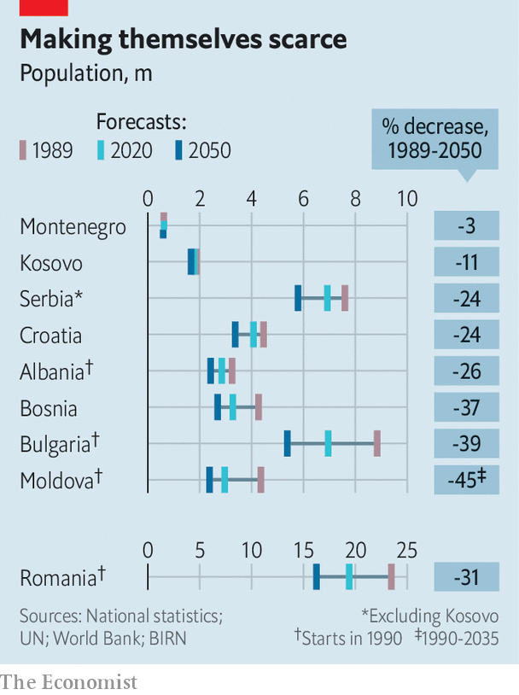

On current projections Bulgaria will have 39% fewer people by 2050 than it did in 1990 (see chart). The region has some of the world’s lowest fertility rates. Bosnian women have an average of 1.3 children and Croatians 1.4. Kosovo, with a median age of 29, has the region’s youngest population, but its fertility rate of 2.0 (just under the replacement rate) has been falling for years too. Elsewhere, rates are similar to those of western European countries. But because the Balkans host hardly any taxpaying immigrants, money for pensioners is scarce.

The effects of population shrinkage are stark. At the height of the summer holidays Rasnov, a pretty town in Romania’s Transylvanian hills which once had a bustling marketplace, is eerily empty, with barely a café open. A generation ago its ethnic Saxon population, which traced its roots to the Middle Ages, left for Germany. Its ethnic Romanians seek work elsewhere. They send money home to ageing parents, but few come back except to retire. Why work in a café in Rasnov when you can do the same for far more money abroad?

A few of the region’s cities have grown. Cluj, another town in Transylvania, is booming. Albania’s capital, Tirana, is also drawing people in. Its mayor, Erion Veliaj, says it faces an influx of 25,000 people every year. But those are exceptions.

This combination of rapid emigration, low fertility and sparse immigration produces the worst imaginable result, says Kresimir Ivanda, a Croatian demographer. Greece, Italy and Spain have low birth rates, but attract lots of immigrants. In Poland, more than 1m Ukrainians have filled gaps in the labour market left by emigration.

Mr Nikitovic worked for a national commission on solving Serbia’s demographic crisis, but the government, he says, did not act on enough of its ideas to make much difference. As in many Balkan countries, the problems are legion. Women are discouraged from having more children by the lack of protection against being fired when they become pregnant. Cheap air travel makes seeking work abroad easy (or did before covid-19 struck). In normal times, Croatian carers in Britain or Romanians in German slaughterhouses can commute to short-term jobs. This worsens labour shortages at home, which in turn pushes up wages. Ivan Vejvoda, of the Institute for Human Sciences in Vienna, thinks meeting western Europe’s needs without draining the Balkan countries of their people requires concerted action by the EU and the states of the region.

Of course, for citizens of Balkan countries, earning higher wages abroad is a boon. Remus Gabriel Anghel, a Romanian demographer, says the migration experiences of the past 15 years have also been a motor of social change. Before, people just wanted to make ends meet; now those who have lived in western Europe demand better schools, hospitals and services. This, Mr Anghel says, is something the government “does not really understand”. ■

This article was downloaded by calibre from <https://www.economist.com/europe/2020/08/22/the-balkans-are-getting-short-of-people>

|  |  |  |  |
| --- | --- | --- | --- |
| Previous | Articles | Sections | Next |

|  |  |  |  |
| --- | --- | --- | --- |
| Previous | Articles | Sections | Next |

#### Charlemagne

# Covid-19 is threatening Europe’s Schengen passport-free zone

The real value of the Schengen zone is not economic but political

Aug 22nd 2020 |

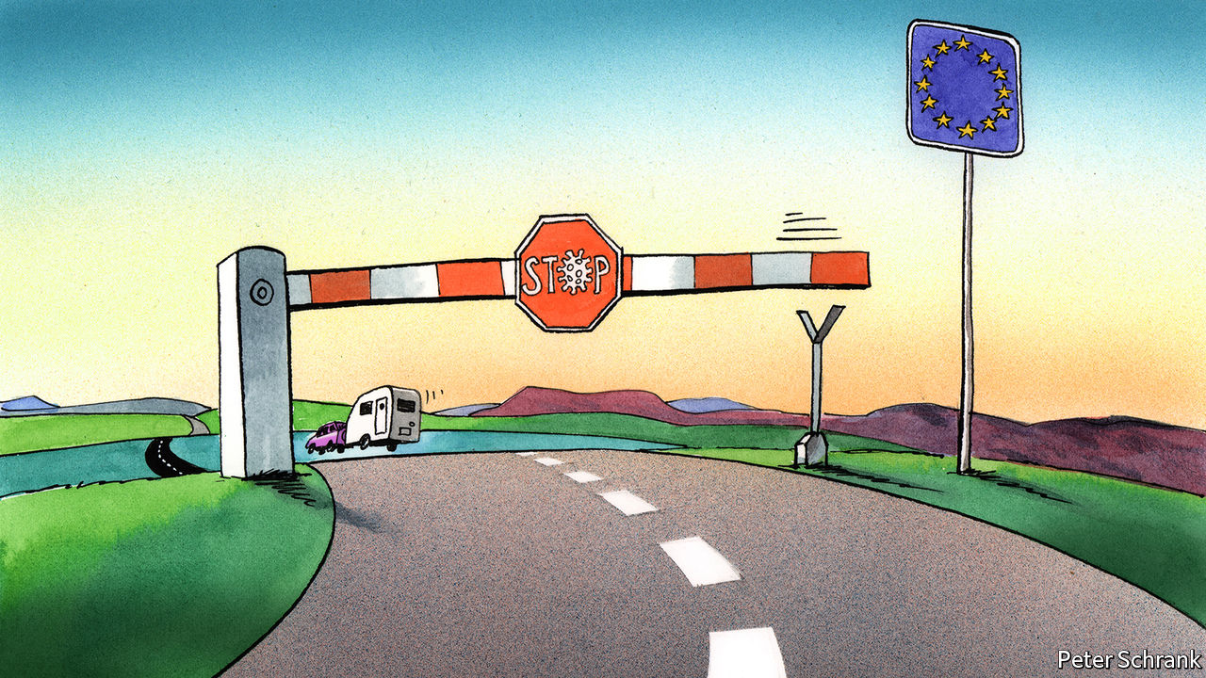

Editor’s note: Some of our covid-19 coverage is free for readers of The Economist Today, our daily [newsletter](https://my.economist.com/user#newsletter). For more stories and our pandemic tracker, see our [hub](https://www.economist.com/news/2020/03/11/the-economists-coverage-of-the-coronavirus)

IN SUMMER MONTHS a common enemy stalks Europe’s motorways: the Dutch caravan. With four times more caravans per head than the European average, the Netherlands’ holidaying families are the nemeses of other vacation-bound drivers. But this year there are fewer of them. Normally 9m Dutch—slightly over half the population—head abroad for a holiday, mostly to southern Europe. Barely half that number said they would bother this time round, as covid-19 scuppered their usual plans. (In an unscientific poll earlier this month, Charlemagne spotted one lonely Dutch caravan during a five-hour drive from the Dordogne to Paris.)

Staying home for the summer is part of a new reality for Europeans used to zipping across borders as they please. In normal times, the EU’s Schengen area extends across 26 countries both inside and outside the EU, allowing people to go from Lisbon to Tallinn without showing a passport. In pandemic times, however, the EU’s cherished passport-free zone is under threat.

The absence of border checks across much of Europe is among the most tangible effects of EU integration. The Schengen agreement was reached 35 years ago between Belgium, France, Germany, Luxembourg and the Netherlands. It now stretches across the continent—or at least it did. As soon as the covid-19 crisis struck, borders slammed shut. Checks are still in force in a handful of countries. Emmanuel Macron, the president of France, put the situation bluntly during a crisis meeting in spring: “The risk we are facing is the death of Schengen.” He was right to worry, but not so much because of the obvious benefits of passport-free travel as because of the zone’s deeper significance.

Schengen may be one of the EU’s greatest achievements, but only a minority of Europeans use it. Just a third of EU citizens take a foreign holiday in a given year, by far the most common reason for travel abroad. Domestic travel feels like an imposition for vitamin D-deprived Dutch, but it is the norm for most Europeans. Indeed, 40% say they never leave their own country at all. Those who cross borders daily make up an even smaller proportion. Only a tiny minority—about 2m out of 440m, clustered in a few places, such as Slovakia and Luxembourg—cross a border to go to work. For most people, Schengen is either rarely used or irrelevant.

For a project often referred to as the “jewel in the crown” by proud EU politicians, Schengen is rather cheap. Economically, the absence of passport checks within the bloc is not worth much. Wonks suggest the reintroduction of border controls within the EU would cost €5bn-18bn ($6bn-21.5bn), a small slice of the union’s €15trn economy. By contrast, the single market is estimated to have added 9% to EU GDP since its inception. Complicated just-in-time supply chains can survive passport checks, as Britain demonstrated when it was within the club but outside the Schengen area. It is Britain’s departure from the EU’s single market and customs union that will provide business with a logistical nightmare.

Perhaps passport-free travel looms large in the minds of Eurocrats because they are the ones who benefit most from it. The EU is about making it easier for people to move, even if most people do not bother. By contrast, in Brussels they generally do: the capital’s well-paid polyglots flit across the continent constantly, for work and pleasure. Borders have always had an outsized significance for the EU’s movers and shakers, going back to its founding fathers. Alcide De Gasperi, Konrad Adenauer and Robert Schuman, the crucial Italian, German and French statesmen during the club’s creation, all hailed from their country’s borderlands, which had meandered with history. But that leads to a distorted picture of everyday life for most Europeans.

Schengen’s actual significance stems not so much from what it offers as from what it requires. It is the obligations of Schengen that are forging the EU into something resembling a state. This is most obvious at the union’s external borders. When covid-19 hit, member states had to come up with a common list of which non-EU citizens were allowed in. There is little point in one country banning, say, Brazilians, if an arrival from Rio de Janeiro can simply fly into a neighbouring country and nip over the border. An absence of internal checks requires stringent checks at the frontier. This lesson was learned painfully during the migration crisis that began in 2015, when 1m refugees streamed in from the Middle East and north Africa. In response, Europe established a standing corps of EU border and coast guards—officers with guns and EU flags determining who can come into a member country. It should be ready by next year. As EU wallahs debate whether the recent move to issue common debt constitutes a “Hamiltonian moment”, it is helpful to recall that the former Treasury secretary founded America’s coast guard, too.

## We’re (not) all going on a summer holiday

Even if few people use it on a day-to-day basis, the symbolic power of passport-free travel is unmatched. Half the countries in the EU have experienced authoritarian regimes within living memory. For citizens threatened by dictatorships, the freedom to move also means the precious freedom to leave. If that right is at the mercy of a man in a uniform at a border post, it feels diluted.

Yet ultimately, Schengen is a symptom. When the EU struggles, so does Schengen. Borders stay open only when countries trust fellow EU members to deal with internal problems, be they terrorism or disease. Other pieces of European integration are not so flexible. (It is easy to install temporary checks on the Italian-French border; it would be impossible to reintroduce the lira temporarily.) The re-emergence of borders within the Schengen area would not be disastrous, but it would be annoying. More important, when EU countries let people cross their borders freely, they are displaying a fundamental confidence in their neighbours. A convoy of Dutch caravans slowly winding their way to southern France would be a sign of a union in fine fettle. Cheer before you honk. ■

This article was downloaded by calibre from <https://www.economist.com/europe/2020/08/22/covid-19-is-threatening-europes-schengen-passport-free-zone>

|  |  |  |  |
| --- | --- | --- | --- |
| Previous | Articles | Sections | Next |

|  |  |  |
| --- | --- | --- |
| Europe | Sections | International |

Britain

Unemployment: It’s coming

.

Gymshark: Primus Insta pares

.

Public Health England: Turning German?

.

Exam marks: U and non-U

.

Race in Northern Ireland: Green or orange, not black

.

Media and society: No news is good news

.

Labour: Left out

.

Bagehot: Rule by algorithm

.

|  |  |  |
| --- | --- | --- |
| Europe | Sections | International |

|  |  |  |  |
| --- | --- | --- | --- |
|  | Articles | Sections | Next |

#### The economy

# Mass unemployment threatens Britain

The country is ill-prepared

Aug 22nd 2020 |

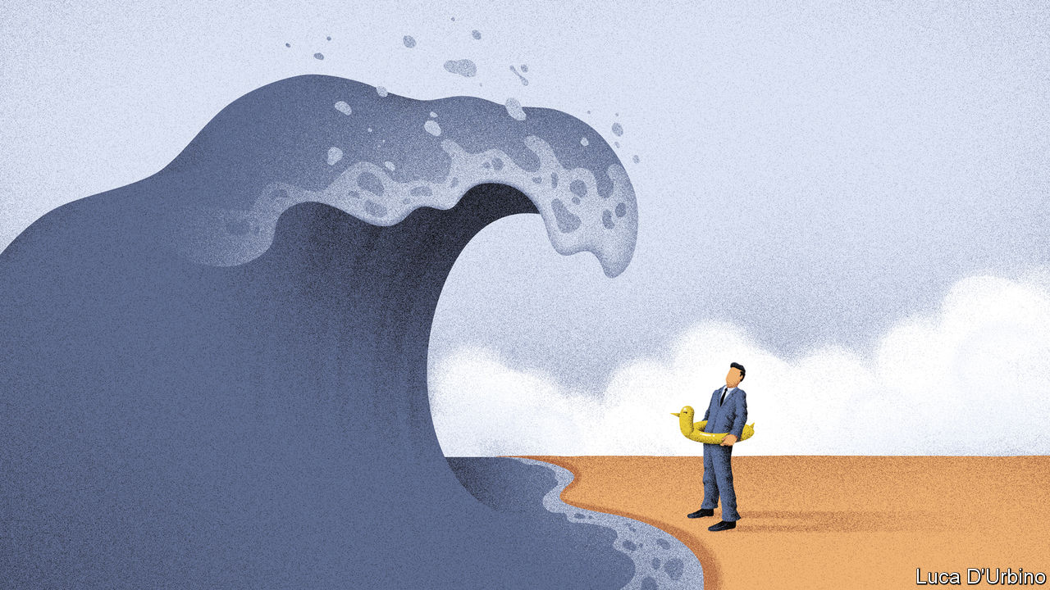

“I’VE HAD members of my association claiming universal credit and they’re shocked by how low it is,” says a Tory MP. It is unusual for Conservative stalwarts to see the benefits system at close quarters: almost three decades of mostly low unemployment have reserved it for the unfortunate few. But as the furlough scheme winds down and the deepest recession for a century hits employment, the system’s weaknesses will gain new political salience.

The official unemployment rate, as of the end of June, was just 3.9%—remarkably low at any time, let alone when GDP had dropped by more than a fifth. America’s June figure was 11.1%. It has stayed low in Britain because of the furlough scheme, under which the government paid 80% of the wages of employees.

Now the sticking plaster is being torn off. The furlough scheme ends in October. This month firms had to start contributing to the cost of furloughed staff. Britain produces its unemployment figures with a two-month lag, so nobody knows what the jobless rate is now; but huge redundancies are being announced. On August 18th, Marks & Spencer announced that it would cut 7,000 jobs. Retail and hospitality are likely to bear the brunt (see chart), but white-collar jobs are going too: Accenture, a consultancy, is cutting 900 jobs—8% of its British workforce—because of a drop in demand for its services. Several law firms, including DWF and BCLP, have recently announced job cuts.

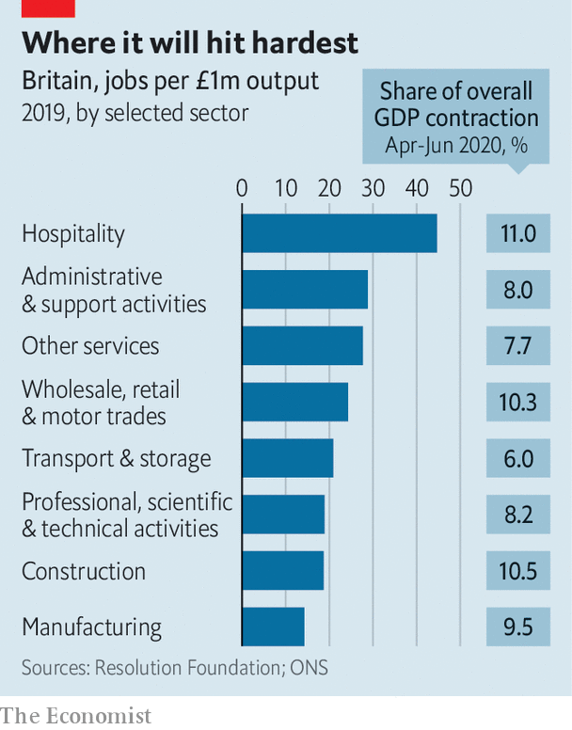

The Bank of England expects unemployment to peak at 7.5%; the Office for Budget Responsibility, the fiscal watchdog, is more pessimistic and has pencilled in a peak of around 12% followed by a relatively rapid fall. Given the scale of the hit to the economy, those numbers are relatively modest. This reflects a belief that, thanks to deregulation in the 1980s and 1990s, the British labour market is flexible.

Recent economic history appears to support this view. In the recession of the early 1980s, a 5% fall in output pushed up the unemployment rate by around seven percentage points; in the early 1990s GDP fell by closer to 2.5% and the unemployment rate rose by almost four percentage points; in the recession of 2008-09, output fell by just over 6% but the unemployment rate rose by just three percentage points. Policymakers are hoping for a similar ratio this time, with the Bank of England expecting GDP to be about 5% lower at the end of 2020 than before the crisis but with only a three and a half percentage-point rise in the unemployment rate.

Not everybody agrees. Paul Gregg, a former Treasury official now at the University of Bath, reckons that the rise in unemployment during a recession is partly the result of the degree of stress on companies, and partly the result of its distribution by sector. In the early 1990s firms had piled on debt and were suffering from the impact of high interest-rates. In 2008-09 low interest-rates and a weak exchange rate helped to sustain profit margins and raised inflation, pushing down real wages. This time round, Brexit-related uncertainty had already squeezed corporate profitability, and now demand—especially in labour-intensive sectors with low productivity and profit margins—has collapsed. Mr Gregg’s framework suggests that any fall in economic output could push up unemployment by more than the drop in GDP and that the bounce-back could take longer than many policymakers expect.

Most European countries are supporting jobs through furlough schemes and part-time work programmes. France has already extended its scheme to two years, and Germany is likely to follow. America opted for higher redundancies while offering generous support to the unemployed.

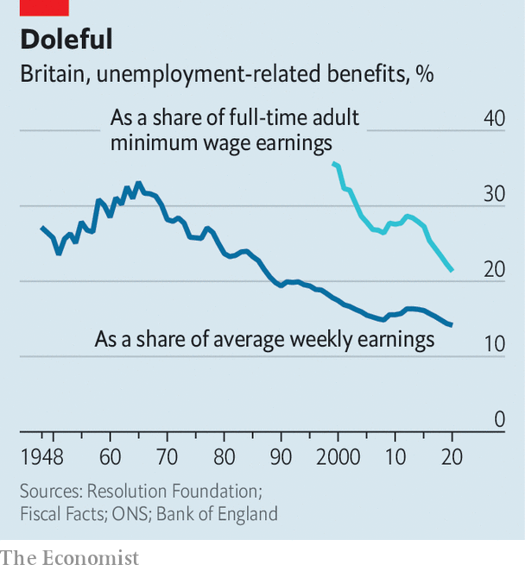

Britain will soon have neither a furlough scheme nor generous unemployment benefits. Universal credit was increased by just £20 a week at the budget in March. The replacement ratio—the percentage of their previous income that British workers receive from benefits—is among the lowest in the OECD, and lower than in the early 1990s (see chart) . A rise in unemployment will thus not only be painful for victims, but also suck spending power from the economy.

Unlike the exam-results system, which has collapsed under the strain of the crisis (see [Bagehot](https://www.economist.com/node/21791017)), the benefits system can probably cope. In April, before the furlough scheme was in place, initial claims leapt from 100,000 or so a week to over half a million. Claimants jammed phone lines and sat in digital queues. Since then the Department for Work and Pensions has redeployed 10,000 staff to processing roles, and reckons it can deal with a second upswing.

But unlike many European countries, Britain has put little effort into actively supporting getting people into work in recent years. The market has looked after itself. These days the government offices that used to help people find jobs, now known as Jobcentre Plus, monitor workers rather than give them a hand. “I spent maybe 80% of my time processing claims and payments and another 15% on stopping the most obvious cases of fraud,” says a long-serving Jobcentre staff member.

Britain’s experience of active labour-market policies has not been encouraging, but the government intends to try some. Rishi Sunak, the chancellor, has allocated £1.6bn ($2.1bn) to supporting work search and hiring job coaches and £2.1bn to a scheme to fund “high-quality jobs” for the young. Details are scarce. The only such scheme that has had much success in recent years was the Future Jobs Fund (FJF) launched in 2009, which provided young people with subsidised jobs and training. Those who took part were more likely to be in work and less likely to claim benefits after they had finished the scheme.

The DWP should be brushing up its knowledge of active labour-market policies. If mass unemployment is on the way, it’s going to need some ideas that work.■

This article was downloaded by calibre from <https://www.economist.com/britain/2020/08/22/mass-unemployment-threatens-britain>

|  |  |  |  |
| --- | --- | --- | --- |
|  | Articles | Sections | Next |

|  |  |  |  |
| --- | --- | --- | --- |
| Previous | Articles | Sections | Next |

#### Clothes, image and Instagram

# How social media made Gymshark

Primus Insta pares

Aug 22nd 2020 |



WHEN RICHARD BRANSON, a serial entrepreneur, was 28, he snapped up a Caribbean island to impress a woman. In London he hobnobbed with rockstars and posed for a photograph in the bath, naked save for a well-positioned copy of the Financial Times. Now the same age, Ben Francis has made more money than the young Mr Branson had. But the Brummie founder of Gymshark, an athletic clothing brand, could hardly be less flamboyant. His black and grey outfit matches his HQ. When he isn’t working, he’s lifting weights, messing around with motorbikes or eating Nando’s. “That’s literally all I do,” he says.“I’m a really boring person.”

But the men share a lucrative knack for capturing the zeitgeist. Mr Francis founded Gymshark from his parents’ garage in 2012, making gym gear his grandmother taught him to sew. On August 14th, General Atlantic, an American fund manager, bought a 21% stake in the firm, in a deal that valued it at more than £1bn ($1.3bn). That transformation makes for a remarkable business story, but it also reveals how quickly gym culture is changing in the rich world.

The brand’s early success owed much to men like Mr Francis. When he first started going to a gym at 16, he found it intimidating. “You have no idea what you’re doing, you think everybody’s looking at you, you feel really self-conscious. Am I doing this bicep curl right?” So he turned to YouTube and online forums for tips. His business milks this merging of physical and online spaces. The 125 influencers Gymshark pays to market its brand on platforms like Instagram are role models as much as fashion models, offering the sort of encouragement Mr Francis once sought. Instagram provides motive as well as means: muscular men in tight-fitting gear attract envy as well as romantic attention.

But Gymshark would not be nearly as valuable if it were not for a second culture shift. That is the trend for “athleisure”, wearing gym gear not just for working out. Though Gymshark initially targeted beefy male weightlifters, women now account for about two-thirds of its sales. And, as Melis Kahya Akar of General Atlantic is quick to point out, they are the bigger spenders. Many women wear Gymshark to lift weights, but plenty favour fit and fashion over performance. Social media allow Gymshark to target distinct demographics simultaneously. A study in 2018 by Linus Juhlin and Miretta Soini, then MBA students in Sweden, explains how it works.

The authors studied the Instagram posts of 30 Gymshark influencers, including such big noises as fitgurlmel, who has 1m followers. Male influencers were more than twice as likely as their female counterparts to pose while working out, but much less likely to stress the fit, colour and design of the gear. “Gym settings were common in the male influencers’ posts,” the authors wrote. In posts by women, poses were more commonly “lifestyle-related”; one wore a sports bra to a basketball game. So Mr Francis can afford to be boring. A tribe of Instagrammers will do the talking—and the selling—for him.■

This article was downloaded by calibre from <https://www.economist.com/britain/2020/08/22/how-social-media-made-gymshark>

|  |  |  |  |
| --- | --- | --- | --- |
| Previous | Articles | Sections | Next |

|  |  |  |  |
| --- | --- | --- | --- |
| Previous | Articles | Sections | Next |

#### Covid-19

# Britain’s government axes Public Health England

A pandemic is not necessarily a great time to scrap the body charged with managing pandemics

Aug 22nd 2020 |

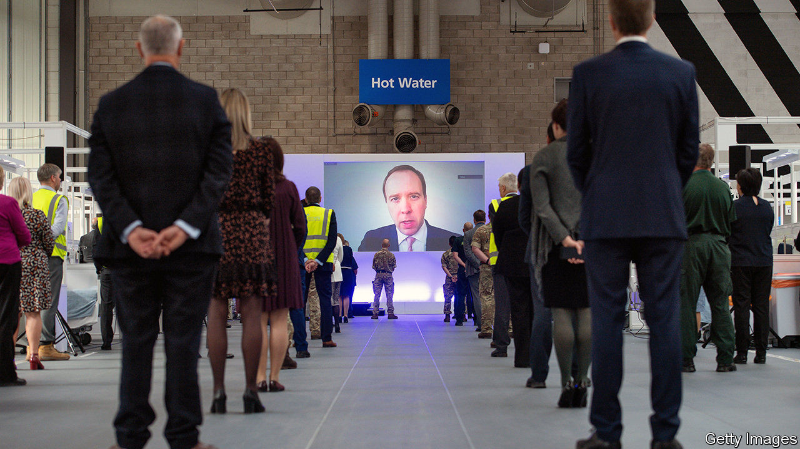

“A STRONG, CAPABLE, co-ordinated, united and efficient public-health agency that rivals any in the world,” was the verdict of a review conducted in 2017 by representatives of some of the world’s top public-health bodies, including the president of Germany’s highly regarded Robert Koch Institute, on Public Health England (PHE). Three years later, PHE is being scrapped. Its responsibility for dealing with external threats such as infectious diseases and biological weapons will be taken over by a new organisation, the National Institute for Health Protection, which will also incorporate the Joint Biosecurity Centre, provider of expert advice on pandemics. How could this happen to an outfit held in such high regard?

PHE was created in 2013 by a merger of 129 organisations, and won those plaudits partly for managing the difficult task of bringing them all together. But the breadth of responsibilities, which included obesity and smoking reduction as well as pandemics and poisoning, cost it something in focus, and its flaws were exacerbated by an instinct to do everything itself. Its failure to outsource testing to private-sector and university labs, which could have helped boost capacity, contributed to a shortage. Its under-resourced contact-tracing system was overwhelmed by early March.

But the government is at least partly responsible for these missteps. Since Britain had plenty of warning of the pandemic, it should have provided the necessary resources for testing, tracking and tracing earlier. By the time it did, the government had lost faith with PHE, and created NHS Test and Trace to do the job, with private-sector outsourcing companies such as Serco and Sitel providing the manpower.

The decision to ditch PHE has received a mixed response. “You probably need a distinct centre for pandemic preparedness,” says Sir John Bell, regius professor of medicine at Oxford University. “We’ve had nine pandemics or close calls in the past 20 years [SARS COV-1 and avian flu twice each, MERS, swine flu, Ebola, Zika and SARS COV-2 once each]. We’ll have another nine in the next 20 years.”

But some in the public-health business argue that PHE has taken the rap for mistakes made by the Department of Health and Social Care and NHS Test and Trace. The failure to provide local authorities promptly with good data, for instance, has made managing local outbreaks unnecessarily difficult. “We have an analyst who does nothing but clean up their data when it finally comes through,” says a local-authority director of public health.

There are also questions about the nature of the change. Britain has been criticised for its centralised approach to the crisis, and Matt Hancock, the health minister, said in announcing the creation of the new agency that Germany was a model for them. But Germany’s public-health system is run by its local authorities, which the Robert Koch Institute supports by providing science and standards. The NIHP will be a large, centralised organisation, replacing the large, centralised organisation that has been axed. “This is the result of a gossamer-thin analysis of the German system, and is being done to save Hancock’s skin. What’s needed is proper local infrastructure,” says a director of public health.

Dido Harding, the organisation’s boss, who has management experience in food retail and telecoms, is not universally regarded as the right choice. “It’s the culture of amateurism,” says a health-system analyst. “The Germans would never appoint somebody like that to this job.”

The timing is also controversial. “The lesson of health reorganisations is that the cost in short-term disruption outweighs any medium- or long-term benefits,” says the analyst. “It’s an incredibly stupid move,” says a health official. “We’re in the middle of a pandemic. I’ve had four meetings in the past few days in which PHE were supposed to participate, and they didn’t turn up.” There are fears that PHE staff may be thinking more about their prospects than about covid-19. “All the people who should be focusing on the next wave will be polishing their CVs,” says the analyst. “This is management 101.”■

Editor’s note: Some of our covid-19 coverage is free for readers of The Economist Today, our daily [newsletter](https://my.economist.com/user#newsletter). For more stories and our pandemic tracker, see our [hub](https://www.economist.com/news/2020/03/11/the-economists-coverage-of-the-coronavirus)

This article was downloaded by calibre from <https://www.economist.com/britain/2020/08/22/britains-government-axes-public-health-england>

|  |  |  |  |
| --- | --- | --- | --- |
| Previous | Articles | Sections | Next |

|  |  |  |  |
| --- | --- | --- | --- |
| Previous | Articles | Sections | Next |

#### Exams

# The A-level results U-turn

A fiasco over grades ends happily for teenagers and universities

Aug 22nd 2020 |



WE ARE ASKED to pity the young, and with reason. They have known little but austerity. Britain is run by a political party that few of them support. Brexit has crimped their freedom to live abroad; covid-19 has shut them in and eradicated the pint-pulling jobs they tend to get. But one cohort, born between late 2001 and late 2002, has just had an amazing break.

In March the government announced that A-level exams (taken at 18) and GCSEs (taken at 16) would be cancelled. Instead teachers would grade and rank pupils based on their past work. Ofqual, which oversees the exam system, would adjust the marks to bring them roughly into line with previous years.

It sounded sensible. And many teachers proved over-generous, as had been feared. They gave A* grades to 13.9% of pupils, compared with 7.7% who got that grade in 2019, and A grades to 23.8%, compared with 17.5% last year. Working-class students did especially well. Ofqual duly stepped in, lowering two-fifths of all grades after weighing students’ GCSE results and their schools’ past performance.

Many pupils felt punished by an algorithm. Some weaker students even ended up with U grades, normally given to utter failures. Others escaped being downgraded because they studied rare subjects, like music, or went to small schools (which are often private) with not enough data on past performance to allow for statistical adjustment. As Sir Jon Coles, chief executive of United Learning, a group of schools, puts it, roughly the right grades were handed out—but not to the right pupils. On August 17th the government caved, announcing that the teachers’ grades would stand.

Against fierce competition, this is the greatest humiliation yet endured by Gavin Williamson, the hapless secretary of state for education. Mr Williamson, who lost his last job after being accused of a leak (which he denies), allowed schools to close in March with no scheme for teaching remotely. His department then botched a plan to get primary children back to school, and failed to distribute enough laptops fast enough to pupils who needed them.

“The stock and credibility of the Department for Education was already quite low,” says David Laws, a former schools minister who is now at the Education Policy Institute, politely. It is now barely detectable. That is a problem. In three weeks’ time schools are supposed to reopen. The teachers’ unions, and many parents, are not convinced this is a good idea. Headteachers would find it easier to cajole everyone into the classroom if they were backed by a competent, respected department.

For universities, though, the fiasco is good news. The better ones expect a shortfall of foreign students, who pay higher tuition fees. Fearing that they would scoop up more Brits to compensate, thus robbing weaker universities, the government had capped their intake. That cap has now been removed. Lower-ranking universities now have an excellent case for demanding bail-outs. The government had been itching for a fight with universities, which it sees as complacent purveyors of often worthless qualifications, and annoyingly left-wing to boot. That will have to wait.

But the biggest winners are 18-year-olds. They have grades far better than they, or the universities that offered them places conditional on their A-level performance, could have expected. A few have even better grades than their teachers awarded: Ofqual adjusted one in 50 grades upwards, and those will stand. This year’s A-level cohort is small—732,000 pupils entered, down from 785,000 in 2017. Many will be able to go to top universities, though some will probably have to wait a year because their courses are full. The losers, if that happens, will be the following cohort, for whom there will be fewer places.

Something like this has happened before. During the turmoil of 1968, France waved many students through the baccalaureat exam. More men born in the late 1940s got degrees and landed professional jobs than in earlier or later cohorts. Even their children did better at school, says Sandra McNally, an economist at the University of Surrey who studied this episode. Degrees are not quite the ticket to middle-class life that they were. Still—to be 18. ■

Editor’s note: Some of our covid-19 coverage is free for readers of The Economist Today, our daily [newsletter](https://my.economist.com/user#newsletter). For more stories and our pandemic tracker, see our [hub](https://www.economist.com/news/2020/03/11/the-economists-coverage-of-the-coronavirus)

This article was downloaded by calibre from <https://www.economist.com/britain/2020/08/22/the-a-level-results-u-turn>

|  |  |  |  |
| --- | --- | --- | --- |
| Previous | Articles | Sections | Next |

|  |  |  |  |
| --- | --- | --- | --- |
| Previous | Articles | Sections | Next |

#### Ethnicity and politics

# Black Lives Matter in Northern Ireland

The province’s own brand of ethnic politics leaves no room for other sorts

Aug 22nd 2020 |

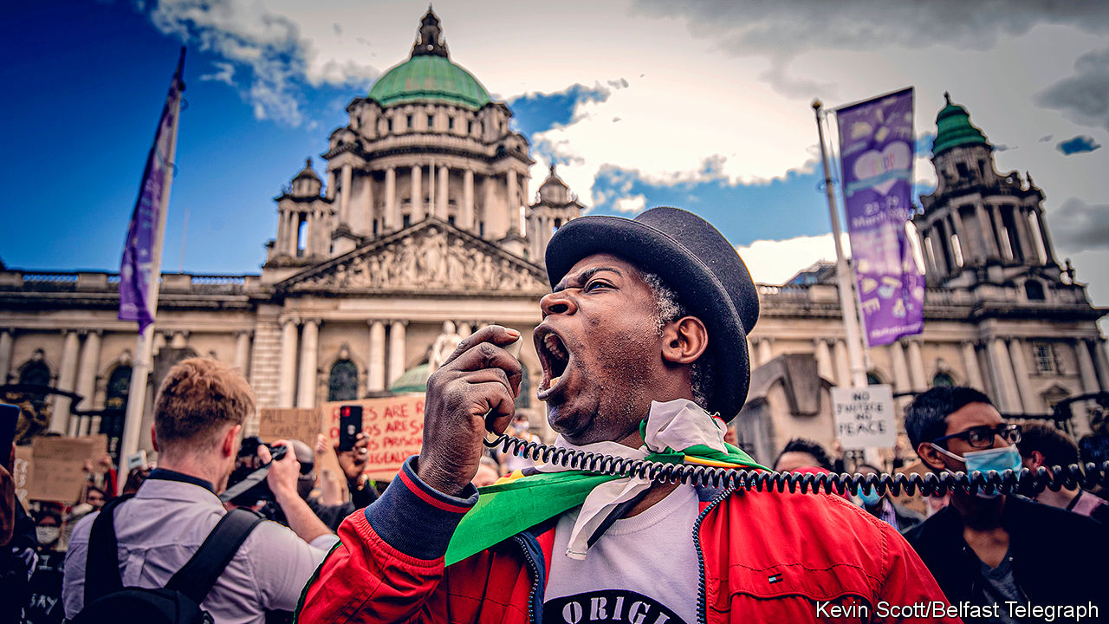

THE SERIOUS CRIME ACT is mostly used against big-time gangsters, but on July 30th Tura Arutura, a musician who has choreographed some exuberant peace events, was interviewed at a police station on the ground that he might have broken that law. He was told he was suspected of “abetting an offence” by addressing a Black Lives Matter protest in Belfast on June 6th.

In theory, the Zimbabwe-born artist could be prosecuted. But he and dozens of others who received fines or summonses because of the BLM rallies are seeking a judicial review of police behaviour, arguing that officers misinterpreted the law and acted too harshly. The police say they will ponder any lessons from the review.

Northern Ireland’s government had told people, on public-health grounds, not to demonstrate and changed the law to curb the event. Those who went retort that the rallies were orderly and distanced. They point to a promise from Boris Johnson that people could join global protests against racism—and to differences in the policing of different communities.

There have been several other hygienically risky gatherings in Northern Ireland this summer, including the huge funeral of an IRA commander and bonfires at which Protestant and Catholic hotheads vented their spleen. At blazes in Derry in mid-August, images of the queen, wreaths commemorating the British war dead and Union flags were incinerated. The Police Service of Northern Ireland (PSNI) did little to restrain those events.

Northern Ireland’s citizens are not in much doubt why the police are selectively lenient. The PSNI answers to a board dominated by Sinn Fein, the Catholic nationalist party, and the pro-British, Protestant Democratic Unionists. That makes the police cautious about confronting either of the main communities, but they seem to act more independently when dealing with smaller segments of society.

The binary division in Northern Irish society is the likely explanation for one of the region’s many political peculiarities: the absence of ethnic-minority representation in its institutions. Black and ethnic-minority citizens form at least 2.2% of the population and possibly twice that, yet no member of an ethnic minority sits in the region’s 90-member assembly. Anna Lo, a Hong Kong-born centrist, retired in 2016, complaining of racism. Municipal councils are similarly all-white. If elected bodies reflected the population, at least a couple of assembly members would be from visible minorities, as would a dozen councillors. That is in contrast with the Irish republic, where an ethnic Chinese woman has just become mayor of Dublin, and the deputy head of government is half-Indian.

Apart from Mr Arutura, many other minority figures make an outsized contribution to Northern Ireland, while steering clear of a political world in which they would feel awkward. Mukesh Sharma, an ethnic Indian who built up a thriving travel business, sponsors big cultural events and plays his homeland’s music. He is a deputy lieutenant of Belfast, a ceremonial but prestigious role.

Angila Chada, another Belfast Indian, has co-founded an NGO called Springboard which helps disadvantaged people of all backgrounds to find work. But running for office has little attraction: “Going into politics would mean deals and compromises which I am unwilling to make,” she explains. One of her north Belfast neighbours, 25-year-old John McGrath, a budding solicitor of Kenyan origin, advises asylum-seekers and is a school governor. He sees little incentive to take the risks that choosing a political side in the city’s ancient feud would carry. “I can just imagine my black face being burned in a bonfire,” he says, only half in jest.■

This article was downloaded by calibre from <https://www.economist.com/britain/2020/08/22/black-lives-matter-in-northern-ireland>

|  |  |  |  |
| --- | --- | --- | --- |
| Previous | Articles | Sections | Next |

|  |  |  |  |
| --- | --- | --- | --- |
| Previous | Articles | Sections | Next |

#### Media and society

# Britons are increasingly avoiding the news

Brexit and the pandemic have taken a toll on the British public

Aug 22nd 2020 |

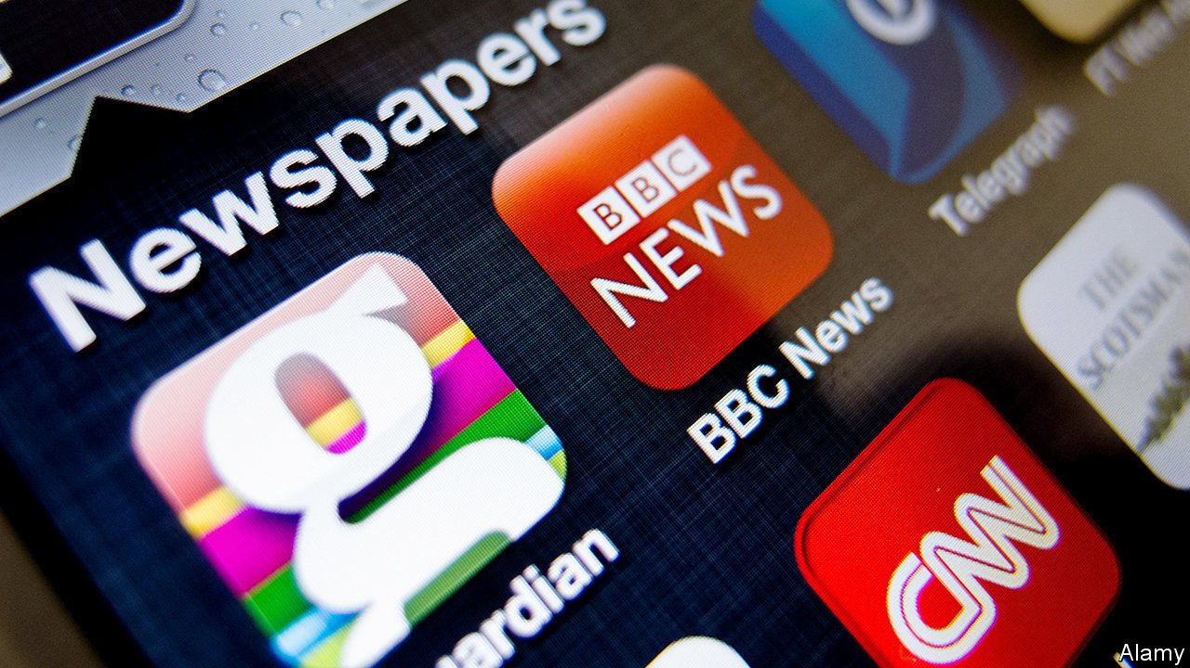

EVERY YEAR Ofcom, the media regulator, conducts research into where Britons get their news. And every year, the answer is roughly the same: mostly from television, decreasingly so from newspapers and more and more from social media. But this year’s “news consumption report” contained a surprise: after years of growth, the number of British adults getting their news from social media declined from 49% to 45%. People’s opinion of social media deteriorated too. Brits consider it the least accurate, trustworthy, impartial or high quality of all sources.

One reason for the decline is the way social-media sites work. Facebook, the most popular, has been demoting news in users’ feeds. Publishers reacted to that by deprioritising Facebook as an outlet to promote their work, notes Alice Pickthall of Enders Analysis, a research firm. Moreover many websites have erected paywalls, reducing the supply of high-quality free content on social networks.

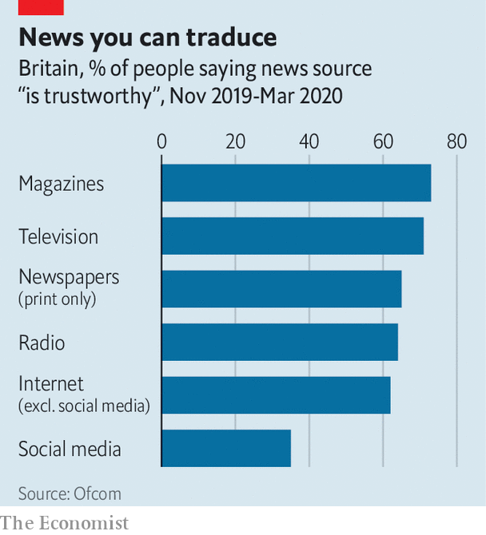

But a more important cause may be that Britons are tiring of the news and actively choosing to avoid it. Research by the Reuters Institute for the Study of Journalism (RISJ) in Oxford found that last year some 35% of Britons said they often or sometimes avoided the news, up from 24% in 2017. The big jump is probably because of polarisation around Brexit, reckons Rasmus Nielsen, RISJ’s director. Benjamin Toff of the University of Minnesota has found that “people who relied on social media as their main source of news were significantly more likely to say they were actively avoiding news”. In Britain women and those on the left are also likelier to avoid news. In research on Britain and Spain, Mr Toff found that one of the main reasons for news avoidance was that “the content was too focused on politics”.

The pandemic has changed the reason, but not the trend. Ofcom’s surveys were conducted mostly before Britain entered lockdown. Subsequent research by the regulator found that the use of social media as a source of news about coronavirus fell from 49% in week one to 29% in week 20. The number of people saying they were trying to avoid news about coronavirus rose from 22% in the first week of lockdown to 35% in the tenth week, at the end of May, before declining to 29% in early August, probably because the virus had stopped dominating the headlines. Research by the RISJ found a similar pattern. The main reason for avoiding news? “It has a bad effect on my mood”.

This article was downloaded by calibre from <https://www.economist.com/britain/2020/08/22/britons-are-increasingly-avoiding-the-news>

|  |  |  |  |
| --- | --- | --- | --- |
| Previous | Articles | Sections | Next |

|  |  |  |  |
| --- | --- | --- | --- |
| Previous | Articles | Sections | Next |

#### Labour Party

# Labour’s left wing is trying a new strategy to gain influence

Deprived of power, leftists are putting their faith in grassroots movements

Aug 22nd 2020 |

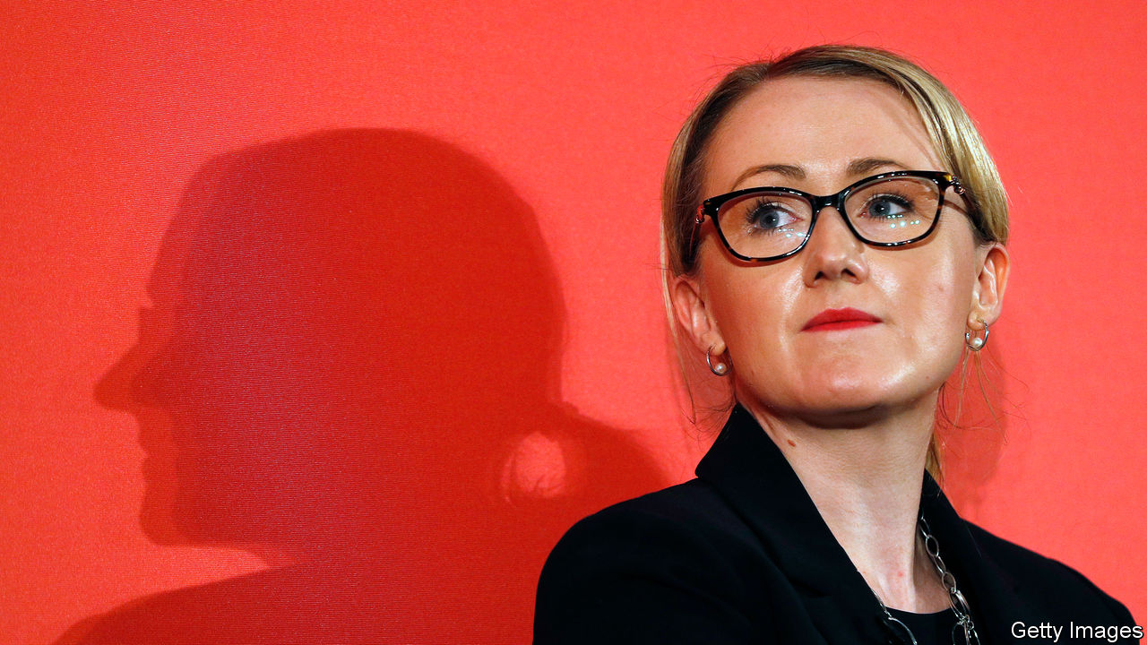

SAUL ALINSKY, whose “Rules for Radicals” inspired community activists in 1970s America, is not normally a name to conjure with in Britain. But his reputation is enjoying a revival among Labour leftists. Deprived of power by Sir Keir Starmer, the party’s new leader, they think Alinsky’s tactics offer a way to regain some clout.

Sir Keir is taking a more centrist line than was generally expected. He has condemned the illegal removal of offensive statues by Black Lives Matter (BLM). He says little about left-wing economics. Claire Ainsley, his policy chief and a former adviser to Onward, a Conservative think-tank, moulds sound-bites designed not to criticise capitalism, but to appeal to a wide range of voters.

The left has a lot of support among party members, but although it is “still numerically strong…institutionally it is quite weak”, says Aaron Bastani, co-founder of Novara Media, a socialist news site. In the parliamentary party, the Socialist Campaign group, with 34 out of Labour’s 202 MPs, is small, but it is noisy and angry. “They are people who are bitter,” says a left-wing MP who has thrown in their lot with the leader, “who think that people like me will never be quite pure enough.” Sir Keir has strengthened his position within the parliamentary party by sacking his former rival, Rebecca Long-Bailey, thus depriving the left of a credible commander. He has given jobs to some left-wingers, and keeps them on a tight leash. “They can’t cough on a policy subject without approval from Keir’s office,” says a Corbyn-era advisor.

Momentum, a 40,000-strong group of activists that acted as a praetorian guard to the Corbyn leadership, has lost its raison d’être. The unions are still powerful, and Len McCluskey, general secretary of Unite, warned earlier this month that Labour shouldn’t take its donations for granted. But the argument over when children should go back to school has demonstrated that Sir Keir is prepared to stand up to them. The main teachers’ union published conditions it wanted met before going back. Sir Keir subsequently demanded that schools reopen in September, with “no ifs, no buts, no equivocations”. The union has since stayed quiet.

Socialists know they are beat. “I don’t think just ‘stay and fight’ is a particularly appealing slogan for much of the left of the party,” says James Schneider, a Momentum co-founder and Corbyn strategist. “It’s like, ‘stay and fight and, for a while, likely lose’ because the left is not going to be in the ascendancy. So we need to offer more.”

That is why talk has turned to Alinsky. Influential figures on Labour’s left want to relaunch along the lines of the grassroots movement he created in Chicago. Extinction Rebellion and BLM, which have turbocharged movements on climate change and race, provide further inspiration. Leftists want to exert public pressure on Sir Keir through protests, community projects and political education. “This is an ‘in and against the Labour Party approach’, where we occupy the corpse of the previous opportunity and continue to leverage that,” says Joe Guinan, a left-wing thinker.

Leftist bigwigs want Momentum to emulate Alinsky’s tactic of uniting communities against common enemies. Landlords will be one, says Mr Schneider. Sir Keir supports an extension of the current ban on evictions, but Labour activists want rent holidays. Mr Schneider thinks that if the left can mobilise tenants, it could force Sir Keir’s hand. Such methods, goes the argument, will reconnect Labour with working-class communities, while showing them alternatives to the status quo.

Sir Keir’s position looks unassailable. But if these plans work, an amorphous and leaderless network of media-savvy campaigns could start to challenge him. The left might look defeated, but it is working on a new rulebook for radicals. ■

This article was downloaded by calibre from <https://www.economist.com/britain/2020/08/22/labours-left-wing-is-trying-a-new-strategy-to-gain-influence>

|  |  |  |  |
| --- | --- | --- | --- |
| Previous | Articles | Sections | Next |

|  |  |  |  |
| --- | --- | --- | --- |
| Previous | Articles | Sections | Next |

#### Bagehot

# How the British government rules by algorithm

The over-enthusiastic application of scientific management is weakening the public sector

Aug 20th 2020 |

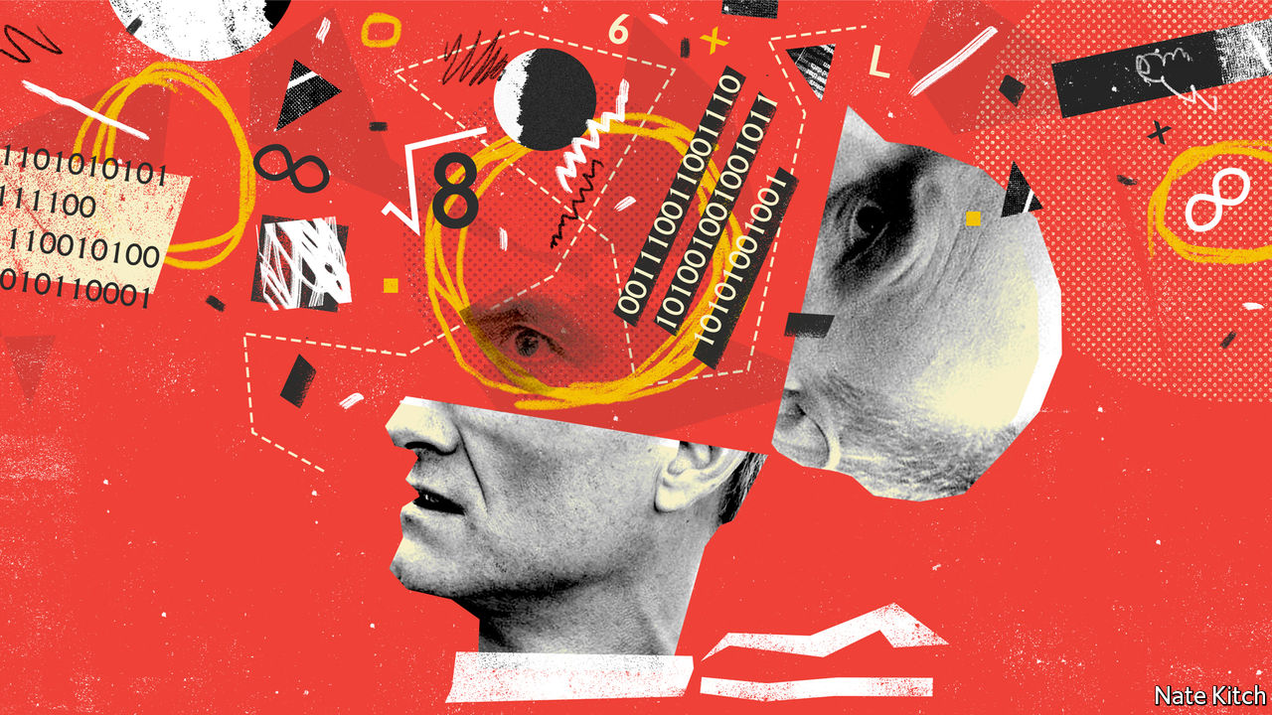

IN ONE OF his travels Gulliver finds himself on the flying island of Laputa. The king, “observing how ill I was clad”, sends a tailor to make him a suit. The tailor “first took my altitude by a quadrant, and then, with a rule and compasses, described the dimensions and outlines of my whole body, all of which he entered upon paper.” Six days later he “brought my clothes very ill made, and quite out of shape, by happening to mistake a figure in the calculation”.

This week much the same happened to the British exam system. An algorithm designed to solve the problem posed by the pandemic, which prevented children from sitting their exams, instead created another of the disasters which have punctuated the government’s crisis-management. Thousands of children got lower grades than they expected and the government was forced to perform a screeching U-turn. The algorithm has now been junked and children are being classified on the basis of teacher assessments.

But the decision to use quadrants, rules and compasses to measure children was not the consequence of the crisis. It is in keeping with the notion of scientific management which pervades Britain’s public sector.

Scientific management rests on four pillars: handing power from front-line workers to general managers; measuring everything you can; setting goals and targets; and linking targets to rewards. The term was invented by Frederick Taylor, an early 20th-century American management guru, who used targets to improve the production of pig iron. But it has deeper roots in Britain. Jeremy Bentham, a philosopher, dreamed of turning government into a utility-maximising machine. Robert Lowe, a Liberal politician, introduced a system for paying schools by results in 1867.

Scientific management retreated in the face of popular fury: Charles Dickens satirised it in the person of Mr Gradgrind, who wanted to “weigh and measure every parcel of human nature”. F.R. Leavis, a literary critic, dubbed it “technologico-Benthamism”. But it returned with a vengeance in the 1980s, driven by a combination of Thatcherism and IT. The defeat of trade unions shifted power to managers. Centralisation encouraged government to favour Whitehall wisdom over local knowledge. The fashion for permanent reorganisation created yet more demand for managers. Tony Blair’s New Labour identified managerialism with modernisation.

There is much to be said for scientific management if it is carefully applied. In schools, standardised tests can reveal whether children are learning. In policing, statistics can be used to focus resources effectively. In development, targets to vaccinate entire populations have been effective.

But badly applied, scientific management can lead to disaster. The A-level mess was a classic. Individuals were judged on the basis not just of their own performance, but also of their institutions’ performance the previous year. The gross unfairness was compounded by the fact that the system favoured private schools.

Targets create three common problems. They produce perverse results when people focus excessively on them. They tempt managers to manipulate numbers. The obsession with measurement diverts people from useful activity to filling in forms.

The department of health provided a fine example of the first when it penalised hospitals whose emergency departments took too long to treat patients after ambulances had dropped them off. Hospitals responded by keeping patients waiting in ambulances rather than in emergency departments. The Metropolitan Police illustrated the second, after it linked pay and promotion to achieving a crime-reduction target. A police whistle-blower told a parliamentary committee that downgrading or underreporting crime had become “an ingrained part of police culture”. The universities to which A-level students are struggling to get admitted provide an example of the third. Tenure and promotion are awarded on the basis of the production of articles (which can be measured) rather than teaching (which can’t), so students suffer.

Mr Johnson’s government should be sensitive to the problem. Brexit was driven in part by a revolt against distant bureaucrats making decisions on the basis of abstract formulae. Tories love to complain about “so-called experts” and “targets gone mad”. One of the party’s favourite philosophers, Michael Oakeshott, put his finger on what is wrong with what he called “rationalism”. Rationalism rests on the idea that the most important form of knowledge is technical knowledge which can be reduced to formulas or recipes. But the most important form of knowledge is often the practical sort which is embedded in the heads of front-line workers.

Rather than preserving what is best in scientific management and mixing it with pragmatism and local knowledge, Mr Johnson is making the problem worse. The government remains fixated on targets: Gavin Williamson, the secretary of state for education, stuck to his algorithm because he was more concerned with preventing grade inflation than working out a fair outcome for students. It also remains besotted with the science of management: the boss of the body that is replacing Public Health England, axed for supposed mismanagement of the pandemic, is not a public-health expert but the former boss of a telecoms company.

Given the government’s record, you don’t need a fancy algorithm to predict that there is worse to come. Mr Johnson’s key adviser, Dominic Cummings, often acts as if he comes from Laputa rather than Durham. The Laputans live on a floating rock and spend their time contemplating geometry and counting comets. Mr Cummings fills his blog with admiring references to “cognitive technologies” and predicts a future in which “there will be trillions of self-replicating robots on the asteroid belt”. The Laputans build houses without right angles, wear clothes that don’t fit, and get so lost in “intense speculations” that they have to be periodically brought back to reality by being hit on the head with bladders filled with pebbles. They lack the one thing that is essential to good government: the gift of common sense.■

This article was downloaded by calibre from <https://www.economist.com/britain/2020/08/20/how-the-british-government-rules-by-algorithm>

|  |  |  |  |
| --- | --- | --- | --- |
| Previous | Articles | Sections | Next |

|  |  |  |
| --- | --- | --- |
| Britain | Sections | Business |

International

Tension in the eastern Mediterranean: Battling over boundaries

.

|  |  |  |
| --- | --- | --- |
| Britain | Sections | Business |

|  |  |  |  |
| --- | --- | --- | --- |
|  | Articles | Sections | Next |

#### Angst in the Aegean

# A row between Turkey and Greece over gas is raising tension in the eastern Mediterranean

A plethora of countries is entangled in a string of disputes in the area

Aug 22nd 2020 | ATHENS, ISTANBUL AND PARIS

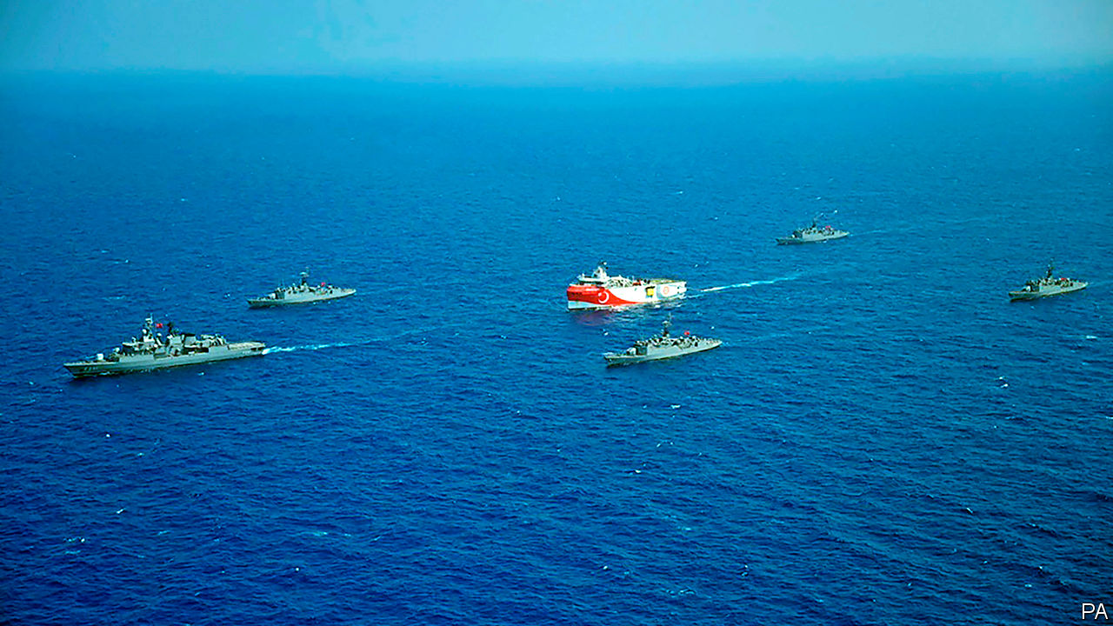

AS NAVAL BATTLES go, it was not a classic. The Kemal Reis, a Turkish frigate named after a 15th-century Ottoman admiral who tormented the Venetian fleet, was one of five escorts sent to protect the Oruc Reis, an exploration ship designed to hunt for undersea oil and gas. The Limnos, an elderly Greek frigate charged with protecting Greece’s Exclusive Economic Zone (EEZ) from such predations, watched warily from a distance. On August 12th they collided after a clumsy manoeuvre.

Both governments tried to keep the incident under wraps, but Greek navy officials soon leaked details to local news websites. “We have fewer and older ships, but we protected Greece’s maritime rights,” boasted one veteran naval officer. Greece’s defence minister is said to have congratulated the captain of the Limnos. “If this goes on, we will retaliate,” thundered Recep Tayyip Erdogan, Turkey’s president. “We shall not leave either the dead or the living of our kin alone.” After a call to Kyriakos Mitsotakis, the Greek prime minister, Emmanuel Macron, France’s president, said that he had decided to “temporarily reinforce” France’s military presence in the region with two fighter jets and a pair of warships in order to “make sure that international law is respected.”

Dust-ups between Greece and Turkey are nothing new. The two countries came to the brink of war in 1996 over disputed Aegean islets, and continue to spar over them. Greece complained that Turkish warplanes ventured into its airspace over 3,000 times in 2017. They also disagree over the status of Cyprus, split into two after a Turkish invasion in 1974. The current dispute, however, is part of a larger tapestry of growing tensions in the eastern Mediterranean over energy, security and ideology. Turkey finds itself pitted against a broad coalition of European and Middle Eastern rivals in battlegrounds stretching from Libya to Syria.

On the face of it, the latest skirmish is all about energy. Ten years ago Israel, the most energy-starved country in the Middle East, announced it had a huge hydrocarbon resource, after all. Tucked beneath 1,645 metres of sea were some 450 billion cubic metres (bcm) of recoverable gas reserves, in a field presciently named Leviathan. Israeli officials dubbed it the best energy news in the country’s history.

The decade since has seen another boom. In 2015 Eni, an Italian oil-and-gas giant, discovered the huge Zohr field off Egypt’s coast. Big gasfields have been found near Cyprus, too, their names borrowed from Ovid or Homer: Glaucus (ExxonMobil and Qatar Petroleum), Aphrodite (Noble Energy, Royal Dutch Shell and Delek Drilling) and Calypso (Eni and Total). Together Egypt, Israel and Cyprus have 2.3tcm of gas, reckons Rystad Energy, a Norwegian research firm, with the potential for a lot more. Optimists claim that such riches may not only enhance the local supply of natural gas, but foster new co-operation in a fractious region and, via an ambitious pipeline, bolster energy security in Europe. Some of these lofty aspirations have been realised. Others remain the stuff of myth.

Many countries in the region are successfully exploiting hydrocarbons without provoking their neighbours. Zohr and Leviathan have become important suppliers of gas to their domestic markets. Egypt has become a hub for foreign investment. Eni’s swift development of Zohr brought other big oil and gas companies to Egypt, lured by geology, favourable regulations and a large, growing domestic market for gas. It helps that Egypt is also home to two large liquefied natural gas (LNG) facilities, which can accept gas by pipeline and turn it into LNG suitable for shipping around the world.

Shared gas interests have also fostered unlikely collaboration. Leviathan’s gas serves not only Israel but Jordan and Egypt. Leviathan’s developers, America’s Noble Energy and Israel’s Delek Drilling, have taken minority stakes in the pipeline that serves Egypt. They plan to export 18.4mcm a day of Israeli gas to Egypt by mid-2022.

Yet ten years after Leviathan’s discovery, the economics of eastern Mediterranean energy are shakier. Oil and gas companies, under pressure from investors, were cutting capital spending even before covid-19 punctured energy demand. The price of gas is almost half what it was in 2010. Chevron in July said it would buy Noble for a bargain $5bn. ExxonMobil, Total and Eni have delayed further drilling off Cyprus, as the firms slash spending and struggle to deploy crews in the pandemic.

## Club Med

The scramble for resources and how best to exploit them is aggravating international tensions. That is partly because of the awkward history and geography of the eastern Mediterranean. Greece argues that each of its scattered islands, however small, is legally entitled to its own continental shelf with sole drilling rights. Turkey, hemmed into the Aegean by a forbidding archipelagic wall of those islands, counters that the eastern ones rest on Turkey’s continental shelf and refuses to accept that they generate economic zones around them. It is one of only 15 countries, including Israel and Syria, that have refused to join the UN Convention on the Law of the Sea, which largely supports Greece’s case.

Turkey, which has been increasingly at odds with its Western allies over a number of issues, from illiberalism at home to migration flows into Europe, is also the only country to recognise the breakaway republic in the northern third of Cyprus and therefore the legitimacy of its waters. It insists that any exploitation of energy resources in the region must take into account Northern Cyprus. To back up these demands, it has sent exploration ships with naval escorts into Cypriot waters and those of Greek islands, most recently around Kastellorizo, close to Turkey’s mainland (see map).

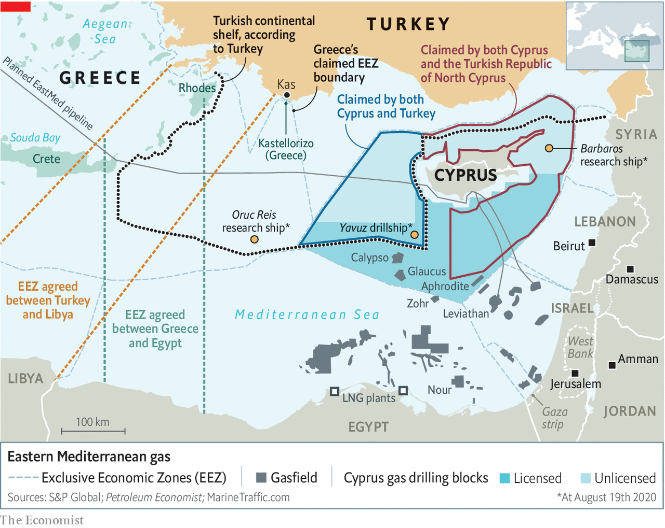

“Let those who come to the region from far away, and their companies, see that nothing can be done in that region without us,” boasted Turkey’s foreign minister last year. In the past couple of years, Mr Erdogan’s government has embraced a revanchist doctrine known as the Blue Homeland, which seeks to give Turkey control over the waters of the eastern Aegean and the northern Mediterranean, disregarding every Greek island from Samothrace to Rhodes.

Turkey has discovered no new Mediterranean gas of its own (though as The Economist went to press, there were reports it may have done so in the Black Sea). But it too aspires to become an energy hub through the Trans-Anatolian pipeline (TANAP), which can deliver up to 16bcm from Azerbaijan to Turkey and Europe each year. Turkey plans to increase the pipeline’s capacity to 61bcm. “The problem is that Azerbaijan does not have enough to fill that,” says Michael Tanchum of the Austrian Institute for European and Security Policy. “Turkmenistan has among the world’s largest volumes of gas, but Russia and Iran keep preventing pipelines from there,” says Mr Tanchum. “So if you’re thinking where Turkey can get gas that Russia can’t interfere with, that’s Iraqi Kurdistan or Israel or the eastern Mediterranean.”

Others in the eastern Mediterranean have snubbed Turkey, however. In January Greece, Cyprus and Israel signed a deal to build a 1,900km undersea pipeline to carry 10bcm of natural gas a year (around a tenth of the EU’s needs) to Europe, bypassing mainland Turkey. The viability of the plan is questionable. The pipeline would travel at extraordinary depth—3km below the surface in one stretch—as well as through areas of seabed prone to earthquakes. Industry analysts reckon its projected cost of $6bn-7bn is optimistic.

To help settle these questions, the region is getting organised—without Turkey. In January Cyprus, Greece, Israel, Italy, Jordan and Palestine established a bloc called the East Mediterranean Gas Forum. France has applied for membership, America for observer status. The forum has taken on an increasingly Turkosceptic tenor as many of its members lock horns with Turkey over a host of issues beyond energy.

“A decade ago the question was whether these gas discoveries would help to overcome political conflicts, or whether they would exacerbate political conflicts”, says Sir Michael Leigh, who served in the European Commission from 2006 to 2011. “It’s pretty clear that it’s more the latter than the former now. The gas issue has fed into other conflicts. And what we’re seeing is very largely a result of the standoff over Libya.”

## The Libyan connection

For years, Libya has been riven by civil war between a UN-recognised government in the west and the forces of Khalifa Haftar, a renegade general, in the east. Turkey supports the government, which works with Islamist militias, whereas France, Egypt, the United Arab Emirates (UAE) and Russia have aided General Haftar, who last year came close to seizing Tripoli, the capital. Though it now claims to be taking a neutral stance, France, which is battling jihadists in Mali, views the general as a useful bulwark against extremist forces. Total, France’s largest energy company, has investments in Libyan oilfields controlled by him. French anti-tank missiles were found at one of the general’s bases last summer, though France denied sending them.

In January Turkey halted General Haftar’s offensive by sending arms, troops and thousands of Syrian mercenaries to beef up the government in Tripoli. That prompted a crisis in June, when a French frigate, operating as part of a NATO mission, was threatened by a trio of Turkish naval vessels while inspecting a ship suspected of breaking the UN arms embargo on Libya.

Mr Erdogan’s intervention in Libya starkly illustrated how energy and security in the region are entangled. His price for halting General Haftar was the Libyan government’s assent to a maritime deal bolstering Turkey’s claims. The accord mapped out Libyan and Turkish continental shelves and EEZs spanning the Mediterranean. They overlapped with those of Cyprus and Greece—ignoring the existence of Crete and Rhodes—and pointedly cut across the path of the proposed pipeline. The deal prompted howls of complaint in Greece. So on August 6th Greece and Egypt, which supports General Haftar and chafes at Turkey’s support for Islamist factions in the Middle East, signed their own maritime accord. That contributed to Mr Erdogan’s decision to send in the Oruc Reis and so to the latest flare-up.

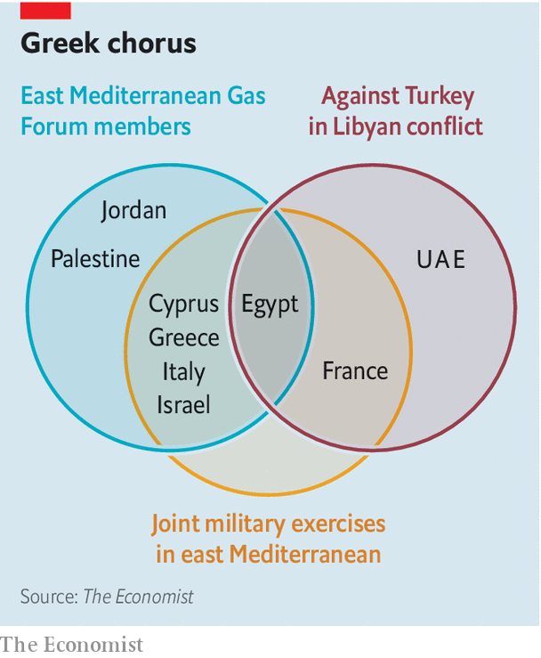

Libya is only one of several Franco-Turkish flashpoints. Last year Mr Macron denounced a Turkish offensive in northern Syria which disrupted American, British and French support for Kurdish fighters battling Islamic State. “This re-emergence of authoritarian powers, essentially Turkey and Russia, which are the two main players in our neighbourhood policy... creates a kind of turmoil,” he declared. France also responded to Turkish incursions into Cypriot waters by expanding its naval presence in Cyprus and conducting joint military exercises in the area with Greece, Cyprus and Italy (see diagram).

## A growing problem

Turkey’s relations with other eastern Mediterranean countries have also soured. A decade ago Israel and Turkey were close military partners, but that ended after Israeli commandos attacked Turkish civilian ships trying to break a blockade of Gaza in 2010. “Greece became very important in providing a substitute, especially in terms of training space,” says Oded Eran, a former Israeli diplomat at the Institute for National Security Studies in Tel Aviv. Yossi Cohen, Israel’s spy chief, is reported to have told his Saudi, Emirati and Egyptian counterparts last year that Turkey posed a greater threat than Iran.

He would have found a sympathetic audience, for Turkey is at loggerheads with both Egypt and the UAE. A kaleidoscope of grievances against Turkey has helped to meld a trio of European states (Greece, Cyprus and France), a pair of Arab ones (Egypt and the UAE) and Israel into a loose but formidable geopolitical front. “Turkey basically has had its back against the wall for the last four or five years,” says Nathalie Tocci of the Italian Institute of International Affairs, who advises Josep Borrell, the EU’s foreign-policy chief. “What Turkey managed to do in the last year is get back into the game through Libya,” she says.

When Greece and Turkey came close to war in 1996, America helped calm the crisis. It remains a big player in the region and has its own gripes about Turkey. After Mr Erdogan bought Russia’s S-400 air-defence system against NATO objections, the Trump administration kicked Turkey out of the programme for buying F-35 warplanes.

In December America lifted an arms embargo on Cyprus, part of a batch of measures it said would boost energy security in Cyprus and Europe; that Cypriot interests align with ExxonMobil’s may have helped. Last month America said it would fund military training for the island for the first time and sent an aircraft-carrier to exercise with Greece off Crete, prompting the Oruc Reis to scurry back to harbour. This week a brand-new American helicopter carrier anchored in Souda Bay, a Greek base on Crete.

Yet American policy is erratic. Its approach to Libya has see-sawed. Donald Trump is unlikely to pay much attention to the intricacies of maritime boundaries as America’s presidential election looms. That makes the EU, which Cyprus joined in 2004, a vital actor. The club lacks America’s armadas. But it has other levers at its disposal. It has already sanctioned Turkey for “unauthorised drilling activities”. Mr Macron is keen to go further.

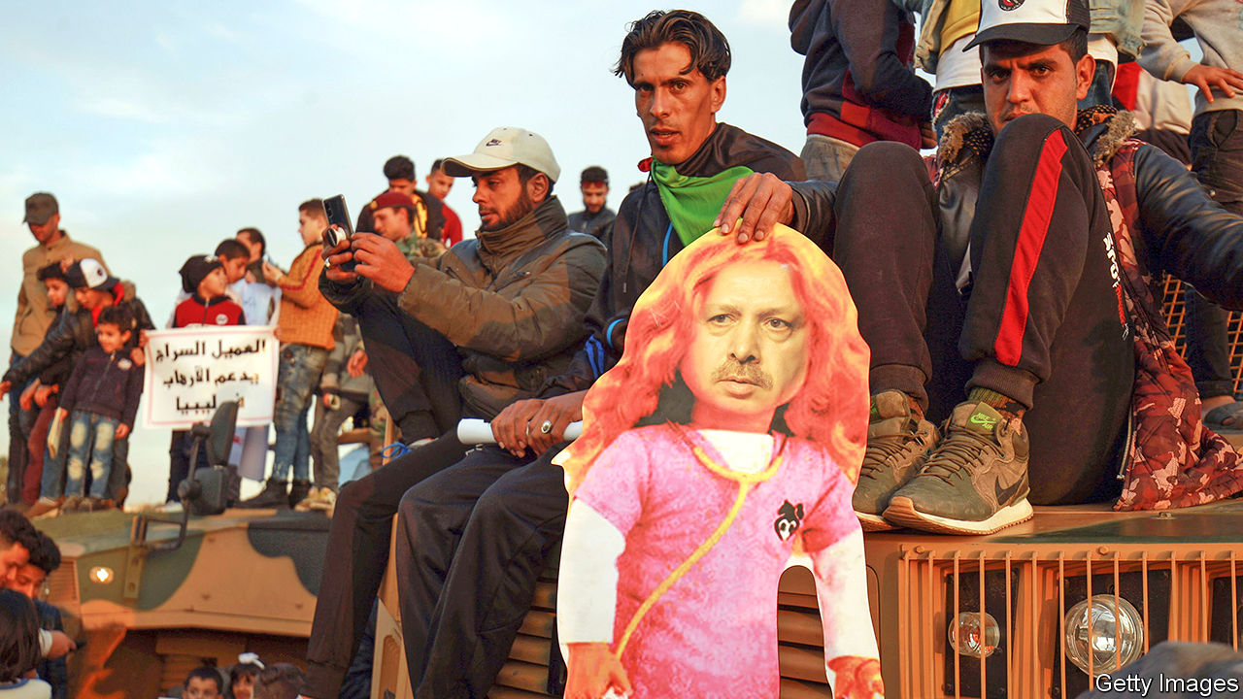

Dr Erdogan makes a house call in Libya

The problem is that the EU, which makes foreign-policy decisions by consensus, is itself divided. Italy and Spain want to smooth things over with Turkey. Germany was irked by Greece’s decision to tweak Turkey’s nose by signing the maritime pact with Egypt just a day before talks between Greece and Turkey—mediated by Germany—were to take place.

Others are irritated by France, particularly its support for General Haftar in Libya. “There is little love for Turkey in Western capitals these days, but the French way of confronting Erdogan is not popular either,” writes Emile Hokayem of the International Institute for Strategic Studies in London.

On August 19th European leaders expressed “full solidarity” with Greece and Cyprus and agreed to discuss the issue further in September, promising that “all options will be on the table”. But Ms Tocci concludes that “ultimately Europeans are not going to do anything significant.” That infuriates France, which believes someone should stand up to Turkey’s challenges to the EU’s maritime borders. “Defence is not a spectator sport,” comments François Heisbourg of the Foundation for Strategic Research, referring to German policy.

Neither Greece nor Turkey can afford these rising tensions in the Mediterranean. Both depend on their coastlines for billions of dollars from tourism. The few foreigners considering a trip to a Turkish or Greek resort later this year may be willing to risk covid-19, but not war. But neither country can back down easily. Mr Mitsotakis, Greece’s centre-right prime minister, is held hostage by a nationalist faction in his New Democracy party with enough MPs to topple his government. Mr Erdogan may be a divisive figure, but his Mediterranean policy wins bipartisan backing at home, notes Sinan Ülgen, a former Turkish diplomat who chairs EDAM, a think-tank in Istanbul. “This is viewed as an attack on Turkey’s national sovereignty.”

On August 16th Turkey’s foreign ministry vowed to press ahead with exploration: “No alliance of malice will manage to prevent this. Those who think otherwise have not taken their lessons from history.” On August 18th another Turkish vessel, the Yavuz, a drillship, headed for Cypriot waters to start four weeks of seismic surveys. A third vessel, the Barbaros, has been in the area since late July. If Turkish ships were to enter Crete’s potentially oil-rich waters, which under the Turkey-Libya accord is assigned to Libya, then “all bets are off,” warns Mr Tanchum. That is unlikely for the moment. But in the past, says Selim Kuneralp, a former Turkish ambassador to the EU, “there was the army and the president who acted as a brake. But now there is no brake and a guy [Mr Erdogan] who’s completely unpredictable.” ■

This article was downloaded by calibre from <https://www.economist.com/international/2020/08/22/a-row-between-turkey-and-greece-over-gas-is-raising-tension-in-the-eastern-mediterranean>

|  |  |  |  |
| --- | --- | --- | --- |
|  | Articles | Sections | Next |

|  |  |  |
| --- | --- | --- |
| International | Sections | Finance & economics |

Business

Technology listings: Partying like it’s 1999

.

Apple’s Epic dust-up: Playing hard ball

.

Electric vehicles: Believe the hypercar

.

Entertainment: A big-sum game

.

Working hours: Weekend plans

.

Sino-American tech war: No more quarter

.

Schumpeter: Supply chained and bound

.

|  |  |  |
| --- | --- | --- |
| International | Sections | Finance & economics |

|  |  |  |  |
| --- | --- | --- | --- |
|  | Articles | Sections | Next |

#### Partying like it’s 1999

# Initial public offerings are back in Silicon Valley

Why technology startups are keen to go public in the middle of a pandemic

Aug 22nd 2020 | SAN FRANCISCO

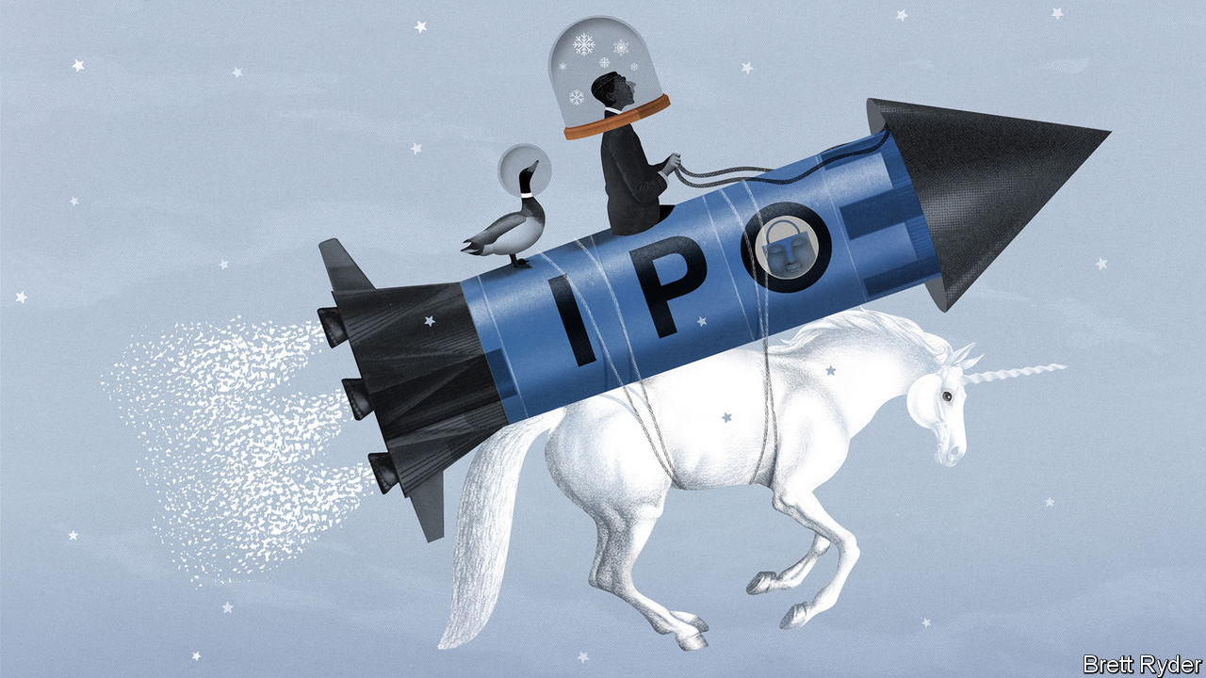

Editor’s note: Some of our covid-19 coverage is free for readers of The Economist Today, our daily [newsletter](https://my.economist.com/user#newsletter). For more stories and our pandemic tracker, see our [hub](https://www.economist.com/news/2020/03/11/the-economists-coverage-of-the-coronavirus)

THE IPO is dead, long live the IPO. When the pandemic hit in March, initial public offerings, particularly those by technology startups, were predicted to be among the early victims. After all, who wants to go public in a once-in-a-century crisis?

Quite a few people, it turns out. In the past couple of months IPOs, which all but dried up until late May, have come back with a vengeance in America. None of Silicon Valley’s recent and upcoming listings rivals that of Ant Group. The payments affiliate of Alibaba, an online giant, wants to raise a record $30bn in China by October, which could value the firm at around $200bn. But America’s technology startups have brought in $10bn so far this year (see chart 1)—and there is more to come. On August 19th Airbnb, which rents homes to travellers, filed for an IPO. Other privately held “unicorns” reportedly ready for public pastures include Snowflake Computing, which makes cloud software; DoorDash, which delivers food; and Instacart, which delivers groceries. Add Palantir, a cryptic data-management firm preparing for a direct sale of existing shares in public markets, and the latest combined valuation of these five is $80bn, according to Pitchbook, a data provider. Even if they float only a portion of their shares, billions-worth of fresh tech stocks will soon trade publicly.

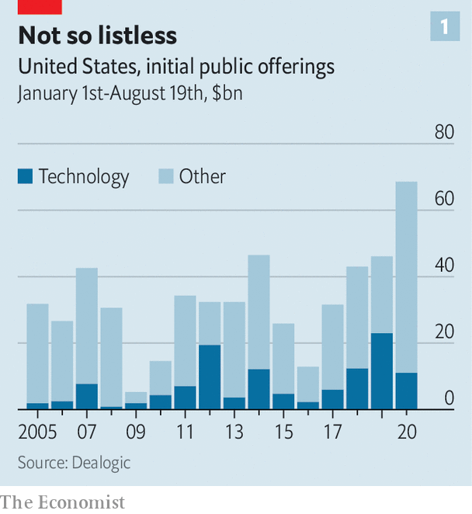

This flurry of activity has not reached dotcom-bubble territory from the turn of the century, when dozens of startups floated each month. But there is a whiff of “irrational exuberance” in the air, detects Lise Buyer, who has watched technology stocks since the heady late 1990s and now helps startups with IPOs at Class V Group, an advisory firm. When Duck Creek, an insurance-tech company, went public on August 14th, it closed nearly 50% higher. BigCommerce, an online-shopping platform which floated a week earlier, saw its shares “pop” by more than 200%.

With the S&P 500 index of big American firms at an all-time high, never mind that covid-19 rages on, investors’ rationality is certainly up for debate (see Buttonwood). But for many startups, the desire to go public is perfectly rational, for two reasons.

The first has to do with the financial markets themselves. Venture capitalists who had been pouring billions into unlisted firms began to cool on frothy startups before the pandemic, after a few unicorn listings disappointed (Lyft and Uber) or collapsed (WeWork). At the same time, rock-bottom interest rates are pushing public capital to seek returns. As a result, stockmarket investors are ready to accept high valuations, says Lauren Cummings of Morgan Stanley, an investment bank and a leading underwriter of IPOs. “There is insatiable demand by public investors,” agrees Brian Feinstein of Bessemer Venture Partners, a venture-capital (VC) firm.

Startups are keen to slake it before it dissipates. Many firms are therefore dusting off listing plans that were put on hold in the wake of the ride-hailing duds and the WeWork snafu. Their case is bolstered because—and this is the second reason for startups’ listing-lust—the pandemic has been a boon for many tech firms.

The five big platforms—Alphabet’s Google, Amazon, Apple, Facebook and Microsoft—have thrived as self-isolating consumers spend more time and money online, and firms splash out on cloud-computing services to enable remote working. On August 19th Apple briefly touched a market capitalisation of $2trn, the first American company to do so. Not-so-big tech, too, has benefited, including many companies that have recently gone public.

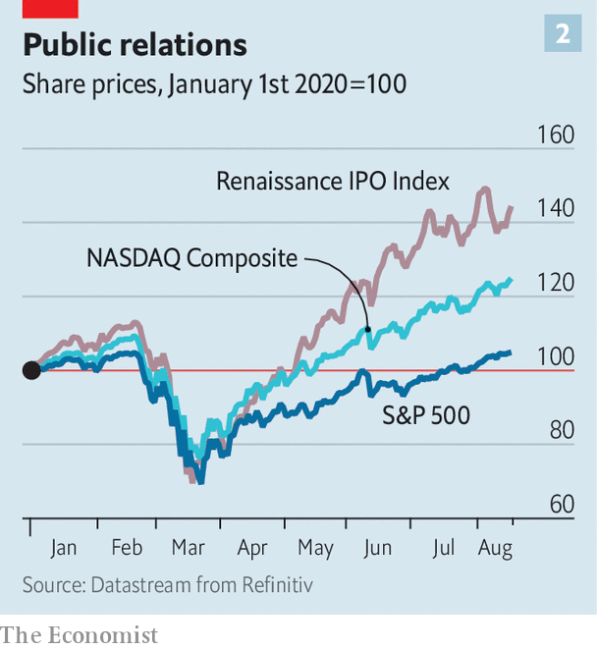

The pandemic has highlighted and sped up a fundamental shift towards digital businesses, says Sarah Cannon of Index Ventures, a VC firm. The trend will last for decades, she predicts. Markets concur. The tech-heavy Renaissance IPO Index, which includes most listers of the past two years, is up by more than 40% since January (see chart 2). Zoom, whose videoconferencing app has become ubiquitous amid lockdowns, has seen its share price rise fourfold since floating in April 2019; it is worth $78bn. CrowdStrike, a cyber-security firm which listed in June last year, has quadrupled in value since March.

One thing the latest boom has done is highlight how unhappy startups and VC firms have grown with the current process of going public. It is cumbersome, with reams of paperwork, and can take more than a year. It is also pricey—and seen as too cosy for Wall Street. Investment banks’ fees alone eat up between 4% and 7% of a typical IPO’s proceeds, not counting lawyers and other advisers. Startups and VC firms point to big first-day pops as evidence that offerings are underpriced to give banks’ big investors a quick return. After all, those customers are regulars that must be kept sweet, whereas most startups only go public once.

Disaffection with the IPO process, combined with a renewed desire to go public, has led some firms to consider alternatives. One is a “direct listing” of the sort Palantir is pursuing, and which Spotify, a music-streaming service, and Slack, a corporate-messaging firm, have used to good effect. Asana, which sells web-based project-management software, may be another unicorn to take the direct route. Direct listings use an electronic auction by the stock exchange to get startups a fairer price for their shares than investment bankers might. But they do not allow firms to raise new money. As a result, they are an option only for cash-rich firms.

Another route that has gained prominence is the special-purpose acquisition company. These SPACs, as they are known for short, are shell firms that go public promising to buy one or more private businesses with the proceeds from the listing. The private business then fills up the listed shell through a reverse merger. SPACs have a dodgy history; many have underperformed the broader stockmarket. But the latest lot promise to fix the flaws while preserving the benefits, which include direct negotiations over the purchase price that can make deals faster and more predictable. From January to early August 60 SPACs went public, raising $22.5bn. In July Bill Ackman, a hedge-fund boss, launched a $5bn-7bn vehicle, the biggest so far.

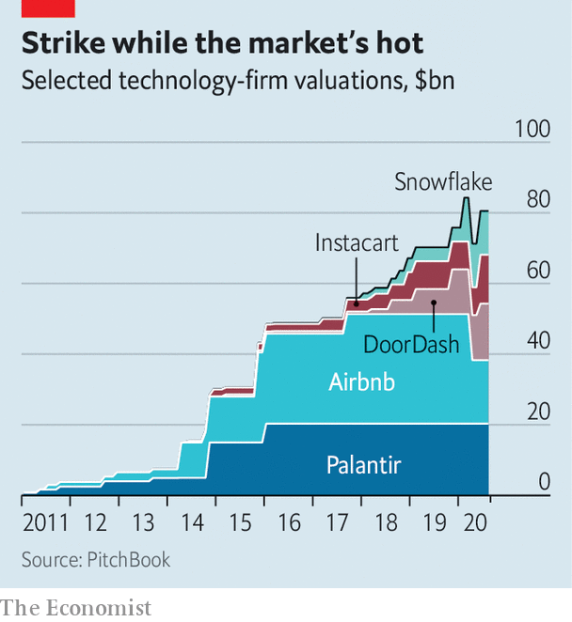

It is unclear if Silicon Valley will embrace SPACs wholeheartedly. The biggest tech firm to have used one is Nikola, a secretive zero-emission-lorry startup which now boasts a market capitalisation of about $16bn. Many entrepreneurs and their backers would resist letting their firms be sucked up into a shell. But SPACs have a place in tech world. On August 18th Kevin Hartz, an early investor in Airbnb and Uber, launched one. Ribbit Capital, a VC firm, is reportedly planning another.

The IPO-industrial complex is not averse to direct listings or SPACs, even if they are less lucrative than the old-school ways. Bankers predict a diverse future of increasingly tailor-made flotations that, say, target specific investors and predetermine how long staff must hold on to their shares. As Greg Chamberlain of JPMorgan Chase, a bank, sums up, “Not all technology companies are the same. They have different objectives.” So long as startups want to cash in, as all ultimately do, they will need Wall Street to shepherd them through.■

This article was downloaded by calibre from <https://www.economist.com/business/2020/08/22/initial-public-offerings-are-back-in-silicon-valley>

|  |  |  |  |
| --- | --- | --- | --- |
|  | Articles | Sections | Next |

|  |  |  |  |
| --- | --- | --- | --- |
| Previous | Articles | Sections | Next |

#### Power play

# Epic Games takes on Apple

The iPhone-maker is provoked into booting “Fortnite” from its App Store. There will be blood

Aug 22nd 2020 |

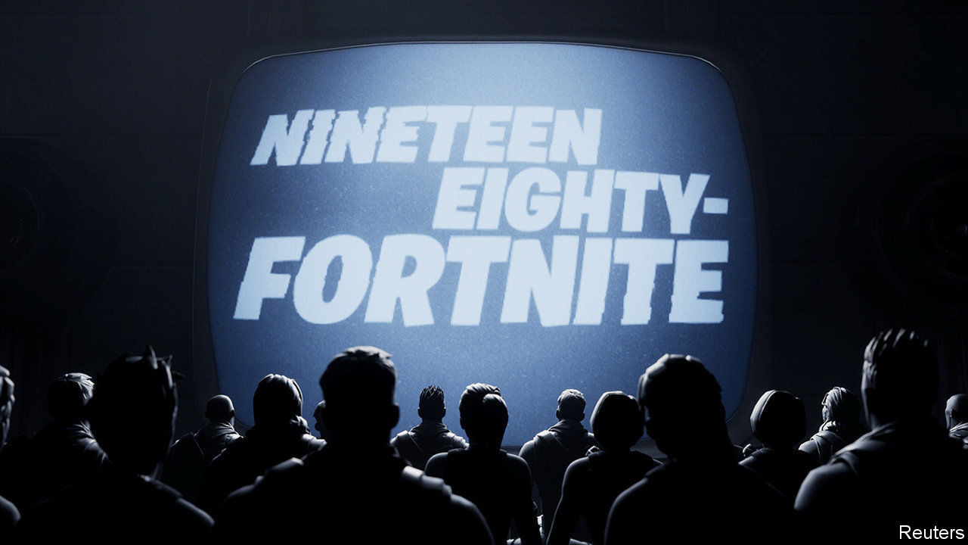

IT WAS A surgical operation worthy of the best “Fortnite” players. On August 13th Epic Games goaded Apple into booting its hit game from the App Store. Within an hour of Apple’s decision, Epic launched an antitrust lawsuit against the tech giant. Epic’s slick parody of Apple’s famous “1984” advert now cast its enemy as the oppressive, grey Big Brother.

Epic’s provocation was to offer users alternative payment methods for in-game goodies. Those who bought 1,000 V-Bucks, the game’s internal currency, via the App Store would cough up $9.99. Buy directly from Epic, which would thus avoid the 30% cut that Apple takes from every in-app transaction, and you pay $7.99. This dodge violates the App Store’s rules, hence the expulsion. The same day “Fortnite” was removed from Google’s Play Store, which serves users of Android phones, for the same reason.

At issue is the tight grip Apple exerts over its devices. The firm tries to ensure that the App Store is the only way for iPhone users to obtain software. This, Apple says, keeps apps kosher and secure. Critics allege that it stifles competition and allows Apple to hold app-sellers over a barrel. Unlike owners of Apple phones, Android users can buy software, including “Fortnite”, from various vendors, limiting Google’s power; in 2018 Epic launched its own web-based store for PC games, where it takes a 12% cut from developers.

App developers and companies from Airbnb to Match Group have had run-ins with Apple similar to Epic’s. Complaints from Spotify, a music-streaming service, and Kobo, which makes an e-book reader, have led to an EU antitrust probe. Shortly after Epic launched its lawsuit, Spotify and Match voiced their support for it. Epic claimed that a ban on “Fortnite” would threaten dozens of other iPhone games that have licensed its code.

On August 17th Apple said the App Store would welcome “Fortnite” back if Epic shelved its payments ploy. Tim Sweeney, Epic’s feisty boss, is unlikely to give up that easily.

This article was downloaded by calibre from <https://www.economist.com/business/2020/08/22/epic-games-takes-on-apple>

|  |  |  |  |
| --- | --- | --- | --- |
| Previous | Articles | Sections | Next |

|  |  |  |  |
| --- | --- | --- | --- |
| Previous | Articles | Sections | Next |

#### Believe the hypercar

# Rimac is making a big name for itself in battery-powered transport

The small Croatian firm’s low volumes belie its ambitions

Aug 19th 2020 |

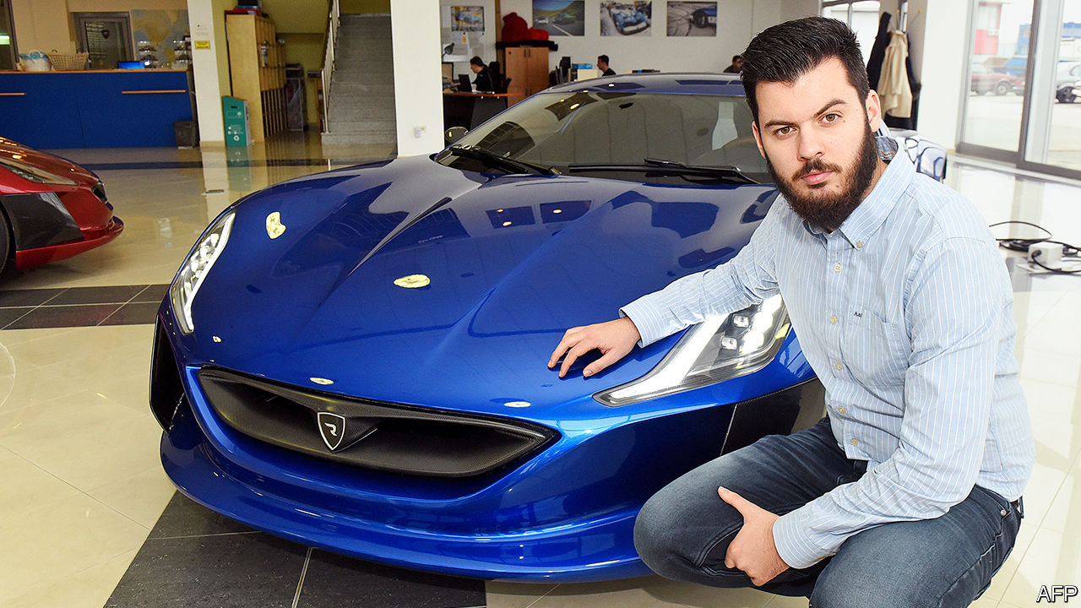

THE BUSHY beard sported by Mate Rimac, the 32-year-old founder of a Croatian electric-car-technology firm named after him, long predates lockdown affectation. He is said to have grown it to conceal youthful features that might put off potential customers and partners among the world’s big carmakers, who could be wary of a company from a country with no track record to speak of in technology or making cars. (The infamous Soviet-era Yugo was built in what is now Serbia.)

Whether or not the facial hair helped, the limited run of 150 C Two electric hypercars, Rimac’s second model, sold out almost as soon as it was unveiled in 2018, despite an eye-watering price-tag of over €2m ($2.4m). Pandemic-related delays have forced buyers to wait until 2021 for their neck-snappingly brisk machines. Once they do hit the road, they will showcase technology that has attracted the attention of—and investments from—not just luxury marques like Porsche (which owns 15.5% of Rimac), but also mass-market ones such as Kia and Hyundai.

Rimac’s roster of clients is said to include almost all of Europe’s big carmakers, though most are quieter about their involvement than the soft whirr of an electric motor. Those that have made public pronouncements include Aston Martin, a posh (if struggling) British brand, and Koenigsegg, a more niche Swedish one, both of which Rimac is supplying with lightweight battery systems for hybrid hypercars, and Pininfarina, a new maker of fancy electric cars from Italy. Rimac is also collaborating with bigger carmakers such as Renault of France and SEAT (part of Germany’s Volkswagen Group).

Indeed, for all the hypercar hype, Rimac’s main business in years to come will be supplying electric-vehicle technology. Constructing battery packs, cooling systems and management software to give the right combination of power for speed and energy for range is as applicable to runarounds as it is to absurdly fast cars.

The firm has plenty of advantages. It is small—with only 700 employees—and nimble, unlike bigger suppliers that require, in Mr Rimac’s words, “five non-disclosure agreements and six meetings…and months to get anything started”. Big car firms, which have jealously kept the know-how to build internal-combustion engines close to their chests, can now eke out only tiny, incremental improvements in efficiency. Since electric-vehicle tech is in its infancy, opportunities abound for efficiency leaps by clever interlopers like Rimac.

Mr Rimac seems well on the way to realising his dual aim of becoming the best maker of electric hypercars and helping the rest of the industry go electric. But he also has an eye on longer-term trends that will see mobility services become more important as private car-ownership declines. His firm will be “part of the transition”, he says. How? He won’t say for now; another use for a beard is to stroke it enigmatically.■

This article was downloaded by calibre from <https://www.economist.com/business/2020/08/19/rimac-is-making-a-big-name-for-itself-in-battery-powered-transport>

|  |  |  |  |
| --- | --- | --- | --- |
| Previous | Articles | Sections | Next |

|  |  |  |  |
| --- | --- | --- | --- |
| Previous | Articles | Sections | Next |

#### A big-sum game

# Tencent Video battles iQiyi in China’s streaming wars

But the two big Chinese streaming platform may onc day settle into a cosy duopoly

Aug 22nd 2020 |

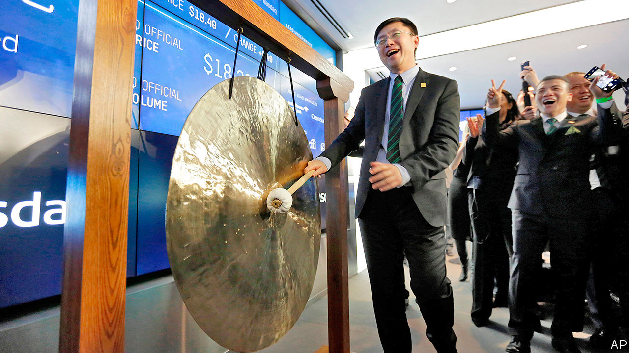

LAUNCHED IN 2010, iQiyi has grown used to the foreign press calling it “the Netflix of China”. Not the worst nickname, given the videostreaming pioneer’s success. But Gong Yu, iQiyi’s founder and boss, insists that his firm is more accurately described as “Netflix plus”. A bold claim for a loss-making business worth one-fifteenth as much as America’s (cash-generating) entertainment powerhouse with a market value of $214bn. Still, Mr Gong has a point.

Like Netflix, iQiyi offers customers a deep catalogue of licensed and original content. Unlike Netflix, which relies almost entirely on subscription fees, iQiyi has multiple revenue streams. “Membership fees”, which start from 19.8 yuan ($2.87) a month, accounted for just over half of iQiyi’s 7.4bn yuan in revenues in the second quarter. The rest came mainly from an online store (which sells “entertainment-related merchandise”), a nascent mobile-gaming arm, an e-book business and advertisements; iQiyi operates a “freemium” model which allows stingier users to stream some content free of charge provided they agree to watch ads.

Conveniently for iQiyi, which does little business outside its home market, Netflix is blocked in China, under laws that ban a lot of foreign content. But that is not to say that China is free from the streaming wars of the sort that pits Netflix against rivals like Disney, HBO (owned by AT&T) and NBCUniversal (belonging to Comcast). Far from it. Mr Gong is battling Tencent Video, part of the eponymous technology conglomerate. It overtook iQiyi at the end of June with 114m video subscribers to iQiyi’s 105m (see chart). Mr Gong’s firm shed 14m subscribers in the most recent quarter while Tencent Video, which also runs a freemium model and charges subscribers 20 yuan a month, added 2m.



IQiyi insists the setback was down to one-off factors, such as virus-induced disruption to film production, which temporarily emptied the content pipeline. Perhaps. But Tencent Video offers a richer selection of English-language content, including hit television series like “Chernobyl” and “Silicon Valley”. More important, the rivalry between Tencent Video and iQiyi is a proxy war between mighty Tencent and fading Baidu, a search firm that is iQiyi’s majority owner. Indeed, iQiyi seemed to concede as much in its latest annual report, writing that “competitors include well-capitalised companies that are capable of offering compensation packages more attractive to talents.”

Still, as Westerners who pay for a few video subscriptions can attest, streaming is not a zero-sum game. Gigi Zhou of BOCOM International, a broker, reckons the Chinese market will soon be big enough to sustain both iQiyi and Tencent Video, which also has yet to make money. Ms Zhou expects 400m Chinese to subscribe to video-streaming platforms by 2023, up from some 300m in 2019. So long as no new rival emerges, each firm could capture around 150m, helping them spread costs over more subscribers and so turn a profit.

Before streaming peace can break out, iQiyi faces another fight. On August 13th it said it was under investigation by America’s Securities and Exchange Commission after a short-seller accused it of inflating sales data, a charge it denies. If found guilty, it may have to delist from New York’s Nasdaq exchange. The firm’s stable share price implies investors’ faith in battle-hardened Mr Gong is unshaken. ■

This article was downloaded by calibre from <https://www.economist.com/business/2020/08/22/tencent-video-battles-iqiyi-in-chinas-streaming-wars>

|  |  |  |  |
| --- | --- | --- | --- |
| Previous | Articles | Sections | Next |

|  |  |  |  |
| --- | --- | --- | --- |
| Previous | Articles | Sections | Next |

#### Weekend plans

# IG Metall is pushing for a four-day week

Germany’s most powerful union thinks metal-bashers deserve a three-day weekly rest

Aug 20th 2020 | BERLIN

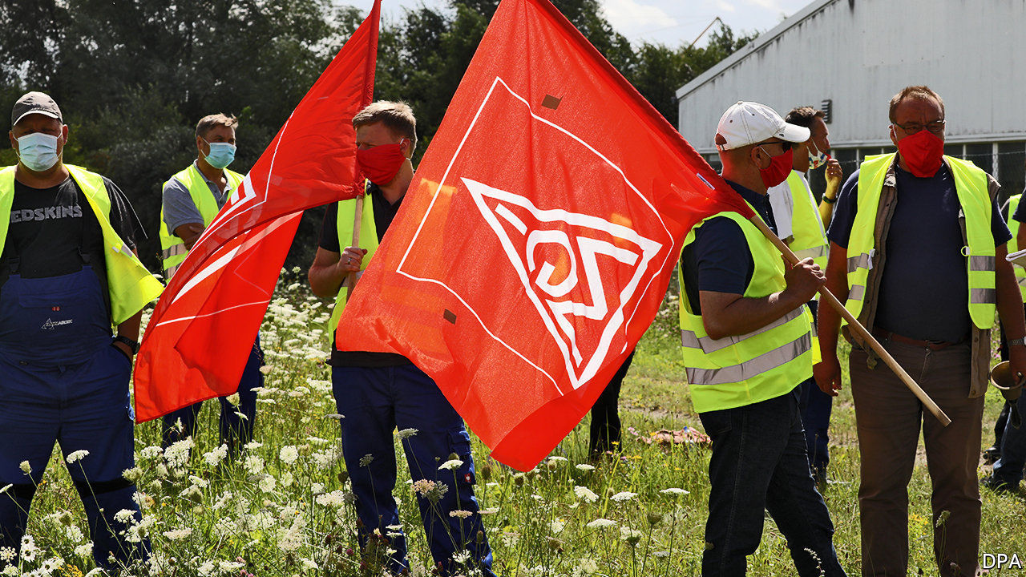

A RECESSION IS not a good time to ask your boss for a pay rise. So IG Metall, Germany’s biggest trade union, is mulling other perks its metal-bashing members might extract from employers. On August 15th its boss, Jörg Hofmann, told the Süddeutsche Zeitung newspaper he would push for firms to adopt a four-day working week.

German workers should not make Friday leisure plans just yet. Employers have not responded—it is mid-August, after all—but they are likely to put up a fight. Nonetheless, Mr Hofmann’s salvo ahead of collective-bargaining talks later this year points to a new stage in European labour relations—and a culmination of decades of pushing for working hours to be cut.

If you think no worker would object to a three-day weekend, think again. Even fans fret about trade-offs. Workers could face longer hours from Monday to Thursday, or a cut in pay. Some employers, notably technology startups, already dangle longer weekends to recruit sought-after brainboxes, or offer flexible hours. But a five-day slog will probably remain the norm in lower-paid jobs, where productivity gains from more rest are less obvious.

IG Metall’s timing is not coincidental. Its members agreed to forgo a pay rise in the covid-19 crisis. Around 6m Germans currently participate in the Kurzarbeit furlough scheme, estimates IFO, a think-tank. The 12-month scheme now looks likely to be extended to 24 months. Hubertus Heil, Germany’s labour minister, said truncated working hours—and a trimmed payslip—could be “an appropriate measure”. State top-ups of the wages of employees who go down to four days a week might be painted as part of the extension.

German workers face problems beyond covid-19. The car industry that underpins blue-collar jobs has been slow to shift to electric vehicles, let alone driverless ones. IG Metall thinks cutting hours will allow firms to retain expertise needed for the transition, without the expense and bad publicity of sacking workers, only to have to rehire some later if prospects improve.

Where IG Metall goes others often follow, in Germany and beyond. Its members were striking for a 35-hour week long before it became law in France. A four-day week equates to around 30 hours. If union bosses pull that off without causing big cuts to workers’ pay, they truly will deserve an extra day of rest.■

This article was downloaded by calibre from <https://www.economist.com/business/2020/08/20/ig-metall-is-pushing-for-a-four-day-week>

|  |  |  |  |
| --- | --- | --- | --- |
| Previous | Articles | Sections | Next |

|  |  |  |  |
| --- | --- | --- | --- |
| Previous | Articles | Sections | Next |

#### No more quarter

# America closes the last loophole in its hounding of Huawei

In a few months the Chinese telecoms giant will run out of chips—and options

Aug 18th 2020 |

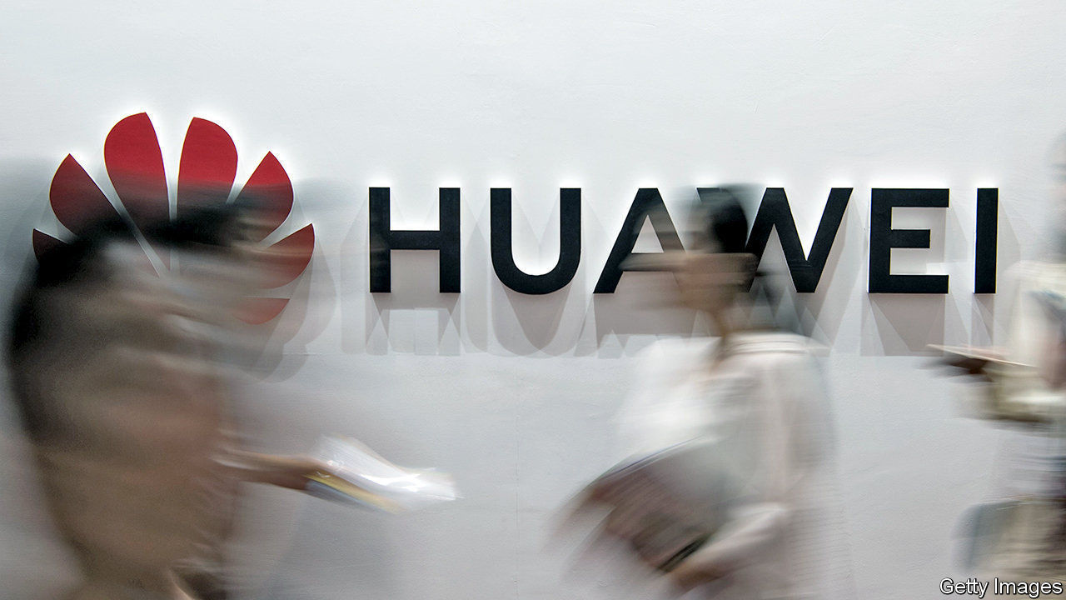

THANKS TO ITS high quality and low prices, Huawei’s telecoms gear is popular around the world. Not in America, where the Chinese giant is banished over (unsubstantiated) fears that it could be used by spies in Beijing to eavesdrop on Americans. But expelling Huawei from the United States—and pressing allies like Australia and Britain to do the same—was not enough for the Trump administration. It seems to want Huawei dead.

Last year the Department of Commerce (DoC) barred American firms from selling Huawei chips made in America, which oxygenate swathes of the global semiconductor industry. In May the DoC added a rule banning domestic and foreign firms from using American-built chipmaking equipment to create custom-made processors for Huawei.

On August 17th the DoC tightened the noose once again—this time, many experts think, for good. Its new rule prohibits anyone from selling any chips to Huawei, custom or not, if these were produced with American technology. This covers practically every chipmaker in the world, including those in China, thus closing loopholes that the global chip industry’s high-powered lawyers have found in the earlier edicts. The share price of MediaTek, a Taiwanese company which was hoping to sell Huawei generic components, plunged by 10% on the news.

The changes take effect on August 20th. After that, Huawei will start running down its stockpile of chips. It has been amassing them for months and probably has enough to last it into 2021, reckons Dan Wang of Gavekal Dragonomics, a research firm. But its customers, including European mobile operators using Huawei kit and in need of spares, will start panicking before then. And who would buy new network kit from a firm which may be unable to fulfil orders?

Huawei’s options are limited. It could sue, claiming that the DoC’s actions contravene America’s own laws, but its two ongoing lawsuits against the American government already look like long shots. Its suppliers, particularly Chinese ones, may sell it chips in breach of DoC rules. Yet that could provoke American ire—and Huawei-like sanctions against them, too.

America’s chip firms are also in a bind. The Semiconductor Industry Association said it was “surprised and concerned by the administration’s sudden shift” from an approach that balanced national security with corporate interests. Besides lost sales to Huawei, which bought $19bn in components from American firms last year, technology bosses fret that their government’s actions will drive investment away from them to rivals in other countries.

If Beijing retaliates with a counter-claim of jurisdiction over any product made in China, that would devastate the supply chains of Apple and other American technology firms. On August 18th China’s government accused America of “violating international trade rules”. But it has so far resisted striking back, perhaps counting on Mr Trump’s defeat in November’s presidential election by Joe Biden, who may take a softer stance against China.

The DoC can still issue licences to firms that want to keep supplying Huawei with components. American trade negotiators may want to use this power to extract concessions from China in ongoing trade talks to boost Mr Trump’s re-election chances, diminished by his mishandling of the covid-19 pandemic. Given the supposed threat Huawei poses, it may be odd to let it live in exchange for a few extra tonnes of soyabean sales to China. Then again, policy inconsistency has not been an obstacle for the Trump administration in the past. Many Western technology firms hope that remains the case.■

This article was downloaded by calibre from <https://www.economist.com/business/2020/08/18/america-closes-the-last-loophole-in-its-hounding-of-huawei>

|  |  |  |  |
| --- | --- | --- | --- |
| Previous | Articles | Sections | Next |

|  |  |  |  |
| --- | --- | --- | --- |
| Previous | Articles | Sections | Next |

#### Schumpeter

# Forced labour in China presents dilemmas for fashion brands

Some feel they are guilty until proven innocent

Aug 22nd 2020 |

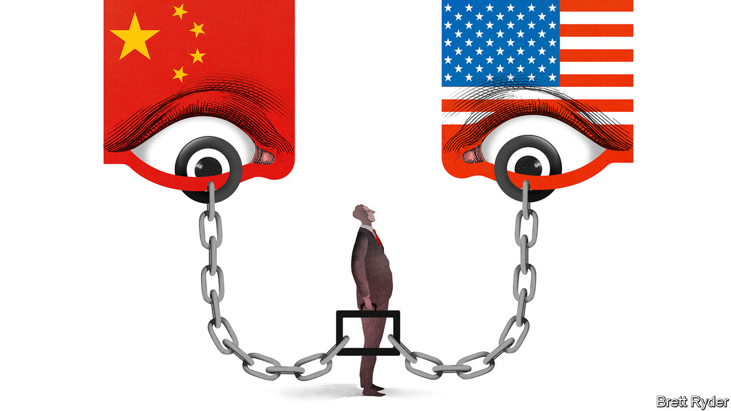

THE WORLD has few more Orwellian conglomerates than the Xinjiang Production and Construction Corps (XPCC), a nearly 3m-strong paramilitary-style business in western China. It was set up in 1954 to spur an influx of demobbed soldiers from the Han majority into an area dominated by Muslim Uighurs. It retains a militia of 100,000, charged with rooting out extremism. The militiamen and others help the XPCC furnish the world with a panoply of goods. About 400,000 XPCC farmers harvest a third of China’s cotton. Others are part of Xinjiang’s tomato-exporting business. From pyjamas to passata, XPCC products penetrate global supply chains.

America’s State Department says that it also uses forced labour. In late July the US Treasury hit XPCC with sanctions, alleging a connection with human-rights abuses in Xinjiang where at least 1m Uighurs and members of other ethnic minorities have been held in detention camps. That followed a memo from President Donald Trump’s administration advising firms to sever any connection they may have with forced labour within and outside the autonomous region. Some retailers, such as PVH Corp, whose brands include Calvin Klein and Tommy Hilfiger, publicly said they would cut ties with Xinjiang, out of concern for labour practices. Supply-chain auditors for Western makers of electronics and footwear say there are numerous “red flags” indicating Uighurs may have been forcibly transferred to factories in other Chinese regions.

Assessing the treatment of workers is nothing new for big firms sourcing materials from places of poverty and repression. But in China these problems are compounded by the power of the state, the size of the economy and tensions with America. At a time when covid-19 has forced many companies to consider reducing their Chinese supply chains, concerns over Uighur forced labour have added “gasoline to the fire”, says one executive.

Western firms thus face several conundrums. How can they prove that their supply chains are free of forced labour when auditing in Xinjiang is taboo? How do they respond to labour-rights worries publicly without enraging either Beijing or Washington? And how do they ensure that overzealous scrutiny of their workplaces does not make life even worse for Uighurs? These are moral, political and social questions that businesses feel they should not have to answer alone.

Start with traceability. Xinjiang is at the heart of China’s cotton, yarn and textile industry, the world’s biggest. The region supplies 84% of the country’s cotton. Its extra-long staple variety is coveted; it produces fabric that is whiter and less knotty than other sorts, making it a favourite for dress shirts sold around the world. It contains spinning factories belonging to some of China’s most advanced shirtmakers, under contract to Western brands.

Until recently, when those brands fretted about labour conditions in Xinjiang, they sent auditors to inspect the factories. That stopped when they began to be monitored by Xinjiang authorities, “as if doing something wrong”, says one. Without audits, Xinjiang has become a black hole in the supply chain, making it almost impossible for Western firms to retain suppliers there. Furthermore, even outside Xinjiang, its cotton is a staple ingredient of Chinese yarn, where it may be mixed with other varieties, including imported stuff, and exported all over the world. Verifying the provenance of that cotton to show that none of it is from Xinjiang is “the hardest work we have ever done,” an auditor laments.

The second big problem is geopolitical. Navigating the Sino-American stand-off is getting tougher. Big international firms say that even if they reduce their dependence on supply chains within mainland China, they have no desire to pull out completely. But keeping Chinese factories, if only to supply domestic consumers, risks using tainted Xinjiang raw materials. And the Chinese government is so hostile to any criticism about human rights in Xinjiang, especially from outsiders, that Western firms must rely on Chinese suppliers to lobby on their behalf, a delicate endeavour.

In America, meanwhile, penalising the repression of Uighurs has bipartisan support that is unlikely to wane whoever wins the elections in November. But American brands feel that politicians have put them on the front line to safeguard human rights in China, without backup from Uncle Sam. They have little diplomatic support when negotiating with China, and the Twitter court of public opinion can be harsh. As one aggrieved executive puts it: “It is like the old witching days. The bar of guilt is incredibly low. The bar of innocence is extremely high.” It is easy to point fingers.

All of this leaves global firms feeling ultra-cautious—and poses a final dilemma. Averting a backlash from activists (and, potentially, consumers) requires removing Uighur employees from supply chains simply because it is so hard to prove whether they were coerced or not. Ultimately, it may necessitate breaking ties with Chinese suppliers with any links to Xinjiang—ie, most of them—even if a relationship of trust goes back decades. That can end up hurting the Uighurs, whom Western firms would gladly offer decent jobs, directly or indirectly.

## A stitch in time

Textile firms believe technology may provide an answer. Pilot programmes exist to test DNA and other things to verify the source of cotton in yarn and fabric. Patricia Jurewicz of the Responsible Sourcing Network, an NGO, says fashion brands are studying how tech firms like Apple responded to a part of America’s Dodd Frank Act of 2010 to ensure no conflict minerals from the Democratic Republic of Congo entered their supply chains.

Of course a T-shirt is cheaper than a smartphone, and traceability costs money. The ideal solution would be for the Chinese government to stop persecuting its Muslim minority. As a businessman notes, the irony is that the more heavy-handed its tactics in Xinjiang are in an attempt to preserve stability, the more economically unstable the region risks becoming. ■

This article was downloaded by calibre from <https://www.economist.com/business/2020/08/22/forced-labour-in-china-presents-dilemmas-for-fashion-brands>

|  |  |  |  |
| --- | --- | --- | --- |
| Previous | Articles | Sections | Next |

|  |  |  |
| --- | --- | --- |
| Business | Sections | Schools brief |

Finance & economics

Dubai: Navigating the storm

.

Mask economics: Cloth of gold

.

People’s Bank of China: Conforming to norms

.

Buttonwood: Foam party

.

Free exchange: State of the unions

.

|  |  |  |
| --- | --- | --- |
| Business | Sections | Schools brief |

|  |  |  |  |
| --- | --- | --- | --- |
|  | Articles | Sections | Next |

#### Navigating the storm

# Can Dubai enter the premier league of financial centres?

It will need to adapt to a less globalised world, and clean up its act

Aug 22nd 2020 |

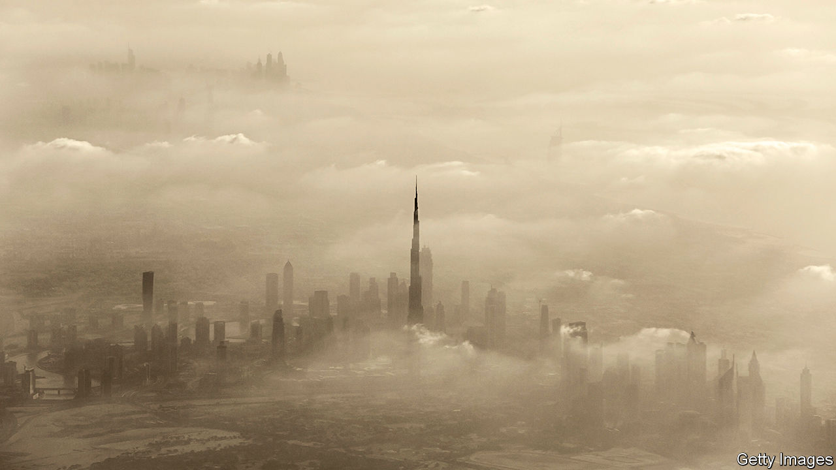

Editor’s note: Some of our covid-19 coverage is free for readers of The Economist Today, our daily [newsletter](https://my.economist.com/user#newsletter). For more stories and our pandemic tracker, see our [hub](https://www.economist.com/news/2020/03/11/the-economists-coverage-of-the-coronavirus)

THE DEAL to normalise relations between Israel and the United Arab Emirates (UAE), announced on August 13th, was a diplomatic coup. Might it be a commercial one too? Moneymen in Dubai, the UAE’s largest financial centre, are hoping to cash in on increased investment and travel between the two countries. Israelis are expected to join the hordes of well-heeled foreigners who have opened businesses or bought swanky pads in the coastal emirate.

Dubai, one of seven emirates that make up the UAE, will be glad of the custom. Its media may be full of feel-good financial stories—drooling, for instance, over the recent foundation-pouring for the world’s tallest hotel, set to rise to 82 storeys, and the unveiling of “the world’s highest infinity pool”—but closer to earth things look less impressive. Thanks to overbuilding, property prices remain far below peaks reached six years ago. Covid-19 has clobbered an economy built largely on retail and hospitality. Low oil prices have strengthened the headwinds: Dubai is not hydrocarbon-rich but its economy feeds on petrodollars.

Adding to the challenges, Dubai faces increasing international pressure to clean up its act. It has long been less than discerning about the provenance of money flowing in. Its property market is heavily stained with laundered loot. If Dubai is forced to tighten standards, that would dent business in the short term, complicating its efforts to push its way into the premier league of financial centres.

Viewed over a longer timeline, Dubai’s growth has been spectacular. In the 1950s, as the City of London was about to ride the Eurodollar boom, Dubai was little more than a fishing village, with 20,000 souls and no airport. Today it is a metropolis. Its financial centre, which first began to take off in the 1990s, is a super-regional champion, serving as a gateway for investment from and to the Middle East, South Asia and Africa. Underpinning this is its stable polity and high quality of life: it offers the region’s ritziest penthouses, finest dining and best shopping and entertainment.

Strong trade and transport links support its financial offering. The city has the world’s largest man-made harbour and the Middle East’s busiest port, with enough space for 22.4m twenty-foot containers. Its airport is—or was, at least, until the pandemic—a key east-west transit point. In 2019 it was the world’s busiest airport for international passengers. Dubai is, in short, the closest thing its region has to a Singapore- or Hong Kong-style entrepot.

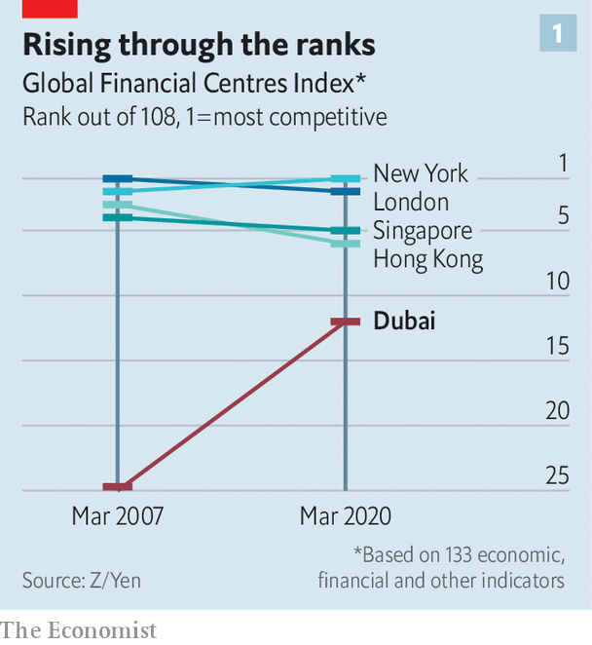

According to the Global Financial Centres Index, which since 2007 has ranked cities according to a range of financial, economic and quality-of-life measures, Dubai has steadily closed the gap with the top tier (see chart 1). It now hovers just outside the top ten. The next highest Middle Eastern centre is Tel Aviv in 36th place, followed by Abu Dhabi, the capital of another emirate (and the UAE) in 39th.

The heart of Dubai’s financial ecosystem is the Dubai International Financial Centre (DIFC), a 110-acre “free zone” in the city centre set up in 2004 to boost Dubai as both financial waystation and investment destination. The DIFC has grown into an impressive cluster of banks, fund managers, and law and accounting firms, with over 2,500 registered companies—820 of them financial—and 25,000 professionals.

The DIFC says it hosts 17 of the world’s top 20 banks; eight of the ten leading global law firms; and six of the ten biggest asset managers. Many of them have their regional headquarters there. The banks have around $180bn of assets booked there; DIFC firms arranged an additional $99bn of lending last year. Some specialise in trade finance and infrastructure lending. The DIFC’s fund managers have assets of $424bn. Its financial firms are restricted to foreign-currency transactions. Some Dubai-based banks have operations in the zone too, but conduct dirham-denominated business from branches outside it.

The DIFC’s appeal lies largely in its bespoke tax regime and regulation. Like the other 40-odd free zones in the UAE, it sets its own rules. It is tax-light, allows foreigners full ownership (outside zones this is capped at 49%) and sets no local-hiring quotas. It has its own regulator, the Dubai Financial Services Authority, run by a former bank supervisor for America’s Office of the Comptroller of the Currency. Financial firms outside free zones fall under the central bank and other national authorities.

The DIFC has its own judicial system too, based on common law and with courts that hear cases in English. (By contrast, the UAE’s system is based on civil law.) The DIFC passes its own laws: one on data protection, based on EU regulations, took effect on July 1st.

This autonomy is prized especially by investors whose home countries’ legal systems are less dependable. Indians flock to it because of Mumbai’s clogged, clunky and capricious courts; some joke that Dubai and Singapore are India’s real financial capitals. In a big boost, Dubai’s judgments became enforceable in India in January.

The DIFC’s judicial system has grown quickly. In 2019 its courts heard a record 952 commercial cases, 43% more than in 2018. It has a growing reputation as a regional arbitration centre, helped by a joint venture with the London Court of International Arbitration, and the hiring of judges from Australia, Britain and elsewhere.

The DIFC has navigated the coronavirus crisis well. It even managed to sign up 310 new companies in the first half of 2020—a six-month record. This followed a record year in 2019, in which 493 new companies joined, among them an insurance arm of Berkshire Hathaway and the asset-management division of State Street.

This unlikely growth was, the DIFC says, largely driven by interest from Asian firms and fintechs. Having invested heavily to launch a fintech “accelerator”, Dubai claims to be home to over half of all fintechs in the Middle East and North Africa. The January-June registration numbers were probably helped by a speedily assembled relief package for DIFC clients, unveiled in March, including licensing-fee waivers, lease-payment deferrals as well as three-month rent forgiveness for retailers.

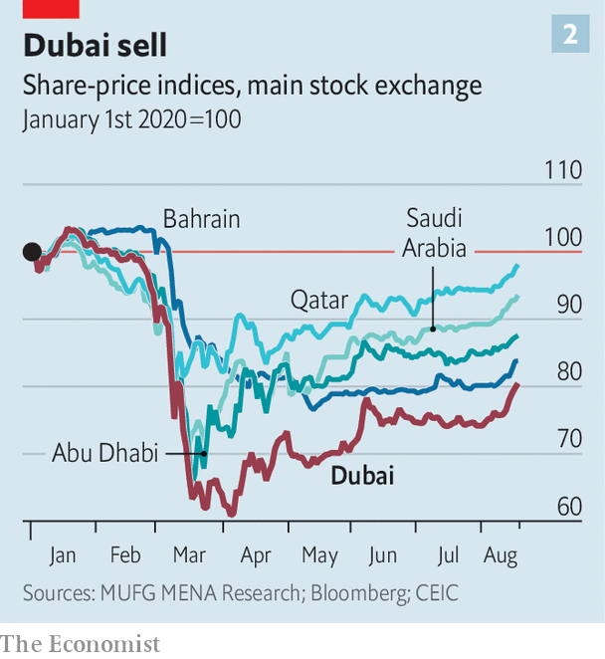

Still, covid-19 has taken a heavy toll on Dubai. It is more vulnerable than the region’s other economies because of its reliance on retail and recreation, both highly susceptible to physical-distancing and travel restrictions, says Ehsan Khoman, head of Middle East research at MUFG, a bank. Its equity market has fallen further than others in the Gulf this year (see chart 2).

Moreover, Dubai was struggling to shake off several pre-existing conditions when the virus struck. A debt and building binge had left it exposed during the financial crisis of 2007-09. It took a $10bn bail-out by Abu Dhabi to stave off the threat of sovereign default. But Dubai’s “government-related entities” (GREs)—conglomerates with tentacles across the economy, such as Dubai World (from ports to leisure) and Dubai Holding (telecoms, property and more)—remain heavily burdened, and there is talk of another debt crisis. Capital Economics, a consultancy, reckons total public debt is $153bn, of which GREs owe $89bn, equivalent to 140% and 81% of GDP respectively. Their repayment schedule is gruelling, with over 60% of their debt due in the next four years. They had topped up their borrowing to fund projects ahead of the World Expo, which had been scheduled for October, hoping for a flurry of deals and up to 25m visitors. But the event has been pushed back a year because of covid-19.

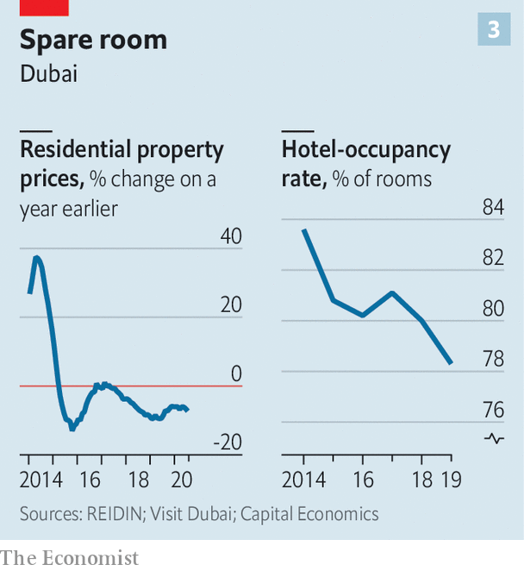

Dubai’s property market, too, was in pain well before the pandemic because of oversupply. Residential property prices have fallen in recent years, as have occupancy rates at hotels (see chart 3). The number of visitors to Dubai from elsewhere in the Gulf fell by 10% between 2016 and 2019. Developers were cutting back before the virus; now some fear for their survival. In July S&P, a rating agency, downgraded the debt of two of Dubai’s biggest property companies to junk. It also expects the economy to shrink by 11% this year.

As it seeks to shake off these ailments and recover from the effects of its covidinduced lockdown (which was among the world’s strictest), Dubai faces longer-term challenges. One is the slowing and possible reversal of globalisation as trade tensions rise and populist policies spread. Having redesigned its economy around the flow of people, goods and capital, Dubai was a big beneficiary of globalisation, and used its strategic location to punch above its weight. Now the model looks like a vulnerability. (The consequences are not clear-cut, though. Entrepots sometimes benefit when big powers squabble, as dealmaking moves to neutral ground. And if global trade turns more parochial, then regional hubs like Dubai could pick up some types of business even as they lose others.)

Protracted weakness in the oil price could also cause problems. Oil-related activities make up just 1% of Dubai’s nominal GDP, according to MUFG. Still, its prospects are entwined with oil-price fluctuations. A lot of the finance in Dubai involves reinvesting oil money from the region. Its property boom was largely built on regional petrodollars. And many of its tourists come from oilier Gulf countries.

Another question is whether Dubai can stay ahead of regional rivals that covet its crown. Oil-rich Abu Dhabi, a 90-minute drive away, is a frenemy: it is both a source of bail-outs and a would-be usurper. It attracts a smattering of foreign investment managers, keen to work with its sovereign-wealth fund, the UAE’s biggest. But its financial district is not a patch on the DIFC.

Riyadh could prove a more serious competitor, especially if Saudi Arabia’s social liberalisation continues and attracts more fun-loving expats. The completion of the 59-tower King Abdullah Financial District, a banking hub in the Saudi capital, has taken on more urgency under Muhammad bin Salman, the country’s crown prince. Hints have been dropped that foreign banks that open an outpost there may be better placed to win Saudi mandates, says one banker.

The biggest long-term threat, however, comes from within: Dubai’s attitude to corrupt capital. Of all the big global financial centres, it is the shadiest—not only a haven for clean money seeking investments or fleeing turmoil elsewhere, but also for the dirty stuff. It is used by kleptocrats, money-launderers, arms-smugglers, sanctions-busters and other criminals. The UAE and Iran are the only Gulf countries on America’s list of “major money-laundering jurisdictions”; its moneymen are under scrutiny for suspected financial ties to Syria’s president and his cronies. And it doesn’t just take the bad guys’ money; a flock of fugitives, alleged fraudsters and disgraced public figures live in Dubai, including a suspect in the massive “cum-ex” tax-fraud case (who denies wrongdoing).

Not surprisingly then, the UAE scores poorly in a leading index of money-laundering risk—worse, in fact, than several notoriously shady sunny places, including the Seychelles (see chart 4). That score and its size together make Dubai the biggest single hole in the global anti-money-laundering (AML) system, say some experts. The UAE’s finance ministry and central bank declined to comment.

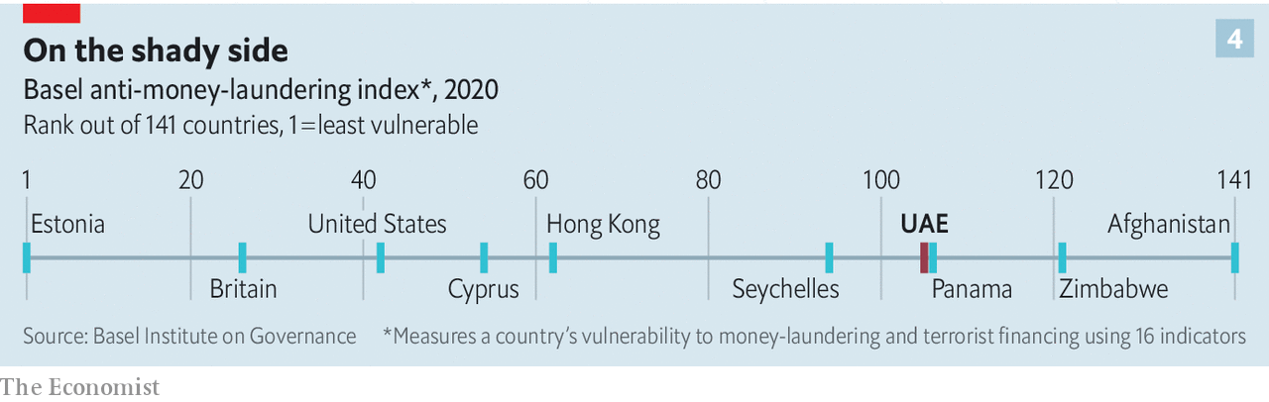

Much of the dodgy cash goes into luxury flats and villas. A leak of property records in 2016 revealed 800 Dubai properties, worth $400m, linked to over 300 Nigerian “politically exposed persons” (current or former officials, their relatives or associates). Another channel is Dubai’s 30 or so free zones. Though economically important, some hubs are opaque and, investigators and anti-corruption NGOs suspect, misused by money-rinsers.

Corporate malfeasance is not restricted to secretive shell companies or trading firms. Thanks to weak governance and a culture of self-dealing, the UAE has more than its fair share of once-high-flying companies that were felled by financial scandals—among them Abraaj, once the Middle East’s top private-equity firm, and NMC Health, a company once included in the FTSE 100, Britain’s stockmarket index.

Dubai’s weaknesses in combating illicit finance are “a feature, not a bug” of its political economy, as a recent report by the Carnegie Endowment, a think-tank, puts it. When international rules designed to root out tax evaders took effect a few years ago, the UAE offered inveterate dodgers ways to invest in its companies and property that circumvented the rules (it tightened up after the EU cried foul).

Another sign of this is Dubai’s lack of co-operation with foreign governments probing suspected corruption with Dubai links. According to the Financial Action Task Force (FATF), which writes and polices global AML standards, between 2013 and 2018 Dubai’s public prosecutor received around 300 such “mutual legal assistance” requests, but acted on only 89 of them.

One reason Dubai has got away with such foot-dragging is that it has been shrewd, for instance by paying lip service to reform at moments of international scrutiny, then doing nothing much when the pressure eases. Another reason is its strategic importance: the UAE is a key ally for Western powers. As a result, the FATF, over which those powers hold great sway, has pulled its punches.

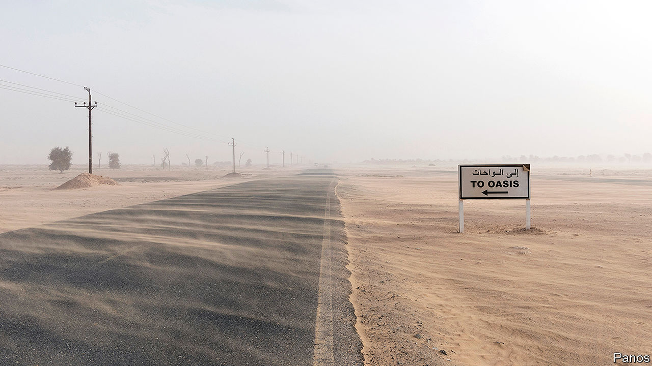

Sanctuary for sanctions-busters

There are signs the tide is starting to turn. The FATF issued a (by its standards) stinging report on the UAE earlier this year, and reportedly placed it under year-long observation to ensure that it implements recently passed AML laws. If it does not, it could be added to the FATF’s “grey list”, joining the likes of Syria and Zimbabwe. That is one naughty-step away from blacklisting, which would, in effect, require international banks to disengage.

It almost certainly will not come to that. Dubai’s rulers may seem impervious to international criticism, but “will act very quickly” to weed out the dodgiest business if Dubai’s financial links are threatened, says a well-connected Emirati financier.

They are, he adds, also confident they can secure new sources of revenue if cleaning up cuts off business. He also notes that, as long as the UAE remains stable and its region volatile, it will benefit from capital flight. The Arab spring was high season for Dubai’s deposit-takers. Now they are doing brisk business with clients from Lebanon.

Other new business takes more effort. The UAE’s political and business leaders have worked tirelessly over the past couple of years to strengthen links with China, signing deals in logistics, chemicals, finance and more. Not for them the moral high ground or bans on Huawei. They are beginning to reap the benefits. The DIFC is the regional headquarters for China’s four largest banks as well as several big firms. Though the UAE is not a key player in China’s Belt and Road initiative, Dubai is becoming the hub of choice for Chinese expansionism in the region. Ever ambitious, the DIFC has talked of tripling in size by 2030. Its burgeoning eastern connections make that seem a little less fanciful. ■

This article was downloaded by calibre from <https://www.economist.com/finance-and-economics/2020/08/22/can-dubai-enter-the-premier-league-of-financial-centres>

|  |  |  |  |
| --- | --- | --- | --- |
|  | Articles | Sections | Next |

|  |  |  |  |
| --- | --- | --- | --- |
| Previous | Articles | Sections | Next |

#### Cloth of gold

# Why the economic value of a face mask is $56.14

A new frontier in facial finance

Aug 22nd 2020 |

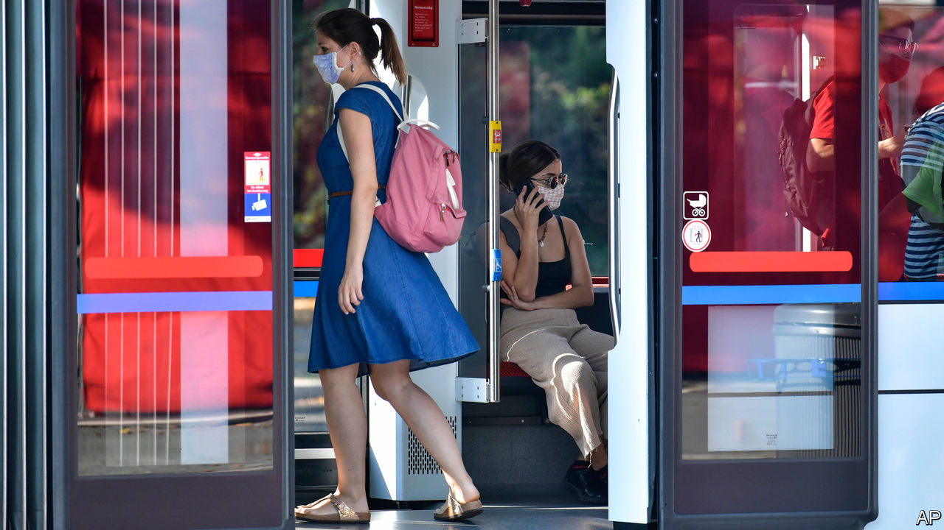

Editor’s note: Some of our covid-19 coverage is free for readers of The Economist Today, our daily [newsletter](https://my.economist.com/user#newsletter). For more stories and our pandemic tracker, see our [hub](https://www.economist.com/news/2020/03/11/the-economists-coverage-of-the-coronavirus)

AFTER A BRUTAL first six months of the year, governments across the world are hoping for an economic bounce-back. Rich-world GDP fell by about 10% in the first half of 2020. Yet much has changed since—including that more people are now wearing masks. Economists, obsessed with translating everything into GDP, wonder if more widespread face-covering could help the recovery.

The thinking goes that masks can, in part, substitute for lockdowns. People wearing them need not be discouraged as much from using public transport. More shops and offices might be able to reopen, albeit while practising social distancing.

Calculations from Goldman Sachs, a bank, suggest that a 15 percentage-point rise in the share of the population that wears masks would reduce the daily growth of cases by about one percentage point. That obviates the need for lockdown measures that would otherwise subtract nearly 5% from GDP. The Economist took those calculations a step further. According to our reckoning, an American wearing a mask for a day is helping prevent a fall in GDP of $56.14. Not bad for something that you can buy for about 50 cents apiece.

These economic benefits suggest that governments should do even more to nudge the minority of people who still forgo masks. English shoppers without a face-covering risk a fine of £100-3,200 ($130-4,200). Authorities in Turkey and Tuscany have handed out free ones to citizens. Perhaps governments should do more—such as pay people to wear them. After all, the large economic benefits of doing so have finally been unmasked.

This article was downloaded by calibre from <https://www.economist.com/finance-and-economics/2020/08/22/why-the-economic-value-of-a-face-mask-is-5614>

|  |  |  |  |
| --- | --- | --- | --- |
| Previous | Articles | Sections | Next |

|  |  |  |  |
| --- | --- | --- | --- |
| Previous | Articles | Sections | Next |

#### Conforming to norms

# China’s monetary stimulus is unusually restrained

Its apparent conservatism is partly an unwinding of past excesses

Aug 22nd 2020 | SHANGHAI

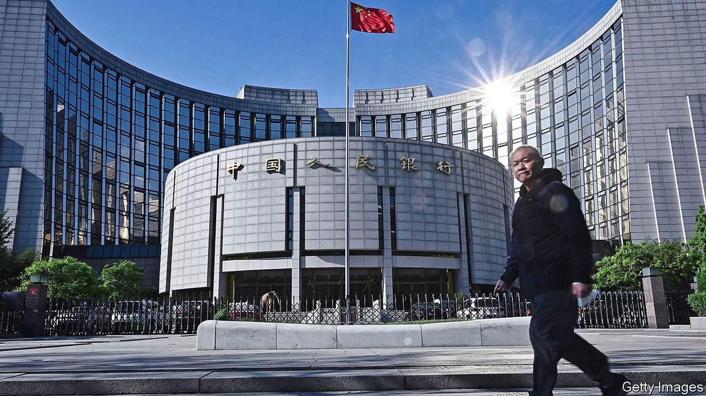

YI GANG, THE head of China’s central bank, is fond of saying that he wants to run “normal” monetary policy. By that he means keeping interest rates well above zero, ensuring that the yield curve slopes upwards and avoiding direct purchases of the government’s bonds—much of which, in fact, make the People’s Bank of China (PBoC) a highly abnormal central bank these days. The clearest sign of this is its balance-sheet. In terms of its assets, the PBoC has gone from the undisputed heavyweight to a middleweight. Its restraint is a combination of two different strands in its pursuit of policy normality: an avoidance of the unusual manoeuvres that have become common elsewhere and a reversal of some of the unusual manoeuvres that used to be common in China.

Starting in the early 2000s, the PBoC accumulated assets at a prodigious rate, almost entirely in the form of foreign-exchange reserves. The build-up was a result of its policy of limiting the yuan’s appreciation at a time when China was running a giant trade surplus. The PBoC’s assets peaked at 70% of GDP in 2008, more than twice the level of its peers in America, Europe and Japan at the time. But as China’s foreign-exchange reserves have shrunk and then stabilised over the past five years, so has the central bank’s balance-sheet.

By contrast, the assets of the Federal Reserve, the European Central Bank and the Bank of Japan have mostly risen over the past decade or so, as they undertook quantitative easing, buying up government bonds and, in some cases, corporate paper and equities. In order to minimise the economic damage from the coronavirus pandemic, they are buying yet more bonds. The PBoC, though, has barely added to its assets (see chart). As a share of GDP, the size of its balance-sheet is now roughly the same as the Fed’s—around 35%.

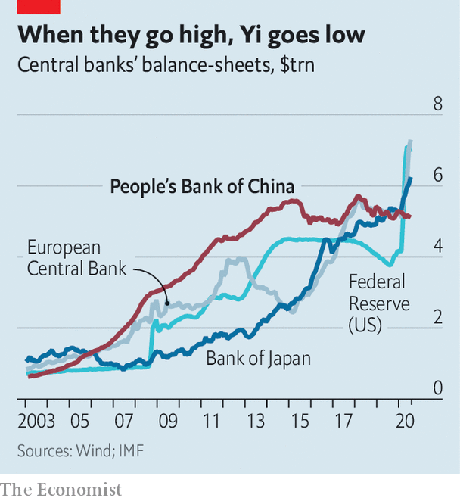

In part China’s restraint is because the economy is in relatively better shape, with the virus all but stopped and a growth rebound well under way. Partly it also reflects what might be called the Kipling doctrine in China’s bid to promote the yuan’s international role: if you can keep your money supply in check when all about you are expanding theirs like mad, then reserve-currency status may some day be yours.

There is also a deeper reason for China’s apparent conservatism, though. It is gradually reversing some of its extraordinary past interventions. In order to maintain an undervalued currency, the PBoC printed as much yuan as needed to buy the foreign currency streaming into China. To prevent that newly created money from causing inflation, it then had to soak much of it back up, or to “sterilise” the inflows. It did that primarily by jacking up reserve-requirement ratios for commercial banks. At the peak in 2011, banks were forced to place 21.5% of their deposits at the central bank. After repeated cuts, including two since the coronavirus outbreak, mid-sized banks now need to set aside only 9.5% of their deposits, freeing them to lend more. Coupled with targeted liquidity injections and old-fashioned moral suasion (a powerful tool in a largely state-owned financial system), the PBoC can support the economy without dramatically scaling up its balance-sheet.

Still, the very stability of that balance-sheet has led to questions about whether it may be accumulating foreign-exchange reserves on the sly. The main reason for suspicion is that even as China has notched up huge trade surpluses ($62bn in July, just shy of a monthly record set in May), its reserves have barely budged. But a focus on trade overlooks the cash that has left through other channels. In the second quarter, net financial outflows (excluding direct investment) soared to $104bn—equivalent to two-thirds of trade earnings—partly thanks to mainlanders punting on stocks in Hong Kong. This points to one more way in which the monetary system looks more normal—it is becoming fiendishly complex to monitor all the cash criss-crossing China’s borders as, little by little, it opens up its capital account. ■

This article was downloaded by calibre from <https://www.economist.com/finance-and-economics/2020/08/22/chinas-monetary-stimulus-is-unusually-restrained>

|  |  |  |  |
| --- | --- | --- | --- |
| Previous | Articles | Sections | Next |

|  |  |  |  |
| --- | --- | --- | --- |
| Previous | Articles | Sections | Next |

#### Buttonwood

# Bubble-hunting has become more art than science

With the usual gauges of frothiness out of action, behavioural signals are all investors have

Aug 19th 2020 |

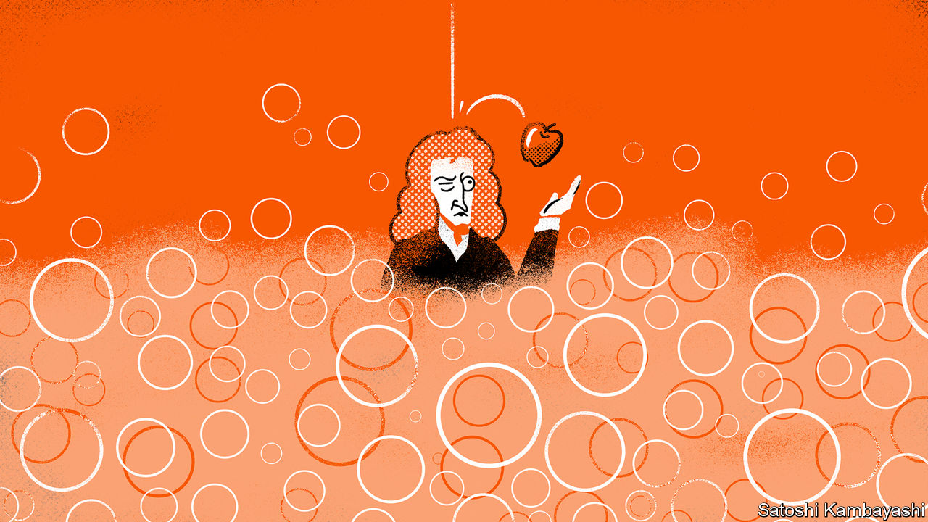

UPON BEING sucked into investing during the South Sea Bubble, Sir Isaac Newton reflected that he could “calculate the motions of the heavenly bodies but not the madness of people”. From tulip mania in 17th-century Amsterdam to railway fever in Victorian Britain, history is littered with tales of investors who lost their heads shortly before they lost their shirts, in the grip of mass delusions described by Alan Greenspan, a former chairman of the Federal Reserve, as “irrational exuberance”.

These delusions seem obvious with the cold clarity of hindsight. Spotting them in real time, however, is trickier—especially when the usual measures of frothiness are out of action. Wall Street types typically pore over price-to-earnings ratios, which compare a firm’s value with its profits, or free-cashflow measures, which look at the cash firms crank out after investment. Warren Buffett targets firms with a high return on capital, which compares their profits with the size of their balance-sheets. But the covid-induced economic slump has caused earnings to sink even as the Fed and other policymakers have helped buoy share prices. The obvious gauges of frothiness are not much use.

This poses a problem for investors confronting the startling fact that the S&P 500, a share-price index of America’s biggest public companies, reached an all-time high on August 18th in the middle of perhaps the sharpest ever economic downturn. Without hard numbers to count on, they must interpret the market’s unusual behavioural signals in order to spot the froth.

One such sign is the mystifying moves in some stocks. On August 19th Apple became the first American company to touch a valuation of $2trn. Tesla, a carmaker that is undertaking a stock split at the end of August, has quadrupled in value so far this year. It is now worth $354bn, more than Ford, Toyota and Volkswagen combined. Nikola, an electric-truck firm (that has yet to make any lorries), has tripled in value since May. Even more perplexing was investors’ fondness for Hertz, a car-rental firm. Its share price rose tenfold after it declared bankruptcy (though this bubble has since popped).

Anecdotally at least, this frothiness seems linked to a second phenomenon: a zeal for retail investing. Take, for instance, the popularity of Robinhood, a trading platform, which has opened 3m accounts since the end of 2019, taking its users to 13m. Or consider “r/wallstreetbets”, a forum on Reddit, which encourages its readers to make “YOLO” (you only live once) bets on short-dated speculative options (akin to lottery tickets) in order to earn “tendies” (short-term gains). The number of subscribers to it has nearly doubled since January to over 1.4m, edging out its staid cousin, “r/investing”, which preaches the virtues of punting on diversified baskets of low-cost index funds.

That exuberance has been matched by a third behavioural oddity: companies’ enthusiasm for issuance. Dealogic, a data provider, finds that stock issuance in America has jumped by 85% year-on-year so far in 2020. Part of that may be a result of the pandemic; many companies have raised capital to build up war-chests. But issuance is also compelling in bubblier times, because it allows firms to capitalise on lofty valuations. Hertz tried to raise up to $1bn in new equity after it had filed for bankruptcy, before regulators intervened.

Moreover, after a hiatus in the first half of the year, tech firms are rushing to list. Special-purpose acquisition companies (SPACs)—listed shell companies that then merge with private firms, offering a speedy, back-door route to going public—are all the rage. SPACs were once a dirty word on Wall Street, thought fit only for firms unworthy of an initial public offering. But now they are in favour with firms and investors. They have raised $12bn so far this year, just shy of the amount raised in all of 2019.

What to do, in the face of all this enthusiasm? Other assets may start to seem more alluring. On August 14th Berkshire Hathaway, Mr Buffett’s investment firm, said that it had sold chunks of its stakes in banks and bought up shares in Barrick Gold, a mining company. But gold and other assets have also shot up in value this summer.

As markets rise further it may become even harder to resist joining the fray. Some investors may pile in, and exit with a profit. But even the most brilliant minds can be bamboozled. Sir Isaac spotted the bubble early and liquidated his holdings—only to be sucked back in at the very peak.

This article was downloaded by calibre from <https://www.economist.com/finance-and-economics/2020/08/19/bubble-hunting-has-become-more-art-than-science>

|  |  |  |  |
| --- | --- | --- | --- |
| Previous | Articles | Sections | Next |

|  |  |  |  |
| --- | --- | --- | --- |
| Previous | Articles | Sections | Next |

#### Free exchange

# America’s fiscal federalism is less superior than you might think

Europe’s federation has been surprisingly effective

Aug 20th 2020 |

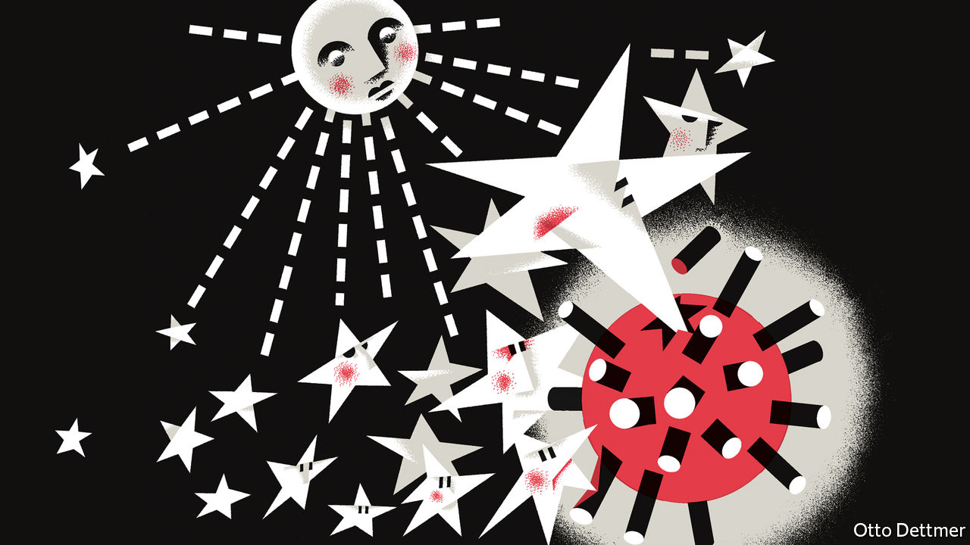

QUICK: WOULD you rather face the worst economic crisis in history as a resident of America’s fiscal union, or Europe’s? An easy choice, surely; a decade ago, the euro area’s skeletal economic institutions turned an American-made panic into a near-collapse of the European project. By 2013 euro-zone output was 3% below its peak in 2008, whereas America’s was nearly 5% higher. Look again, though, and the answer is less obvious. Both fiscal federations have flaws. But the covid-19 crisis shows that Europe may not be so badly outclassed by America’s fiscal union after all.

The division of the power to tax and spend across many layers of government—fiscal federalism—has many potential benefits. Decentralisation allows governments to satisfy a diverse population’s policy preferences and cope with regional needs. Given free movement of labour and capital within a federation, competition between regional governments can lead to policy innovation and limit state overreach. At the same time, membership of a federal entity brings scale economies: access to more resources and a bigger market; more effective risk-sharing. Economists reckon that the task of macroeconomic stabilisation is best left to the highest level of government. It has a greater capacity to manage local shocks: as federal-tax receipts in one region fall, revenue is cushioned by those from elsewhere. For a federal authority, the spillover of fiscal easing across state borders is not a problem. A shared currency, too, should be complemented by fiscal powers.

A strong federal budget, though, creates the risk of moral hazard. The lower levels of government may borrow too much, counting on federal bail-outs when things go wrong. Effective fiscal federalism thus requires a mechanism to constrain states’ borrowing. America confronted this problem in the 19th century. After fiscal integration led to reckless state borrowing and defaults, state governments adopted balanced-budget rules. All except Vermont are bound by them, leaving countercyclical policy the prerogative of the federal government. In downturns, states depend on federal relief: in the form of reduced federal-tax payments, increased welfare spending, and occasional discretionary stimulus (like the $1,200 cheques posted to most Americans earlier this year).

No real-world federal system meets the ideal. The euro area, on the eve of the financial crisis in 2007-09, suffered from dangerous defects. Monetary power rested with the supranational European Central Bank (ECB). But member states retained near-total control over crucial policy levers, like the power to tax and spend, and to regulate banks. The crisis exposed these weaknesses. Unsure that the ECB would act as lender of last resort to troubled member states, investors shunned vulnerable governments, sending bond yields soaring and raising the spectre of chaotic exits from the EU. The predicament contrasted starkly with events in America, where a fiscally powerful central government backed by a proactive central bank stood ready to help hard-hit states and troubled banks. Many economists urged the euro area to replicate two centuries’ worth of American-style fiscal integration. Instead the zone did just enough to survive. A promise by the ECB to defend the single currency persuaded bond vigilantes to retreat.

Even as it limped out of crisis, Europe seemed to sow the seeds of future troubles. As its crisis abated, the euro area moved to minimise moral hazard. Limits on government borrowing agreed in the late 1990s were strengthened post-crisis: through the introduction of closer monitoring and punitive sanctions, for instance. But these efforts were not matched by complementary, American-style mechanisms to provide collective stimulus. The oversight seemed designed to leave the European project vulnerable, once again, in the face of any new recession.

Yet for all its missteps, Europe’s fiscal performance compares surprisingly well with America’s. Government spending contributed positively to euro-area growth in every year except 2011, when its effect was neutral, and 2012, when governments’ budgets reduced growth by just 0.1 percentage points. Austerity did concentrate economic pain in parts of the periphery. But that was also the case in American states, where balanced-budget rules led states to make deep spending cuts. Indeed, these were so large that the federal largesse intended to keep America’s overall fiscal position stimulative barely managed to offset the cuts. Government spending at all levels contributed 0.7 percentage points to growth in 2009, but was neutral in 2010 and subtracted 0.7 percentage points from growth in 2011—even as the federal government provided roughly half a trillion dollars in aid to states that year.

## Just you wait

The response to covid-19’s economic devastation looks similar. On the surface, the staggering stimulus package enacted in America in the spring, worth about 13% of GDP, looks a far more potent contribution than the EU’s fiscal package, agreed in July. That recovery fund, supported by collective borrowing, will spend nearly 5% of EU GDP over several years. But America’s stimulus is largely exhausted, and its dysfunctional Congress has been unable so far to pass additional measures. Cuts to state and local governments are already weighing on the economy, subtracting 0.4 percentage points from the (annualised) growth rate in the second quarter. The euro area, by contrast, agreed that fiscal rules should not apply during the pandemic, allowing members to provide economic support on a par with America’s federal response.

No one will mistake the euro area for an exemplar of federalism. Some member states, such as Italy, Spain and even France, will exit the crisis with huge public-debt burdens. The suspension of borrowing rules could deepen anxiety about moral hazard, and lingering hardships could yet trigger a crisis that threatens the entire European project. But conventional wisdom could use some revision. American fiscal federalism, so often cited as a model for the euro area, looks ever less clearly the superior system.■

This article was downloaded by calibre from <https://www.economist.com/finance-and-economics/2020/08/20/americas-fiscal-federalism-is-less-superior-than-you-might-think>

|  |  |  |  |
| --- | --- | --- | --- |
| Previous | Articles | Sections | Next |

|  |  |  |
| --- | --- | --- |
| Finance & economics | Sections | Science & ... |

Schools brief

Hidden figures: A flattened curve

.

|  |  |  |
| --- | --- | --- |
| Finance & economics | Sections | Science & ... |

|  |  |  |  |
| --- | --- | --- | --- |
|  | Articles | Sections | Next |

#### Hidden figures

# Why does low unemployment no longer lift inflation?

The Phillips curve, the logic of which guides central banks today, has become oddly flat

Aug 22nd 2020 |

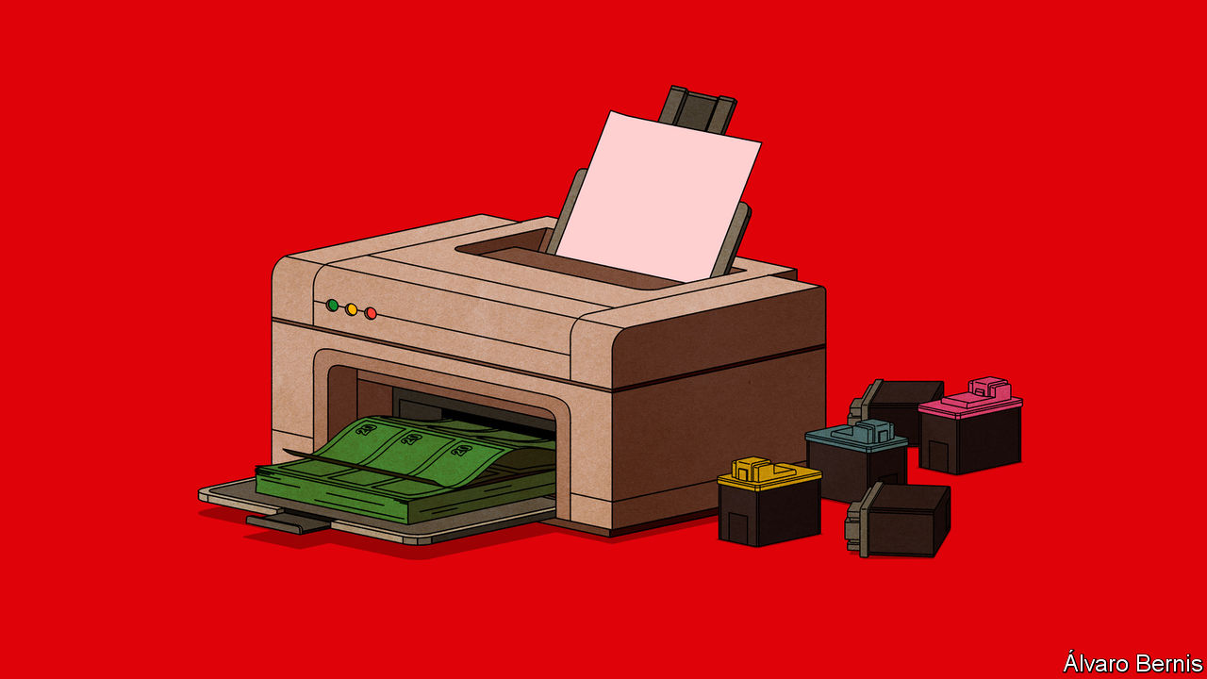

EVERY NIGHT at about 10pm the lights of the prisoner-of-war camp in Indonesia would mysteriously dim, to the puzzlement of the Japanese guards. They failed to spot the makeshift immersion heaters, used to brew cups of tea for the inmates, that had been cobbled together by a prisoner from New Zealand, William Phillips. These secret contraptions were just one example of his resourcefulness.

After the second world war he built a “hydraulic” model of the circular flow of income in an economy—a labyrinth of water tanks, valves and pipes that helped earn him an appointment at the London School of Economics. But neither of these exploits is the reason why Phillips is known to every economist today. His fame rests instead on his “quick and dirty” study, published in 1958, documenting a striking, decades-long relationship between British wage inflation and unemployment: the one tended to be high when the other was low. A downward-sloping curve, which he drew largely freehand, illustrated the point. The Phillips curve, as it became known, has been described as “probably the single most important macroeconomic relationship”. It has also been called the “least solid piece of work” he ever did.

The Phillips curve’s solidity and shape has been called into question more than once in the past 60 years, including in the period since the global financial crisis of 2007-09. But the logic of the curve still guides central banks today.

When business is brisk and unemployment low, central bankers worry that workers will demand pay raises over and above inflation and any improvement in their productivity. If firms pass these higher wages on to customers by increasing prices, inflation will rise. If central bankers wish to prevent this, they will raise the interest rate they charge for the money they lend, slowing the economy and curbing the wage pressure.

The opposite happens at the other end of the curve. High unemployment flattens wages and spending, putting downward pressure on inflation. To counteract this, policymakers typically cut interest rates.

Central bankers hope to find themselves somewhere in the middle: with inflation where they want it to be and unemployment neither high nor low enough to dislodge it. In these happy circumstances, they aim to set a “neutral” interest rate that will leave inflation where it is.

Most central banks in the rich world target an inflation rate of about 2%. At such modest levels, inflation does not greatly complicate financial planning or erode confidence in the currency. But it allows wages to fall modestly, relative to prices, without anyone suffering a thinner pay packet. That cheapening of labour may, in turn, help preserve jobs in a downturn.

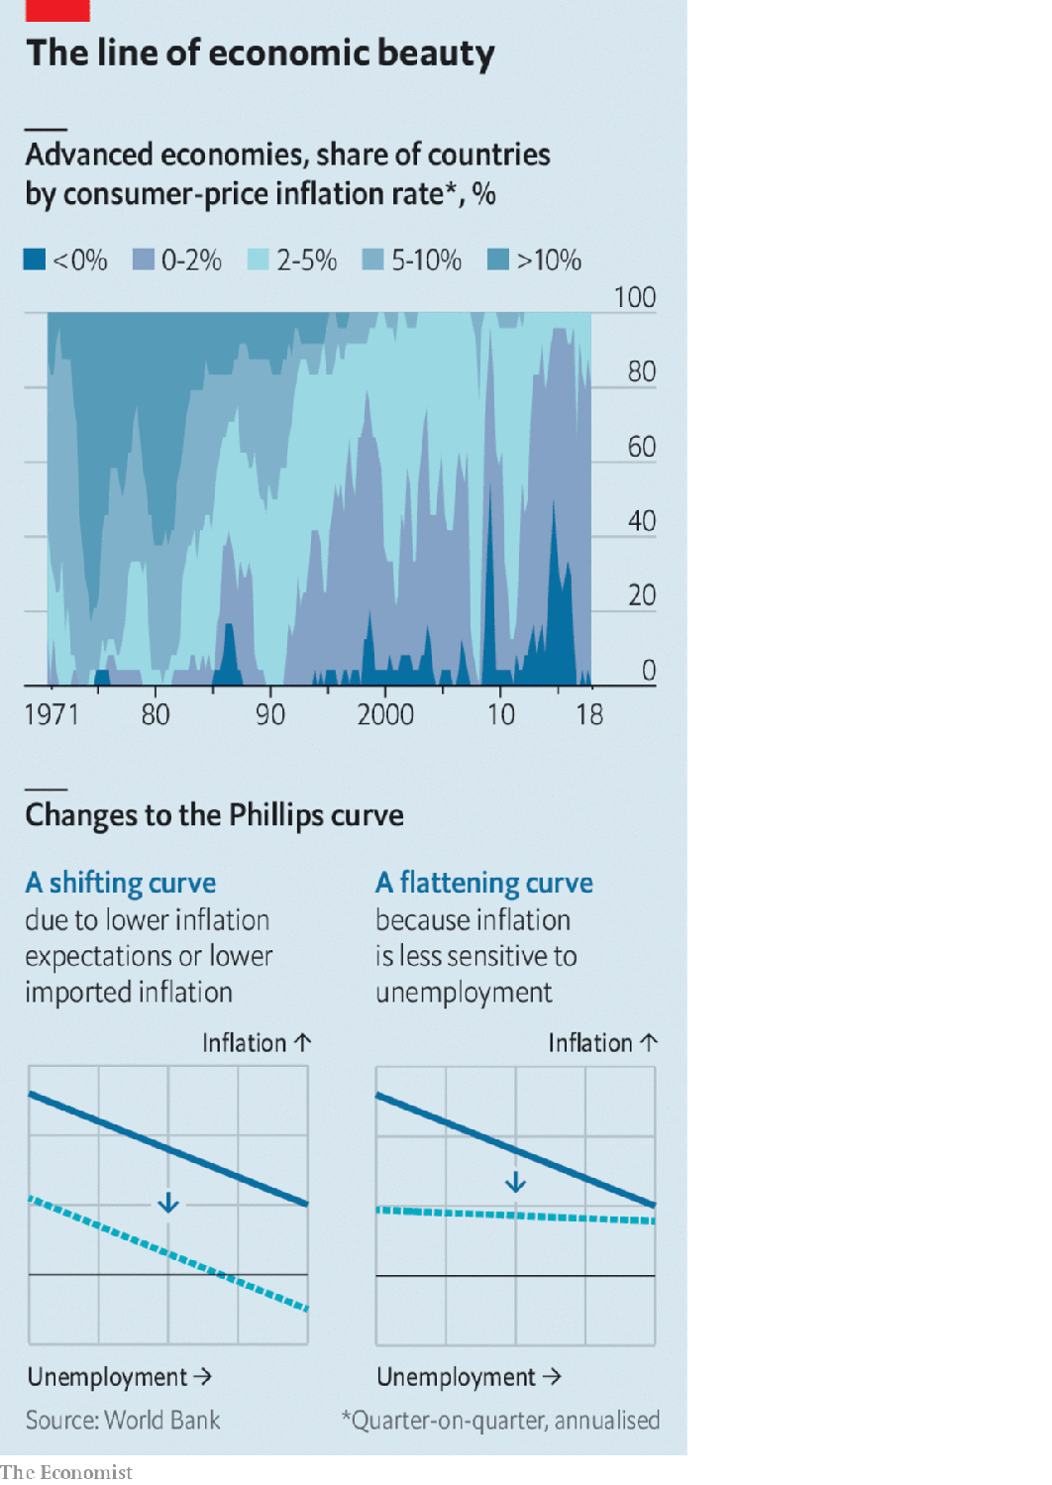

In recent years, however, inflation has fallen persistently short of the central bank’s target in many countries (see chart). In the immediate aftermath of the global financial crisis, such low inflation was no puzzle. Unemployment rose sharply, reaching 10% in America in October 2009. In those circumstances, the only surprise was that inflation did not fall further. But after the recovery inflation continued to remain muted even as unemployment in America, the euro area and Japan fell unusually far. That has forced economists to rethink the relationship.

In the 1960s some sceptics, perhaps most notably Milton Friedman, pointed out that the relationship between unemployment and inflation is only as solid as the expectations that underlie it. If inflation is expected to be 2%, then workers emboldened by low unemployment might demand a wage increase of 3 or 4%. But if inflation is expected to be 10%, then similarly emboldened workers might demand a wage increase of 11% or more. In the 1970s, high inflation persisted despite high unemployment precisely because workers’ expectations of inflation had risen so much. Economists decided to “augment” the Phillips curve by adding expectations alongside unemployment as a separate determinant of inflation.

Another complication comes from imports. Unemployment at home has little bearing on wages abroad. The price of anything consumers buy from the rest of the world will be determined by other forces. For this reason, some economists add a measure of import prices to the curve.

Neither of these additions, however, can explain the missing inflation of recent years. Imports from countries like China may have depressed the price of some products, such as electrical appliances. But that is no reason why prices in general should be subdued. If China is holding down the price of one corner of the shopping basket, the central bank should be able to encourage other prices to rise to offset it. Inflation of 2% is perfectly compatible with some prices dropping steeply, as long as enough others rise sufficiently fast.

Inflation expectations can also explain only part of the puzzle. They have been low for decades: in America, they have not exceeded 3% for 20 years, according to the Federal Reserve Bank of Cleveland. These subdued expectations have shifted the Phillips curve downwards, so that a given rate of unemployment is associated with a lower rate of inflation.

## Middle of the riddle

But what has happened to the curve in recent years is different: more akin to a rotation, rather than a shift up or down. Inflation has become seemingly insensitive to joblessness, yielding a curve that has become strangely flat. This may be because the unemployment rate misstates the amount of spare capacity or “slack” in the economy. By 2019 unemployment in America, Europe and Japan had fallen to surprisingly low levels, which tempted some people on the periphery of the labour force back into work. Japan’s firms found room to grow by hiring many women and old folk who had not been counted as unemployed.

Inflation may also be slow to rise in a jobs boom for the same reason it is slow to fall in a bust. In downturns, firms are reluctant to lower wages, because of the harm to staff morale. But because they refrain from cutting wages in bad times, they may delay raising them in good. According to this view, wages will eventually pick up. It just takes time. And many other things, like a pandemic, can intervene before they do.

The impact of low unemployment would be easier to spot in the data if it were not so rare, according to Peter Hooper of Deutsche Bank, Frederic Mishkin of Columbia University and Amir Sufi of the University of Chicago in a paper published in 2019. To increase the number of observations, they unparcelled America into its separate states and cities. At this subnational level, they found numerous examples of red-hot jobs markets over the past few decades, and a clearer link to wage and price inflation. The local Phillips curve is “alive and well”, they note, and perhaps the national version is just “hibernating”.

It may also take time for higher wages to translate into dearer prices. In bustling fruit-and-vegetable markets stalls display their prices in chalk, making them easy to scrub out and revise. But for many other firms, changing prices is costly. When inflation is low, they may change prices only infrequently: it does not seem worth printing a new menu just to change prices by 2%. This inertia, however, also means firms rarely have the opportunity to reprice their goods to reflect swings in their business. The economy has to move a lot before prices will move at all.

Although the flat Phillips curve puzzles central banks as much as anyone, they may be partly responsible for it. The curve is supposed to slope downwards (when inflation or unemployment is high, the other is low). But central banks’ policies tilt the other way. When inflation looks set to rise, they typically tighten their stance, generating a little more unemployment. When inflation is poised to fall, they do the opposite. The result is that unemployment edges up before inflation can, and goes down before inflation falls. Unemployment moves so that inflation will not.

The relationship between labour-market buoyancy and inflation still exists, according to this view. And central banks can still make some use of it. But precisely because they do, it does not appear in the data. “Who killed the Phillips curve?” asked Jim Bullard, an American central banker, at a conference of his peers in 2018. “The suspects are in this room.”

But what happens when the killers run out of ammunition? To keep the Phillips curve flat, central banks have to be able to cut interest rates whenever inflation threatens to fall. Yet they can run out of room to do so. They cannot lower interest rates much below zero, because people will take their money out of banks and hold onto cash instead.

When Mr Bullard spoke, the Federal Reserve expected the economy to continue strengthening, allowing it to keep raising interest rates. But that proved impossible. The Fed was able to raise interest rates no higher than 2.5% before it had to pause (in January 2019) then reverse course. The neutral interest rate proved to be lower than it thought. That left it little room to cut interest rates further when covid-19 struck.

The neutral interest rate has fallen, according to some observers, because of global capital flows. Heavy saving by the world’s ageing populations has resulted in too much money chasing too few investments. By lowering the neutral rate, this “global savings glut” has left central banks closer to the floor on interest rates than they would like. That has made it harder for them to offset any additional downward pressures on prices.

Friedman thought central banks could prevent inflation if sufficiently determined to do so. “There is no technical problem about how to end inflation,” he wrote in 1974. “The real obstacles are political.” Is reviving inflation any different? Central banks face two technical limits. First, they cannot lower interest rates much below zero. And they can only purchase financial assets, not consumer goods. Central banks can create unlimited amounts of money. But they cannot force anyone to spend it.

One solution is to work in tandem with the government, which can spend any money the central bank creates. Before covid-19, such dalliances were rare. But an increasing number of central banks, in both the rich and emerging world, are changing course. These partnerships will try to stop pandemic-related unemployment turning low inflation into outright deflation. If they fail it will be an economic disaster: mass joblessness coupled with negative inflation. And it will be no consolation to students of economics that this combination will remove the flatness from one of their discipline’s most famous curves. ■

This article was downloaded by calibre from <https://www.economist.com/schools-brief/2020/08/22/why-does-low-unemployment-no-longer-lift-inflation>

|  |  |  |  |
| --- | --- | --- | --- |
|  | Articles | Sections | Next |

|  |  |  |
| --- | --- | --- |
| Schools brief | Sections | Books & arts |

Science & technology

Covid and chronic illness: Lingering fog

.

|  |  |  |
| --- | --- | --- |
| Schools brief | Sections | Books & arts |

|  |  |  |  |
| --- | --- | --- | --- |
|  | Articles | Sections | Next |

#### Covid-19

# When covid-19 becomes a chronic illness

Scientists are investigating why some people suffer with the virus for many months

Aug 22nd 2020 |

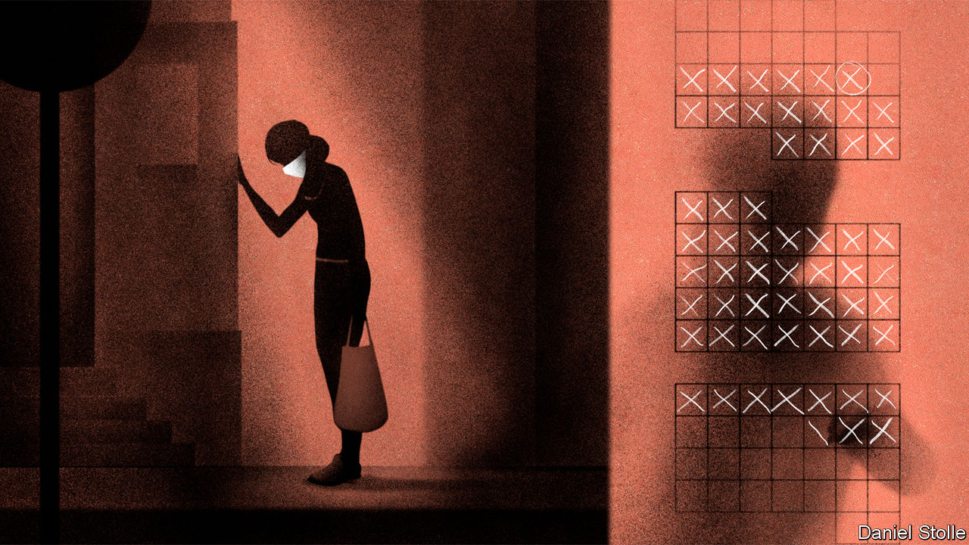

Editor’s note: Some of our covid-19 coverage is free for readers of The Economist Today, our daily [newsletter](https://my.economist.com/user#newsletter). For more stories and our pandemic tracker, see our [hub](https://www.economist.com/news/2020/03/11/the-economists-coverage-of-the-coronavirus)

THE SYMPTOMS began in March, says Laura, a British woman in her mid-20s. At first covid-19 felt like a bad case of flu: a dry cough, fever, shortness of breath, loss of smell, “horrendous nausea” and general fatigue. After three weeks of rest, things started to improve. Five months later, she has still not recovered. Sometimes her symptoms ease for a week or two, but they inevitably return. “When it’s bad I can’t even go on work calls, because if I talk too much I can’t breathe.”

In March, as covid-19 cases began their exponential rise in country after country, doctors focused on saving patients’ lives. Speedy sharing of knowledge, clinical trials and hands-on experience have made the illness less deadly. In Britain about half the patients treated in intensive-care units (ICUs) in the weeks to the middle of April died. By the end of June mortality was below 30%. Reductions were seen across all age groups, which means the fall cannot have been caused by fewer frail old people arriving in hospital (see chart 1). In places where the epidemic has subsided, calmer wards have meant better care. But improved knowledge about treatment probably accounts for much of the improvement.

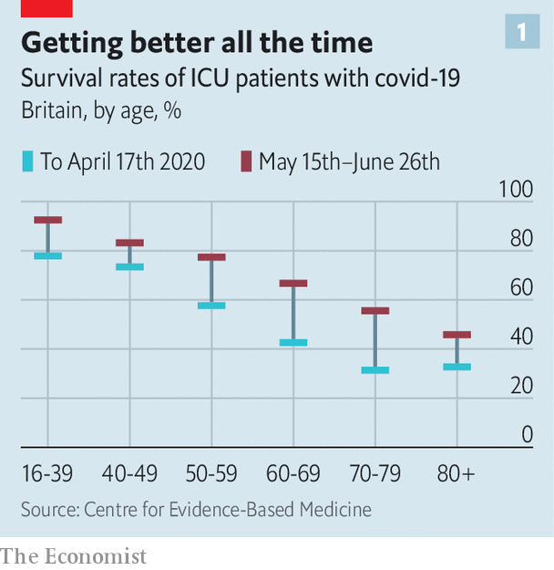

Doctors have learned a lot. They have stopped rushing covid-19 patients onto ventilators, which can cause lung damage. Oxygen supplied through small prongs in the nostrils is much less invasive and often does the job. In British ICUs the share of covid-19 patients on ventilation fell from 90% in the early days to 30% in June. Treatment protocols have improved further with the addition of dexamethasone, an immune-dampening drug that increases survival rates in patients who need oxygen.

Now, though, doctors and scientists are shifting their focus to those who survive the infection—including the subset of people like Laura, who have never been ill enough to be hospitalised, but who have also never recovered sufficiently to return to normal life.

In most people, covid-19 is a brief, mild illness. Between a third and a half of those infected do not notice any symptoms. In those who do become unwell symptoms usually clear within two to three weeks with just home rest. In Europe only around 3-4% of those who become infected are admitted to hospital.

Yet at the same time it is becoming clear that some small but significant proportion of those infected have symptoms that persist for months. Prolonged recovery is not unusual for patients hospitalised for pneumonia, a frequent complication of covid-19. It is also common for people who have been admitted to an ICU, who are by definition seriously ill. But many clinicians say that the share of covid-19 patients with lingering problems is far higher than is seen with other viral illnesses such as influenza. The problems are also more varied, often including lung, heart and psychological symptoms, says Sally Singh of the University of Leicester, who leads the development of a covid-19 rehabilitation programme for Britain’s health service.

## The walking wounded

Anecdotal reports of long-lasting illness have been around since the early days of the pandemic. But with more than 22m cases confirmed worldwide, and with infection rates having peaked several months ago in most rich countries, statistical patterns about the virus’s lingering effects are starting to emerge. A paper in the British Medical Journal on August 11th concluded that as many as 60,000 people in Britain have long-term symptoms. Yet only about 6% of Britain’s population—around 4m people—seems to have been infected with the virus so far.

Severity of the illness is one predictor of lasting problems. Ian Hall, the director of the Biomedical Research Centre at the University of Nottingham, reckons that 30-50% of patients hospitalised with covid-19 have significant symptoms six to eight weeks after they have been discharged. That number rises further for patients who were admitted to an ICU. But even those who escaped with a mild illness, like Laura, are at risk. More than 10% of them remain unwell for more than three weeks, according to a patient-tracking study that follows mostly American and British patients. They struggle with fatigue, breathlessness, body aches and cognitive problems which many describe as “brain fog” (see chart 2).

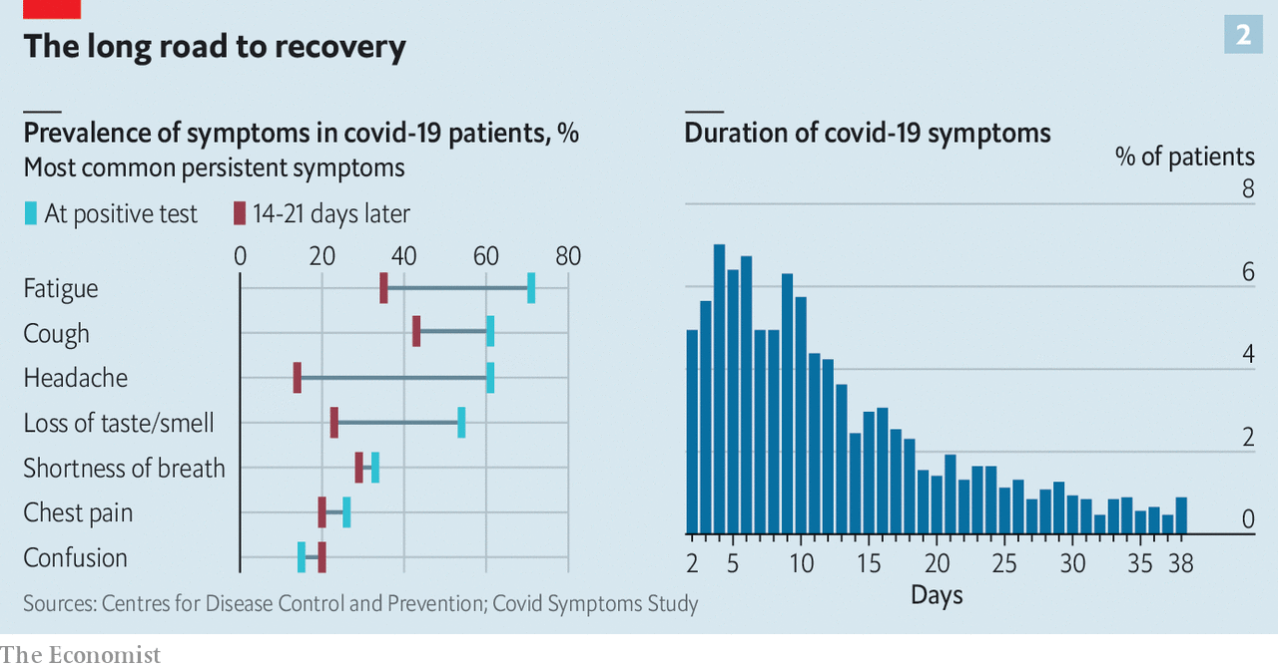

Some long-term covid-19 patients may be suffering from undiagnosed conditions such as diabetes or thyroid dysfunction, which are “unmasked” by the infection, says Avindra Nath of the National Institutes of Health in America. For others, the collection of symptoms is suggestively similar to those seen in chronic fatigue syndrome (CFS). The biological causes of CFS are still poorly understood, but data from America indicate that three-quarters of cases follow viral or bacterial infections. One hypothesis is that the syndrome is caused by the immune system failing to properly stand down after being called on to battle an infection. It may be that SARS-CoV2, the virus that causes covid-19, is unusually likely to provoke such a lingering over-reaction.

If the root cause is not known, then the growing understanding of just what covid-19 can do to the body can at least suggest what sorts of care long-term sufferers may need. The hallmark of many covid-19 cases is damage to the lungs. Aggressive inflammation leads to the destruction of lung tissue and the formation of scars. The scarring, in turn, impedes the flow of oxygen from the lungs into the blood. That can cause breathlessness, even with light exercise. Small studies of covid-19 patients discharged from hospitals have found that 25-30% have impaired oxygen flow.

The prognosis is unclear. People treated in ICUs for other viral infections usually recover about 80% of their previous lung function fairly quickly, but the final 20% can take three to six months, says Dr Hall. And in some cases lung scarring can worsen over time, especially if combined with new health problems later in life.

Breathing problems can also arise from another effect of covid-19—its tendency to cause blood clots, which is unusual for a respiratory virus. When they form in the lungs, clots can choke off blood flow, making it even harder to absorb oxygen. And the virus may cause breathlessness in a more subtle way, too, by damaging the lining of blood vessels, which limits how much blood can flow through them.

Covid-19 can also damage the heart. It can inflame the tissues that surround the organ, as well as the blood vessels that ferry nutrients to it. That can weaken the heart muscle, and eventually lead to heart failure. Blood clots cause problems here, as well, since the heart must pump harder to push blood through partly blocked vessels. Over time, that can weaken the muscle.

Nobody knows exactly how often such cardiac complications occur. But news from Germany is worrying, says Clyde Yancy, a cardiologist at Northwestern University, in Illinois. Using MRI scans, one study found evidence that covid-19 causes inflammation and other heart changes—including in people who had tested positive for the virus more than two months earlier and were, by the time of their scans, free from symptoms. The changes were small, and not enough by themselves to cause clinical symptoms. But even a minor injury to the heart may eventually lead to heart failure if it lingers for long enough, says Dr Yancy.

Least understood are the long-term effects of covid-19 on the nervous system and the brain. Patients with lingering post-covid symptoms complain of headaches, tingling and numbness in the feet, and other neurological problems. Problems that suggest a dysfunction of the autonomic nervous system, such as irregular heart beat, dry mouth and gastrointestinal problems are also common, says Dr Nath. But the exact cause of such symptoms remains unclear, as does the reason why more than half of those infected suffer a temporary loss of their sense of smell. (Some, rather than losing it, have it altered instead, so that things smell different after the infection than they did beforehand.)

Confronted with a baffling array of symptoms and few detailed explanations about exactly what is going wrong, doctors are desperate for guidance. A third of general practitioners in Britain already have patients with lasting post-covid symptoms. For now, the best they can offer is referral to lung or cardiac rehabilitation. Such therapy may improve a patient’s quality of life with something as simple as a breathing exercise. Britain, Belgium and other countries are setting up specialised covid-19 rehabilitation programmes for those recovering from the disease. Waiting lists are already long.

In the absence of understanding, doctors must fall back on lessons from other illnesses. Lingering symptoms are not the exclusive preserve of covid-19. Full recovery from other viral diseases such as influenza can occasionally take months. Data on CFS suggests chances of recovery are best in the first three months.

More specific data are on the way. Studies in America, Britain, China and Europe have enrolled thousands of patients, and should begin reporting initial results in the next few months. But for now, those suffering the lingering effects of the disease must deal not only with the physical symptoms, but with uncertainty about just how long it will take them to get better. ■

This article was downloaded by calibre from <https://www.economist.com/science-and-technology/2020/08/22/when-covid-19-becomes-a-chronic-illness>

|  |  |  |  |
| --- | --- | --- | --- |
|  | Articles | Sections | Next |

|  |  |  |
| --- | --- | --- |
| Science & ... | Sections | Economic & ... |

Books & arts

The American story: Twentieth-century fox

.

Johnson: Moral minorities

.

Colombia: A river and a nation

.

Home Entertainment: In the mind’s eye

.

British fiction: Unmoored

.

|  |  |  |
| --- | --- | --- |
| Science & ... | Sections | Economic & ... |

|  |  |  |  |
| --- | --- | --- | --- |
|  | Articles | Sections | Next |

#### Twentieth-century fox

# Albert Murray was a bard of America’s racial complexity

In his essays and criticism, he insisted that black and white Americans shared a common culture

Aug 22nd 2020 | WASHINGTON, DC

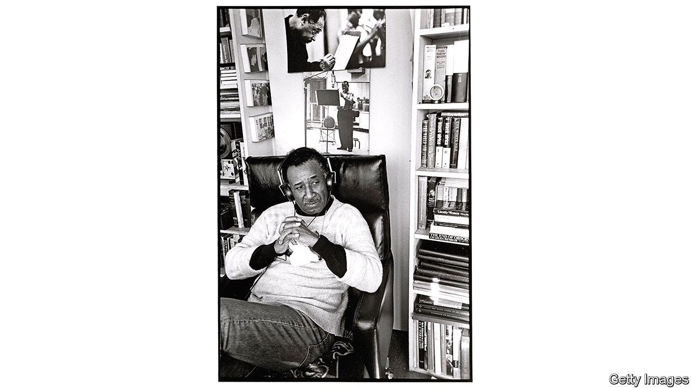

THE ORIGINAL sins of American race relations are as stark as they were horrific. For over two centuries, black people were enslaved. For decades afterwards they endured legal and de facto segregation, and, in the South—where Albert Murray grew up—forced labour and peonage imposed through convict-leasing and sharecropping. These brute facts bequeathed pain and injustice. But they also left a complex cultural legacy. Murray probed that complexity as deeply, seriously and joyously as any American writer.

He was a poet and novelist and—most lastingly—an essayist and critic. He wrote elegantly about art, music, literature, travel and people. He was, in Isaiah Berlin’s taxonomy, one hundred percent fox, viewing the world through many lenses (as opposed to the single perspective of the hedgehog). His life was an American hero’s journey—and his work is as urgent now as when it was first published.

Born in 1916 to an unmarried 16-year-old in Nokomis, Alabama, Murray was brought up by adoptive parents near Mobile, among survivors of the Clotilda, the last ship to bring enslaved Africans to America. He came to know—or at least know of—Cudjo Lewis, a Clotilda survivor whom Murray turned into Unka Jo Jo in his first novel, “Train Whistle Guitar” (published in 1974). He died 97 years later in Harlem, having helped create the jazz programme at New York’s Lincoln Centre, been elected to the American Academy of Arts and Letters (and of Arts and Sciences), and lived a life of the mind that should make today’s writers weep into their Twitter feeds.

## Don’t miss the comedians at the Apollo

At the heart of his work was a belief in the heroism of artistic struggle and expression—not as a route to fame, riches or influence, nor to express political views, but as a means to make sense of the world and an individual’s place in it. As he wrote in “Stomping the Blues” (1976), an extended explication of jazz and blues, America’s greatest native art forms, artists confront “the complexities inherent in the human situation”. For Murray, “human existence is almost always a matter of endeavour and hence also a matter of heroic action.”

At the Tuskegee Institute in Alabama he met Ralph Ellison, who, Murray noticed, had taken out many of the same books that he had. They were intellectual comrades for much of their lives, both preoccupied with the range of the American experience and the central role of black people in it. As Ellison put it, “Whatever else the true American is, he is also somehow black.” But they took inverse paths as writers. Ellison published just one novel in his lifetime, “Invisible Man”, one of America’s greatest, in 1952.

By contrast, Murray did not publish his first book, “The Omni-Americans”, until 1970, after a career in the air force that had begun during the second world war. His last, a series of interviews with Papa Jo Jones, a mercurial drummer, came out when he was 95. Both he and Ellison viewed improvisational jazz and blues musicians, able to conduct conversations without words, as the supreme artists. He mimicked their back and forth on the page: among the most joyful passages in his memoir, “South to a Very Old Place” (1971), is his perfect orchestration of a barbershop chat about race relations that he overheard during a return visit to Mobile.

This late start meant that Murray’s voice emerged fully formed. It is learned and didactic, yet playful and nuanced—and above all, highly attuned to multiplicity, and suspicious of generalisation. He rejected the claim, common among white southerners during segregation, that black and white Americans had two separate cultures. “American culture,” he wrote in “The Omni-Americans”, “even in its most rigidly segregated precincts, is patently and irrevocably composite…the so-called black and so-called white people of the United States resemble nobody else in the world so much as they resemble each other.”

Murray had an aversion to social scientists who portrayed black Americans as uniformly downtrodden. In his view, “the background experience of US Negroes includes all of the negative things that go with racism and segregation; but it also includes all of the challenging circumstances that make for ambition, integrity and transcendent achievement.” For him, the liberal tendency to find black people pitiable was a moral and aesthetic failing, which often stopped whites seeing African-American life in its full splendour and variety.

Similarly, he had little patience for black separatism, which he viewed as shallow escapism: “So far as white people are concerned, the most revolutionary, radical and devastating action any US Negro can engage in is to compete with other Americans for status, employment, total social equality and basic political power.” He regarded black Americans not as displaced Africans but as wholly and irreducibly American—not merely partakers of American culture but its creators and, as much as anyone else, its proprietors.

The literary corollary of that stance was a dislike of protest fiction. Murray approvingly quoted James Baldwin’s assessment of “Uncle Tom’s Cabin”: a book “not intended to do anything more than prove that slavery was wrong; was, in fact, perfectly horrible. This makes material for a pamphlet but it is hardly enough for a novel.” But Murray castigated Baldwin himself for failing to fulfil his promise, and for writing about Harlem’s woes without its wonders. “Sometimes he writes as if he had never heard the comedians at the Apollo Theatre,” Murray teased, chiding Baldwin for leaving material untapped. “Life in Harlem is the very stuff of romance and fiction, even as was life in Chaucer’s England, Cervantes’ Spain, Rabelais’ France.”

He seemed to esteem Thomas Mann and James Joyce highest among novelists, and, like some of theirs, his four novels are in essence coming-of-age tales—beautifully written, replete with memory and detail, but lacking his essays’ spark and thrust. Like his poems, in their richness they make an implicit argument against what he called “the folklore of white supremacy and the fakelore of black pathology”.

Those last four words are more important than they may seem. The “fakelore” is not that some black people are disadvantaged; it is that they are responsible for that disadvantage, and defined by it. Murray did not downplay whites’ role in black Americans’ plight. As he averred in “The Omni-Americans”: “The deliberate debasement of the black image has been so viciously systematic…that the scope of white malevolence is hard to exaggerate.” But he did not end in outrage or despair. The glory of the blues man, Murray wrote, is his gift for eliciting beauty from sorrow and struggle, thus becoming “an agent of affirmation and continuity in the face of adversity”.

Reading Murray now is exhilarating, as great writing always is. It is also poignant. Today America is less racially stratified than during his formative years in the early 20th century, but it remains much more so than it ought to be. Fixing that is the work of policy, which did not seem to interest Murray much as a writer. What concerned him was a proper reverence for self-definition: for judging people first as individuals, rather than members of a group.

The novels of William Faulkner were his lodestar. Faulkner’s fiction took in the struggles of African-Americans, even making them heroic. But his underlying point, for Murray, was not “that the meek shall inherit the Earth. His point was that no man could inherit the Earth, that the only thing worth inheriting is humanity.” ■

This article was downloaded by calibre from <https://www.economist.com/books-and-arts/2020/08/22/albert-murray-was-a-bard-of-americas-racial-complexity>

|  |  |  |  |
| --- | --- | --- | --- |
|  | Articles | Sections | Next |

|  |  |  |  |
| --- | --- | --- | --- |
| Previous | Articles | Sections | Next |

#### Johnson

# How a contested region became a model for multilingual coexistence

Schools are at the heart of the success on the German-Danish border

Aug 22nd 2020 |

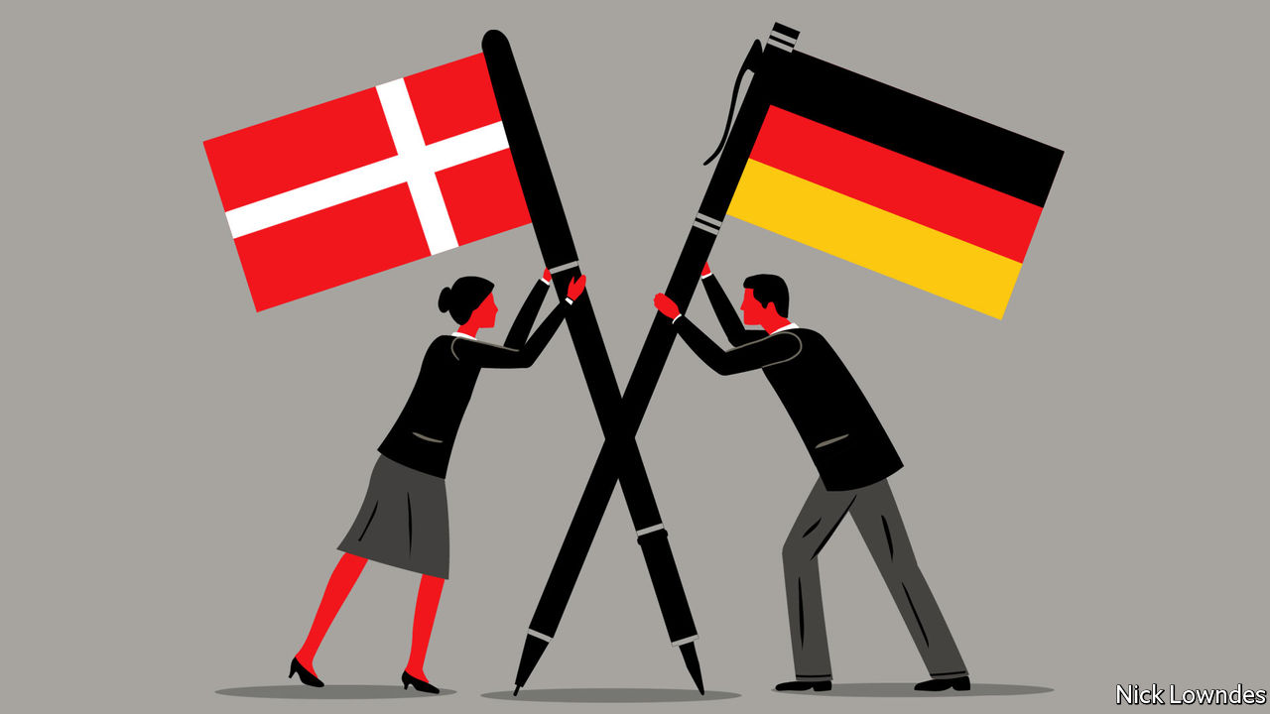

DIFFERING NAMES for a historical event can be an ominous sign of competing, zero-sum national memories. Not so in the case of what Germans refer to as “the plebiscite of 1920”. That round of votes, which cost Germany the territory of north Schleswig, led to what Danes call the “reunification” of their country, the centenary of which they recently celebrated. It also began a process that has turned a bloody European frontier into one of the world’s most successfully integrated and multilingual border regions.

Territory controlled by Denmark once extended deep into what is now the German state of Schleswig-Holstein. But successive defeats, especially to Prussia in 1864, saw the border pushed up the Jutland peninsula. After the first world war much of Germany (and Austria-Hungary) was hacked out to create new states or to reward winners, which left many new minorities stranded in the “wrong” country. Denmark had sat out the war, but managed to get the victors to support a plebiscite in Schleswig.

A northern zone voted convincingly to join Denmark, and a southern one to stay in Germany. The border was redrawn. But Danes remained in Germany and Germans in Denmark, fomenting bad blood. The Nazis occupied Denmark during the second world war.

The true settlement came in 1955. To join NATO, West Germany had to agree to make nice with Denmark. The Bonn and Copenhagen declarations gave generous support to both minorities: German-speakers in Denmark could go to private schools teaching in German, with the state picking up the tab; the same went for Danes in Germany. The momentum continued when Denmark joined the European Economic Community (now Union) in 1973, and when the border in effect disappeared entirely with the advent of the passport-free Schengen zone.

Schools are at the core of what became a remarkable success. A typical German school in Sonderborg in Denmark, not far from the city’s German Museum, displays the German, Danish and European flags, with the motto “Two languages, two cultures” in Danish and German. The minority-language schools are much sought after, not only by members of the minority. Parents who do not speak the schools’ language choose them for reasons of quality, says Martin Klatt, a historian at the University of Southern Denmark and a German who sent his children to a Danish-medium school in Flensburg.

Another parent who did likewise is Robert Habeck, co-leader of Germany’s Green party. He grew up in Schleswig-Holstein and picked up Danish as a student. Later he sent his four sons to Danish schools, from which they brought home customs—such as flying the Danish flag on birthdays—that he now happily adopts. Mr Habeck has a small chance of making it to the very top of German politics at the next election: he could be chancellor if a coalition emerges with two other left-wing parties.

For a leader to show such deep ties to another country would be unthinkable in many places. Germany, of course, eschewed overt nationalism after 1945. That has led to warm neighbourly relations; there was no question of Danish triumphalism when “reunification” was marked. When a leader of the populist-nationalist Danish People’s Party suggested a few years ago that he would like to see the border moved down to the Eider river, he soon clarified that he had commented with “a twinkle in my eye” and that “we have the best border co-operation anyone could hope for.”

The region is not properly bilingual. Most Germans, in particular, do not learn much Danish. Flemming Meyer, head of the ethnic Danish party in the state of Schleswig-Holstein, would like more people to take up the generous opportunities to study and practice the other tongue; he envisions a campaign under the banner “Speak our neighbours’ language!” But it can be hard to convince Germans to focus on a language with just 5.5m or so speakers. On the other side of the border the Danes, who once had fairly good German, now prefer English. The lingua franca is both a boon (being neutral) and a drawback (removing the incentives to learn an alternative).

But Mr Meyer sees relations continuing to warm. Once, Germans near the border spoke derisively of Dänenschulen, schools for Danes. Then, in a subtle shift, they became dänische Schulen, the adjective replacing the essentialising noun. Now he hears unsere dänischen Schulen, the local majority speaking proudly of “our Danish schools”.

This article was downloaded by calibre from <https://www.economist.com/books-and-arts/2020/08/22/how-a-contested-region-became-a-model-for-multilingual-coexistence>

|  |  |  |  |
| --- | --- | --- | --- |
| Previous | Articles | Sections | Next |

|  |  |  |  |
| --- | --- | --- | --- |
| Previous | Articles | Sections | Next |

#### A river and a nation

# An enchanting trip down the mighty Magdalena

“Colombia as a nation,” writes Wade Davis, “is the gift of the river”

Aug 22nd 2020 |

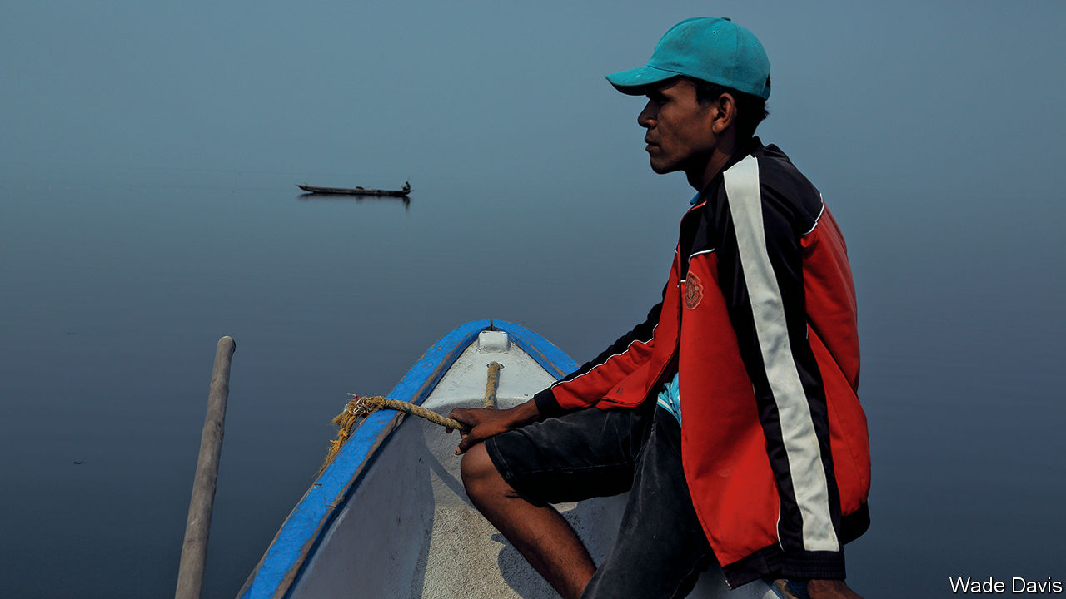

Magdalena: River of Dreams. By Wade Davis. Knopf; 432 pages; $30. Bodley Head; £25

FOR A COUNTRY of 50m people, Colombia has been strangely overlooked and often misunderstood. A generation ago it was a pariah nation, synonymous for outsiders with drug-trafficking and violence. Yet Colombia has gradually moved towards internal peace, disarming right-wing paramilitaries and left-wing guerrillas, while maintaining a vibrant civil society and finding a place for indigenous peoples and environmentalism in its democracy. Colombians are characterised, writes Wade Davis, not just by their resilience but also by “an enduring spirit of place, a deep love of a land that is perhaps the most bountiful on Earth, home to the greatest ecological and geographical diversity on the planet”.

Its heart and soul is the Magdalena river. It defines Colombia rather as that other great river that empties into the Caribbean, the Mississippi, does the United States. It bisects the country, from its source in a high-altitude bog not far from the southern border with Ecuador, to the vast tropical wetlands and lagoons of its lower course. Four out of five Colombians live in its drainage. For centuries it was their main transport artery. It is, too, “the wellspring of Colombian music, literature, poetry and prayer,” Mr Davis argues. “Colombia as a nation is the gift of the river. The Magdalena is the story of Colombia.”

The author and his subject make an ideal match. Mr Davis, a Canadian writer, anthropologist and explorer, fell in love with Colombia on a school trip at the age of 14, and returned often. In this book he travels the thousand-mile length of the river, on foot, horseback, by car or—often—by boat. What lifts his account far above a run-of-the-mill travelogue is that he organised some remarkable and knowledgeable companions. They start with William Vargas, a botanist who grew up on the river’s upper course and has discovered more than 100 plant species. Mr Vargas is the perfect guide to the country’s extraordinary wealth of flora and fauna.

The Magdalena’s middle course was the bloody backyard of Colombia’s long internal conflict. Its riverside towns were an internal frontier terrorised by guerrillas and paramilitaries, its waters a graveyard for victims. Mr Davis meets survivors and hears harrowing stories of horror and loss. What comes through is the determination of many to forget the past and move on. The river’s lower course, celebrated in the writing of Gabriel García Márquez, is home to many zambos (of mixed African and Amerindian descent) who have created much of Colombia’s rich musical tradition of cumbia, vallenato and tambora.

As an anthropologist, Mr Davis is sympathetic to Colombia’s indigenous cultures, and sensitive to the often tragic clash of belief systems—a theme of his previous work, “Into the Silence”, on British expeditions to the Himalayas. His prose has an incantatory timbre, which occasionally cloys but often carries the reader deep into Colombian ethnography and ecology.

For the most part, he is admirably judicious in his treatment of the country’s complex conflicts. He skilfully weaves into his journey themes and episodes of Colombian history, from the Spanish conquest to the battles of Liberals and Conservatives and the tragedy of the volcanic eruption of the Nevado del Ruiz. Twice that difficult balance eludes him, in long detours on Pablo Escobar and the fall and rise of Medellín (the city that was home to Escobar’s cartel), and on Símon Bolívar, the Venezuelan who led the struggle for independence from Spain. Here Mr Davis has nothing original to say. Like many good tourist guides, he sometimes over-embroiders: some of what he claims as uniquely Colombian applies equally to other Latin American countries.

But these are minor blemishes. “Magdalena” is a revelatory and often enchanting book, enhanced by fine photographs and good maps (though some readers might have wished for a glossary). Mr Davis also has a message. In recent decades the river has become a sewer, to the extent that it faces partial ecological death. Its cleansing and redemption could and should be a matter of national pride. ■

This article was downloaded by calibre from <https://www.economist.com/books-and-arts/2020/08/22/an-enchanting-trip-down-the-mighty-magdalena>

|  |  |  |  |
| --- | --- | --- | --- |
| Previous | Articles | Sections | Next |

|  |  |  |  |
| --- | --- | --- | --- |
| Previous | Articles | Sections | Next |

#### Home Entertainment

# For your summer getaway, try an imaginary city

Italo Calvino’s “Invisible Cities” are all versions of Venice

Aug 22nd 2020 |

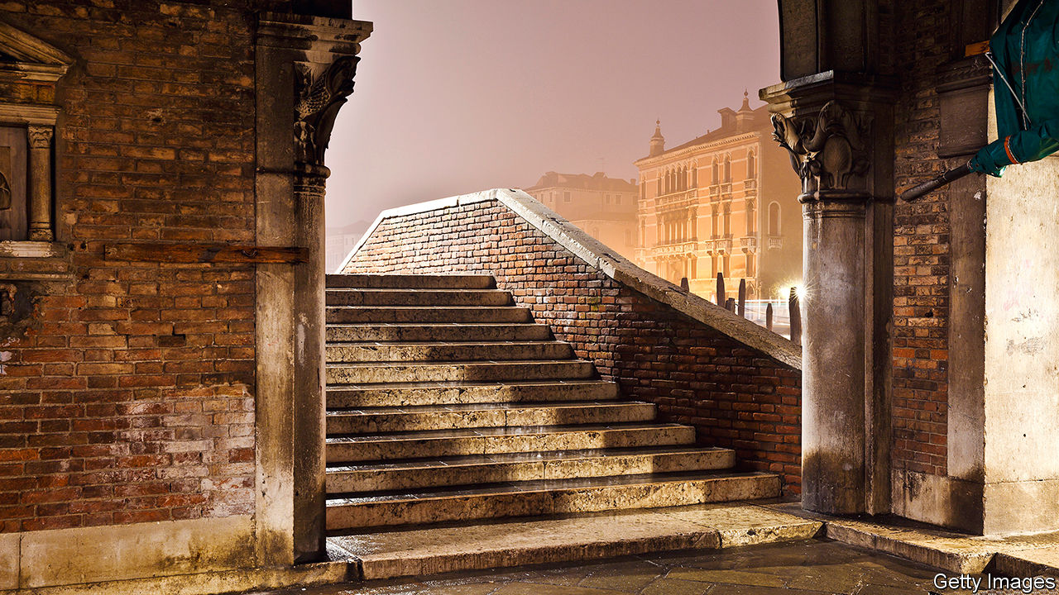

LOOKING FOR a summer getaway? Try the city of Isidora, “where the buildings have spiral staircases encrusted with spiral seashells”. Or perhaps Anastasia, famed for its golden pheasant cooked “over fires of seasoned cherry wood and sprinkled with much sweet marjoram”, a place where “your desires waken all at once and surround you”. Seeking somewhere even more adventurous? Consider Octavia, which is built on ropes, chains and catwalks across a void between two mountain peaks.

This fantastical itinerary awaits readers of “Invisible Cities”, Italo Calvino’s masterpiece of 1972. Nominally a series of tales that Marco Polo tells Kublai Khan, it is actually a collection of layered, labyrinthine meditations on cities, memory, desire and language. Conversations between the traveller and the emperor frame 55 short prose-poems, each describing one city and following a strict mathematical structure that bears the hallmark of the avant-garde Oulipo movement to which Calvino belonged. All these cities are simultaneously visions from Calvino’s imagination and versions of Polo’s home town, the most splendid city of all, Venice. “Memory’s images, once they are fixed in words, are erased,” Polo says (in William Weaver’s translation from the Italian). “Perhaps I am afraid of losing Venice all at once, if I speak of it. Or perhaps, speaking of other cities, I have already lost it, little by little.”

“Invisible Cities” is a short book but should be savoured slowly, like an Aperol spritz on Campo Santa Margherita at dusk. Sip, sit, and let your perspective bend under its spell. You need not go to a city in person to visit it, the book shows. The richest travels are those along the thoroughfares of the mind—a welcome insight in this era of trips not taken, sights not seen, back streets not explored. Or as the Khan comes to understand: “The empire is nothing but a zodiac of the mind’s phantasms.”

For Calvino’s cities are manifestations of ideas, thought experiments in urban form. In frenetic Thekla, construction never stops so that destruction can never begin. Unhappy Raissa “contains a happy city unaware of its own existence”. Over the course of the book, the mood darkens, the cities taking on the tones of a waning empire. In Theodora, the penultimate stop, humans have extinguished every other species, down to the spiders and the rats.

Echoing Dante, the Khan sees his empire devolving into an “infernal city”. But the inferno of the living, Polo tells him, is already here. He offers the Khan a bit of timeless advice on how to escape its suffering: “The first [way] is easy for many: accept the inferno and become such a part of it that you can no longer see it,” he says. “The second is risky and demands constant vigilance and apprehension: seek and learn to recognise who and what, in the midst of the inferno, are not inferno, then make them endure, give them space.” ■

This article was downloaded by calibre from <https://www.economist.com/books-and-arts/2020/08/22/for-your-summer-getaway-try-an-imaginary-city>

|  |  |  |  |
| --- | --- | --- | --- |
| Previous | Articles | Sections | Next |

|  |  |  |  |
| --- | --- | --- | --- |
| Previous | Articles | Sections | Next |

#### Unmoored

# In “Sisters”, love and danger are grippingly entwined

Daisy Johnson’s novel is an ode to sisterly devotion—and a warning

Aug 22nd 2020 |

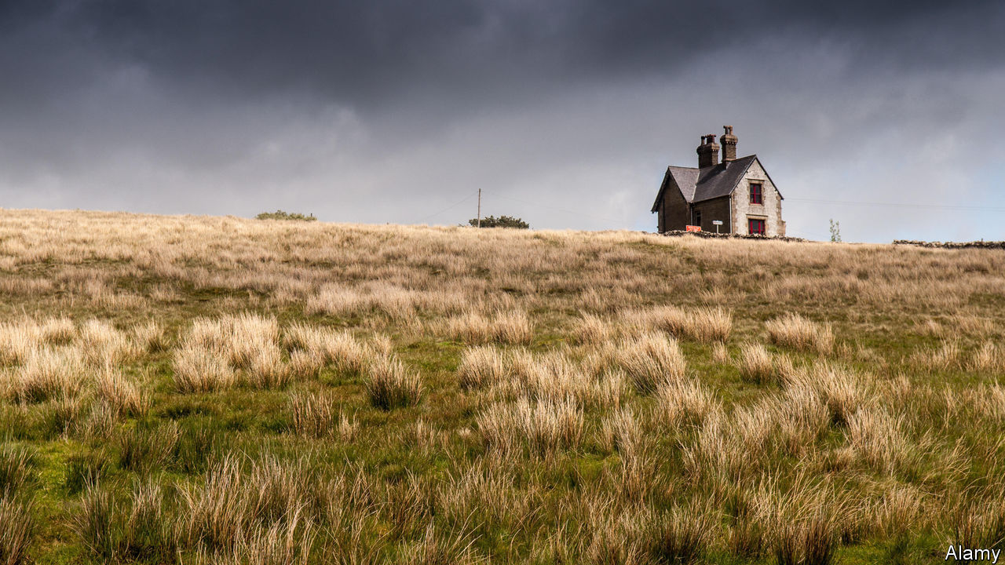

Sisters. By Daisy Johnson. Riverhead Books; 224 pages; $26. Jonathan Cape; £14.99

THE STORIES Daisy Johnson tells are at once heart-rending and hair-raising. Her prose is elegantly emotional; her plotting would make Shirley Jackson, a master of upmarket horror, proud. “Sisters”, her second novel, is a gripping, if nightmare-inducing, tale.

July and September, the siblings of the title, and their mother Sheela have left Oxford for a remote rented house on the Yorkshire moors, driven to a new life by a shadowy event for which July blames herself. That incident hovers over the novel, adding a layer of menace to the ominous atmosphere of the family’s new home. Ominous, too, is Sheela’s retreat to her bedroom; she emerges only at night, otherwise leaving her daughters to their own devices—which, in practice, means leaving September in charge of July.

Often, thrillers and horror stories rely on conflicts between love and danger. In “Sisters” the two are fused. September and July adore each other. At first their relationship seems their saving grace, but it slowly modulates from balm to threat. July loathes being separated from her sister—which puts her at constant risk, since September is domineering to the point of violence, extracting terrible oaths of loyalty and goading July to self-harm.

Ms Johnson tells most of the story from July’s perspective. When she briefly switches to Sheela’s point of view, it is no surprise to learn of the “things the teachers said about [the girls] at school: isolated, uninterested, conjoined, young for their age, sometimes moved to great cruelty.” The shock is discovering their real age.

The disjuncture between how old they are and how old they seem builds an uncanny kind of suspense: clearly, something has gone very wrong. When July finds a love interest, her feelings are a relief. But they are also a force for rupture and change. As her relationship with September is strained, July starts to remember the event that drove them from Oxford. The revelation to which Ms Johnson has stealthily progressed proves devastating. “Sisters” is an ode to sisterly love—and a warning of how destructive devotion can be.

This article was downloaded by calibre from <https://www.economist.com/books-and-arts/2020/08/22/in-sisters-love-and-danger-are-grippingly-entwined>

|  |  |  |  |
| --- | --- | --- | --- |
| Previous | Articles | Sections | Next |

|  |  |  |
| --- | --- | --- |
| Books & arts | Sections | Graphic detail |

Economic & financial indicators

Economic data, commodities and markets

.

|  |  |  |
| --- | --- | --- |
| Books & arts | Sections | Graphic detail |

|  |  |  |  |
| --- | --- | --- | --- |
|  | Articles | Sections | Next |

# Economic data, commodities and markets

Aug 22nd 2020 |

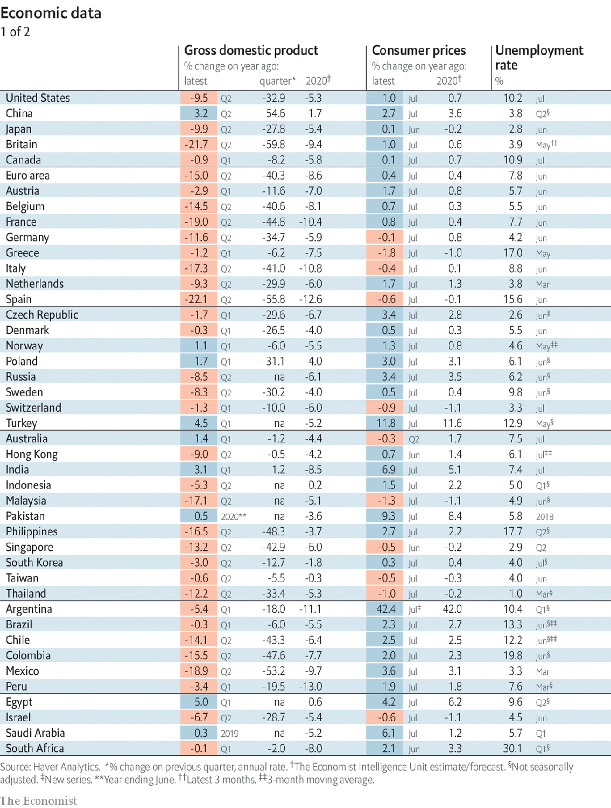

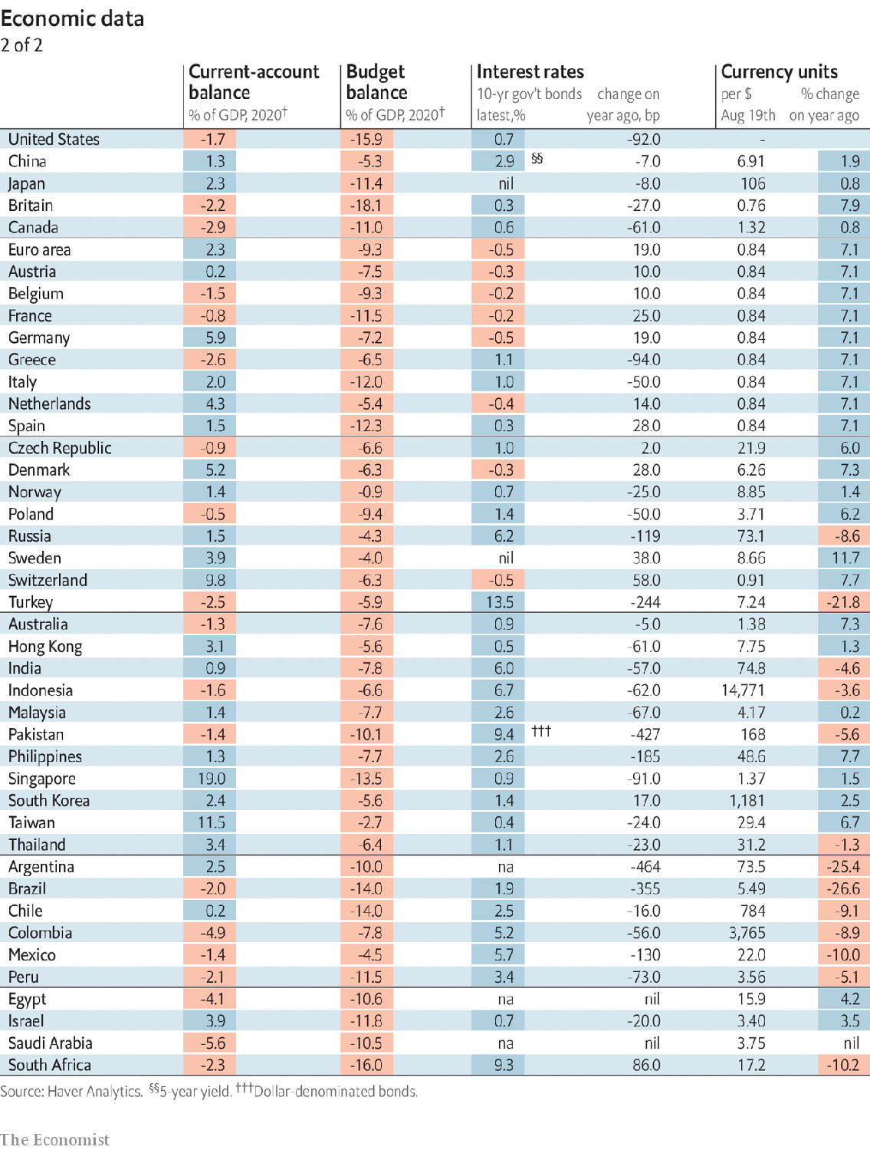

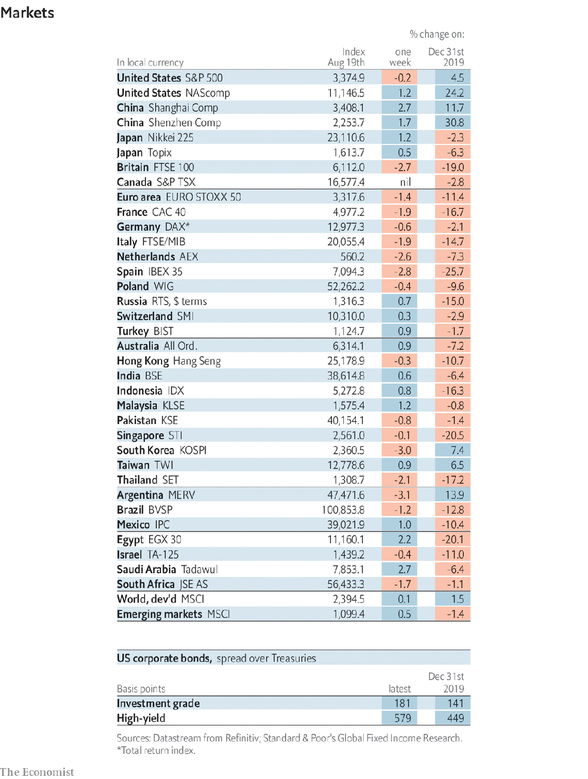

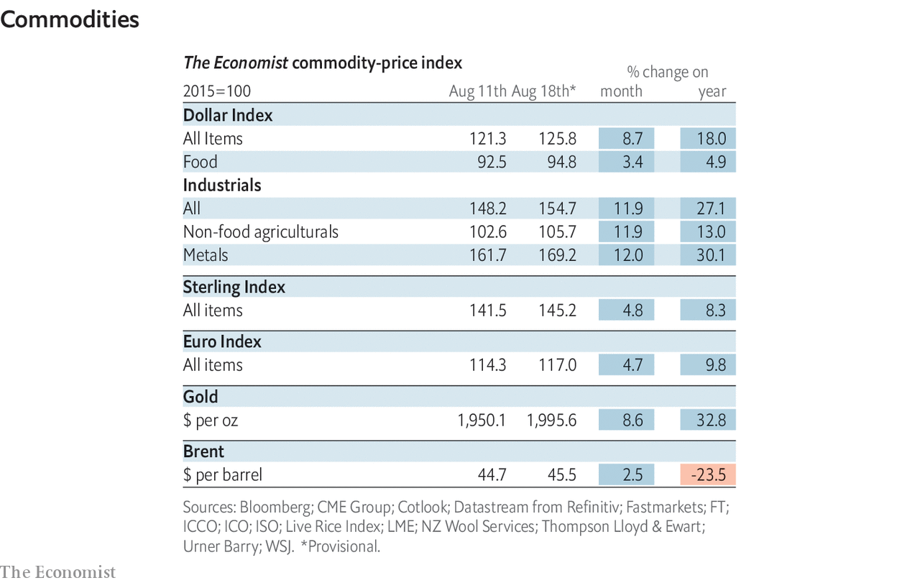

This article was downloaded by calibre from <https://www.economist.com/economic-and-financial-indicators/2020/08/22/economic-data-commodities-and-markets>

|  |  |  |  |
| --- | --- | --- | --- |
|  | Articles | Sections | Next |

|  |  |  |
| --- | --- | --- |
| Economic & ... | Sections | Obituary |

Graphic detail

Authoritarianism: Drifting apart

.

|  |  |  |
| --- | --- | --- |
| Economic & ... | Sections | Obituary |

|  |  |  |  |
| --- | --- | --- | --- |
|  | Articles | Sections | Next |

#### Drifting apart

# A rift in democratic attitudes is opening up around the world

People from weak democracies are increasingly likely to support autocrats

Aug 22nd 2020 |

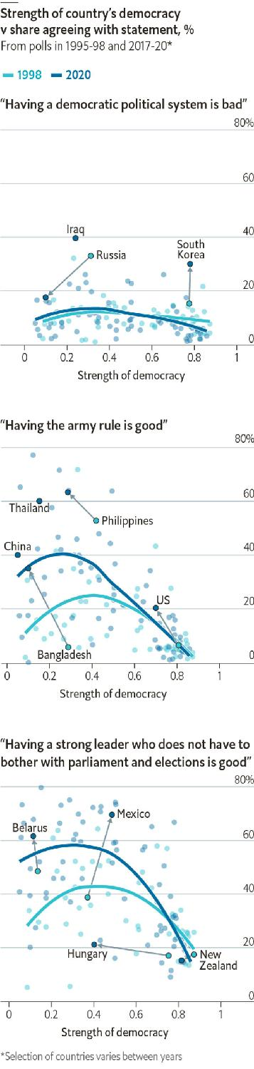

IS DEMOCRACY ON the rise or in decline? Proponents of either claim could find supporting evidence in this week’s headlines. In Belarus and Thailand protesters are trying to topple draconian regimes. Meanwhile, the leader of the free world wants to restrict postal voting and China is rounding up dissidents in Hong Kong.

Looking across the globe, however, academics generally agree that democracy is in a slump. One much-watched barometer is the World Values Survey (WVS), a poll published twice a decade. We combined its data with those from the European Values Survey to study trends in 98 countries from 1995 to 2020. Our analysis found that support for autocrats has indeed grown in most parts of the world, but this effect is weakest in healthy democracies, despite their recent flirtations with populism.

Since 1995 the WVS has asked people to rate several types of government as good or bad for their country. Among the options are “having a democratic political system”, “having the army rule” and “having a strong leader who does not have to bother with parliament and elections”. In the latest wave, only about a tenth of respondents were willing to describe democracy as a bad thing. However, nearly a quarter of them said that having the military in charge is a good thing, and more than two-fifths were in favour of strongmen who would ignore the outcomes of elections.

When analysing changes in these sentiments, we compared them with countries’ actual levels of political freedom, as measured by the University of Gothenburg. On average, we found a big increase in support for despots in flawed democracies, but little change in places with lots of political freedom. For example, Mexico’s approval for a strongman leader has surged from 39% to 70% over the past two decades, whereas New Zealand’s ebbed from 17% to 15%. Contrary to widespread fears about the death of democracy in the West, the share of people who think it is a bad system has fallen in the past decade in ten of the 15 most wealthy and free countries.

Using the WVS’s individual-level data, we built statistical models which predict the attitudes of a hypothetical person in a given country and year. We estimated the opinions of a 40-year-old person with middling education, ideology and income, to test the impact of a change in a single characteristic on their overall beliefs.

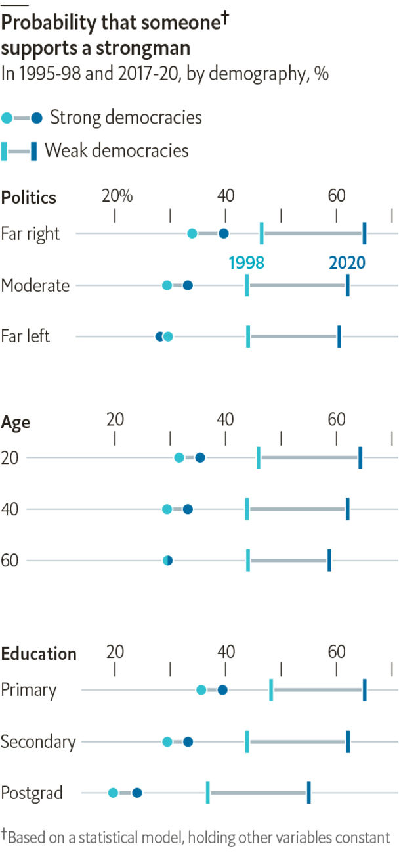

In highly democratic countries, our model thinks the probability that such a middling person would favour a strongman rose from 29% to 33% between 1998 and 2020. And in countries with unhealthy democracies, the increase for such a middling person has been far greater, rising from 44% to 62%. The growth has been particularly high in Latin America, South-East Asia and former Soviet states.

Like previous analysts of the WVS, we found that young people tend to be the most susceptible to autocratic preferences. Right-wing and less-educated people also lean that way. But in countries where enthusiasm for despots is rising strongly, the growth seems to be similar across demographic groups. Whatever is driving people towards strongmen is affecting entire countries, not just cohorts within them. ■

Sources: World Values Survey; European Values Survey; V-Dem Institute, University of Gothenburg;The Economist

This article was downloaded by calibre from <https://www.economist.com/graphic-detail/2020/08/22/a-rift-in-democratic-attitudes-is-opening-up-around-the-world>

|  |  |  |  |
| --- | --- | --- | --- |
|  | Articles | Sections | Next |

|  |  |  |
| --- | --- | --- |
| Graphic detail | Sections |  |

Obituary

Julian Bream: Passion plays

.

|  |  |  |
| --- | --- | --- |
| Graphic detail | Sections |  |

|  |  |  |  |
| --- | --- | --- | --- |
|  | Articles | Sections | Next |

#### Passion plays

# Julian Bream died on August 14th

The player who restored the reputation of both the classical guitar and the lute was 87

Aug 22nd 2020 |

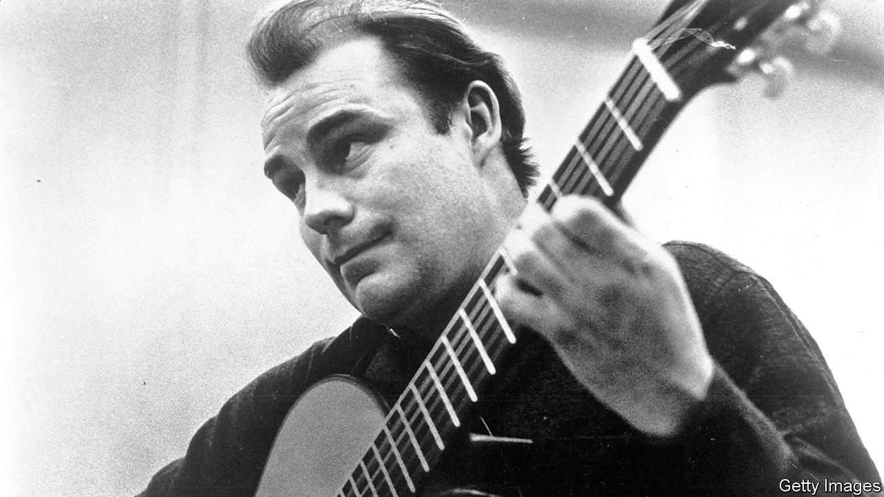

ALMOST AS SOON as he started his long love affair with the guitar, Julian Bream was aware he was doing something disreputable. When he was caught as a teenager practising Bach in the Royal College of Music, he was warned not to bring that instrument into the building again. It lowered the tone. Signing on to do his National Service in an army band, he was told he could play piano and cello, fine, but the guitar only “occasionally”. Audiences clapped long and hard when he performed in the Wigmore Hall at 18, in 1951, but as he toured round Britain in the mid-1950s, sleeping in his Austin van to save on hotels, not many came to hear him. The guitar was not a proper instrument, somehow. Its voice was too soft to carry over an orchestra. The electric version was for pumped-up rock ’n’ rollers, the non-electric for holidays in Spain. And from Spain, the spiritual and historical home of the guitar, came the loudest scorn of all. An Englishman playing a guitar, said one virtuoso, was a kind of blasphemy.

But this Englishman, almost as devoted to cricket and dogs as to music, was in love, and nothing was going to deter him. His life’s passion was to restore the guitar’s reputation as a serious instrument, to bring its acres of repertory to the public, and to open their eyes to its beauty. He offered a different approach, clarity and a certain coolness, against the emotional vibrato of the Spanish style. To get the message across he toured the world, picked up four Grammys in the process, encouraged the building of guitars in England, and asked the best composers of the day—Benjamin Britten, William Walton, Michael Tippett, Hans Werner Henze—to write pieces for an instrument they had never considered before. His methods of persuasion were chummy and larky, as might be expected of a South Londoner, proudly born in Battersea between the power station and the dogs’ home: convivial drinks, invitations to his farmhouse in Dorset, races round the lanes in his classic cars, demonic table-tennis games. And they worked.

In effect he had two lives. One was the gregarious whirl of jet planes, hotels, parties and interviews, when he would throw himself around in his chair with the sheer joy of talking guitars. The other was rapt communion with the object of his love. No one had taught him how to play, beyond basic scales and chords as a child. He had picked up technique for himself, and was continually stretching and perfecting it. Practice demanded at least four hours a day, but he also took long sojourns away from the stage to study, play alone and gather his thoughts. To learn Britten’s “Nocturnal after John Dowland”, which was nearly beyond him, he immured himself in a shepherd’s hut on Robert Graves’s estate in Majorca. To make recordings, he would use an empty chapel near his house, at night, with no one else there save a producer and one sound engineer. This intense need for privacy inevitably flowed over into his performances, he and his guitar alone and barely moving in the spotlight, his body bent low over the instrument, coaxing the strings to express more, wincing when they did not, opening his mouth with delight, closing his eyes, until he was almost surprised on finishing to find an audience there.

Where had this passion come from? Partly from his father, who played in a dance band and left his own guitar lying about at home; partly from the burning anguish of Django Reinhardt and the Quintette du Hot Club de France; partly from watching Andrés Segovia, the greatest Spanish master of the age, closely through clenched binoculars at a London concert. Still quite young, he had followed his father’s repair of a battered Ramírez guitar, discovering the instrument’s inner life. He could tell later, simply from playing for a few minutes, how the internal bars were spaced, or what adjustment, perhaps a thousandth of an inch, was needed in the bridge saddle. He mourned lost loves: the little singing guitar made for him by José Romanillos in 1973, which after a decade had started to lose its vitality, as they all did; the noble Hauser and the Bouchet, an absolute pearl, stolen from his car in the 1960s. But the instrument’s character flaws did not escape him either. The guitar might be a great wooer, so suggestive in its fullness and complexity of tone; it could also be obstinate and shallow, a deceiver.

In that respect he seemed to love the lute even more. This, too, he rescued from ignorance and virtual obsolescence, revelling in its repertory of songs and sad airs from Tudor and Elizabethan times. (He supposed that, like all jesters, he was a melancholy person underneath.) Again, he taught himself to play, starting as a boy on a lute picked up by his father, dodgily, for a couple of quid on Charing Cross Road. He persevered with this new enterprise of plucking with his nails rather than fingering, and formed a consort of period instruments to revive the music, mostly, of Dowland and Thomas Morley. The tenor Peter Pears teamed up with him for lute songs. Against the democratic guitar, played from street corner to (now, at last) concert hall, the lute struck him as more beautiful, more aristocratic, more honest. It was also guarded by scholars, who criticised his technique until, in his usual style, he shut himself away and worked out mutually, just man, instrument and many packs of Gauloises, what needed to be done.

One great attraction of the lute was its relative Englishness. The spirit that lived in it, and had done since the wood was first fashioned from the tree, was one he instinctively understood. All through, though, he knew that the spirit of the guitar had been infused in Spain. There was no getting away from this, nor from the country whose language he never spoke but whose music made up most of his life. So in 1985 he tipped his English hat to it, with an eight-part TV series called “¡Guitarra!” in which he described the history of the instrument, went to bars, smoked cigars and played in Spanish cloisters, villas and castles, looking perfectly at home.

Yet perfection was always two steps off. Did he feel, an interviewer once asked him, that he had removed the tag of “blasphemy” from an Englishman playing the guitar? Had he, in fact, sanctified it? The question stunned him for a moment. Then he stammered, with his flat London vowels, “Not necessarily.”■

This article was downloaded by calibre from <https://www.economist.com/obituary/2020/08/22/julian-bream-died-on-august-14th>

|  |  |  |  |
| --- | --- | --- | --- |
|  | Articles | Sections | Next |